**Bliss to Text Translation Using Deep Learning**

Project - II Report submitted to

*Indian Institute of Technology Kharagpur*

in partial fulfillment for the award of the degree of Bachelor of Technology

In

*Instrumentation Engineering*

By

**Piyush Kumar(19IE10022)**

**Under the supervision of Professor Manjira Sinha**



**Indian Institute of Technology Kharagpur Spring Semester, 2022-2023**

**1st May, 2023**

**Declaration**

we certify that

1. The work contained in this report has been done by me under the guidance of our supervisor.
2. The work has not been submitted to any other Institute for any degree or diploma.
3. we have conformed to the norms and guidelines given in the Ethical code of conduct of the Institute.
4. Whenever we have used materials (data, theoretical analysis, figures, and text) from other sources, we have given due credit to them by citing them in the text of the thesis and giving their details in references. Further, we have obtained permission from the copyright owners of the sources, whenever necessary.

Date : May 01, 2023 Piyush Kumar(19IE10022) Place : Kharagpur

**DEPARTMENT OF ELECTRICAL ENGINEERING INDIAN INSTITUTE OF TECHNOLOGY, KHARAGPUR KHARAGPUR - 721302, INDIA**

**CERTIFICATE**

This is to certify that the project report entitled "**Bliss to Text Translation using Deep Learning**" submitted by Piyush Kumar(19IE10022) to the Indian Institute of Technology Kharagpur towards partial fulfilment of requirements for the award of a degree of Bachelor of Technology in Instrumentation Engineering is a record of bona fide work carried out by them under my supervision and guidance during the Spring Semester, 2022–23.

Professor Manjira Sinha

Date: May 01, 2023 Department of Electrical Engineering

Place: Kharagpur Indian Institute of Technology Kharagpur Kharagpur, 721302, India

**Abstract**

Name of the student: **Piyush Kumar**

Roll No. : **19IE10022**

Degree for which it was submitted: **Bachelor of Technology**

Department: **Department of Electrical Engineering**

Thesis title: **Bliss to Text Translation Using Deep Learning**

Thesis supervisor: **Professor Manjira Sinha**

Month and year of thesis submission: **May 01, 2023**

The desire for communication is every human being’s own. It lives in people’s mind whose own body deprives themselves of the possibility of relations between people. In the last few decades it was realized that not only the number of people who were kept alive is important, but also their quality of life. One of the base of the prosperities is the ability to adapting themselves to the community.

Acknowledgements

We would first like to thank our thesis advisor, Prof. Manjira Sinha. The door to Prof. Manjira Sinha’s office was always open whenever we ran into a trouble spot or had a question about our research or writing. He consistently allowed this paper to be our own work but steered us in the right direction whenever he thought we needed it.

Finally, We must express very profound gratitude to our parents for providing us with unfailing support and continuous encouragement throughout our years of study and through the process of researching and writing this thesis. This accomplishment would not have been possible without them. Thank you.

Piyush Kumar

**Contents**

Bliss to Text Translation using Deep Learning 7

1. [Introduction](https://docs.google.com/document/d/1aGMUAhqSVtaNoETPHRp7A402NPO37lebpZwtK961AWo/edit#heading%3Dh.xa6zwlfvrrur) 7
   1. Background 7
   2. Previous works 9
2. Methodology 11
   1. Dataset Information 11
   2. Dataset Creation for English Corpus 12
   3. Dataset Creation for Bliss Corpus 13
   4. Translation Modeling 15
3. Experiments and Results 17
   1. Pictogram Addition 19
   2. Changing Tenses 22
   3. Web Service 24
4. Discussion 25
5. Future Work 27
6. References 27

**Bliss to Text Translation using Deep Learning**

## Introduction

#### Background

Blissymbolics, also called Semantography, is an international symbol system, developed by Charles K. Bliss as a bridge between concepts and their expression through traditional orthography in an attempt to improve international relations by creating an easily learned language for use by all people.

Bliss symbols are a set of approximately 2500 simple pictograms, each one representing a single object or concept. The symbols also can be combined in order to express complex concepts. Because both abstract and concrete levels of concepts can be represented, Blissymbolics can be applied with both children and adults, and are appropriate for persons having a wide range of intellectual abilities. In practice, the symbols used are organized on a communication board (Bliss Board). Pointing at the symbols, one can deliver messages to the communication partner.

The researchers, working in the field of assistive technologies for alternative communication, face the problem of translation of symbolic messages into text in natural language and vice versa. In this project, we aim to generate coherent grammatically correct english sentences from the sequence of bliss symbols. We take inputs from the people who face difficulty in speech and pass them to deep learning models to convert them into a set of bliss symbols. In this report, all the processes and methods have been discussed in detail.

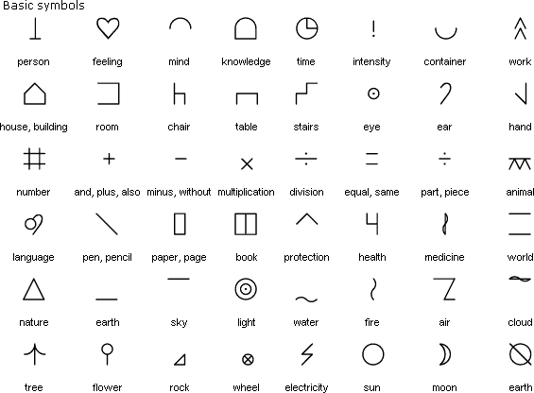

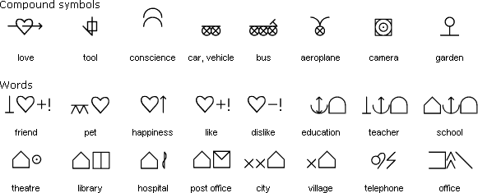

Fig 1: Example of Bliss Symbols

Source: <https://omniglot.com/writing/blissymbolics.htm>

In the figure, on the left it has sequence of Bliss symbols along with their official Ids and on right, their corresponding english translations.

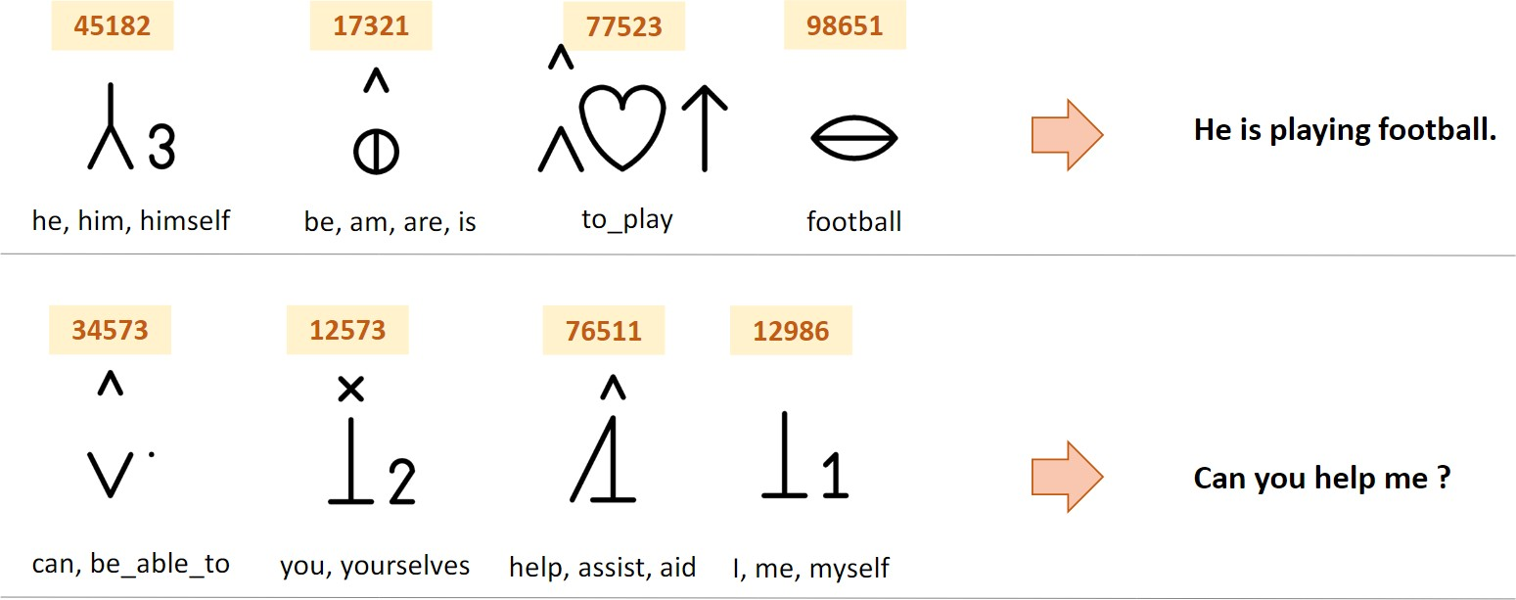

#### Previous Works

Present computer technology enables people with disabilities to become effective partners in communication using Bliss symbols (McNaughton, 1989). In addition to conventional communication, computers provide the benefit of flexible organization of the symbols, and storing and recalling messages. With the use of a speech synthesizer, the assembled messages can be pronounced as well.

In recent years, computerized tools have been developed based on Blissymbolics, such as AccessBliss (Blissymbolics Communication International, Don Mills, ONT, Canada), or Blissymbol Component— Minspeak—Words Strategy . The latter is a vocabulary system produced by the Prentke Romich Company for use with its products, TouchTalker and

Liberator. Both are powerful communication tools providing artificial speech using formant synthesis technology. Handicom, in the Netherlands, also has developed a series of computer programs for working with Blissymbolics. These include a Bliss word processor, symbol and vocabulary editor, paper chart maker, and a personal communication tool with a speech synthesizer.

Over the years demand has risen for developing a computer tool for communication and educational purposes. It would display the Bliss symbols on a screen along with their Hungarian meaning, provide easy access to pupils with disabilities for the purpose of assembling messages, allow the teacher to store and recall messages, and pronounce the sentences created.

Following are the more papers on previous works-

###### From Bliss Symbols to Voice Output:

In this method they have used linguistic module is to transform sequences of words into grammatically well-formed Hungarian sentences with inflected word forms, using a dictionary with morphological and syntactic information and some phrase and sentence pattern rules

###### Web-service for translation of pictogram messages

This paper examines design and implementation of a web-service for translating pictogram messages into text messages in Russian. For more long input sequences, the method based on machine learning is applied. To use neural network translation it was added a second layer of the server written in

Python language. Python part serves the neural network and set up as a local internal server available only for first PHP layer.

###### Natural Language Generation from Pictographs

We present a Pictograph-to-Text translation system for people with Intellectual or Developmental Disabilities (IDD). The system translates pictograph messages, consisting of one or more pictographs, into Dutch text using WordNet links and an n-gram language model. We also provide several pictograph input methods assisting the users in selecting the appropriate pictographs..

### Methodology

* 1. **Datasets Information**

There are no official dataset available for parallel text translation between english and bliss symbols sequence. In this project we have created a dataset. We have used **CHILDES** dataset which is the collection and annotation of speech to and by children. <https://childes.talkbank.org/>.

The dataset contains the transcript of communication done with children of different age group from different countries in the world. In this project dataset of North American English of age group 6 - 16 is used

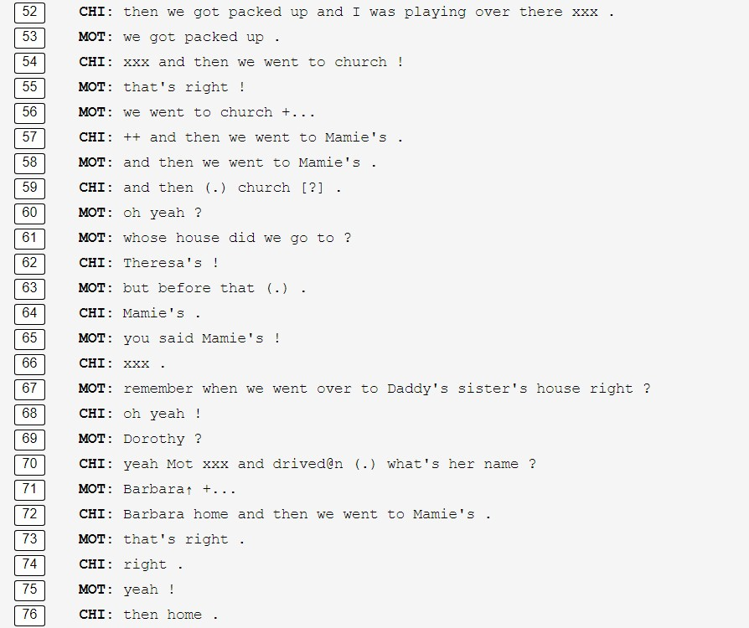

Fig 3: Example of CHILDES dataset

#### Dataset Creation for English Corpus

After collecting all the recorded transcript texts from the CHILDES database, various preprocessing techniques have been applied using Python and Natural Language Processing using the spacy(<https://spacy.io/>) library in python. The dataset has been cleaned in following ways -

* Manual Cleaning -removing meaningless english words
* Punctuation marks and symbols removal
* Stop words removal
* Lemmatization
* Stemming
* Tokenization

#### Dataset Creation for Bliss Corpus

Blissymbolics is a language with a wide vocabulary, a grammar which allows for sentences in past, future and present tenses, and markers for possession, plurality, questions and commands.

There are many strategies within the system of Blissymbolics which enable the user to create new symbols. It is a totally generative system with each new symbol interpretable by the receiver through analyzing the component parts. In the same way that letters represent sounds that are used to create words in print, meaning-based Bliss-characters are sequenced to define the meaning of each compound symbol or Bliss-word.

The full current vocabulary is built from around 1200 such semantic characters. However, since these Bliss-characters are built from a limited number of elements, called key symbols, the learner need only master the meaning of approximately a maximum of 100 to 120 elements.

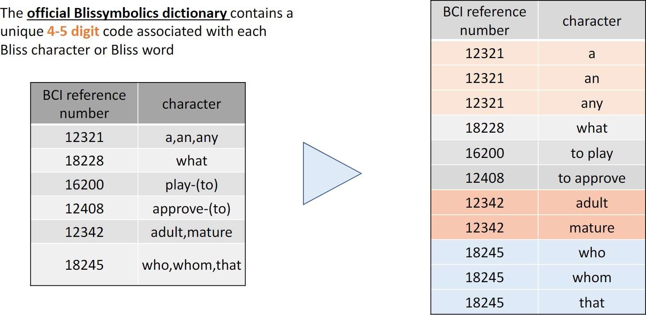

Fig 4: Bliss corpus creation

As explained in this figure, for bliss symbols we have a list of approx 2000 bliss words and their corresponding bliss ids and symbols. One ID and symbol may denote many similar words as shown in the figure. We will discuss more on this later in this report.

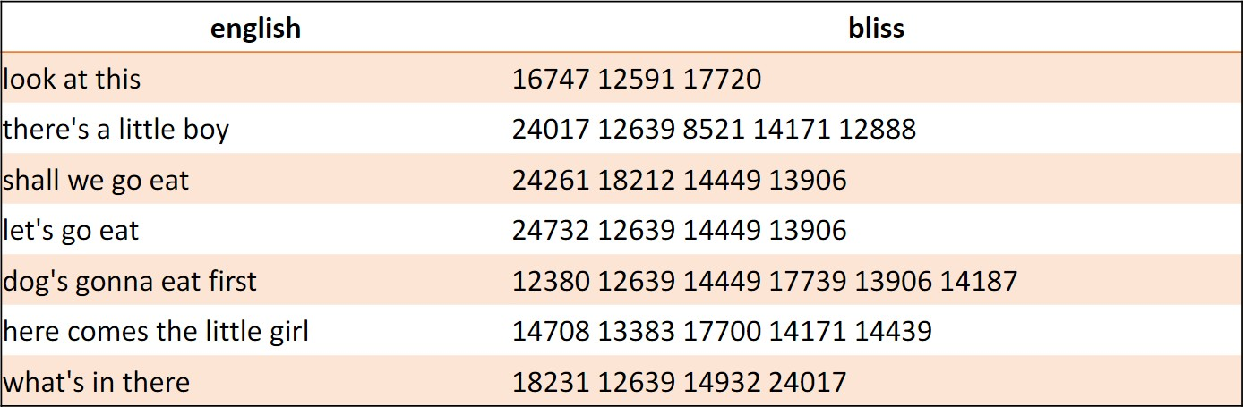

Fig 5: Final parallel dataset from english to bliss

##### Translation Modeling

* + 1. **Method 1 - Heuristic Mapping Method**

Using word to word mapping. I have taken all the words from bliss dictionary and mapped them to their corresponding english words. The sentences which were observed made some sense when read by experts in the English language and its grammar. Since this method lacks the use of grammar in the sentence, it is tough to extract complete meaning from these sentences.

* + 1. **Method 2 - Translation using Transformer with attention heads**

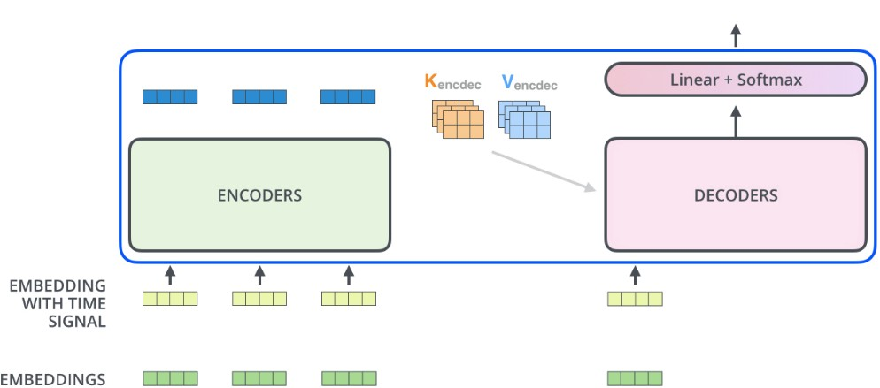

Fig6: Transformer model for translation using encoder decoder

The Transformer model extracts the features for each word using a self-attention mechanism to know the importance of each word in the sentence. No other recurrent units are used to extract this feature, they are just activations and weighted sums, so they can be very efficient and parallelizable.

###### Model Training

Teacher Forcing is a popular training method for neural machine translation. It uses the actual output instead of the predicted output from the previous timestamp as inputs during training, and thus reduces the training time. Here the **input** is the bliss words sequence of ids and **output** is their corresponding English sentences.

###### Model Prediction

* + - 1. The encoder encodes the input sentence of the source language.
      2. The decoder uses the code generated by the encoder and the start token

<start> of the sentence to predict the model.

* + - 1. At each decoder time step, the predicted token from the previous time step is fed into the decoder as an input, in order to predict the output sequence token by token. When the end-of-sequence token <end> is predicted, the prediction of the output sequence is complete.

### Experiments and Results

Table1: Accuracy scores on translation

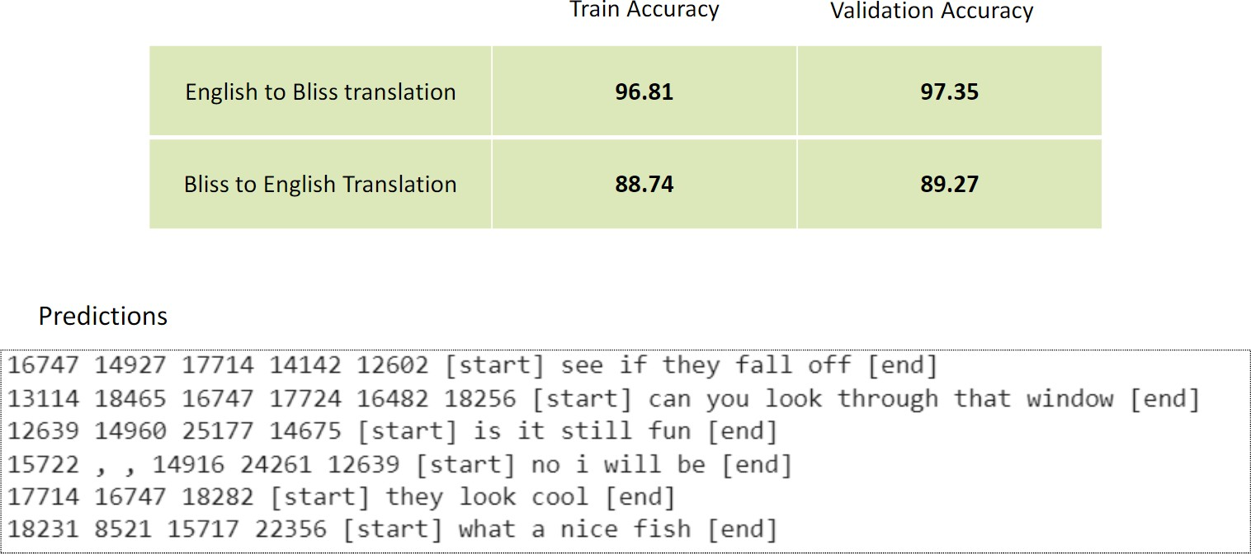

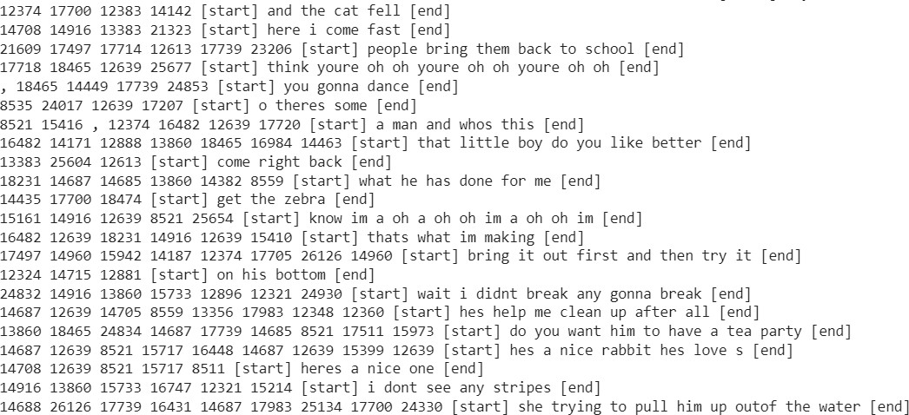

Loss and accuracy graphs -

**Bliss - to - English Translation**

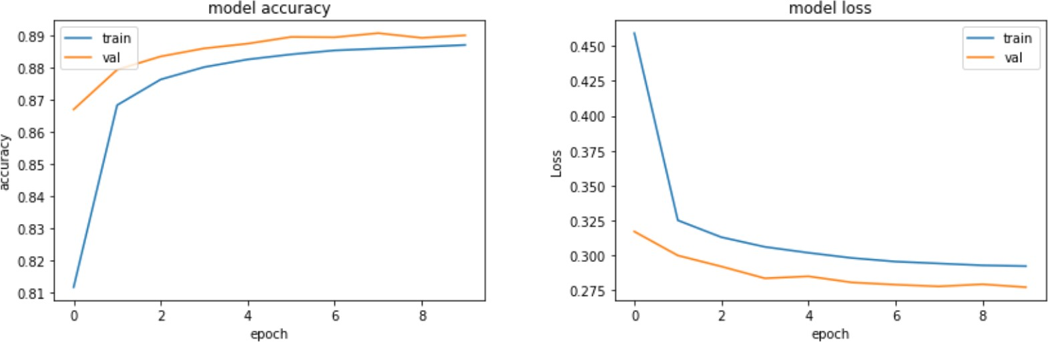

**English- to - Bliss Translation**

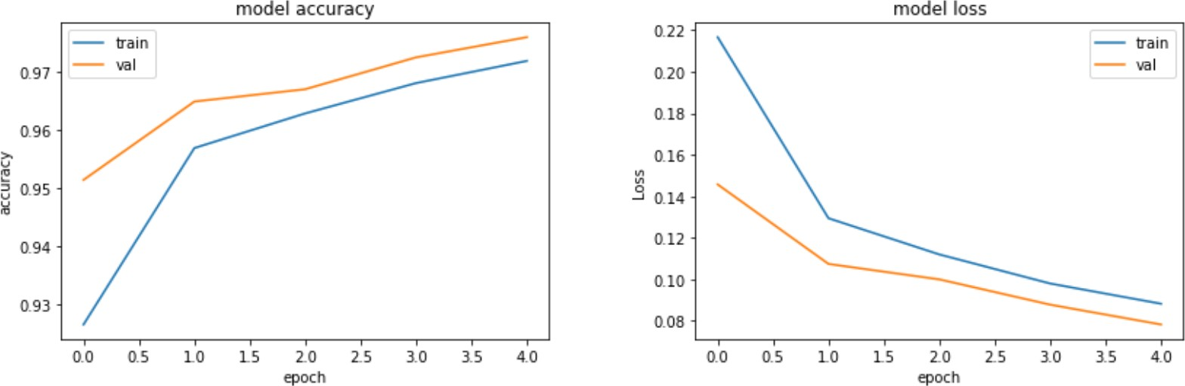

Fig7: Graphs of loss and accuracy metrics

**Mean Meteor Score**: 0.6504

##### Pictogram Addition

A pictogram, also called pictograph, picto or simply icon, is the most simple and efficient way to convey a message or an idea and has been used throughout civilization. Pictograms have constantly evolved over the centuries. Often they’ve been used to convey religious ideas or even been used as a secret code.

**Pictograms and Ideograms -** A pictogram is a symbol that conveys meaning through its resemblance to a physical object. Examples of pictograms include wayfinding signage, such as in airports and other environments where many people may not be familiar with the language of the place they are in.

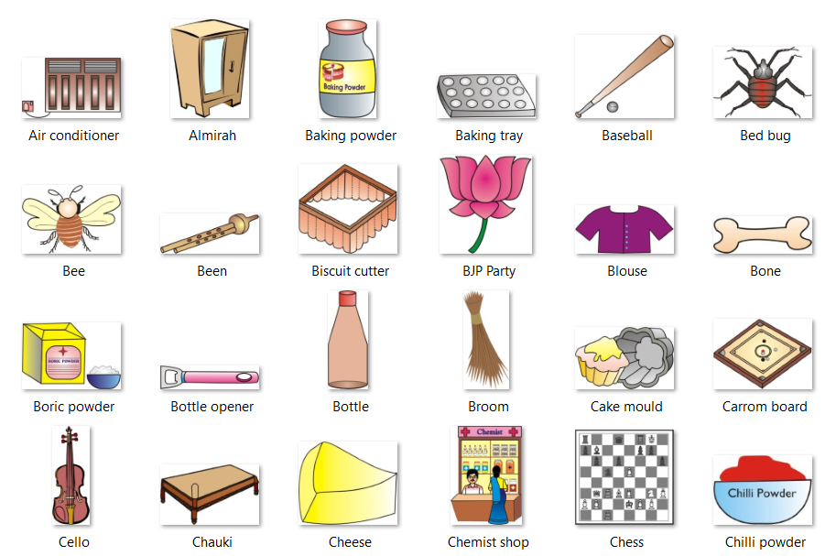

**Pictograms and Blissymbols share a few similarities.** Both use visual symbols to convey meaning, rather than relying on written language. This makes them useful for communicating across different languages and cultures. Both use simple, easily recognizable images or geometric shapes to represent concepts. This makes them easy to learn and understand, even for people who may not have prior knowledge of the specific symbols. Both can be used to communicate a wide range of concepts and ideas, from basic instructions to more complex concepts. They can be used in various settings, including public places, educational settings, and healthcare facilities.

Overall, while pictograms and Blissymbols have distinct purposes and designs, they share some similarities in their use of visual symbols to convey meaning in a simplified, universally recognizable way.

**We have expanded our collection of pictograms beyond Blissymbols**. As a result, certain items or concepts that were previously represented by Blissymbols can now be replaced with more appropriate pictograms from our collection.

This update allows us to offer a wider range of symbols that are more specific and accurate in their representation of certain concepts or actions. By using more suitable pictograms, we hope to improve communication and comprehension for individuals who rely on these symbols for effective communication. Our goal is to make our symbol collection as inclusive and useful as possible, and this expansion is an important step towards achieving that objective.

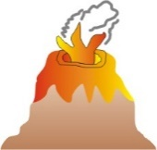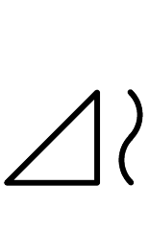

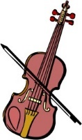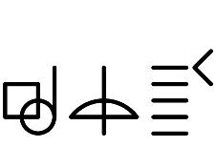

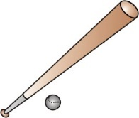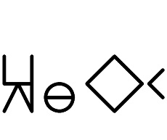

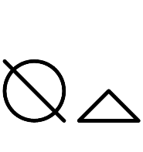

Although we have added many new pictograms to our collection, there are still some Blissymbols for which we don't have corresponding pictograms. As a result, we have not been able to replace all of the Blissymbols in our previous set. However, we have made efforts to preserve the unique word-combining properties of Blissymbols in our new set of pictograms.

Our aim is to ensure that individuals who rely on Blissymbols for communication can continue to use them with ease, while also providing a wider range of symbols for more accurate and specific representation of concepts. We recognize that Blissymbols have been a valuable tool for many individuals with communication impairments, and we want to ensure that our new set of pictograms can seamlessly integrate with Blissymbols for those who prefer to continue using them.

Overall, our approach has been to expand our collection of pictograms while also ensuring that we don't completely replace Blissymbols, but rather complement them. This way, individuals who use Blissymbols can continue to use them, while also having access to a larger collection of symbols that can improve their ability to communicate effectively.

##### Changing Tenses

One feature which we included in our language model is the ability to change the tense of the output sentences. This feature enables our model to generate text in different tenses, such as past, present, and future, depending on the context and input provided by the user. This is particularly useful in scenarios where the tense of the text needs to be consistent with the rest of the document or conversation.

By incorporating this feature, we are able to provide more flexibility and accuracy in our model's output, and make it more adaptable to a wide range of applications, including grammar assistance, language translation, and text generation tasks. Our ultimate goal is to make our model as useful and effective as possible in supporting various language-related tasks and improving communication across different contexts and audiences.

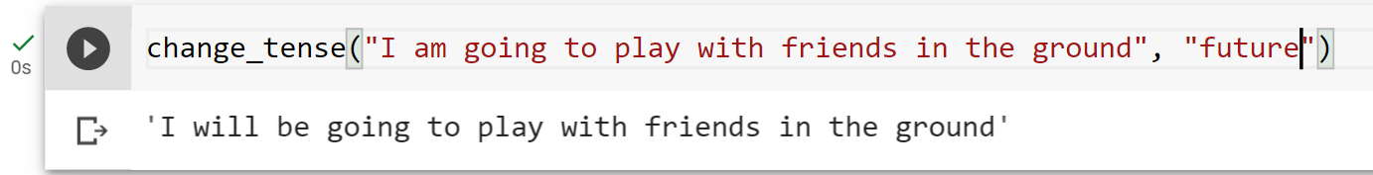

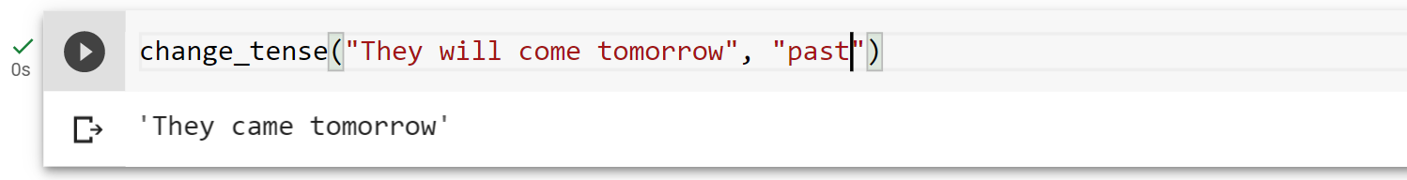

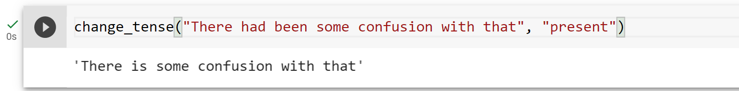

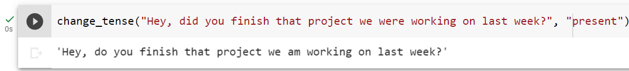

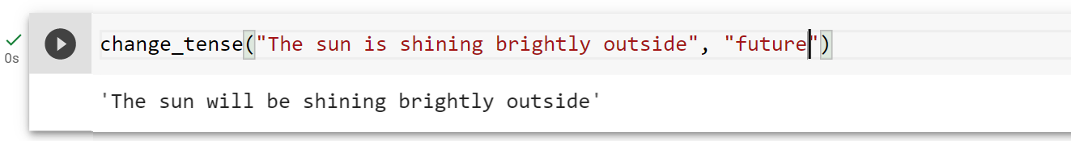

The language model is not only capable of changing the tense of individual sentences, but it can also apply tense changes to entire paragraphs or longer sections of text. This means that users can easily transform a piece of writing from one tense to another, whether it's for editing purposes, stylistic preferences, or other reasons. For example, someone might use our model to convert a past-tense narrative into a present-tense one, or vice versa, to create a different tone or perspective. This feature can be especially useful for writers, editors, and language learners who need to practice using different tenses in their writing.

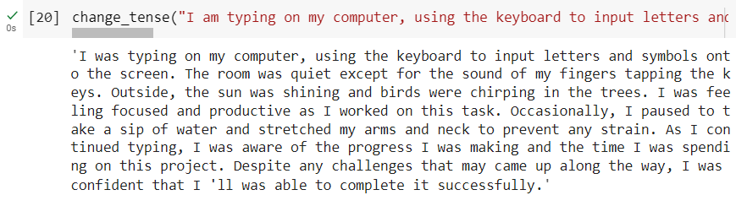

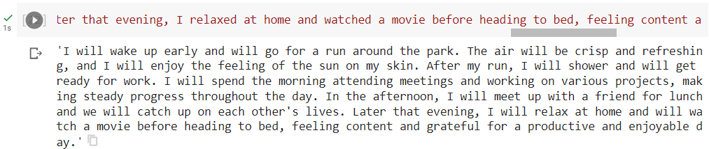

##### Web Services

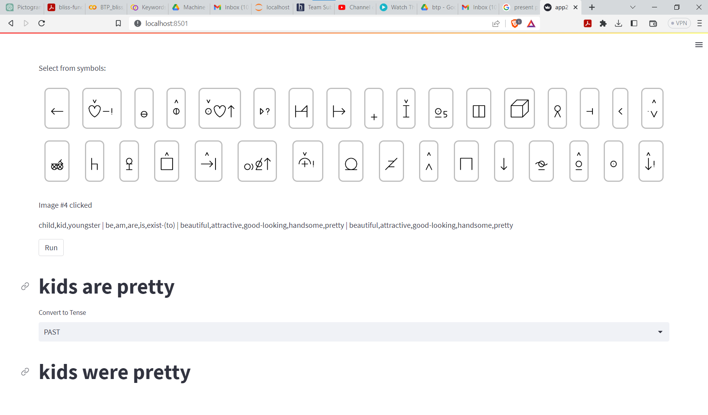

This is a demo web service page for the project. Here, users can select a group of images and our language model will generate corresponding grammatically correct statements based on the images selected, using pictograms and bliss symbols where appropriate. This feature can be especially helpful for those who struggle with traditional language or communication methods, as it allows for a more visual and intuitive learning experience.. All the websites and codes can be run from the project link on github:

<https://github.com/mepiyush2000/BTP_bliss_symbol_project>

### Discussion

The aim of our work was to create a computer - based tool for educational and

communicational purposes for people with severe speech impairments. The

machine learning method using the transformer performed well on both side

translations that are bliss-to-English and English-to-bliss.

When applying the English translation of Bliss symbols, problems arise in the

grammaticality of the assembled messages. There is a need for linguistic

processing in order to complete the endings necessary for English sentences.

Another problem is that of transitive and intransitive verbs, which still has not

been solved. In English, there is often no difference in these forms, in contrast

with English, which consistently uses different verbs, and the two verbs

involve different complement structures (with different endings!). Both

English verbs are represented by the same Bliss symbol, and only one of the

pair is coded now and used in the speaking system. Therefore, the generated

sentence is sometimes clumsy in spite of the linguistic improvements. The

automated solution for the task would need serious context-sensitive

investigation or modification and extension of the original Bliss symbols. The

speech generated after the application of language processing is more natural

and intelligible. In order to create highly natural text, a semantic module

should be developed that could examine the compatibility of the sentence

constituents on the basis of the classification of the notions, and so better

provide the lacking endings. The algorithms of the system described could be

used in other natural language and speech processing applications for Bliss to

English

### Future Work

Future work will look into generation-heavy and transfer approaches for Bliss-to-Text translation considering blissymbolics as bag of words

Add more number of pictograms for training and language model text generation using bliss symbols

Improve website UI and make it more easy to use by dividing the symbols intp section and sub sections.

### References

1. Blissymbolics Communication International <https://www.blissymbolics.org/>
2. Electronic usage of BLISS symbols [https://www.researchgate.net/publication/238474375_Electronic_usage_of_](https://www.researchgate.net/publication/238474375_Electronic_usage_of_BLISS_symbols) [BLISS_symbols](https://www.researchgate.net/publication/238474375_Electronic_usage_of_BLISS_symbols)
3. Application of Blissymbolics to the non-vocal communicatively handicapped[https://scholarworks.umt.edu/cgi/viewcontent.cgi?article=2595](https://scholarworks.umt.edu/cgi/viewcontent.cgi?article=2595&context=etd) [&context=etd](https://scholarworks.umt.edu/cgi/viewcontent.cgi?article=2595&context=etd)
4. Web-service for translation of pictogram messages into Russian text [https://ieeexplore.ieee.org/stamp/stamp.jsp?tp=&arnumber=8633677](https://ieeexplore.ieee.org/stamp/stamp.jsp?tp&arnumber=8633677)
5. Natural Language Generation from Pictographs <https://aclanthology.org/W15-4711.pdf>
6. From Bliss Symbols to Grammatically Correct Voice Output: A Communication Tool for People with Disabilities

https://link.springer.com/content/pdf/10.1023/A:1013682632553.pdf

1. A Neural Machine Translation Approach to Translate Text to Pictographs in a Medical Speech Translation System

<https://aclanthology.org/2022.amta-research.19.pdf>

1. CHILDES Dataset <https://psyling.talkbank.org/years/1985/jcl-childes.pdf>