Dorian Dressler(eeu436)
This document aims to introduce the new functions added to the image class.
The added functions are: Median Filter, Gaussian Filter, Laplacian Filter, Sobel Filter, Prewitt Filter, Sharpen, image segmentation, image blending and a histogram, as well NCC and SAE.
The document further contains visual test data for each function.
A critical evaluation is contained under point 2, code under point 3.
Please note that the code section only contains the newly added functions.
2016
Assignment 2
ICP 3038 – Computer vision
test Document

1. Tests:
This section includes test images for the functions added to the image.cpp class.
NCC and
NCC: SAE:
- Laplacian Edge Detection 1.00132, 49789
- Prewitt Edge Detection -0.0519489 1.11368e+07
- Sobel Edge Detection 0.996511 3.69748e+06
- Box Blur 1.0005 267743
- Gaussian Blur 0.906742 1.36636e+07
- Median Filter 0.995457 176000
- Image sharpening 0.565888 1.10934e+07
- Threshold segmentation 0.0892192 2.3348e+08
- Image blending

Laplacian Edge Detection:
Input:
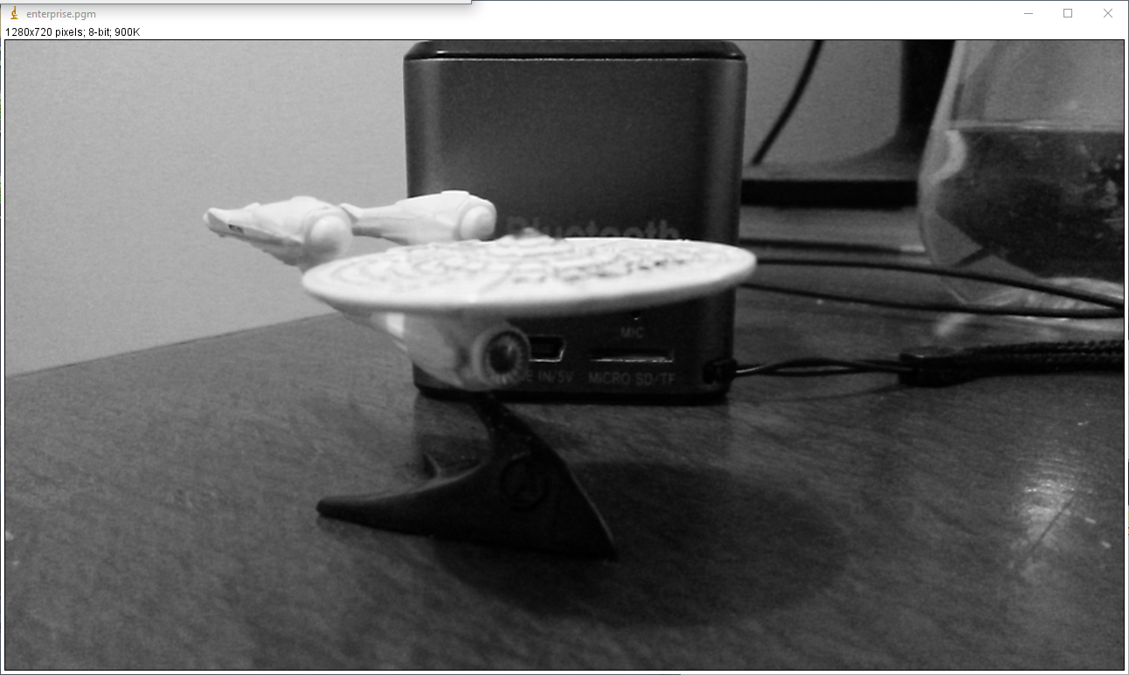
Output:
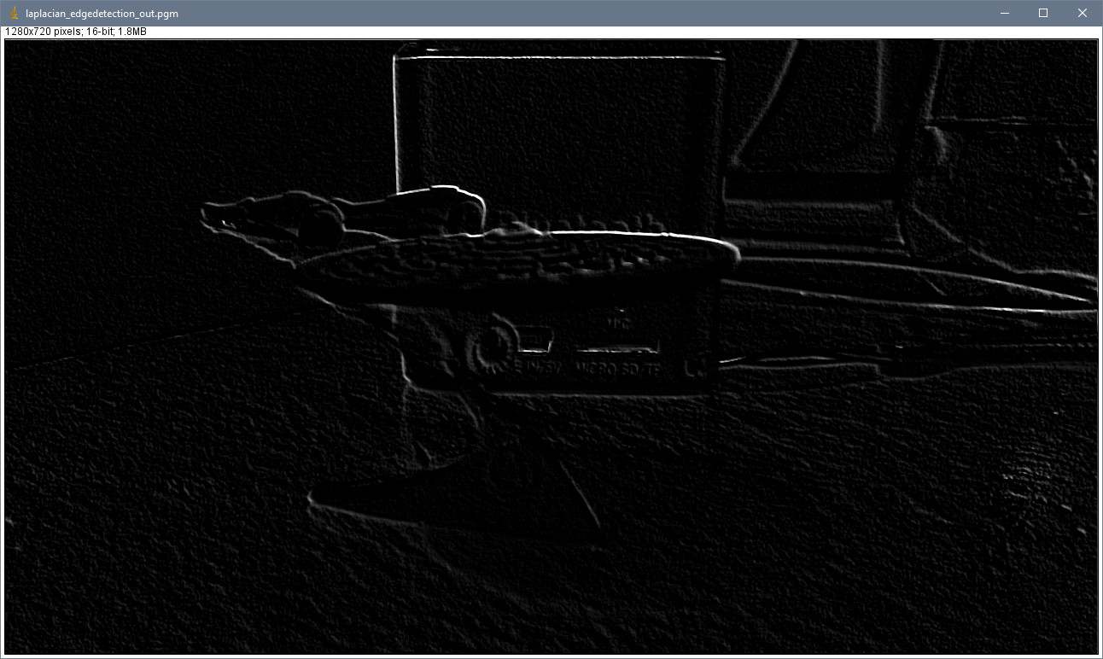
imageJ:
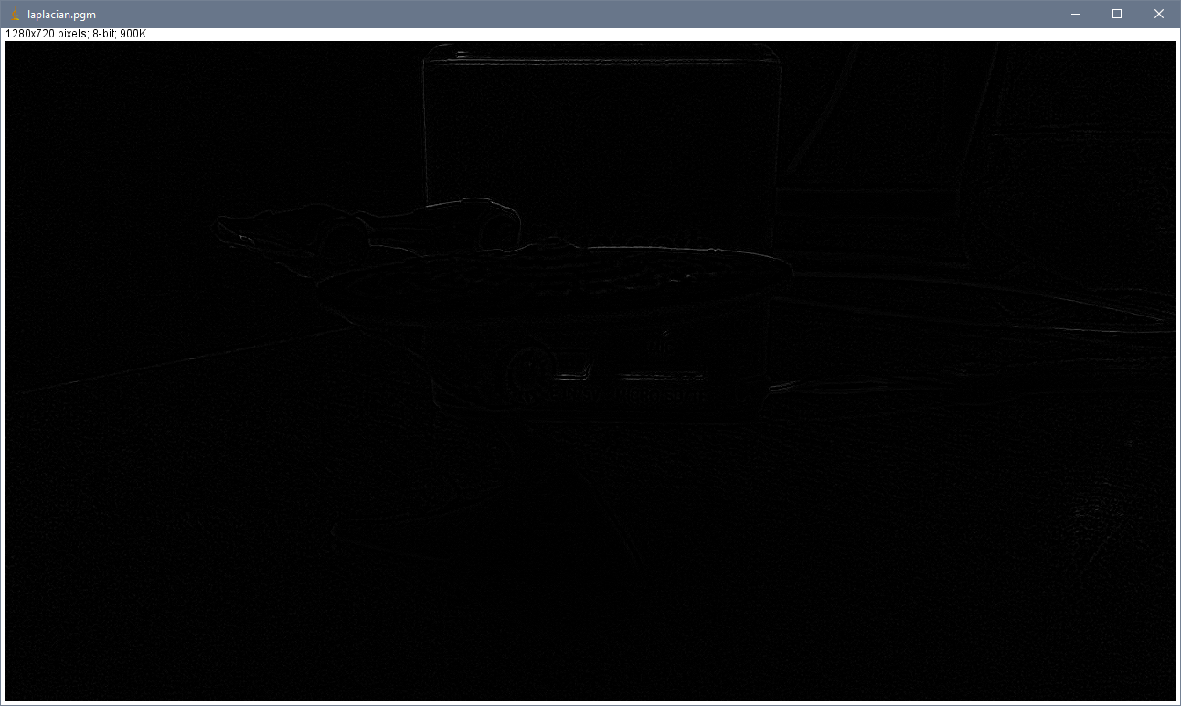

Prewitt Edge Detection:
Input: as above
Output:
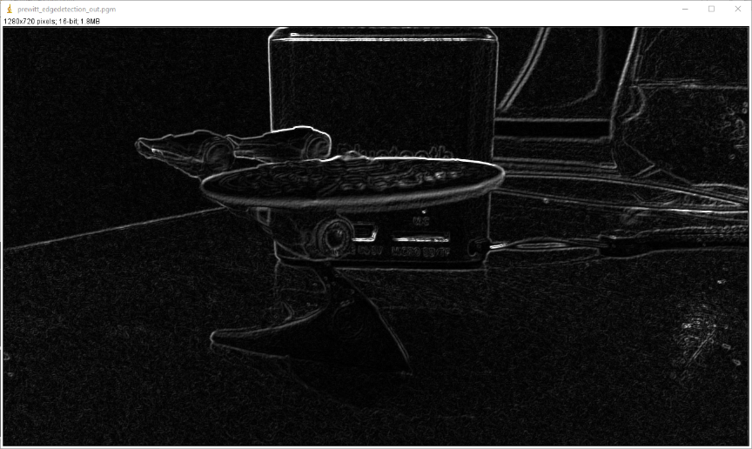
imageJ:
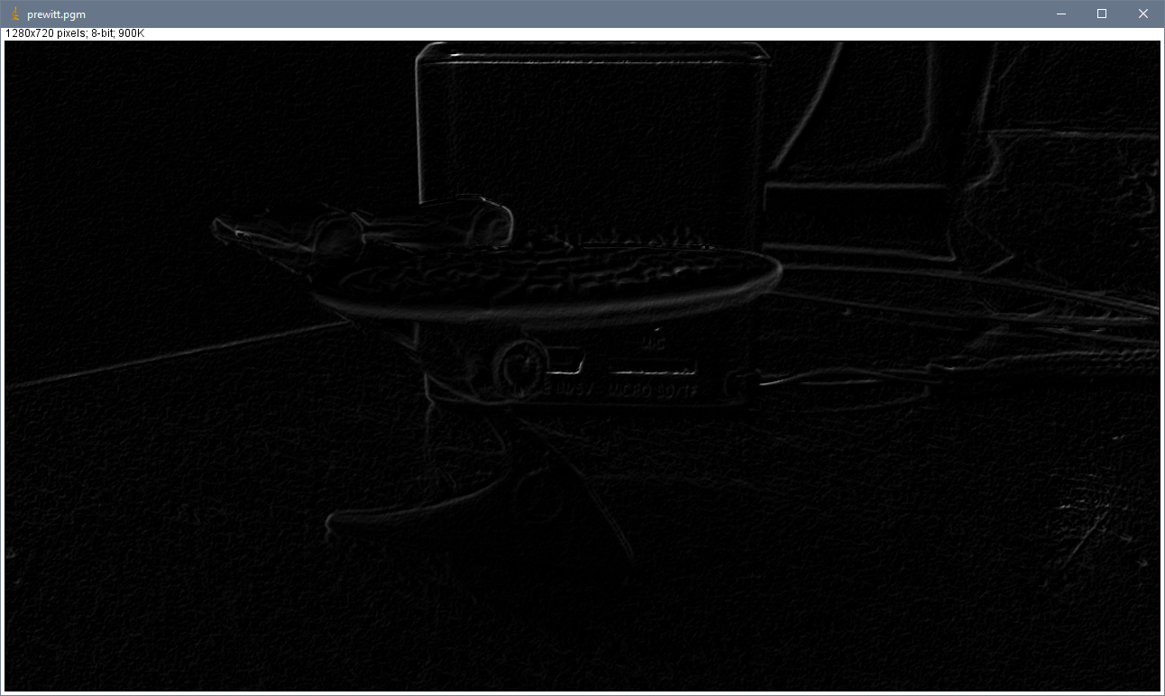

Sobel Edge Detector:
Input: as above
Output:
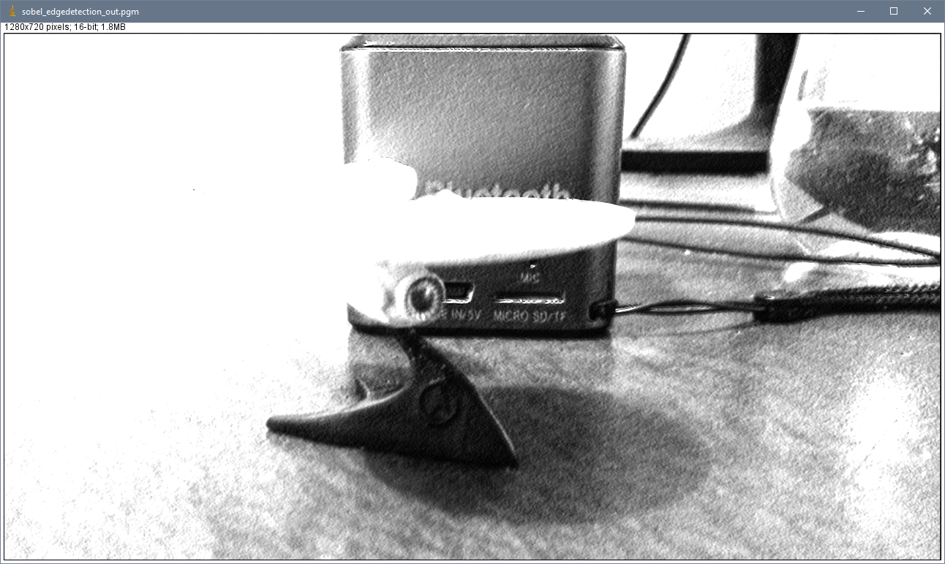
imageJ:
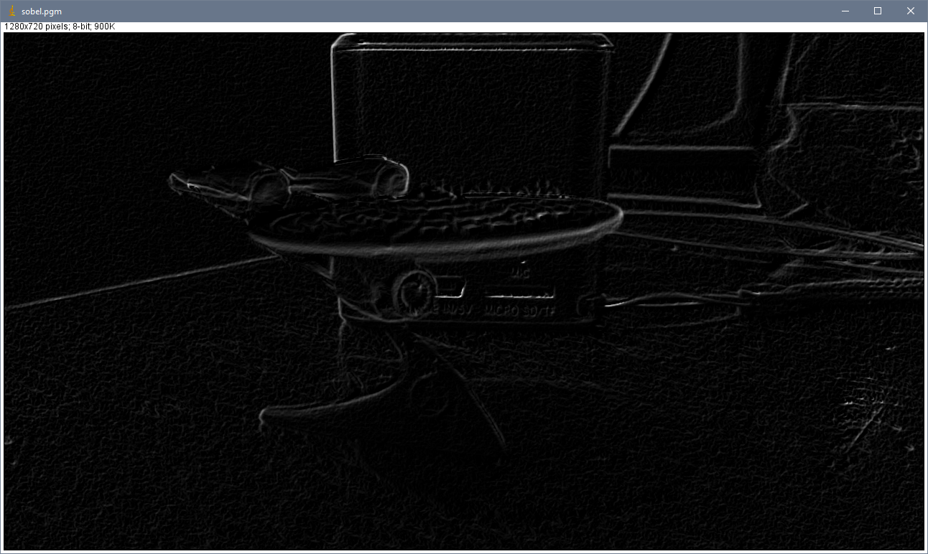
Box Blur:
Input:
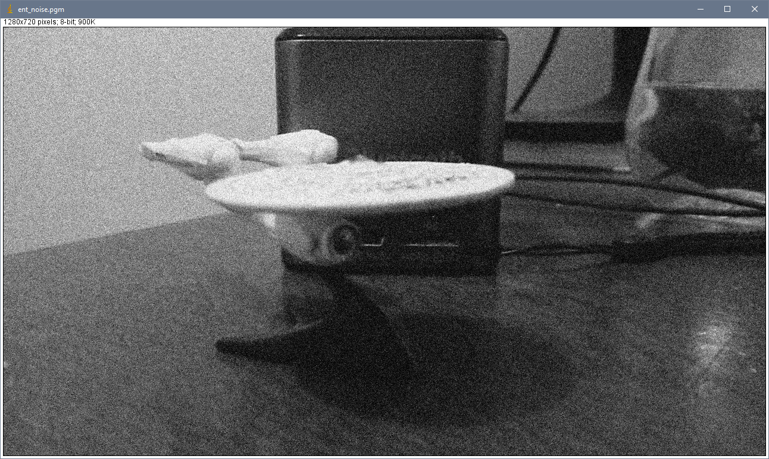
Output:
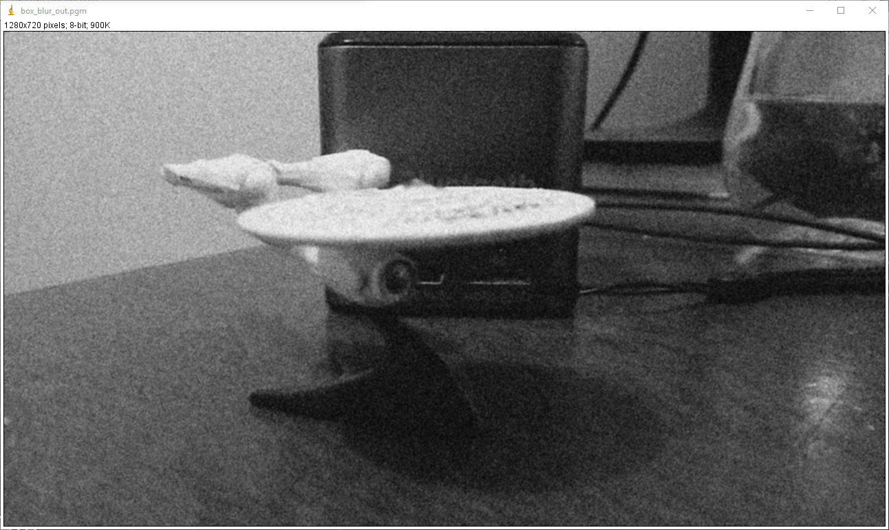
imageJ:
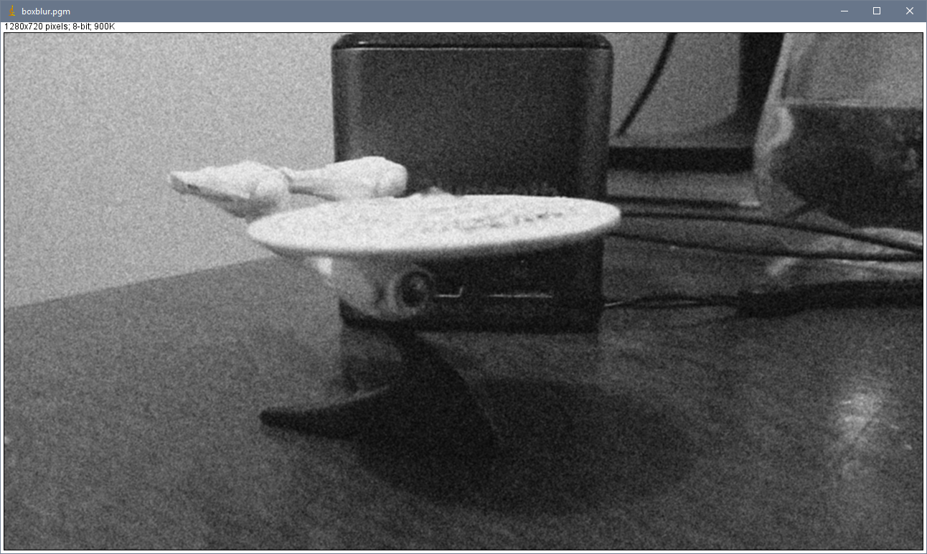
Gaussian Blur:
Input: as above.
Output:
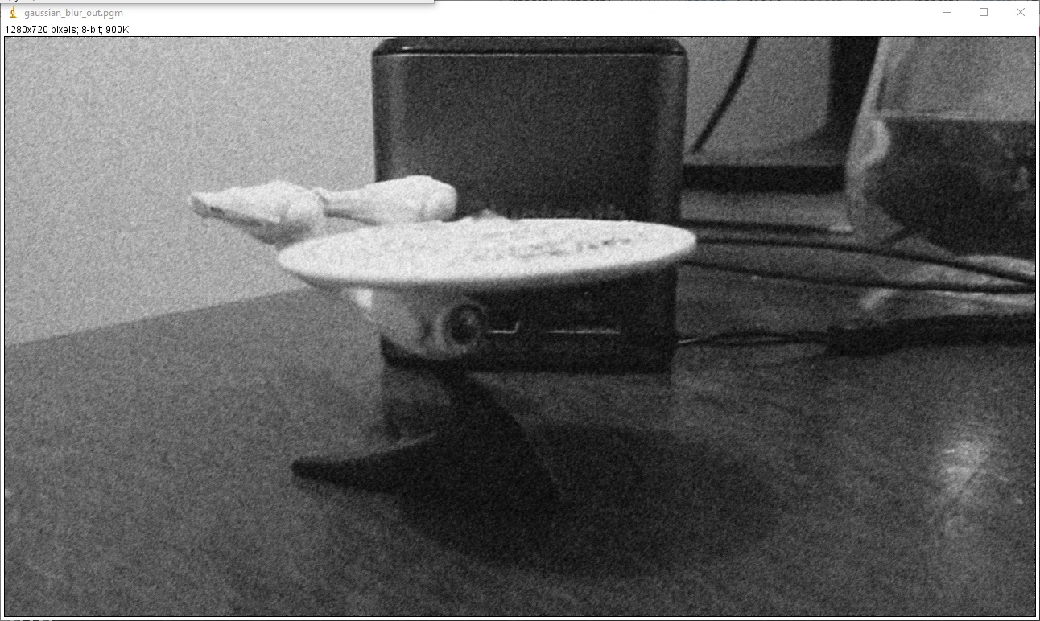
imagej:
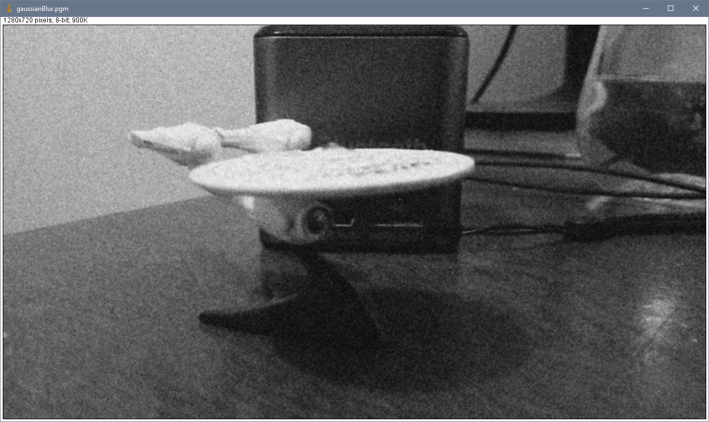
Median Filter:
Input: as above
Output:
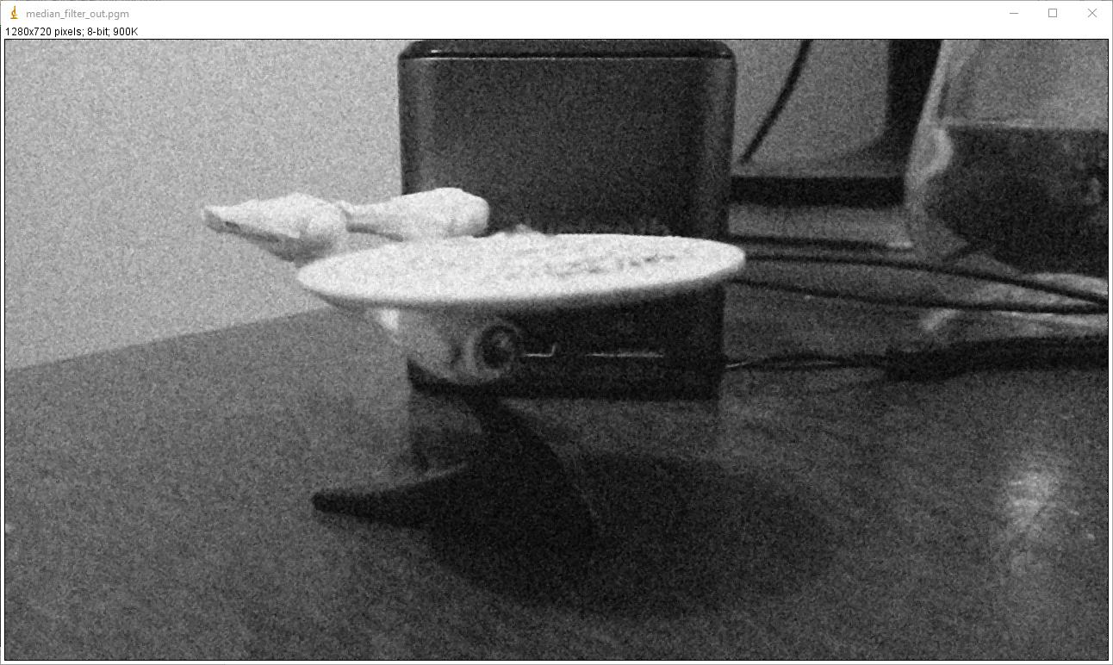
imageJ:
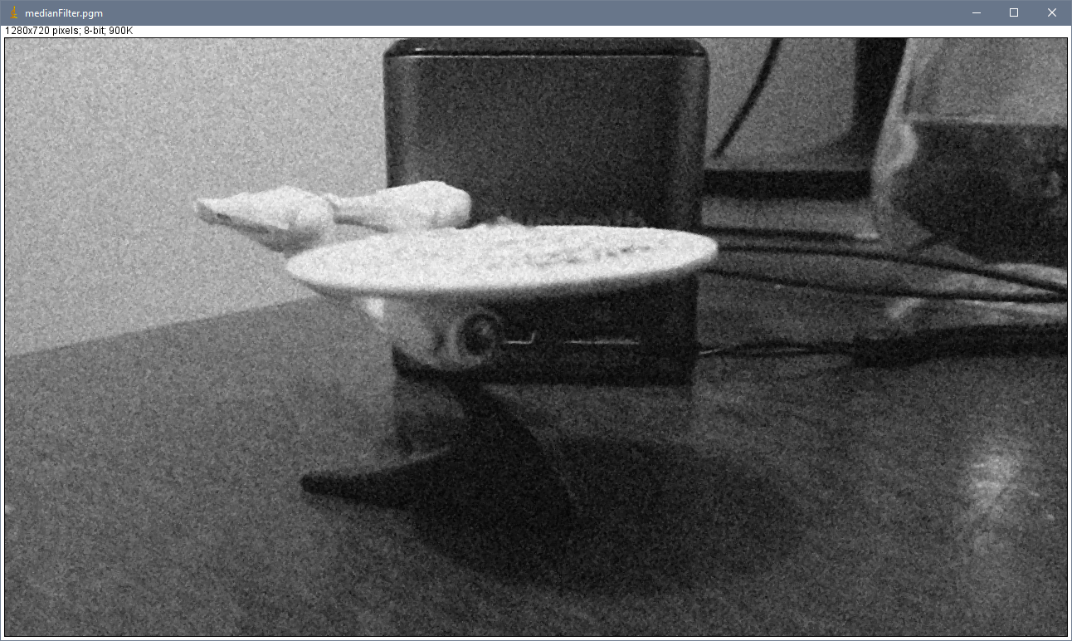

Image sharpening:
Input:
Output:
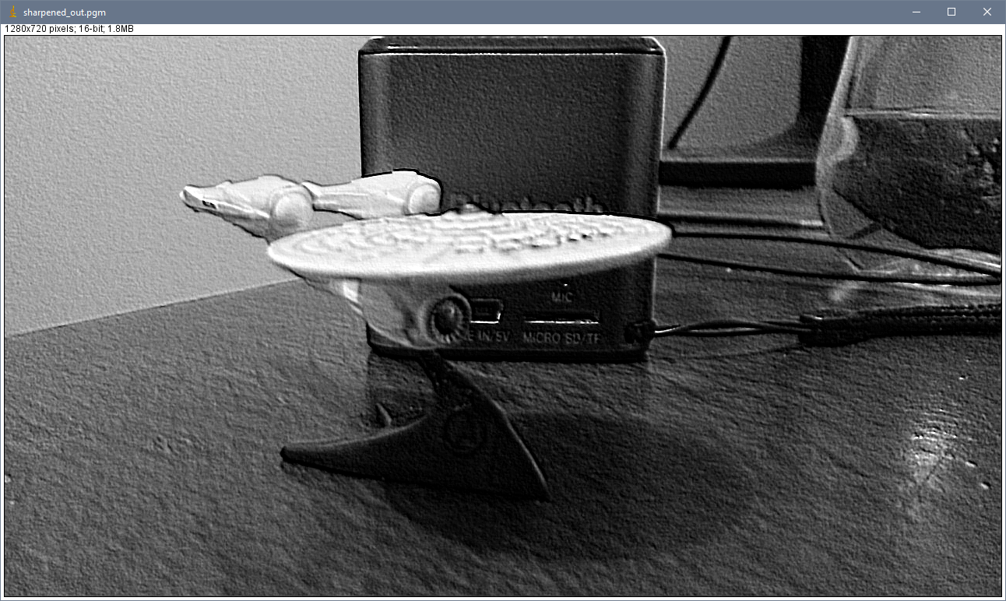
imageJ:
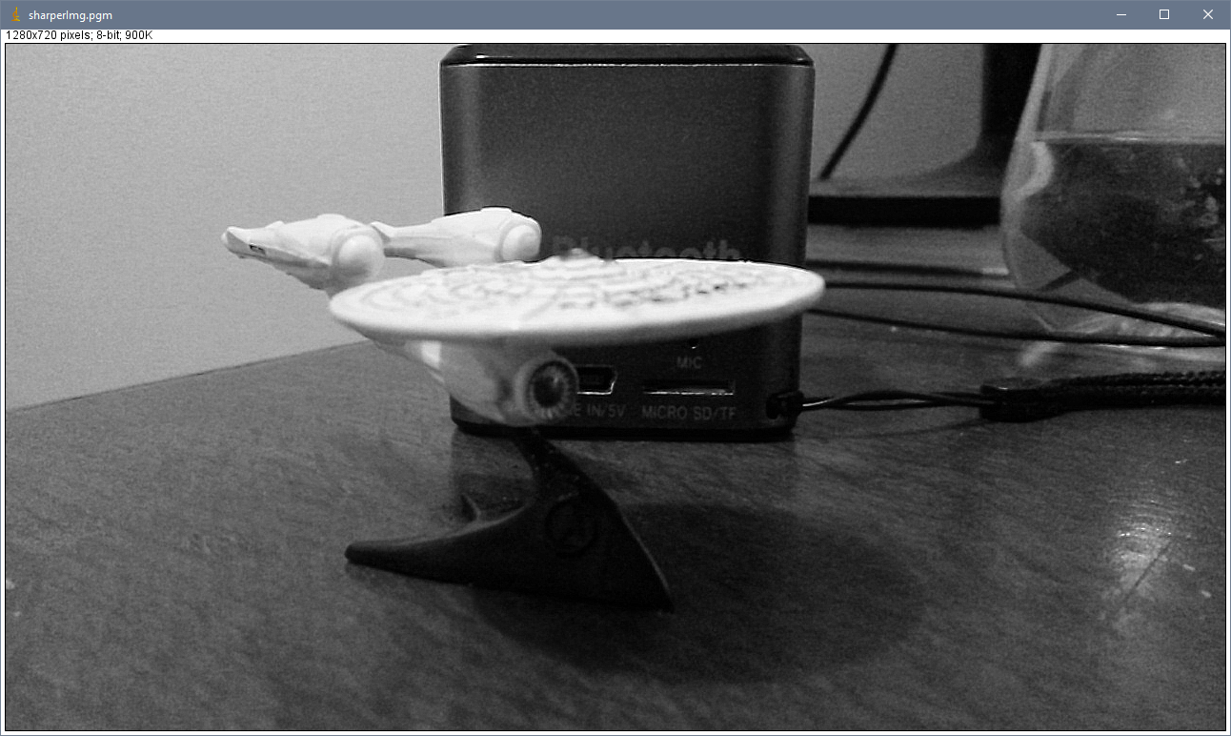
Threshold segmentation: Threshold@125
Input:
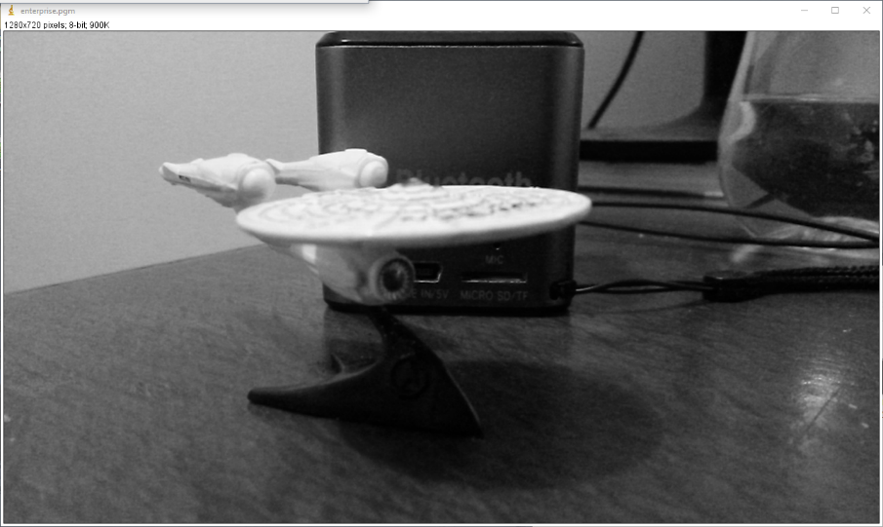
Output:
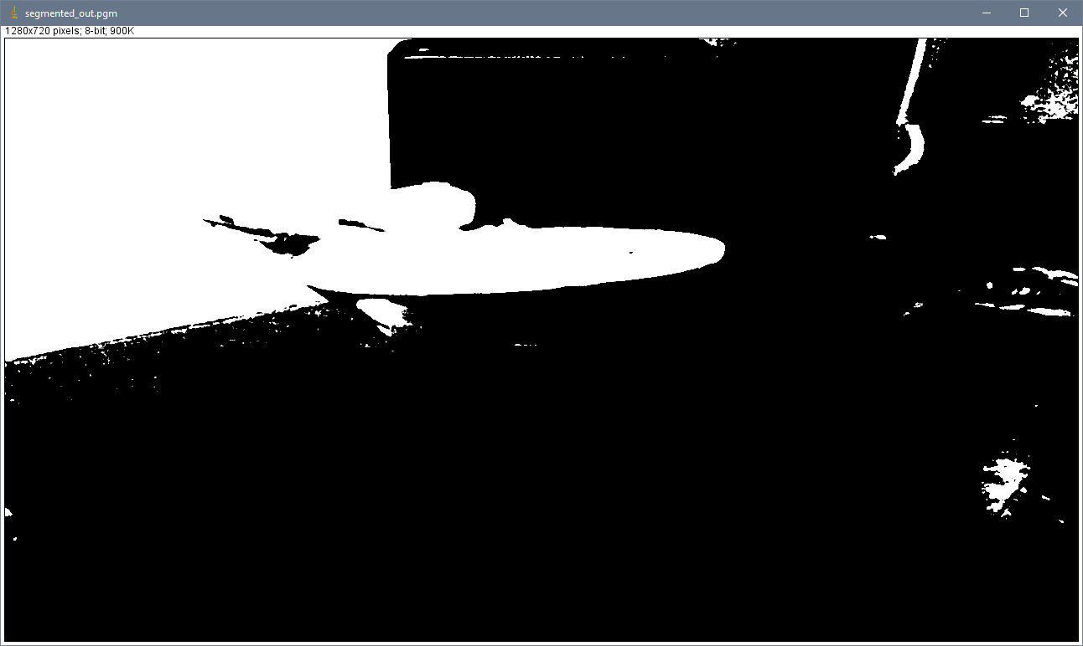
imageJ:
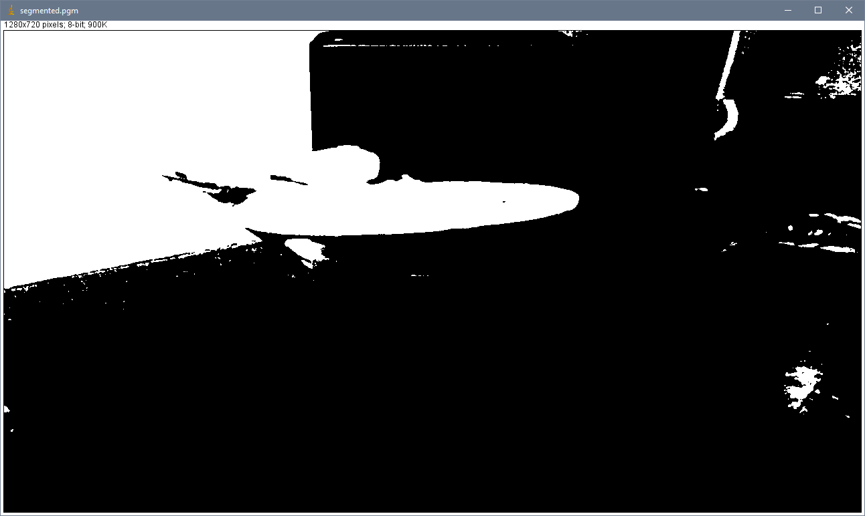
Image blending: 2 images, 512x512, Ratio: 50%
Input:
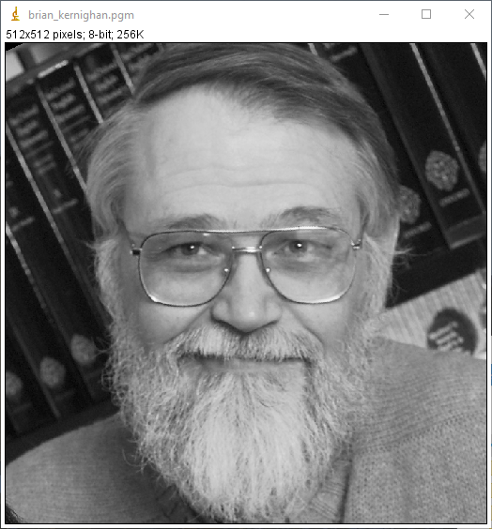 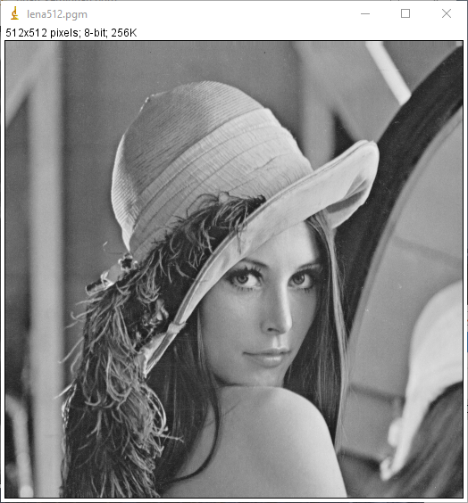
Output:
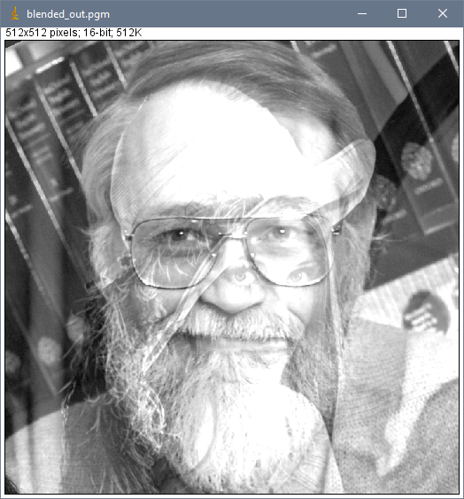
2. Critical Evaluation:

In its entirety, I was not able to implement all functions satisfactorily.
The NCC value based tests failed for each function I implemented, however this may be due to errors in generating the imageJ files using the kernels provided.
The output for the Laplacian Edge Detection I implemented looks better than the Laplacian I generated with imageJ. It is however noteworthy that my implementation did not achieve to highlight all edges, when compared to the original image. Similar issues arose for the Prewitt Edge Detection. My class’ output highlights edges much stronger and much more clearly. By contrast, imageJ’s results fail to highlight some of the vertical lines, for instance the right edge of the Bluetooth speaker in the background. The Sobel Edge Detector kernel failed to work in my class, I strongly suspect I might have missed a line of code or used the wrong kernel. This is evident, as the edge detector does not actually detect edges. The same applies to the Gaussian Blur and the Median Filter. Image.cpp sharpening function sharpens the image quite drastically, as can be seen by the wooden surface. ImageJ’s built in function creates a much smoother result. This is probably because I did not implement a way to allow the user to determine the intensity of the sharpening filter.
Both threshold segmentation functions deliver very similar visual results.
The box blur seems to work okay, as I cannot visually detect a vast difference between imageJ and my function. Image blending seems to work fine.
Altogether, I feel that I could’ve cleaned up my code a lot more and found a better solution for defining edge cases, but the functions work, despite their limitations.

3. Code
/**
********************************************************************************
*
* @file test2.cpp
*
* @brief Tests for: getSAE, getNCC, image blending,threshold segmentation,
* median filter, sobel filter, prewitt filter, laplacian filter,
* box blur.
*
* @version 1.0
*
* @date 23/12/2016
*
* @author Dorian Dressler
*
*
********************************************************************************
*/

//******************************************************************************
// Include
//******************************************************************************
#include <sstream>
#include <iostream>
#include <exception>

#include "Image.h"

//-----------------------------
int main(int argc, char** argv)
//-----------------------------
{
// Return code
int error_code(0);

// Catch exceptions
try
{
// Load an image
Image input_1, input_2, input_3, input_4;
input_1.loadPGM("C:\\Users\\Mepnomon\\Desktop\\CV Assignment 2\\test_data\\enterprise.pgm");
input_2.loadPGM("C:\\Users\\Mepnomon\\Desktop\\CV Assignment 2\\test_data\\brian_kernighan.pgm");
input_3.loadPGM("C:\\Users\\Mepnomon\\Desktop\\CV Assignment 2\\test_data\\lena512.pgm");
input_4.loadPGM("C:\\Users\\Mepnomon\\Desktop\\CV Assignment 2\\test_data\\ent_noise.pgm");

//load reference images
Image ref_1, ref_2, ref_3, ref_4, ref_5, ref_6, ref_7, ref_8;
ref_1.loadPGM("C:\\Users\\Mepnomon\\Desktop\\CV Assignment 2\\test_data\\Reference\\medianFilter.pgm");
ref_2.loadPGM("C:\\Users\\Mepnomon\\Desktop\\CV Assignment 2\\test_data\\Reference\\laplacian.pgm");
ref_3.loadPGM("C:\\Users\\Mepnomon\\Desktop\\CV Assignment 2\\test_data\\Reference\\gaussianBlur.pgm");
ref_4.loadPGM("C:\\Users\\Mepnomon\\Desktop\\CV Assignment 2\\test_data\\Reference\\boxblur.pgm");
ref_5.loadPGM("C:\\Users\\Mepnomon\\Desktop\\CV Assignment 2\\test_data\\Reference\\sharperImg.pgm");
ref_6.loadPGM("C:\\Users\\Mepnomon\\Desktop\\CV Assignment 2\\test_data\\Reference\\segmented.pgm");
ref_7.loadPGM("C:\\Users\\Mepnomon\\Desktop\\CV Assignment 2\\test_data\\Reference\\prewitt.pgm");
ref_8.loadPGM("C:\\Users\\Mepnomon\\Desktop\\CV Assignment 2\\test_data\\Reference\\sobel.pgm");

//test output
Image medianFilteredImage;
medianFilteredImage = input_4.selectFunction_3x3(0);
medianFilteredImage.savePGM("C:\\Users\\Mepnomon\\Desktop\\CV Assignment 2\\test_data\\results\\median_filter_out.pgm");
medianFilteredImage.saveASCII("C:\\Users\\Mepnomon\\Desktop\\CV Assignment 2\\test_data\\results\\median_filter_out.ascii");
medianFilteredImage.saveRaw("C:\\Users\\Mepnomon\\Desktop\\CV Assignment 2\\test_data\\results\\median_filter_out.raw");
std::cout << (std::abs(medianFilteredImage.getNCC(ref_1) - 1.0) < 1.0e-3 ? "SUCCESS" : "FAILURE") << std::endl;
std::cout << abs(medianFilteredImage.getSAE(ref_1)) << std::endl;

Image laplacianFilterImage;
laplacianFilterImage = input_1.selectFunction_3x3(1);
laplacianFilterImage.savePGM("C:\\Users\\Mepnomon\\Desktop\\CV Assignment 2\\test_data\\results\\laplacian_edgedetection_out.pgm");
laplacianFilterImage.saveASCII("C:\\Users\\Mepnomon\\Desktop\\CV Assignment 2\\test_data\\results\\laplacian_degedetection_out.ascii");
laplacianFilterImage.saveRaw("C:\\Users\\Mepnomon\\Desktop\\CV Assignment 2\\test_data\\results\\laplacian_edgedetection_out.raw");
std::cout << (std::abs(laplacianFilterImage.getNCC(ref_2) - 1.0) < 1.0e-3? "SUCCESS" : "FAILURE") << std::endl;
std::cout << abs(laplacianFilterImage.getSAE(ref_2)) << std::endl;

Image gaussianBlurImage;
gaussianBlurImage = input_4.selectFunction_3x3(2);
gaussianBlurImage.savePGM("C:\\Users\\Mepnomon\\Desktop\\CV Assignment 2\\test_data\\results\\gaussian_blur_out.pgm");
gaussianBlurImage.saveASCII("C:\\Users\\Mepnomon\\Desktop\\CV Assignment 2\\test_data\\results\\gaussian_blur_out.ascii");
gaussianBlurImage.saveRaw("C:\\Users\\Mepnomon\\Desktop\\CV Assignment 2\\test_data\\results\\gaussian_blur_out.raw");

gaussianBlurImage.getSAE(input_4);
std::cout << (std::abs(gaussianBlurImage.getNCC(ref_3) - 1.0) < 1.0e-3 ? "SUCCESS" : "FAILURE") << std::endl;
std::cout << abs(gaussianBlurImage.getSAE(ref_3)) << std::endl;

Image boxBlurImage;
boxBlurImage = input_4.selectFunction_3x3(3);
boxBlurImage.savePGM("C:\\Users\\Mepnomon\\Desktop\\CV Assignment 2\\test_data\\results\\box_blur_out.pgm");
boxBlurImage.saveASCII("C:\\Users\\Mepnomon\\Desktop\\CV Assignment 2\\test_data\\results\\box_blur_out.ascii");
boxBlurImage.saveRaw("C:\\Users\\Mepnomon\\Desktop\\CV Assignment 2\\test_data\\results\\box_blur_out.raw");
std::cout << (std::abs(boxBlurImage.getNCC(ref_4) - 1.0) < 1.0e-3 ? "SUCCESS" : "FAILURE") << std::endl;
std::cout << abs(boxBlurImage.getSAE(ref_4)) << std::endl;

Image sharperImage;
sharperImage = input_1.selectFunction_3x3(4);
sharperImage.savePGM("C:\\Users\\Mepnomon\\Desktop\\CV Assignment 2\\test_data\\results\\sharpened_out.pgm");
sharperImage.saveASCII("C:\\Users\\Mepnomon\\Desktop\\CV Assignment 2\\test_data\\results\\sharpened_out.ascii");
sharperImage.saveRaw("C:\\Users\\Mepnomon\\Desktop\\CV Assignment 2\\test_data\\results\\sharpened_out.raw");
std::cout << (std::abs(sharperImage.getNCC(ref_5) - 1.0) < 1.0e-3 ? "SUCCESS" : "FAILURE") << std::endl;
std::cout << abs(sharperImage.getSAE(ref_5)) << std::endl;

Image segmentedImage;
segmentedImage = input_1.segmentImage(125);
segmentedImage.savePGM("C:\\Users\\Mepnomon\\Desktop\\CV Assignment 2\\test_data\\results\\segmented_out.pgm");
segmentedImage.saveASCII("C:\\Users\\Mepnomon\\Desktop\\CV Assignment 2\\test_data\\results\\segmented_out.ascii");
segmentedImage.saveRaw("C:\\Users\\Mepnomon\\Desktop\\CV Assignment 2\\test_data\\results\\segmented_out.raw");
std::cout << (std::abs(segmentedImage.getNCC(ref_6) - 1.0) < 1.0e-3 ? "SUCCESS" : "FAILURE") << std::endl;
std::cout << abs(segmentedImage.getSAE(ref_6)) << std::endl;

Image blendedImage; //x
blendedImage = input_2.blendImage(input_3, 0.5);
blendedImage.savePGM("C:\\Users\\Mepnomon\\Desktop\\CV Assignment 2\\test_data\\results\\blended_out.pgm");
blendedImage.saveASCII("C:\\Users\\Mepnomon\\Desktop\\CV Assignment 2\\test_data\\results\\blended_out.ascii");
blendedImage.saveRaw("C:\\Users\\Mepnomon\\Desktop\\CV Assignment 2\\test_data\\results\\blended_out.raw");;

Image prewittImage; //x
prewittImage = input_1.selectFunction_3x3(5);
prewittImage.savePGM("C:\\Users\\Mepnomon\\Desktop\\CV Assignment 2\\test_data\\results\\prewitt_edgedetection_out.pgm");
prewittImage.saveASCII("C:\\Users\\Mepnomon\\Desktop\\CV Assignment 2\\test_data\\results\\prewitt_edgedetection_out.ascii");
prewittImage.saveRaw("C:\\Users\\Mepnomon\\Desktop\\CV Assignment 2\\test_data\\results\\prewitt_edgedetection_out.raw");
std::cout << (std::abs(prewittImage.getNCC(ref_7) - 1.0) < 1.0e-3 ? "SUCCESS" : "FAILURE") << std::endl;
std::cout << abs(prewittImage.getSAE(ref_7)) << std::endl;

Image sobelImage; //x
sobelImage = input_1.selectFunction_3x3(6);
sobelImage.savePGM("C:\\Users\\Mepnomon\\Desktop\\CV Assignment 2\\test_data\\results\\sobel_edgedetection_out.pgm");
sobelImage.saveASCII("C:\\Users\\Mepnomon\\Desktop\\CV Assignment 2\\test_data\\results\\sobel_edgedetection_out.ascii");
sobelImage.saveRaw("C:\\Users\\Mepnomon\\Desktop\\CV Assignment 2\\test_data\\results\\sobel_edgedetection_out.raw");
//sobelImage.getNCC(input_1);
std::cout << (std::abs(sobelImage.getNCC(ref_8) - 1.0) < 1.0e-3 ? "SUCCESS" : "FAILURE") << std::endl;
std::cout << abs(sobelImage.getSAE(ref_8)) << std::endl;
}
// An error occured
catch (const std::exception& error)
{
error_code = 1;
std::cerr << error.what() << std::endl;
}
catch (const std::string& error)
{
error_code = 1;
std::cerr << error << std::endl;
}
catch (const char* error)
{
error_code = 1;
std::cerr << error << std::endl;
}
catch (...)
{
error_code = 1;
std::cerr << "Unknown error" << std::endl;
}

return (error_code);

}

/**
********************************************************************************
*
* @file Image.cpp
*
* @brief Class to handle a greyscale image.
*
* @version 1.1
*
*
* @date 11/11/2016
*
* @author Franck Vidal (amended by Dorian Dressler)
*
*
********************************************************************************
*/

//******************************************************************************
// Define
//******************************************************************************
#define LINE_SIZE 2048

//******************************************************************************
// Include
//******************************************************************************
#include <sstream> // Header file for stringstream
#include <fstream> // Header file for filestream
#include <algorithm> // Header file for min/max/fill
#include <cmath> // Header file for abs
#include <vector>
#include <iostream>

#include "Image.h"

//------------------
Image::Image():
//------------------
m_width(0),
m_height(0),
m_p_image(0)
//------------------
{}

//----------------------------------------------
Image::Image(const Image& anImage):
//----------------------------------------------
m_width(anImage.m_width),
m_height(anImage.m_height),
m_p_image(new float[m_width * m_height])
//----------------------------------------------
{
// Out of memeory
if (m_width && m_height && !m_p_image)
{
throw "Out of memory";
}

// Copy the data
std::copy(anImage.m_p_image, anImage.m_p_image + m_width * m_height, m_p_image);
}

//----------------------------------------------
Image::Image(const float* apData,
unsigned int aWidth,
unsigned int aHeight):
//----------------------------------------------
m_width(aWidth),
m_height(aHeight),
m_p_image(new float[m_width * m_height])
//----------------------------------------------
{
// Out of memeory
if (m_width && m_height && !m_p_image)
{
throw "Out of memory";
}

// Copy the data
std::copy(apData, apData + m_width * m_height, m_p_image);
}

//----------------------------------------------
Image::Image(unsigned int aWidth,
unsigned int aHeight):
//----------------------------------------------
m_width(aWidth),
m_height(aHeight),
m_p_image(new float[m_width * m_height])
//----------------------------------------------
{
// Out of memeory
if (m_width && m_height && !m_p_image)
{
throw "Out of memory";
}

// Initialise the data
std::fill_n(m_p_image, m_width * m_height, 0);
}

//-------------
Image::~Image()
//-------------
{
// Release memory
destroy();
}

//-------------------
void Image::destroy()
//-------------------
{
// Memory has been dynamically allocated
if (m_p_image)
{
// Release the memory
delete [] m_p_image;

// Make sure the pointer is reset to NULL
m_p_image = 0;
}

// There is no pixel in the image
m_width = 0;
m_height = 0;
}

//---------------------------------------------
Image Image::getROI(unsigned int i,
unsigned int j,
unsigned int aWidth,
unsigned int aHeight) const
//---------------------------------------------
{
// Create a black image
Image roi(aWidth, aHeight);

// Process every row of the ROI
for (unsigned y(0); y < aHeight; ++y)
{
// Process every column of the ROI
for (unsigned x(0); x < aWidth; ++x)
{
unsigned int index_i(x + i);
unsigned int index_j(y +j);

// The pixel index is valid
if ((index_i < m_width) && (index_j < m_height))
{
// Get the pixel intensity from the current instance
float intensity(getPixel(index_i, index_j));

// Set the pixel of the ROI
roi.setPixel(x, y, intensity);
}
}
}

return (roi);
}

//----------------------------------------------------------------
void Image::setPixel(unsigned int i, unsigned int j, float aValue)
//----------------------------------------------------------------
{
// The pixel index is not valid
//std::cout << i;
//std::cout <<" " << j << std::endl;
if (i >= m_width || j >= m_height)
{
throw "set pixel Invalid pixel coordinate";
}

// Change the pixel value
m_p_image[j * m_width + i] = aValue;
}

//---------------------------------------------------------
float Image::getPixel(unsigned int i, unsigned int j) const
//---------------------------------------------------------
{
//std::cout << "i " << i;
//std::cout << " j " << j << std::endl;
// The pixel index is valid
if (i >= m_width || j >= m_height)
{
std::cout << i;
std::cout << " " << j << std::endl;
throw "get pixel Invalid pixel coordinate";
}

// Return the pixel value
return (m_p_image[j * m_width + i]);
}

//------------------------------------------------
bool Image::operator!=(const Image& anImage) const
//------------------------------------------------
{
return (!(operator==(anImage)));
}

//-------------------------------------------
Image& Image::operator=(const Image& anImage)
//-------------------------------------------
{
// The images different
if (this != &anImage)
{
// Release memory
destroy();

// Copy the image properites
m_width = anImage.m_width;
m_height = anImage.m_height;
m_p_image = new float[m_width * m_height];

// Out of memeory
if (m_width && m_height && !m_p_image)
{
throw "Out of memory";
}

// Copy the data
std::copy(anImage.m_p_image, anImage.m_p_image + m_width * m_height, m_p_image);
}

// Return the instance
return (*this);
}

//------------------------------------------
Image Image::operator+(const Image& anImage)
//------------------------------------------
{
// Deal with images of different sizes
unsigned int min_width(std::min(m_width, anImage.m_width));
unsigned int min_height(std::min(m_height, anImage.m_height));

// Copy the instance into a temporary variable
Image temp(getROI(0, 0, min_width, min_height));

// Copy the data
for (unsigned int j(0); j < min_height; ++j)
{
for (unsigned int i(0); i < min_width; ++i)
{
temp.m_p_image[j * temp.m_width + i] += anImage.m_p_image[j * anImage.m_width + i];
}
}

// Return the result
return (temp);
}

//------------------------------------------
Image Image::operator-(const Image& anImage)
//------------------------------------------
{
// Deal with images of different sizes
unsigned int min_width(std::min(m_width, anImage.m_width));
unsigned int min_height(std::min(m_height, anImage.m_height));

// Copy the instance into a temporary variable
Image temp(getROI(0, 0, min_width, min_height));

// Copy the data
for (unsigned int j(0); j < min_height; ++j)
{
for (unsigned int i(0); i < min_width; ++i)
{
temp.m_p_image[j * temp.m_width + i] -= anImage.m_p_image[j * anImage.m_width + i];
}
}

// Return the result
return (temp);
}

//--------------------------------------------
Image& Image::operator+=(const Image& anImage)
//--------------------------------------------
{
// Re-use operator+
*this = *this + anImage;

// Return the result
return (*this);
}

//--------------------------------------------
Image& Image::operator-=(const Image& anImage)
//--------------------------------------------
{
// Re-use operator-
*this = *this - anImage;

// Return the result
return (*this);
}

//----------------------------------
Image Image::operator+(float aValue)
//----------------------------------
{
// Copy the instance into a temporary variable
Image temp(*this);

float* p_temp(temp.m_p_image);
for (unsigned int i(0); i < m_width * m_height; ++i)
{
*p_temp++ += aValue;
}

// Return the result
return (temp);
}

//----------------------------------
Image Image::operator-(float aValue)
//----------------------------------
{
// Copy the instance into a temporary variable
Image temp(*this);

float* p_temp(temp.m_p_image);
for (unsigned int i(0); i < m_width * m_height; ++i)
{
*p_temp++ -= aValue;
}

// Return the result
return (temp);
}

//----------------------------------
Image Image::operator*(float aValue)
//----------------------------------
{
// Copy the instance into a temporary variable
Image temp(*this);

float* p_temp(temp.m_p_image);
for (unsigned int i(0); i < m_width * m_height; ++i)
{
*p_temp++ *= aValue;
}

// Return the result
return (temp);
}

//----------------------------------
Image Image::operator/(float aValue)
//----------------------------------
{
// Division by zero
if (std::abs(aValue) < 1.0e-6)
{
throw "Division by zero.";
}

// Copy the instance into a temporary variable
Image temp(*this);

float* p_temp(temp.m_p_image);
for (unsigned int i(0); i < m_width * m_height; ++i)
{
*p_temp++ /= aValue;
}

// Return the result
return (temp);
}

//-----------------------------------
Image& Image::operator+=(float aValue)
//-----------------------------------
{
float* p_temp(m_p_image);
for (unsigned int i(0); i < m_width * m_height; ++i)
{
*p_temp++ += aValue;
}

// Return the result
return (*this);
}

//------------------------------------
Image& Image::operator-=(float aValue)
//------------------------------------
{
float* p_temp(m_p_image);
for (unsigned int i(0); i < m_width * m_height; ++i)
{
*p_temp++ -= aValue;
}

// Return the result
return (*this);
}

//------------------------------------
Image& Image::operator*=(float aValue)
//------------------------------------
{
float* p_temp(m_p_image);
for (unsigned int i(0); i < m_width * m_height; ++i)
{
*p_temp++ *= aValue;
}

// Return the result
return (*this);
}

//------------------------------------
Image& Image::operator/=(float aValue)
//------------------------------------
{
// Division by zero
if (std::abs(aValue) < 1.0e-6)
{
throw "Division by zero.";
}

float* p_temp(m_p_image);
for (unsigned int i(0); i < m_width * m_height; ++i)
{
*p_temp++ /= aValue;
}

// Return the result
return (*this);
}

//----------------------
Image Image::operator!()
//----------------------
{
// Copy the instance into a temporary variable

Image temp(*this);
float min_value(getMinValue());
float max_value(getMaxValue());
float range(max_value - min_value);

float* p_temp(temp.m_p_image);

// Process every pixel
for (unsigned int i(0); i < m_width * m_height; ++i, ++p_temp)
{
// Take care to preserve the dynamic of the image
*p_temp = min_value + range * (1.0 - (*p_temp - min_value) / range);
}

// Return the result
return (temp);
}

//---------------------------------
float Image::getAspectRatio() const
//---------------------------------
{
return (float(m_width) / float(m_height));
}

//----------------------------------
unsigned int Image::getWidth() const
//----------------------------------
{
return (m_width);
}

//-----------------------------------
unsigned int Image::getHeight() const
//-----------------------------------
{
return (m_height);
}

//------------------------------
float Image::getMinValue() const
//------------------------------
{
// The image is empty
if (!m_p_image)
{
throw "Empty image";
}

return (*std::min_element(&m_p_image[0], &m_p_image[m_width * m_height]));
}

//------------------------------
float Image::getMaxValue() const
//------------------------------
{
// The image is empty
if (!m_p_image)
{
throw "Empty image";
}

return (*std::max_element(&m_p_image[0], &m_p_image[m_width * m_height]));
}

//----------------------------------------------------------------
void Image::shiftScaleFilter(float aShiftValue, float aScaleValue)
//----------------------------------------------------------------
{
// Process every pixel of the image
for (unsigned int i = 0; i < m_width * m_height; ++i)
{
// Apply the shilft/scale filter
m_p_image[i] = (m_p_image[i] + aShiftValue) * aScaleValue;
}
}

//---------------------
void Image::normalize()
//---------------------
{
shiftScaleFilter(-getMinValue(), 1.0 / (getMaxValue() - getMinValue()));
}

//----------------------------------------
void Image::loadPGM(const char* aFileName)
//----------------------------------------
{
// Open the file
std::ifstream input_file(aFileName, std::ifstream::binary);

// The file does not exist
if (!input_file.is_open())
{
// Build the error message
std::stringstream error_message;
error_message << "Cannot open the file \"" << aFileName << "\". It does not exist";

// Throw an error
throw (error_message.str());
}
// The file is open
else
{
// Release the memory if necessary
destroy();

// Variable to store a line
char p_line_data[LINE_SIZE];

// Get the first line
input_file.getline(p_line_data, LINE_SIZE);

// Get the image type
std::string image_type(p_line_data);

// Valid ASCII format
if (image_type == "P2")
{
// Variable to save the max value
int max_value(-1);

// There is data to read
unsigned int pixel_count(0);
while (input_file.good())
{
// Get the new line
input_file.getline(p_line_data, LINE_SIZE);

// It is not a comment
if (p_line_data[0] != '#')
{
// Store the line in a stream
std::stringstream stream_line;
stream_line << std::string(p_line_data);

// The memory is not allocated
if (!m_p_image && !m_width && !m_height)
{
// Load the image size
stream_line >> m_width >> m_height;

// Alocate the memory
m_p_image = new float[m_width * m_height];

// Out of memory
if (!m_p_image)
{
throw ("Out of memory");
}
}
// The max value is not set
else if (max_value < 0)
{
// Get the max value;
stream_line >> max_value;
}
// Read the pixel data
else
{
// Process all the pixels of the line
while (stream_line.good())
{
// Get the pixel value
int pixel_value(-1);
stream_line >> pixel_value;
// The pixel exists
if (pixel_count < m_width * m_height)
{
m_p_image[pixel_count++] = pixel_value;
}
}
}
}
}
}
// Valid binary format
else if (image_type == "P5")
{
// Variable to save the max value
int max_value(-1);

// There is data to read
unsigned int pixel_count(0);
while (input_file.good() && !pixel_count)
{
// Process as an ASCII file
if (!m_width || !m_height || max_value < 0)
{
// Get the new line
input_file.getline(p_line_data, LINE_SIZE);

// It is not a comment
if (p_line_data[0] != '#')
{
// Store the line in a stream
std::stringstream stream_line;
stream_line << std::string(p_line_data);

// The memory is not allocated
if (!m_p_image && !m_width && !m_height)
{
// Load the image size
stream_line >> m_width >> m_height;

// Alocate the memory
m_p_image = new float[m_width * m_height];

// Out of memory
if (!m_p_image)
{
throw ("Out of memory");
}
}
// The max value is not set
else
{
// Get the max value;
stream_line >> max_value;
}
}
}
// Read the pixel data
else
{
unsigned char* p_temp(new unsigned char[m_width * m_height]);

// Out of memory
if (!p_temp)
{
throw ("Out of memory");
}

input_file.read(reinterpret_cast<char*>(p_temp), m_width * m_height);

for (unsigned int i(0); i < m_width * m_height; ++i)
{
m_p_image[i] = p_temp[i];
++pixel_count;
}
delete [] p_temp;
}
}
}
// Invalid format
else
{
// Build the error message
std::stringstream error_message;
error_message << "Invalid file (\"" << aFileName << "\")";

// Throw an error
throw (error_message.str());
}
}
}

//-----------------------------------------------
void Image::loadPGM(const std::string& aFileName)
//-----------------------------------------------
{
loadPGM(aFileName.data());
}

//----------------------------------------
void Image::savePGM(const char* aFileName)
//----------------------------------------
{
// Open the file
std::ofstream output_file(aFileName);

// The file does not exist
if (!output_file.is_open())
{
// Build the error message
std::stringstream error_message;
error_message << "Cannot create the file \"" << aFileName << "\"";

// Throw an error
throw (error_message.str());
}
// The file is open
else
{
// Set the image type
output_file << "P2" << std::endl;

// Print a comment
output_file << "# ICP3038 -- Assignment 1 -- 2016/2017" << std::endl;

// The image size
output_file << m_width << " " << m_height << std::endl;

// The get the max value
//output_file << std::min(255, std::max(0, int(getMaxValue()))) << std::endl;
output_file << std::max(255, int(getMaxValue())) << std::endl;

// Process every line
for (unsigned int j = 0; j < m_height; ++j)
{
// Process every column
for (unsigned int i = 0; i < m_width; ++i)
{
// Process the pixel
int pixel_value(m_p_image[j * m_width + i]);
pixel_value = std::max(0, pixel_value);
pixel_value = std::min(255, pixel_value);

output_file << pixel_value;

// It is not the last pixel of the line
if (i < (m_width - 1))
{
output_file << " ";
}
}

// It is not the last line of the image
if (j < (m_height - 1))
{
output_file << std::endl;
}
}
}
}

//-----------------------------------------------
void Image::savePGM(const std::string& aFileName)
//-----------------------------------------------
{
savePGM(aFileName.data());
}

//----------------------------------------
void Image::loadRaw(const char* aFileName,
unsigned int aWidth,
unsigned int aHeight)
//----------------------------------------
{
// Open the file in binary
std::ifstream input_file (aFileName, std::ifstream::binary);

// The file is not open
if (!input_file.is_open())
{
std::string error_message("The file (");
error_message += aFileName;
error_message += ") does not exist";

throw error_message;
}

// Get size of file
input_file.seekg(0, input_file.end);
unsigned int size(input_file.tellg());

// The size is not correct
if (aWidth * aHeight * sizeof(float) != size)
{
std::stringstream error_message;
error_message << "The size of " << aFileName << " is not " <<
aWidth << "x" << aHeight;

throw error_message.str();
}

// Rewind the file
input_file.seekg (0);

// Release the memory
destroy();

// Allocate memory for file content
m_width = aWidth;
m_height = aHeight;
m_p_image = new float[m_width * m_height];

// Read content of input_file
input_file.read(reinterpret_cast<char*>(m_p_image), size);
}

//-----------------------------------------------
void Image::loadRaw(const std::string& aFileName,
unsigned int aWidth,
unsigned int aHeight)
//-----------------------------------------------
{
loadRaw(aFileName.data(), aWidth, aHeight);
}

//----------------------------------------
void Image::saveRaw(const char* aFileName)
//----------------------------------------
{
// Open the file in binary
std::ofstream output_file (aFileName, std::ifstream::binary);

// The file is not open
if (!output_file.is_open())
{
std::string error_message("The file (");
error_message += aFileName;
error_message += ") cannot be created";

throw error_message;
}

// Write content to file
output_file.write(reinterpret_cast<char*>(m_p_image), m_width * m_height * sizeof(float));
}

//-----------------------------------------------
void Image::saveRaw(const std::string& aFileName)
//-----------------------------------------------
{
saveRaw(aFileName.data());
}

//------------------------------------------
void Image::loadASCII(const char* aFileName)
//------------------------------------------
{
// Open the file
std::ifstream input_file (aFileName);

// The file is not open
if (!input_file.is_open())
{
std::string error_message("The file (");
error_message += aFileName;
error_message += ") does not exist";

throw error_message;
}

// Load the data into a vector
std::vector<float> p_data;
std::string line;
int number_of_rows(0);
int number_of_columns(0);

// Read evely line
while (std::getline(input_file, line))
{
number_of_columns = 0;
float intensity;
std::stringstream line_parser;
line_parser << line;
while (line_parser >> intensity)
{
p_data.push_back(intensity);
++number_of_columns;
}
++number_of_rows;
}

// Wrong number of pixels
if (number_of_rows * number_of_columns != p_data.size())
{
std::string error_message("The file (");
error_message += aFileName;
error_message += ") is invalid";

throw error_message;
}

// Release the memory
destroy();

// Allocate memory for file content
m_width = number_of_columns;
m_height = number_of_rows;
m_p_image = new float[m_width * m_height];

// Copy the data
std::copy(p_data.begin(), p_data.end(), m_p_image);
}

//-------------------------------------------------
void Image::loadASCII(const std::string& aFileName)
//-------------------------------------------------
{
loadASCII(aFileName.data());
}

//------------------------------------------
void Image::saveASCII(const char* aFileName)
//------------------------------------------
{
// Open the file
std::ofstream output_file (aFileName);

// The file is not open
if (!output_file.is_open())
{
std::string error_message("The file (");
error_message += aFileName;
error_message += ") cannot be created";

throw error_message;
}

// Write content to file
float* p_data(m_p_image);
for (unsigned int j(0); j < m_height; ++j)
{
for (unsigned int i(0); i < m_width; ++i)
{
output_file << *p_data++;

// This is not the last pixel of the line
if (i < m_width - 1)
{
output_file << " ";
}
}

// This is not the last line
if (j < m_height - 1)
{
output_file << std::endl;
}
}

}

//-------------------------------------------------
void Image::saveASCII(const std::string& aFileName)
//-------------------------------------------------
{
saveASCII(aFileName.data());
}

//------------------------------------------------
bool Image::operator==(const Image& anImage) const
//------------------------------------------------
{
if (m_width != anImage.m_width)
{
return (false);
}

if (m_height != anImage.m_height)
{
return (false);
}

float const * p_data1(m_p_image);
float const * p_data2(anImage.m_p_image);
for (unsigned int i(0); i < m_width * m_height; ++i)
{
if (std::abs(*p_data1++ - *p_data2++) > 1.0e-6)
{
return (false);
}
}

return (true);
}

//----------------------------------------------------------------
float Image::getSAE(const Image& anImage) const
//----------------------------------------------------------------
{
if (getWidth() != anImage.getWidth() || anImage.getHeight() != anImage.getHeight())
{
return (false);
}

float const * p_data1(m_p_image);
float const * p_data2(anImage.m_p_image);
float sae_result(0);

for (unsigned int i(0); i < m_width * m_height; ++i)
{
sae_result += (abs)(m_p_image[i] - anImage.m_p_image[i]);
}

return(sae_result);
}

//----------------------------------------------------------------
float Image::getNCC(const Image& anImage) const
//----------------------------------------------------------------
{
if (getWidth() != anImage.getWidth() || anImage.getHeight() != anImage.getHeight())
{
return (false);
}
const float IMG1_AVG(getAverage());
const float IMG2_AVG(anImage.getAverage());
const float SD(getStandardDeviation() * anImage.getStandardDeviation());
float ncc_result(0);

for (unsigned int i(0); i < m_width * m_height; ++i)
{
ncc_result += ((m_p_image[i] - IMG1_AVG)*(anImage.m_p_image[i] - IMG2_AVG) / SD) / (m_width*m_height);
}

std::cout << ncc_result << std::endl;
return ncc_result*100;
}

//----------------------------------------------------------------
float Image::getAverage() const
//----------------------------------------------------------------
{
float avg(0);

for (unsigned int i(0); i < m_width*m_height; ++i)
{
avg += m_p_image[i];
}

return (avg / (m_width*m_height));
}

//----------------------------------------------------------------
float Image::getVariance() const
//----------------------------------------------------------------
{
float variance(0);
float avg(Image::getAverage());

for (unsigned int i(0); i < m_width*m_height; ++i)
{
variance += pow((avg - m_p_image[i]), 2); //squared
}

return variance /= (m_width*m_height);
}

//----------------------------------------------------------------
float Image::getStandardDeviation() const
//----------------------------------------------------------------
{
float standard_deviation(sqrt(Image::getVariance()));

return standard_deviation;
}

//----------------------------------------------------------------
Image Image::blendImage(const Image& anImage, float blendRatio) const
//----------------------------------------------------------------
{
Image tempImage(*this);
float* p_temp(tempImage.m_p_image);

if (getWidth() != anImage.getWidth() || anImage.getHeight() != anImage.getHeight())
{
std::cout << "Images not of the same size" << std::endl;
}

for (unsigned int i(0); i < m_width*m_height; ++i)
{
p_temp[i]= (m_p_image[i] + (1-blendRatio) * anImage.m_p_image[i]);
}
return tempImage;
}

//----------------------------------------------------------------
float Image::createHistogram(const int aNumberOfBins) const
//----------------------------------------------------------------
{
std::cout << "bins" << aNumberOfBins << std::endl;
//create a dynamic array with size bins
//int bins[bins_to_create] = 0;
std::vector<unsigned int> bins(aNumberOfBins, 0);
const float max_value(getMaxValue());
const float min_value(getMinValue());
float pixel_range((max_value - min_value)/(float) aNumberOfBins);
float pixel_floor(0), pixel_ceiling(0);
int counter(0);

pixel_floor = min_value;
pixel_ceiling = min_value + pixel_range;
for (unsigned int i(0); i < aNumberOfBins; ++i)
{
//if(i < range)
for (int j(0); j < m_width*m_height; ++j)
{
if (m_p_image[j] > pixel_floor && m_p_image[j] < pixel_ceiling)
{
++counter;
}
}
bins[i] = counter;
counter = 0;
pixel_floor = pixel_ceiling;
pixel_ceiling = pixel_floor + pixel_range;
}

for (int i(0); i < aNumberOfBins; ++i) {
std::cout << i << ": "<< bins[i] << " ," << std::endl;
}
//delete[] bins;
return 0;
}

//----------------------------------------------------------------
unsigned int* Image::getHistogram(unsigned int aNumberOfBins) const
//----------------------------------------------------------------
{
unsigned int* histogram_data(new unsigned int[aNumberOfBins]);
std::fill_n(histogram_data, aNumberOfBins, 0);
const float min_value(getMinValue());
float range = getMaxValue() - min_value;
float top;
int temp;

for (int i(0); i < m_height*m_width; i++)
{
top = m_p_image[i] - min_value;
temp = aNumberOfBins * (top / range);
if (temp < aNumberOfBins)
{
histogram_data[temp]++;
}
else if(temp == aNumberOfBins)
{
histogram_data[temp - 1]++;
}
}
return histogram_data;
}

//----------------------------------------------------------------
void Image::writeHistogram(unsigned int aNumberOfBins, const std::string& aFileName) const
//----------------------------------------------------------------
{
writeHistogram(aNumberOfBins, aFileName.data());
}
//----------------------------------------------------------------
void Image::writeHistogram(unsigned int aNumberOfBins, const char * aFileName) const
//----------------------------------------------------------------
{
std::ofstream output_stream(aFileName); // Open the file
if (!output_stream.is_open()) // The file is not open
{
std::string error_message("Cannot open file (output.dat).");
throw (error_message); // Throw an error
}

float range = getMaxValue() - getMinValue();
float bins = range / aNumberOfBins;
float minBinValue = getMinValue();
unsigned int* p_histogram = getHistogram(aNumberOfBins);
output_stream << "\"Min bin value\"" << " " << "\"Count\"" << std::endl;
for (int i = 0; i< aNumberOfBins; i++)
{

output_stream << minBinValue << " " << p_histogram[i] << std::endl;
minBinValue += bins;
}

output_stream.close();
}

//----------------------------------------------------------------
Image Image::segmentImage(const float threshold) const
//----------------------------------------------------------------
{
Image tempImage(*this);
float* p_temp(tempImage.m_p_image);
const float BLACK = 0;
const float WHITE = 255;

for (unsigned int i(0); i < m_width*m_height; ++i)
{
if (m_p_image[i] < threshold)
{
tempImage.m_p_image[i] = BLACK;
}

else if (m_p_image[i] > threshold)
{
tempImage.m_p_image[i] = WHITE;
}
else
{
tempImage.m_p_image[i] = m_p_image[i];
}
}

return tempImage;
}
//----------------------------------------------------------------
Image Image::selectFunction_3x3(int aFunctionId) const {
//----------------------------------------------------------------
Image temp(*this);
//float* p_temp(temp.m_p_image);//pointer
const int MIN_WIDTH(m_width - 1), MIN_HEIGHT(m_height - 1), KERNEL_SIZE(9);
int x(0);
int y(0);
float kernel[KERNEL_SIZE];
//std::cout << "m_width: " << m_width << std::endl;
//std::cout << "m_height: " << m_height << std::endl;
while (y++ < m_height - 1) {

for (x = 0; x < m_width - 1; x++) {
//block below selects appropriate values and deals with corners
//regular case
if (y >= 1 && x >= 1 && y < m_height - 1 && x < m_width - 1)
{
kernel[0] = getPixel(x - 1, y - 1); kernel[1] = getPixel(x - 1, y); kernel[2] = getPixel(x - 1, y + 1);
kernel[3] = getPixel(x, y - 1); kernel[4] = getPixel(x + 1, y - 1); kernel[5] = getPixel(x, y);
kernel[6] = getPixel(x + 1, y); kernel[7] = getPixel(x, y + 1); kernel[8] = getPixel(x + 1, y + 1);
}
//upper left edge
else if (y == 0 && x == 0)
{
kernel[0] = getPixel(x, y); kernel[1] = getPixel(x, y); kernel[2] = getPixel(x, y);
kernel[3] = getPixel(x, y); kernel[4] = getPixel(x, y); kernel[5] = getPixel(x, y);
kernel[6] = getPixel(x + 1, y); kernel[7] = getPixel(x, y + 1); kernel[8] = getPixel(x + 1, y + 1);
}
//left edge
else if (x == 0 && (y != 0 && y != m_height - 1))
{
kernel[0] = getPixel(x, y); kernel[1] = getPixel(x, y); kernel[2] = getPixel(x, y);
kernel[3] = getPixel(x, y - 1); kernel[4] = getPixel(x + 1, y - 1); kernel[5] = getPixel(x, y);
kernel[6] = getPixel(x + 1, y); kernel[7] = getPixel(x, y + 1); kernel[8] = getPixel(x + 1, y + 1);
}
//bottom right edge
else if (x == m_width - 1 && y == m_height - 1)
{
kernel[0] = getPixel(x - 1, y - 1); kernel[1] = getPixel(x - 1, y); kernel[2] = getPixel(x, y);
kernel[3] = getPixel(x, y - 1); kernel[4] = getPixel(x, y); kernel[5] = getPixel(x, y);
kernel[6] = getPixel(x, y); kernel[7] = getPixel(x, y); kernel[8] = getPixel(x, y);
}
//bottom left corner
else if (y == m_height - 1 && x == 0)
{
kernel[0] = getPixel(x, y); kernel[1] = getPixel(x, y); kernel[2] = getPixel(x, y);
kernel[3] = getPixel(x, y); kernel[4] = getPixel(x, y); kernel[5] = getPixel(x, y);
kernel[6] = getPixel(x, y - 1); kernel[7] = getPixel(x + 1, y - 1); kernel[8] = getPixel(x + 1, y);
}
//top right corner
else if (x == m_width - 1 && y == 0)
{
kernel[0] = getPixel(x, y); kernel[1] = getPixel(x, y); kernel[2] = getPixel(x, y);
kernel[3] = getPixel(x, y); kernel[4] = getPixel(x, y); kernel[5] = getPixel(x, y);
kernel[6] = getPixel(x - 1, y); kernel[7] = getPixel(x - 1, y + 1); kernel[8] = getPixel(x, y + 1);
}
//right side no corners
else if (x == m_width - 1 && (y != 0 && y != m_height - 1))
{
kernel[0] = getPixel(x - 1, y - 1); kernel[1] = getPixel(x - 1, y); kernel[2] = getPixel(x - 1, y + 1);
kernel[3] = getPixel(x, y - 1); kernel[4] = getPixel(x, y); kernel[5] = getPixel(x, y);
kernel[6] = getPixel(x, y); kernel[7] = getPixel(x, y + 1); kernel[8] = getPixel(x, y);
}
//bottom side
else if (y == m_height - 1 && (x != 0 && x != m_width - 1))
{
kernel[0] = getPixel(x - 1, y - 1); kernel[1] = getPixel(x - 1, y); kernel[2] = getPixel(x + 1, y - 1);
kernel[3] = getPixel(x, y - 1); kernel[4] = getPixel(x, y); kernel[5] = getPixel(x, y);
kernel[6] = getPixel(x + 1, y); kernel[7] = getPixel(x, y); kernel[8] = getPixel(x, y);
}
//top side
else if (y == 0 && (x != 0 && x != m_width - 1))
{
kernel[0] = getPixel(x, y); kernel[1] = getPixel(x - 1, y); kernel[2] = getPixel(x - 1, y + 1);
kernel[3] = getPixel(x, y); kernel[4] = getPixel(x, y); kernel[5] = getPixel(x, y);
kernel[6] = getPixel(x + 1, y); kernel[7] = getPixel(x, y + 1); kernel[8] = getPixel(x + 1, y + 1);
}
else { std::cout << "something is amiss here" << std::endl; }

//get 1D location
int i = y * m_width + x;
//storage variables for kernel entries
float k_val0 = kernel[0], k_val1 = kernel[1], k_val2 = kernel[2], k_val3 = kernel[3], k_val4 = kernel[4], k_val5 = kernel[5],
k_val6 = kernel[6], k_val7 = kernel[7], k_val8 = kernel[8];

//pixel to be added to temp image
float aPixelValue(0);
switch (aFunctionId)//function id selects function
{
case(0): aPixelValue = temp.filter_Median(k_val0, k_val1, k_val2, k_val3, k_val4, k_val5, k_val6, k_val7, k_val8); break; //median filter
case(1): aPixelValue = temp.filter_Laplacian(k_val0, k_val1, k_val2, k_val3, k_val4, k_val5, k_val6, k_val7, k_val8); break; //laplacian edge detection
case(2): aPixelValue = temp.blur_Gaussian(k_val0, k_val1, k_val2, k_val3, k_val4, k_val5, k_val6, k_val7, k_val8); break; //Gaussian blur
case(3): aPixelValue = temp.blur_Box(k_val0, k_val1, k_val2, k_val3, k_val4, k_val5, k_val6, k_val7, k_val8); break; //box blur
case(4): aPixelValue = temp.sharpenImg(k_val0, k_val1, k_val2, k_val3, k_val4, k_val5, k_val6, k_val7, k_val8); break; //sharpen
case(5): aPixelValue = temp.filter_Prewitt(k_val0, k_val1, k_val2, k_val3, k_val4, k_val5, k_val6, k_val7, k_val8); break; //prewitt operator
case(6): aPixelValue = temp.filter_Sobel(k_val0, k_val1, k_val2, k_val3, k_val4, k_val5, k_val6, k_val7, k_val8); break; //sobel operator
default: std::cout << "Method ID not found" << std::endl; break;
//end program
}
//add new pixel value to temp image
temp.m_p_image[i] = aPixelValue;
} // end of x iterator
} // end of y iterator
//return temp image when done
return (temp);
}

//----------------------------------------------------------------
float Image::filter_Median(float n0, float n1, float n2, float n3,
float n4, float n5, float n6, float n7, float n8)
//----------------------------------------------------------------
{
int median(0);
//kernel: original values x 1
float kernel[9] = { n0,n1,n2,n3,n4,n5,n6,n7,n8 };
//sort first to last
std::sort(kernel, kernel + 9);
//kernel median value
median = kernel[4];
//return median filter
return median;
}

//rename to laplacian
//----------------------------------------------------------------
float Image::filter_Laplacian(float n0, float n1, float n2, float n3,
float n4, float n5, float n6, float n7, float n8)
//----------------------------------------------------------------
{
//inage data in array
float size(9);
//image data
float imageData[9] = { n0, n1, n2, n3, n4, n5, n6, n7, n8 };
//kernel for edge detection laplacian
float kernel[9] = { 0, 1, 0, 1, -4, 1, 0, 1, 0};
int aPixelValue(0);
float sum1, sum2;

//multiplies each kernel enty with each pixel
for (int i(0); i < size; i++) {
imageData[i] *= kernel[i];
//sums values
aPixelValue += imageData[i];
}
//returns sum
return aPixelValue;
}

//----------------------------------------------------------------
int Image::filter_Sobel(float n0, float n1, float n2, float n3,
float n4, float n5, float n6, float n7, float n8)
//----------------------------------------------------------------
{
//sobel kernel for x axis
float kernel_X[9] = {1, 2, 1, 0 ,0 , 0, -1, -2, -1};
//sobel kernel for y axis
float kernel_Y[9] = {1, 0, -1, 2 , 0 , -2, 1, 0, -1};
//original image data
float imageData[9] = {n1,n2,n3,n4,n5,n6,n7,n8,};
//sum of first kernel
float kernelSum_1(0);
float kernelSum_2(0);
float aPixelValue(0);
float normalize(0);

for (int i(0); i < 9; i++)
{
kernelSum_1 += imageData[i] * kernel_X[i];
kernelSum_2 += imageData[i] * kernel_Y[i];
}
//return new pixel value
aPixelValue = abs(kernelSum_1) + abs(kernelSum_2);
//return new pixel value
return aPixelValue;
}

//----------------------------------------------------------------
float Image::filter_Prewitt(float n0, float n1, float n2, float n3,
float n4, float n5, float n6, float n7, float n8)
//----------------------------------------------------------------
{
//image data
float imageData[9] = { n0, n1, n2, n3, n4, n5, n6, n7, n8 };
//prewitt kernel for x axis
float kernel_X[9] = { 1, 0, -1, 1, 0, -1, 1, 0, -1 };
//prewitt kernel for y axis
float kernel_Y[9] = {1, 1, 1, 0, 0, 0,- 1, -1, -1};
float kernelSum_1(0), kernelSum_2(0), aPixelValue(0);
//get kernel sums and multiply data with kernel
for(int i(0); i < 9; i++)
{
kernelSum_1 += imageData[i] * kernel_X[i];
kernelSum_2 += imageData[i] * kernel_Y[i];
}
//get absolute sum of both
aPixelValue = abs(kernelSum_1) + abs(kernelSum_2);
//return new pixel value
return aPixelValue;
}
//----------------------------------------------------------------
float Image::blur_Box(float n0, float n1, float n2, float n3, float n4,
float n5, float n6, float n7, float n8) //vector
//----------------------------------------------------------------
{
float size(9);
float imageData[9] = { n0, n1, n2, n3, n4, n5, n6, n7, n8 };
float aPixelValue(0);
//get get total sum of all kernel data
for (int i(0); i < size; i++) {
aPixelValue += imageData[i];
}
//normalize
aPixelValue /= size;
//return new pixel value
return aPixelValue;
}
//----------------------------------------------------------------
float Image::blur_Gaussian(float n0, float n1, float n2, float n3,
float n4, float n5, float n6, float n7, float n8)
//----------------------------------------------------------------
{
float size(9);
//original data
float imageData[9] = { n0, n1, n2, n3, n4, n5, n6, n7, n8 };
//gaussian kernel
float kernel[9] = { 1, 2, 1, 2, 4, 2, 1, 2, 1 };
float aPixelValue(0);
//multiply original data with kernel and sum
for (int i(0); i < size; i++)
{
imageData[i] *= kernel[i];
aPixelValue += imageData[i];
}
//normalize
aPixelValue /= 16;
//return new pixel value
return aPixelValue;
}
//----------------------------------------------------------------
float Image::sharpenImg(float n0, float n1, float n2, float n3,
float n4, float n5, float n6, float n7, float n8) // alpha
//----------------------------------------------------------------
{
float size(9);
//orginal data
float imageData[9] = { n0, n1, n2, n3, n4, n5, n6, n7, n8 };
//sharpen kernel
float kernel[9] = {0, -1, 0, -1, 5, -1, 0, -1, 0};
float aPixelValue(0);
//multiply each pixel in original data with kernel and compute sum
for (int i(0); i < 9; i++) {
imageData[i] *= kernel[i];
aPixelValue += imageData[i];
}
//return new value
return aPixelValue;
}

#ifndef IMAGE_H
#define IMAGE_H

/**
********************************************************************************
*
* @file Image.h
*
* @brief Class to handle a greyscale image.
*
* @version 1.0
*
* @todo Write here anything you did not implement.
*
* @date 11/11/2016
*
* @author Franck Vidal (amended by Dorian Dressler)
*
*
********************************************************************************
*/

//******************************************************************************
// Include
//******************************************************************************
#include <string>

//==============================================================================
/**
* @class Image
* @brief Image is a class to manage a greyscale image.
*/
//==============================================================================
class Image
//------------------------------------------------------------------------------
{
//******************************************************************************
public:
//--------------------------------------------------------------------------
/// Default constructor.
//--------------------------------------------------------------------------
Image();

//------------------------------------------------------------------------
/// Copy constructor.
/**
* @param anImage: the image to copy
*/
//------------------------------------------------------------------------
Image(const Image& anImage);

//------------------------------------------------------------------------
/// Constructor from an array.
/**
* @param apData: the array to copy
* @param aWidth: the width of the image
* @param aHeight: the height of the image
*/
//------------------------------------------------------------------------
Image(const float* apData,
unsigned int aWidth,
unsigned int aHeight);

//------------------------------------------------------------------------
/// Constructor to build a black image.
/**
* @param aWidth: the width of the image
* @param aHeight: the height of the image
*/
//------------------------------------------------------------------------
Image(unsigned int aWidth,
unsigned int aHeight);

//------------------------------------------------------------------------
/// Destructor.
//------------------------------------------------------------------------
~Image();

//------------------------------------------------------------------------
/// Assignment operator (also called copy operator).
/**
* @param anImage: the image to copy
* @return the updated version of the current image
*/
//------------------------------------------------------------------------
Image& operator=(const Image& anImage);

//------------------------------------------------------------------------
/// Release the memory.
//------------------------------------------------------------------------
void destroy();

//------------------------------------------------------------------------
/// Compute a region of interest (ROI).
/**
* @param i: the position of the first pixel of the ROI along the horizontal axis
* @param j: the position of the first pixel of the ROI along the vertical axis
* @param aWidth: the width of the ROI (in number of pixels)
* @param aHeight: the height of the ROI (in number of pixels)
* @return the ROI
*/
//------------------------------------------------------------------------
Image getROI(unsigned int i,
unsigned int j,
unsigned int aWidth,
unsigned int aHeight) const;

//------------------------------------------------------------------------
/// Accessor on a pixel value.
/**
* @param i: the position of the pixel along the horizontal axis
* @param j: the position of the pixel along the vertical axis
* @return the pixel value
*/
//------------------------------------------------------------------------
float getPixel(unsigned int i, unsigned int j) const;

//------------------------------------------------------------------------
/// Set a pixel.
/**
* @param i: the position of the pixel along the horizontal axis
* @param j: the position of the pixel along the vertical axis //change this
* @param aValue: the new pixel value
*/
//------------------------------------------------------------------------
void setPixel(unsigned int i, unsigned int j, float aValue);
//------------------------------------------------------------------------

//------------------------------------------------------------------------
/// Addition operator. Add anImage
/**
* @param anImage: the image to add
* @return the resulting image
*/
//------------------------------------------------------------------------
Image operator+(const Image& anImage);

//------------------------------------------------------------------------
/// Subtraction operator. Add anImage
/**
* @param anImage: the image to subtract
* @return the resulting image
*/
//------------------------------------------------------------------------
Image operator-(const Image& anImage);

//------------------------------------------------------------------------
/// Addition assignment operator. Add anImage
/**
* @param anImage: the image to add
* @return the updated version of the current image
*/
//------------------------------------------------------------------------
Image& operator+=(const Image& anImage);

//------------------------------------------------------------------------
/// Subraction assignment operator. Add anImage
/**
* @param anImage: the image to subtract
* @return the updated version of the current image
*/
//------------------------------------------------------------------------
Image& operator-=(const Image& anImage);

//------------------------------------------------------------------------
/// Addition operator. Add aValue to every pixel of the image
/**
* @param aValue: the value to add
* @return the resulting image
*/
//------------------------------------------------------------------------
Image operator+(float aValue);

//------------------------------------------------------------------------
/// Subtraction operator. Subtract aValue to every pixel of the image
/**
* @param aValue: the value to subtract
* @return the resulting image
*/
//------------------------------------------------------------------------
Image operator-(float aValue);

//------------------------------------------------------------------------
/// Multiplication operator. Multiply every pixel of the image by aValue
/**
* @param aValue: the value for the multiplication
* @return the resulting image
*/
//------------------------------------------------------------------------
Image operator*(float aValue);

//------------------------------------------------------------------------
/// Division operator. Divide every pixel of the image by aValue
/**
* @param aValue: the value for the division
* @return the resulting image
*/
//------------------------------------------------------------------------
Image operator/(float aValue);

//------------------------------------------------------------------------
/// Addition operator. Add aValue to every pixel of the image
/**
* @param aValue: the value to add
* @return the updated version of the current image
*/
//------------------------------------------------------------------------
Image& operator+=(float aValue);

//------------------------------------------------------------------------
/// Subtraction operator. Subtract aValue to every pixel of the image
/**
* @param aValue: the value to subtract
* @return the updated version of the current image
*/
//------------------------------------------------------------------------
Image& operator-=(float aValue);

//------------------------------------------------------------------------
/// Multiplication operator. Multiply every pixel of the image by aValue
/**
* @param aValue: the value for the multiplication
* @return the updated version of the current image
*/
//------------------------------------------------------------------------
Image& operator*=(float aValue);

//------------------------------------------------------------------------
/// Division operator. Divide every pixel of the image by aValue
/**
* @param aValue: the value for the division
* @return the updated version of the current image
*/
//------------------------------------------------------------------------
Image& operator/=(float aValue);

//------------------------------------------------------------------------
/// Negation operator. Compute the negative of the current image.
/**
* @return the negative image
*/
//------------------------------------------------------------------------
Image operator!();

//------------------------------------------------------------------------
/// Compute the aspect ratio
/**
* @return the aspect ratio
*/
//------------------------------------------------------------------------
float getAspectRatio() const;

//------------------------------------------------------------------------
/// Number of pixels along the horizontal axis
/**
* @return the width
*/
//------------------------------------------------------------------------
unsigned int getWidth() const;

//------------------------------------------------------------------------
/// Number of pixels along the vertical axis
/**
* @return the height
*/
//------------------------------------------------------------------------
unsigned int getHeight() const;

//------------------------------------------------------------------------
/// Compute the minimum pixel value in the image
/**
* @return the minimum pixel
*/
//------------------------------------------------------------------------
float getMinValue() const;

//------------------------------------------------------------------------
/// Compute the maximum pixel value in the image
/**
* @return the maximum pixel
*/
//------------------------------------------------------------------------
float getMaxValue() const;

//------------------------------------------------------------------------
/// Add aShiftValue to every pixel, then multiply every pixel
/// by aScaleValue
/**
* @param aShiftValue: the shift parameter of the filter
* @param aScaleValue: the scale parameter of the filter
*/
//------------------------------------------------------------------------
void shiftScaleFilter(float aShiftValue, float aScaleValue);

//------------------------------------------------------------------------
/// Normalize the image between 0 and 1
//------------------------------------------------------------------------
void normalize();

//------------------------------------------------------------------------
/// Load an image from a PGM file
/**
* @param aFileName: the name of the file to load
*/
//------------------------------------------------------------------------
void loadPGM(const char* aFileName);

//------------------------------------------------------------------------
/// Load an image from a PGM file
/**
* @param aFileName: the name of the file to load
*/
//------------------------------------------------------------------------
void loadPGM(const std::string& aFileName);

//------------------------------------------------------------------------
/// Save the image in a PGM file
/**
* @param aFileName: the name of the file to write
*/
//------------------------------------------------------------------------
void savePGM(const char* aFileName);

//------------------------------------------------------------------------
/// Save the image in a PGM file
/**
* @param aFileName: the name of the file to write
*/
//------------------------------------------------------------------------
void savePGM(const std::string& aFileName);

//------------------------------------------------------------------------
/// Load an image from a Raw file
/**
* @param aFileName: the name of the file to load
*/
//------------------------------------------------------------------------
void loadRaw(const char* aFileName,
unsigned int aWidth,
unsigned int aHeight);

//------------------------------------------------------------------------
/// Load an image from a Raw file
/**
* @param aFileName: the name of the file to load
*/
//------------------------------------------------------------------------
void loadRaw(const std::string& aFileName,
unsigned int aWidth,
unsigned int aHeight);

//------------------------------------------------------------------------
/// Save the image in a Raw file
/**
* @param aFileName: the name of the file to write
*/
//------------------------------------------------------------------------
void saveRaw(const char* aFileName);

//------------------------------------------------------------------------
/// Save the image in a Raw file
/**
* @param aFileName: the name of the file to write
*/
//------------------------------------------------------------------------
void saveRaw(const std::string& aFileName);

//------------------------------------------------------------------------
/// Load an image from an ASCII file
/**
* @param aFileName: the name of the file to load
*/
//------------------------------------------------------------------------
void loadASCII(const char* aFileName);

//------------------------------------------------------------------------
/// Load an image from an ASCII file
/**
* @param aFileName: the name of the file to load
*/
//------------------------------------------------------------------------
void loadASCII(const std::string& aFileName);

//------------------------------------------------------------------------
/// Save the image in an ASCII file
/**
* @param aFileName: the name of the file to write
*/
//------------------------------------------------------------------------
void saveASCII(const char* aFileName);

//------------------------------------------------------------------------
/// Save the image in an ASCII file
/**
* @param aFileName: the name of the file to write
*/
//------------------------------------------------------------------------
void saveASCII(const std::string& aFileName);

//------------------------------------------------------------------------
/// Operator Equal to
/**
* @param anImage: the image to compare with
* @return true if the images are similar,
* false if they are different
*/
//------------------------------------------------------------------------
bool operator==(const Image& anImage) const;

//------------------------------------------------------------------------
/// Operator Not equal to
/**
* @param anImage: the image to compare with
* @return true if the images are different,
* false if they are similar
*/
//------------------------------------------------------------------------
bool operator!=(const Image& anImage) const;
/*Operators*/

//------------------------------------------------------------------------
/// Select function and creates kernel
/**
* @param aFunctionID: the functionality selected
* @return a manipulated Image
*/
//------------------------------------------------------------------------
Image selectFunction_3x3(int aFunctionId) const;

//------------------------------------------------------------------------
//------------------------------------------------------------------------
// Statistics:
//------------------------------------------------------------------------
//------------------------------------------------------------------------

//------------------------------------------------------------------------
/// Sum of All Errors
/**
* @param anImage: the image to compare with
* @return true if the images are different,
* false if they are similar
*/
//------------------------------------------------------------------------
float getSAE(const Image& anImage) const;

//------------------------------------------------------------------------
/// Normalized Cross Correlation
/**
* @param anImage: the position of the pixel along the horizontal axis
* @return: true if they are different
*/
//------------------------------------------------------------------------
float getNCC(const Image& anImage) const;

//------------------------------------------------------------------------
/// Creates a histogram
/**
* @param aNumberOfBins: the number of bins
* @return a histogram of floats
*/
//------------------------------------------------------------------------
float createHistogram(const int aNumberOfBins) const;

//------------------------------------------------------------------------
/// Set a pixel.
/**
* @param i: the position of the pixel along the horizontal axis
* @param j: the position of the pixel along the vertical axis
* @param aValue: the new pixel value
*/
//------------------------------------------------------------------------
unsigned int* getHistogram(unsigned int aNumberOfBins) const;

//------------------------------------------------------------------------
/// Writes the histogram to a file
/**
* @param aNumberOfBins: number of bins selected
* @param aFIleName: name of the file
*/
//------------------------------------------------------------------------
void writeHistogram(unsigned int aNumberOfBins, const std::string& aFileName) const;

//------------------------------------------------------------------------
/// Writes the histogram to a file
/**
* @param aNumberOfBins: number of bins selected
* @param aFIleName: name of the file
*/
//------------------------------------------------------------------------
void writeHistogram(unsigned int aNumberOfBins, const char * aFileName) const;

//------------------------------------------------------------------------
/// Gets the average
/**
* @return an average
*/
//------------------------------------------------------------------------
float getAverage() const;

//------------------------------------------------------------------------
/// Gets the variance
/**
* @return: the variance
*/
//------------------------------------------------------------------------
float getVariance() const;

//------------------------------------------------------------------------
/// Get the standard deviation
/**
* @return the standard deviation
*/
//------------------------------------------------------------------------

float getStandardDeviation() const;

/*Statistics.*/

//------------------------------------------------------------------------
//------------------------------------------------------------------------
// Filters:
//------------------------------------------------------------------------
//------------------------------------------------------------------------

/// Applies median filter
/**
* @param n0-n8: pixel values passed in
* @return aPixelValue: the new pixel value
*/
//------------------------------------------------------------------------
float filter_Median(float n0, float n1, float n2, float n3, float n4,
float n5, float n6, float n7, float n8);

/// Applies a laplacian edge detector
/**
* @param n0-n8: pixel values passed in
* @return aPixelValue: the new pixel value
*/
//------------------------------------------------------------------------
float filter_Laplacian(float n0, float n1, float n2, float n3, float n4, float n5, float n6, float n7, float n8);

/// Applies a Prewitt edge detector
/**
* @param n0-n8: pixel values passed in
* @return aPixelValue: the new pixel value
*/
//------------------------------------------------------------------------
float filter_Prewitt(float n0, float n1, float n2, float n3,
float n4, float n5, float n6, float n7, float n8);

///Applies the Sobel Edge Detector
/**
* @param n0-n8: pixel values passed in
* @return aPixelValue: the new pixel value
*/
//------------------------------------------------------------------------
int Image::filter_Sobel(float n0, float n1, float n2, float n3,
float n4, float n5, float n6, float n7, float n8);
/*Filters.*/

//------------------------------------------------------------------------
// Sharpen & Blur
//------------------------------------------------------------------------
//------------------------------------------------------------------------

///Applies box blur to an image
/**
* @param n0-n8: pixel values passed in
* @return aPixelValue: the new pixel value
*/
//------------------------------------------------------------------------
float blur_Box(float n0, float n1, float n2, float n3, float n4, float n5, float n6, float n7, float n8);

///Applies a Gaussian blur
/**
* @param n0-n8: pixel values passed in
* @return aPixelValue: the new pixel value
*/
//------------------------------------------------------------------------
float blur_Gaussian(float n0, float n1, float n2, float n3, float n4, float n5, float n6, float n7, float n8);

///Applies a sharpening filter
/**
* @param n0-n8: pixel values passed in
* @return aPixelValue: the new pixel value
*/
//------------------------------------------------------------------------
float sharpenImg(float n0, float n1, float n2, float n3, float n4, float n5, float n6, float n7, float n8);

//------------------------------------------------------------------------
// Blend & Segnebt
//------------------------------------------------------------------------
//------------------------------------------------------------------------

//------------------------------------------------------------------------
/// Blends two images.
/**
* @param the image to be blended with
* @param the ratio the image will appear in
* @return a new image with both images blended
*/
//------------------------------------------------------------------------
Image blendImage(const Image& anImage, float blendRatio) const;

//------------------------------------------------------------------------
/// Segments an image
/**
* @param the blending threshold
* @return the image with threshold applied
*/
//------------------------------------------------------------------------
Image segmentImage(const float threshold) const;

//******************************************************************************
private:
/// Number of pixel along the horizontal axis
unsigned int m_width;

/// Number of pixel along the vertical axis
unsigned int m_height;

/// The pixel data
float* m_p_image;
};

#endif

