1. Check your powershell version number

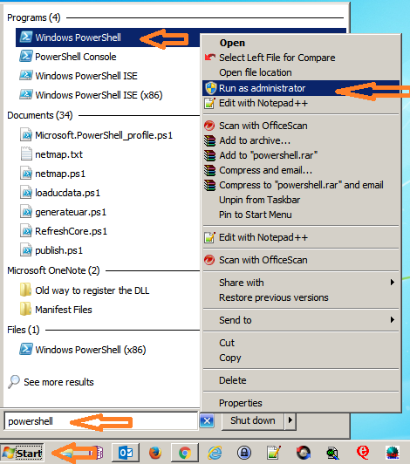

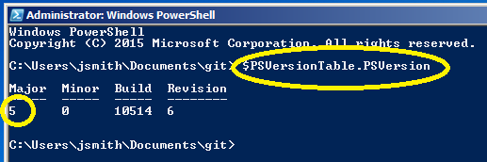

1. Notice, I am running version 5. I suggest downloading the latest Power shell from Microsoft if it don’t show version 5 here
2. After you are running version 5, now we need to allow Power shell scripts to run on your box

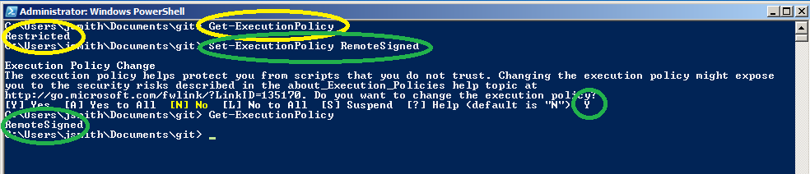

1. Run PowerShell again in admin mode, set the execute policy to RemoteSigned (see above)
2. Now we need to download TFS Power Tools 2013 (here is a link)

<https://visualstudiogallery.msdn.microsoft.com/f017b10c-02b4-4d6d-9845-58a06545627f>

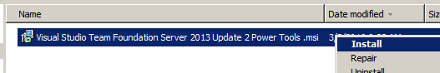

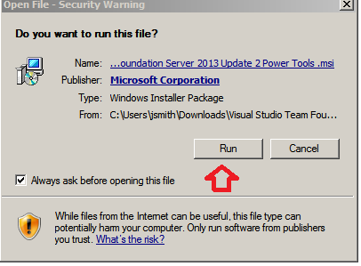

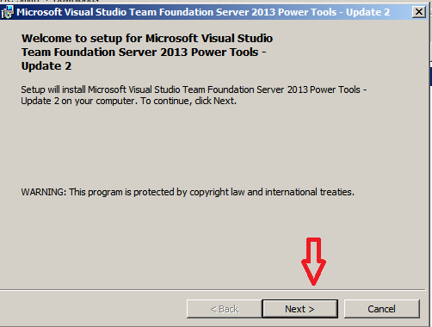

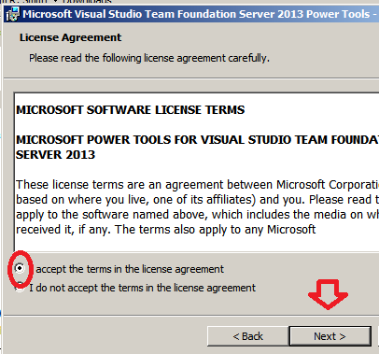

1. We need to run a custom install and make sure that the PowerShell cmdlets are also installed (my scripts need this)

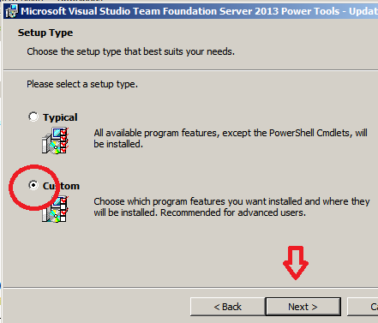

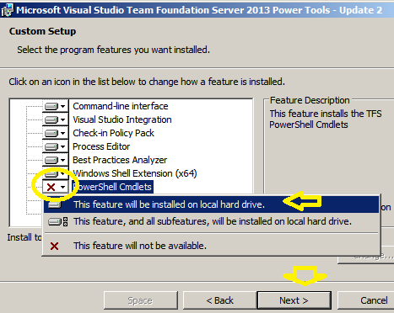

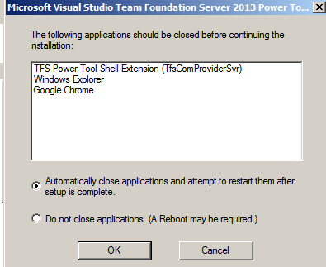

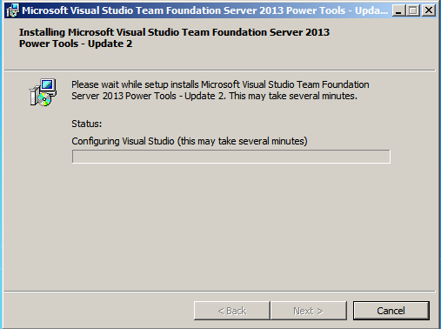

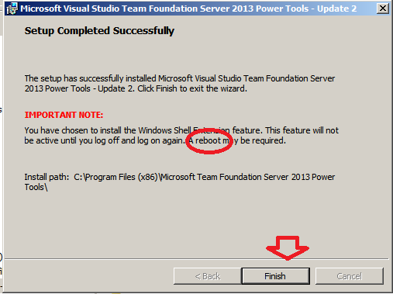

1. Ok, make sure to reboot
2. Now we need to make sure your H: drive is mapped
3. Go to the P: drive for your release and notice the psUpdate folder

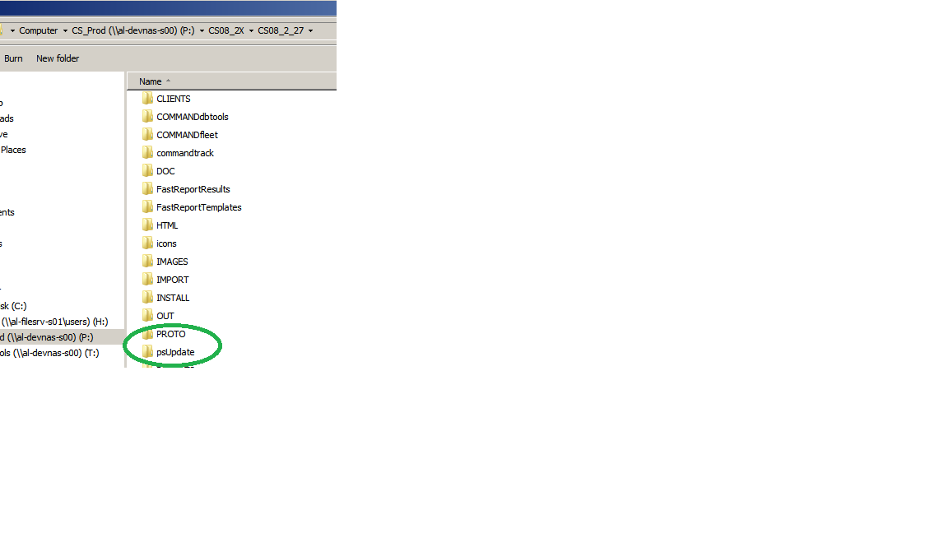

1. Find out your username by opening up a power shell and doing this

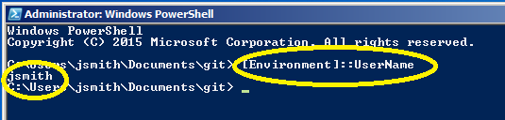

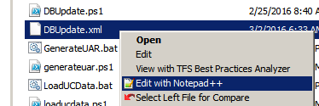

1. Edit the dbupdate.xml to put your H: drive into the settings file
2. The exact username from above is the section under the Network node you need to set up
3. Be aware this is a one-time thing (eventually this will be automated)
4. You will know you need to do it if the PowerShell script warns you and shuts down …

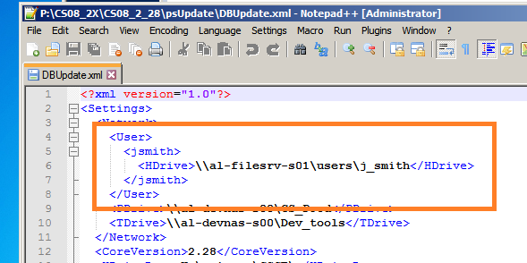

1. Now create a desktop icon
2. Right mouse on dbupdate.bat and pick copy
3. Right mouse on your desktop and pick create shortcut
4. Rename the shortcut to the version number
5. This shortcut is used to launch the scripts

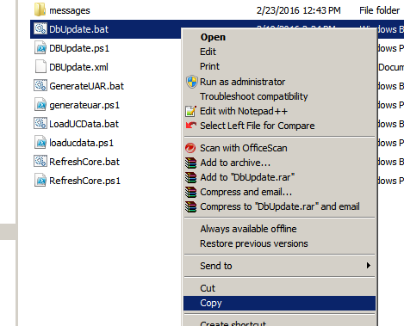

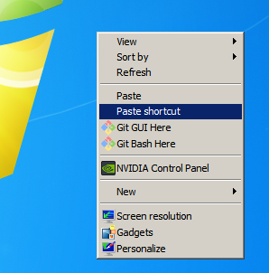

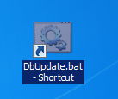

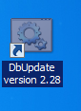

1. When double-clicking the shortcut you will see two (and later a third) scripts start

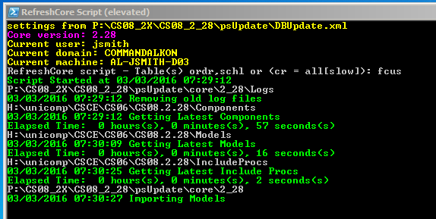

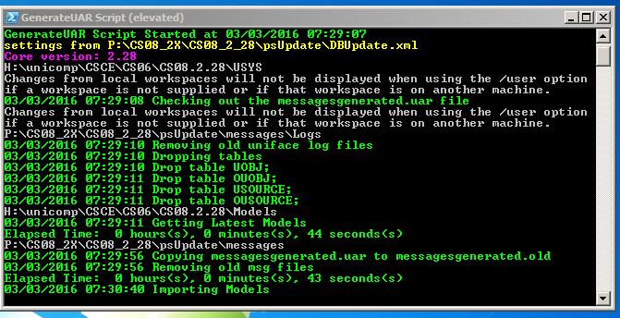

1. There is a logs dir and eventually the scripts will parse these logs to see if a form didn’t compile (for example)