# Search Algorithms

## Benchmark on randomly generated graphs

For this experiment, we generated random graphs and randomly assigned weighed edges between nodes. The graphs were grouped into 4 categories, containing 10, 20, 30 and 40 edges. For each category the edge generation was done with probabilities of 0.2, 0.4, 0.6 and 0.8 giving us 16 graphs in total to run tests.

The tests were finding path between randomly selected nodes from graph. For the algorithms that require heuristic function for estimation, we generated random heuristic function that always estimates optimistically, based on the actual optimal cost between nodes.

The following are the results we found.

### Solution length

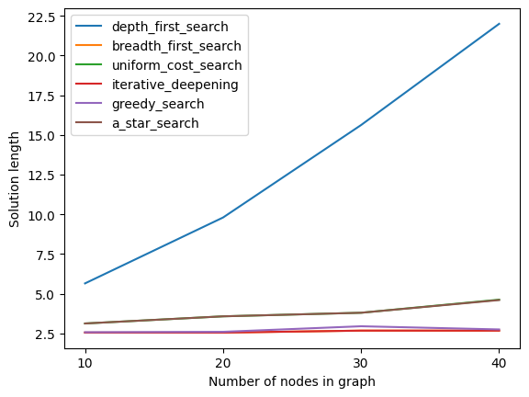

From this graph we can see that **iterative deepening** and **breadth first search** are overlapping. This is expected because both of them give the same solution. The same goes for **uniform cost search** and **A* star search**, (since we used optimistic heuristic function, A* generated optimal solution) which is same as the solution generated by uniform cost search.

The **depth first search** finds solution if it exists but as we can see its solutions are not optimal and includes unnecessary nodes in solution paths.

### Running time

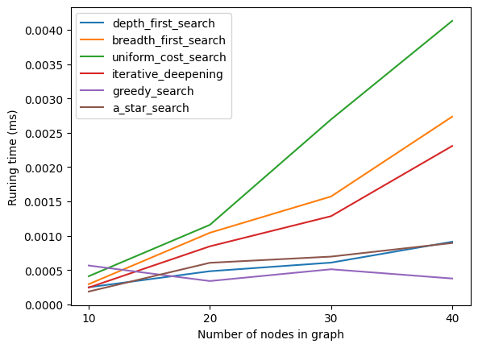

The tests showed us that performing **uniform cost search** is expensive. For large graph with lots of edges, uniform cost search performs poorly and might be **infeasible**. **A* search** which can give us an optimal solution performs significantly better than uniform cost search, if we have good heuristic function.

**Breadth first search** and **iterative deepening** have almost identical performance curve. Iterative deepening seems to perform a bit better than breadth first search.

# Centrality

After computing the centralities of cities from Romania map, we have observed that **Bucharest, Sibiu, Rimnicu Vilcea** and **Pitesti** scored the highest on all centrality measures. This was inline with our expectations because they were located at the center of the map and had relatively more connections. Making them more important linkages (cities) on Romania map.

Cities that are located at the edge of the map, such as **Vaslui, Hirsova, Mehadia, Lugoj, Iasi, Giurgiu, Eforie** and **Neamt,** had small centrality on all measures which indicated their extreme location.

The following tables show the computed centralities for each cities of Romania.

|  |  |  |  |  |  |  |  |  |  |  |  |  |  |  |  |  |  |  |  |  |  |  |  |  |  |  |  |  |  |  |  |  |  |  |  |  |  |  |  |  |  |  |  |  |  |  |  |  |  |  |  |  |  |  |  |  |  |  |  |  |  |  |  |  |  |  |  |  |  |  |  |  |  |  |  |  |  |  |  |  |  |  |  |  |  |  |  |  |  |
| --- | --- | --- | --- | --- | --- | --- | --- | --- | --- | --- | --- | --- | --- | --- | --- | --- | --- | --- | --- | --- | --- | --- | --- | --- | --- | --- | --- | --- | --- | --- | --- | --- | --- | --- | --- | --- | --- | --- | --- | --- | --- | --- | --- | --- | --- | --- | --- | --- | --- | --- | --- | --- | --- | --- | --- | --- | --- | --- | --- | --- | --- | --- | --- | --- | --- | --- | --- | --- | --- | --- | --- | --- | --- | --- | --- | --- | --- | --- | --- | --- | --- | --- | --- | --- | --- | --- | --- | --- | --- |
| |  |  | | --- | --- | | Degree Centrality | | | City | Centrality | | Sibiu | 0.211 | | Bucharest | 0.211 | | Arad | 0.158 | | Rimnicu Vilcea | 0.158 | | Pitesti | 0.158 | | Craiova | 0.158 | | Urziceni | 0.158 | | Oradea | 0.105 | | Zerind | 0.105 | | Timisoara | 0.105 | | Fagaras | 0.105 | | Lugoj | 0.105 | | Mehadia | 0.105 | | Drobeta | 0.105 | | Hirsova | 0.105 | | Vaslui | 0.105 | | Iasi | 0.105 | | Giurgiu | 0.053 | | Eforie | 0.053 | | Neamt | 0.053 | | |  |  | | --- | --- | | Closeness Centrality | | | City | Centrality | | Pitesti | 0.00343 | | Rimnicu Vilcea | 0.00329 | | Bucharest | 0.00329 | | Sibiu | 0.00302 | | Urziceni | 0.00294 | | Craiova | 0.00294 | | Fagaras | 0.00282 | | Giurgiu | 0.00257 | | Arad | 0.00255 | | Drobeta | 0.00247 | | Hirsova | 0.00237 | | Oradea | 0.00233 | | Mehadia | 0.00229 | | Vaslui | 0.00225 | | Zerind | 0.00220 | | Timisoara | 0.00217 | | Lugoj | 0.00217 | | Eforie | 0.00198 | | Iasi | 0.00192 | | Neamt | 0.00165 | |

|  |  |  |  |  |  |  |  |  |  |  |  |  |  |  |  |  |  |  |  |  |  |  |  |  |  |  |  |  |  |  |  |  |  |  |  |  |  |  |  |  |  |  |  |  |  |  |  |  |  |  |  |  |  |  |  |  |  |  |  |  |  |  |  |  |  |  |  |  |  |  |  |  |  |  |  |  |  |  |  |  |  |  |  |  |  |  |  |  |  |
| --- | --- | --- | --- | --- | --- | --- | --- | --- | --- | --- | --- | --- | --- | --- | --- | --- | --- | --- | --- | --- | --- | --- | --- | --- | --- | --- | --- | --- | --- | --- | --- | --- | --- | --- | --- | --- | --- | --- | --- | --- | --- | --- | --- | --- | --- | --- | --- | --- | --- | --- | --- | --- | --- | --- | --- | --- | --- | --- | --- | --- | --- | --- | --- | --- | --- | --- | --- | --- | --- | --- | --- | --- | --- | --- | --- | --- | --- | --- | --- | --- | --- | --- | --- | --- | --- | --- | --- | --- | --- |
| |  |  | | --- | --- | | Betweenness Centrality | | | City | Centrality | | Bucharest | 1.05263 | | Pitesti | 0.93567 | | Urziceni | 0.88889 | | Rimnicu Vilcea | 0.65497 | | Sibiu | 0.63158 | | Craiova | 0.40936 | | Arad | 0.39766 | | Vaslui | 0.39766 | | Drobeta | 0.29240 | | Hirsova | 0.21053 | | Iasi | 0.21053 | | Mehadia | 0.18713 | | Timisoara | 0.11696 | | Lugoj | 0.09357 | | Zerind | 0.04678 | | Oradea | 0.00000 | | Fagaras | 0.00000 | | Giurgiu | 0.00000 | | Eforie | 0.00000 | | Neamt | 0.00000 | | |  |  | | --- | --- | | Eigenvector Centrality | | | City | Centrality | | Rimnicu Vilcea | 0.40410 | | Sibiu | 0.39756 | | Pitesti | 0.38951 | | Bucharest | 0.34233 | | Craiova | 0.33856 | | Fagaras | 0.26563 | | Arad | 0.23855 | | Oradea | 0.19913 | | Urziceni | 0.17544 | | Zerind | 0.15713 | | Drobeta | 0.14948 | | Giurgiu | 0.12291 | | Timisoara | 0.10982 | | Mehadia | 0.07784 | | Vaslui | 0.07395 | | Hirsova | 0.07233 | | Lugoj | 0.06737 | | Iasi | 0.03049 | | Eforie | 0.02597 | | Neamt | 0.01095 | |

|  |  |  |  |  |  |  |  |  |  |  |  |  |  |  |  |  |  |  |  |  |  |  |  |  |  |  |  |  |  |  |  |  |  |  |  |  |  |  |  |  |  |  |  |  |  |
| --- | --- | --- | --- | --- | --- | --- | --- | --- | --- | --- | --- | --- | --- | --- | --- | --- | --- | --- | --- | --- | --- | --- | --- | --- | --- | --- | --- | --- | --- | --- | --- | --- | --- | --- | --- | --- | --- | --- | --- | --- | --- | --- | --- | --- | --- |
| |  |  | | --- | --- | | Katz Centrality | | | City | Centrality | | Sibiu | 0.26209 | | Bucharest | 0.25984 | | Rimnicu Vilcea | 0.24444 | | Pitesti | 0.24424 | | Craiova | 0.24017 | | Arad | 0.23904 | | Urziceni | 0.23852 | | Fagaras | 0.22199 | | Oradea | 0.21755 | | Zerind | 0.21545 | | Drobeta | 0.21506 | | Timisoara | 0.21495 | | Vaslui | 0.21468 | | Hirsova | 0.21275 | | Mehadia | 0.21255 | | Lugoj | 0.21254 | | Iasi | 0.21034 | | Giurgiu | 0.19578 | | Eforie | 0.19107 | | Neamt | 0.19083 | |  |