ShopSphere
E-Commerce Management System

Software Requirements Specification (SRS)

Prepared by:
Mohd. Ayaz (24BCS060)
Meraj Ahmed (24BCS046)

Department of Computer Engineering
Jamia Millia Islamia, New Delhi

Course: Software Engineering (5th Semester)
Date: September 23, 2026
Version: 1.0

TABLE OF CONTENTS

1. Introduction
1.1 Purpose
1.2 Scope
1.3 Definitions, Acronyms, Abbreviations
2. Overall Description
2.1 Product Perspective
2.2 Product Functions
2.3 User Classes
2.4 Operating Environment
3. Functional Requirements
FR1: User Registration and Login
FR2: Product Management
FR3: Product Search
FR4: Shopping Cart Management
FR5: Order Processing
FR6: Payment Processing
FR7: Inventory Management
FR8: Order Tracking
4. Non-Functional Requirements
4.1 Performance
4.2 Security
4.3 Reliability
4.4 Scalability
4.5 Usability
5. Activity Diagram
6. Use Case Diagram
7. Data Flow Diagrams
7.1 DFD Level 0 Description
7.2 DFD Level 1 Description
7.3 DFD Level 2 Description
8. Entity Relationship Diagram
8.1 Core Entities & Attributes
8.2 Relationships & Cardinality
9. Database Design
9.1 User Table
9.2 Categories Table
9.3 Products Table
9.4 Orders Table
9.5 Payments Table
10. Module Description
10.1 User Management Module
10.2 Product Management Module
10.3 Shopping Cart Module
10.4 Order Management Module
10.5 Payment Processing Module
10.6 Inventory Management Module
10.7 Report Generation Module

11. Hardware Requirements
12. Software Requirements
13. Security Requirements
14. Testing
14.1 Test Case 1: User Registration
14.2 Test Case 2: User Login
14.3 Test Case 3: Product Search
14.4 Test Case 4: Order Placement
14.5 Test Case 5: Payment Processing
15. Conclusion
16. Future Scope
17. References

1. Introduction
1.1 Purpose
ShopSphere is an E-Commerce Management Software which is designed to provide customers with an efficient platform to browse, search, and purchase products online. The software also enables administrators to manage products, inventory, orders, payments, and customer information through a centralized system.
1.2 Scope
ShopSphere facilitates online shopping by offering product management, shopping cart functionality, secure payment processing, order tracking, and customer account management. It aims to provide a user-friendly, secure, and scalable e-commerce solution.
1.3 Definitions, Acronyms, Abbreviations:
- SRS: Software Requirement Specification
- DFD: Data Flow Diagram
- COD: Cash on Delivery
- DBMS: Database Management System
- HTTPS: Secure Hypertext Transfer Protocol
- FR : Functional Requirement

2. Overall Description
2.1 Product Perspective
ShopSphere is a standalone web-based system connected to a database and payment gateway. It provides a platform for customers to shop online and for administrators to manage business operations. The system allows customers to register, browse products, add items to a cart, place orders, make online payments, and track their orders. Administrators can manage products, categories, inventory, customers, and orders. The system ensures secure data management and provides an efficient way to manage online sales.

2.2 Product Functions
The software provides:
- User Registration and Login
- Product Search and Filtering
- Shopping Cart Management
- Online Payment Processing
- Order Management
- Inventory Management
- Customer Support
- Report Generation
2.3 User Classes
Customer :
- Creates account
- Searches products
- Places orders
- Makes payment
Administrator :
- Adds and updates products
- Manages orders
- Monitors inventory
- Generates reports
Guest User :
- Can browse products
- Cannot purchase without registration
2.4 Operating Environment
- Operating System: Windows/Linux
- Browser: Chrome, Firefox, Edge
- Database: MySQL
- Web Server: Apache/Nginx

3. Functional Requirements
FR1: User Registration and Login
The system shall allow users to create an account using email and password. Registered users can log in securely and reset passwords if forgotten.
Input:
- Name
- Email
- Password
Output:
- Successful account creation
- Login confirmation
FR2: Product Management
Administrators can add, edit, remove, and update product details including price, category, images, and stock availability.
Input:
- Product name
- Price
- Category
- Quantity
Output:
- Updated product catalog
FR3: Product Search
The system shall allow customers to search products using keywords, categories, brands, and price ranges.
Input:
- Search keyword
Output:
- Matching product list
FR4: Shopping Cart Management
Customers can add products to the cart, remove items, and update quantities before making a purchase.
Input:
- Product selection
Output:
- Updated cart information
FR5: Order Processing
After checkout, the software will generate orders and maintain order records.
Input:
- Customer details
- Cart details
Output:
- Order confirmation

FR6: Payment Processing
The system shall support online payment methods such as credit cards, debit cards, UPI, and net banking.
Input:
- Payment details
Output:
- Payment success/failure notification
FR7: Inventory Management
The quantity of products shall automatically update whenever a purchase is made.
Input:
- Order information
Output:
- Updated stock information
FR8: Order Tracking
Customers can track order status such as:
- Pending
- Processing
- Shipped
- Delivered
Output:
- Order status details

4. Non-Functional Requirements
4.1 Performance
The software should process user requests quickly and support multiple users simultaneously without significant delays.
4.2 Security
The system shall:
- Encrypt user passwords
- Use HTTPS
- Prevent unauthorized access
- Protect payment information
4.3 Reliability
The software should operate continuously with minimal downtime and recover data during system failures.
4.4 Scalability
The system should support increasing numbers of users, products, and transactions without major redesign.
4.5 Usability
The interface should be simple, attractive, and easy to use for both technical and non-technical users.
5. Activity Diagram
1. The process starts when a customer enters ShopSphere.
2. The customer searches for a product in the system.
3. If the product is not found, the customer can browse product categories.
4. If the product is found, the customer views the product details.
5. The customer selects the required product parameters and adds the product to the shopping cart.
6. The system checks whether the customer is registered.
7. If the customer is not registered, registration is completed before proceeding.
8. The customer reviews the shopping cart and updates it if required.
9. If the cart is correct, the customer proceeds to checkout.
10. During checkout, the customer selects the delivery address and delivery method.
11. The customer chooses a preferred payment method.
12. The system processes the payment transaction.
13. If the payment fails, the customer can retry the payment or modify the cart.
14. If the payment is successful, the order is confirmed and a success page is displayed.
15. The process ends after successful order placement.

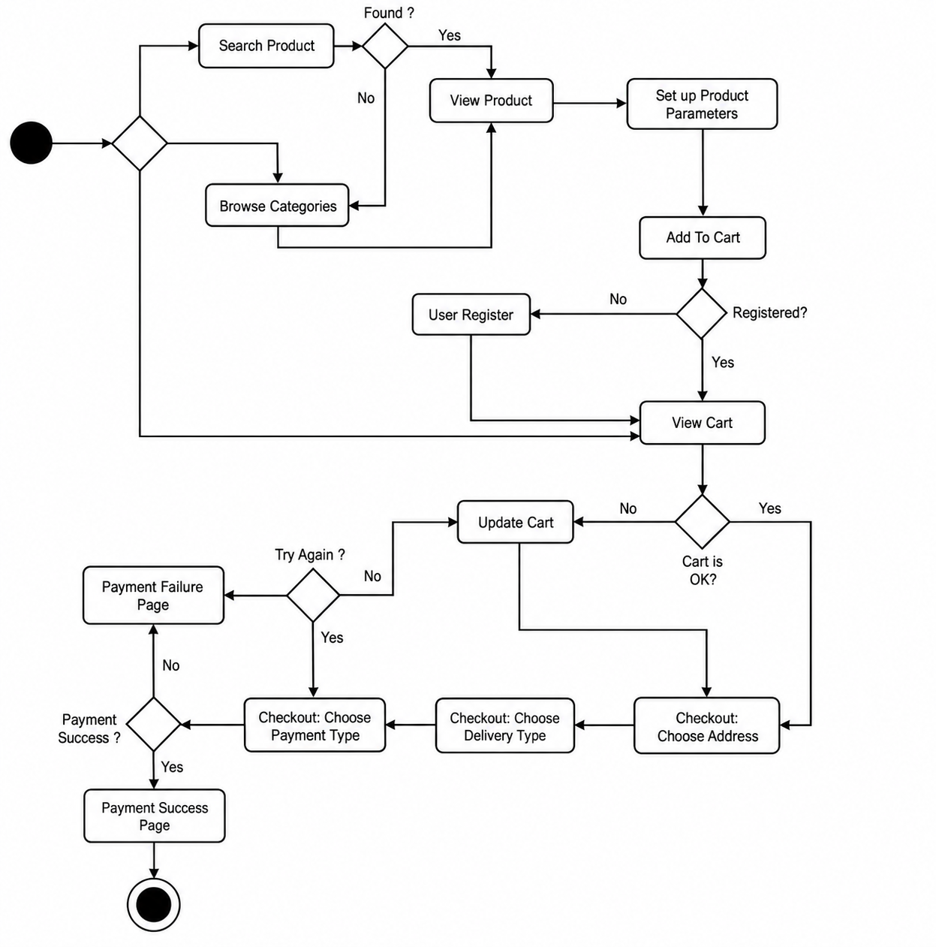
6. Use Case Diagram

6.1 Actors Description :
Customer: Registers/logs into the application, searches and views products, manages the shopping cart, places orders, makes online payments, and tracks order statuses.
Guest User: Browses products and categories; requires account registration before checking out or completing a purchase.
Administrator: Manages product catalog and categories, updates inventory, monitors orders, and generates analytical reports.
Payment Gateway: External actor responsible for authorizing, verifying, and processing payment transactions.

6.2 Use Case Specifications
UC1: Register & Authenticate: Facilitates user sign-up, login, and session validation (extends password recovery).
UC2: Search & Browse Products: Allows querying the catalog by keywords, brands, and categories.
UC3: Manage Cart: Includes adding items, modifying quantities, and removing products from the active session.
UC4: Checkout & Place Order: Collects address details, delivery method, and triggers payment processing.
UC5: Process Payment: Coordinates with the Payment Gateway to verify transactions and confirm order placement.
UC6: Track Order: Provides order status tracking (Pending, Processing, Shipped, Delivered).
UC7: Manage Catalog & Inventory: Allows administrators to add, edit, or remove items and track inventory levels.
UC8: Generate Business Reports: Produces system sales and order reports for administrative review.

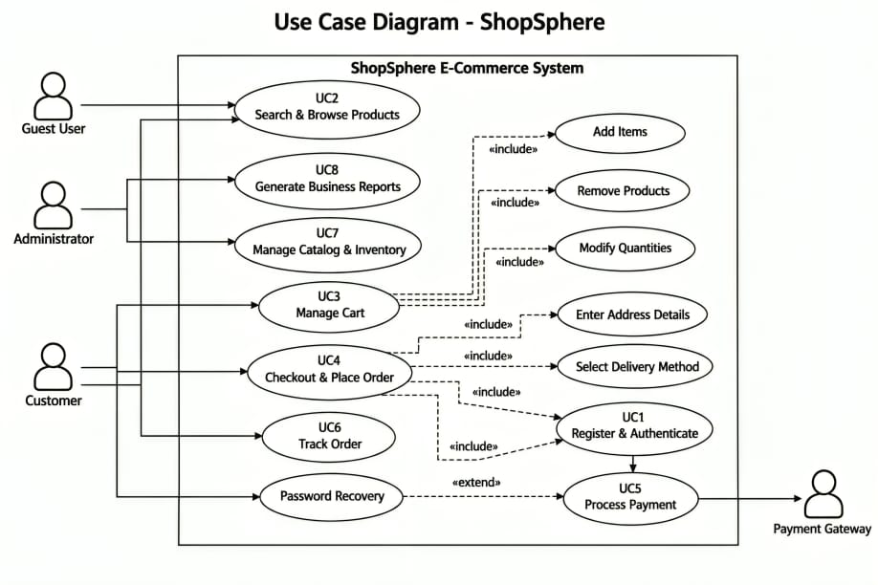

7. Data Flow Diagrams
7.1 DFD Level 0 Description :
- DFD Level 0 provides a high-level view of the E-Commerce Management Software(ShopSphere).
- It shows the interaction between the Customer, Administrator, Payment Gateway, and the system.
- Customers can search products, place orders, make payments, and track orders through the system.
- Administrators manage products, inventory, and reports.
- The Payment Gateway processes online transactions and returns payment status information.

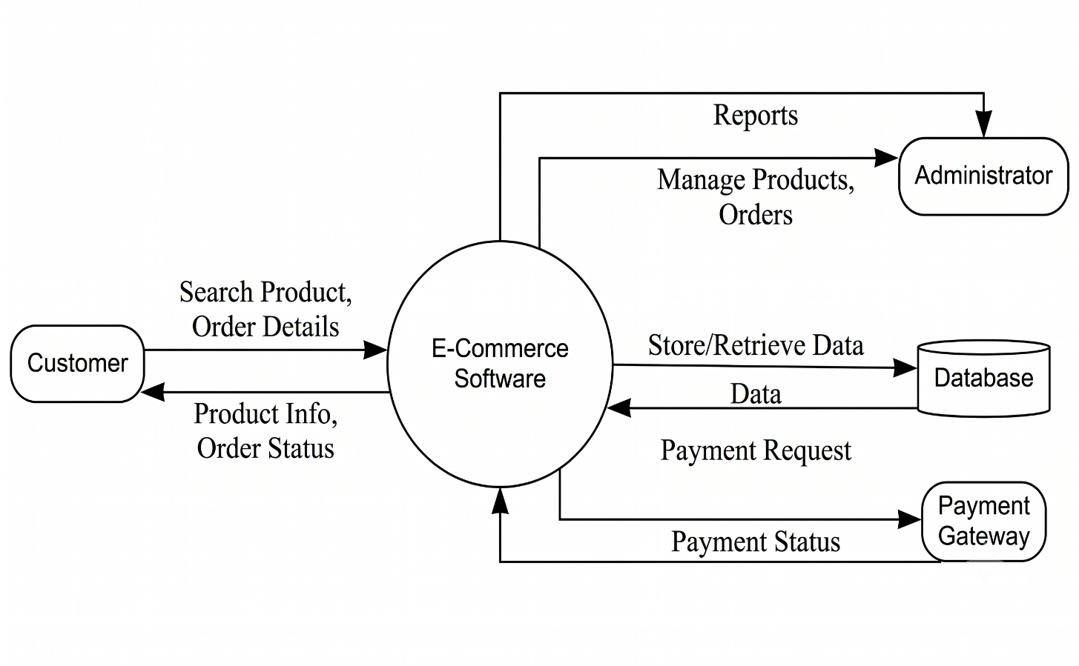

7.2 DFD Level 1 Description :
- DFD Level 1 breaks down the E-Commerce Management Software(ShopSphere) into its major functional modules.
- The User Management module handles customer registration and login activities.
- The Product Search module allows customers to search and view available products.
- The Shopping Cart module manages selected products before checkout.
- The Order Processing module creates and maintains customer orders.
- The Payment Processing module handles online payment transactions and updates payment status.
- The Administrator manages products and inventory through the system database.
- The modules work together to complete the online shopping process efficiently.
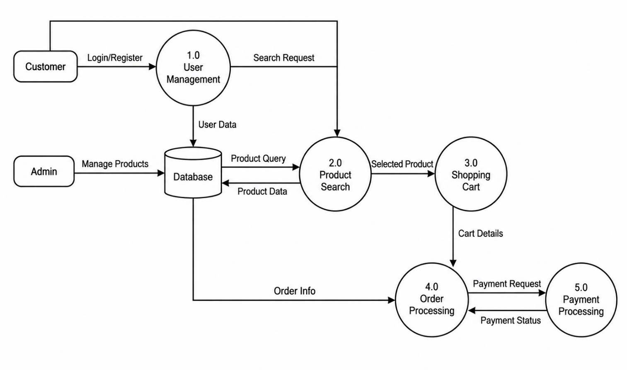
7.3 DFD Level 2 Description :
- DFD Level 2 provides a detailed representation of the internal processes of the E-Commerce Management Software(ShopSphere).
- The User Management process is divided into Registration and Login Verification sub-processes, which validate user information and store records in the user database.
- The Product Search process is divided into Product Search and Product View operations, enabling customers to browse products and view detailed information.
- The Shopping Cart process includes Add to Cart and Update Cart functions, allowing customers to manage selected products before purchase.
- The Order Processing process consists of Order Creation and Order Tracking activities, which generate order records and provide order status information to customers.
- The Payment Processing module is further divided into Payment Transaction and Payment Verification processes, which communicate with the Payment Gateway to authorize payments.
- Different databases are used to store user details, product information, order records, and payment details.
- Administrators can manage products, monitor orders, update inventory, and generate business reports using the stored data.
- This level explains the detailed flow of information between processes, databases, customers, administrators, and the payment gateway.

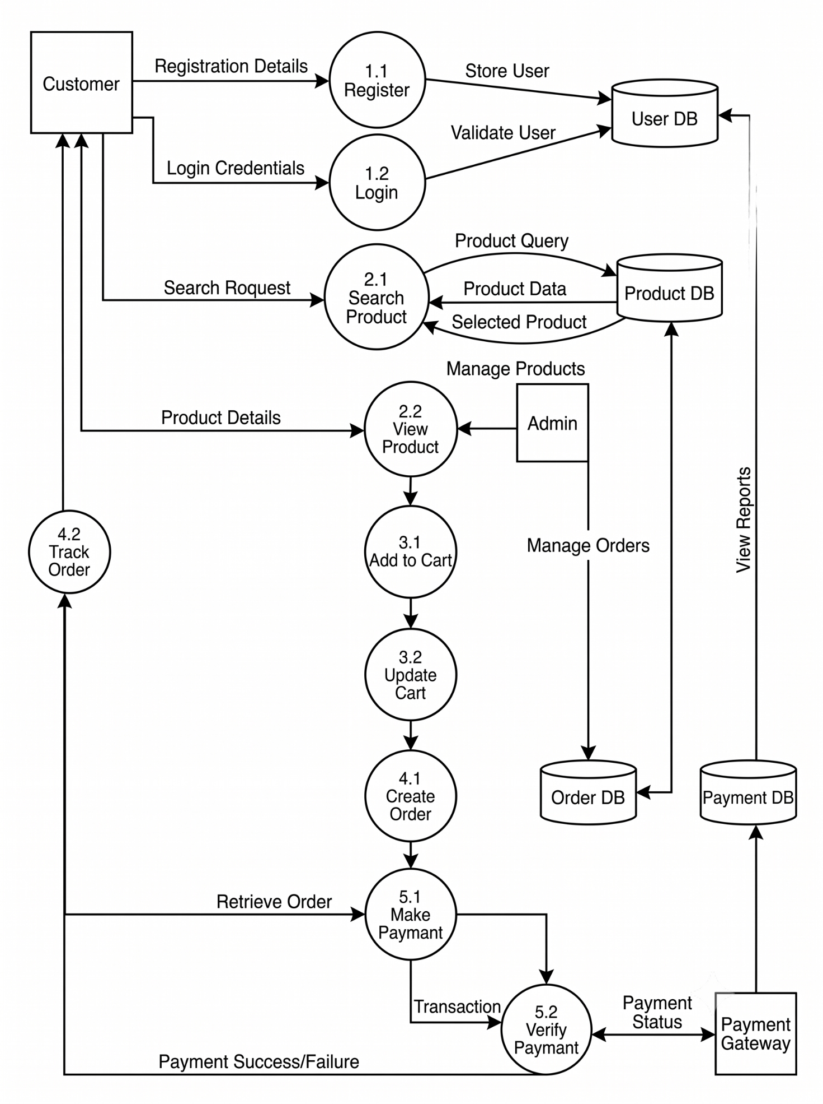

8. Entity Relationship Diagram
8.1 Core Entities & Attributes :
- User: Stores authentication and access levels.
  - Attributes: UserID (PK), Email, Password, Role.
- Categories: Groups inventory items.
  - Attributes: CategoryID (PK), CategoryName.
- Products: Manages item catalog details.
  - Attributes: ProductID (PK), ProductName, Price, StockQuality (Quantity), CategoryID (FK).
- Cart (Users): Represents an active user shopping cart session.
  - Attributes: CartID (PK), UserID (PK/FK).
- CartItems: Stores individual items within a shopping cart.
  - Attributes: CartID (PK), UserID (FK), ProductID (FK), Quality (Quantity).
- Orders: Records completed user purchases.
  - Attributes: OrderID (PK), UserID (FK), OrderDate, OrderStatus.
- OrderItems: Line-item breakdown linking orders to specific products.
  - Attributes: OrderID (PK), ProductID (FK), Quantity.
- Payments: Handles billing and payment gateway records.
  - Attributes: PaymentID (PK), OrderID (FK), PaymentMethod, PaymentStatus.

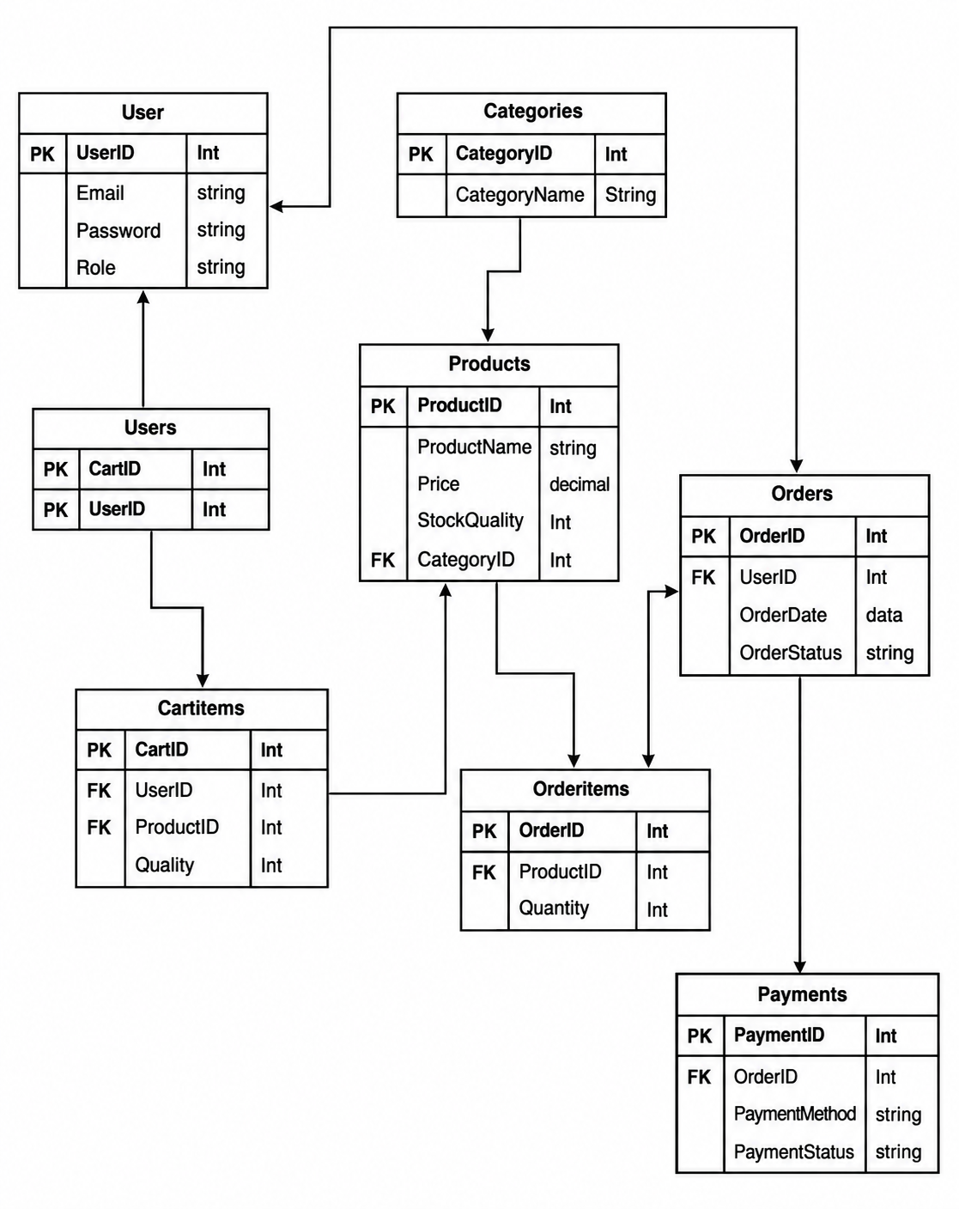

8.2 Relationships & Cardinality :
- User to Cart & Orders: A User can maintain a shopping cart and place multiple Orders (1-to-Many), mapped via UserID.
- Category to Products: Each Category classifies multiple Products (1-to-Many), linked by CategoryID.
- Cart & Products to CartItems: CartItems acts as an associative entity linking a user's cart session and Products (Many-to-Many resolution).
- Orders & Products to OrderItems: OrderItems resolves the Many-to-Many link between Orders and Products, tracking purchased quantities.
- Orders to Payments: Each Order links directly to its transaction via OrderID in Payments.

9. Database Design
9.1 User Table
Field Name | Data Type | Description
UserID | INT | Primary Key
Email | VARCHAR(100) | User Email
Password | VARCHAR(100) | Encrypted Password
Role | VARCHAR(20) | Customer/Admin

Description:
The User table stores authentication and role-based access information for all registered users.

9.2 Categories Table
Field Name | Data Type | Description
CategoryID | INT | Primary Key
CategoryName | VARCHAR(100) | Category Name

Description :
The Categories table stores product classifications such as Electronics, Clothing, Books, and Accessories.

9.3 Products Table
Field Name | Data Type | Description
ProductID | INT | Primary Key
ProductName | VARCHAR(100) | Product Name
Price | DECIMAL | Product Price
StockQuantity | INT | Available Quantity
CategoryID | INT | Foreign Key

Description :
The Products table contains detailed information about products available in the system.

9.4 Orders Table
Field Name | Data Type | Description
OrderID | INT | Primary Key
UserID | INT | Foreign Key
OrderDate | DATE | Order Date
OrderStatus | VARCHAR(30) | Current Status

Description :
The Orders table stores information about customer purchases and delivery status.

9.5 Payments Table
Field Name | Data Type | Description
PaymentID | INT | Primary Key
OrderID | INT | Foreign Key
PaymentMethod | VARCHAR(50) | Payment Method
PaymentStatus | VARCHAR(30) | Transaction Status

Description :
The Payments table stores payment transaction details associated with customer orders.

10. Module Description
10.1 User Management Module
This module handles user registration, login, authentication, profile management, and password recovery functionality. It ensures secure access to the system and maintains user information.
10.2 Product Management Module
This module allows administrators to add, update, delete, and organize products. It maintains product information, pricing, categories, and stock availability.
10.3 Shopping Cart Module
This module enables users to add products to their cart, remove products, update quantities, and review selected items before proceeding to checkout.
10.4 Order Management Module
This module processes customer orders, updates order status, generates order confirmations, and provides order tracking functionality.
10.5 Payment Processing Module
This module handles online transactions using various payment methods such as UPI, debit cards, credit cards, and net banking. It communicates with the payment gateway and stores transaction results.
10.6 Inventory Management Module
This module automatically updates stock quantities whenever a purchase occurs and helps administrators monitor inventory levels.

10.7 Report Generation Module
This module generates reports related to sales, inventory, customers, and orders to support business analysis and decision-making.

11. Hardware Requirements
The minimum hardware requirements for running the E-Commerce Management Software are:
- Processor: Intel Core i3 or higher
- RAM: 4 GB minimum
- Storage: 50 GB free disk space
- Network: Stable Internet Connection
- Input Devices: Keyboard and Mouse
- Output Device: Monitor

12. Software Requirements
The software requirements for the system are:
- Operating System: Windows 10/11 or Linux
- Database: MySQL/PostgreSQL
- Frontend Technologies: HTML, CSS, JavaScript
- Backend Technologies: Node.js / Python / Java
- Browser: Google Chrome, Mozilla Firefox, Microsoft Edge
- Web Server: Apache/Nginx

13. Security Requirements
- User passwords shall be stored in encrypted form.
- All communication shall occur using HTTPS protocols.
- Access to administrator functions shall be restricted to authorized users only.
- Payment information shall be securely processed through trusted payment gateways.
- Regular database backups shall be maintained.
- The system shall prevent unauthorized access and data modification.

14. Testing
14.1 Test Case 1: User Registration
Input: Valid user information
Expected Result: Successful account creation
Actual Result: Account created successfully
14.2 Test Case 2: User Login
Input: Valid login credentials
Expected Result: User dashboard displayed
Actual Result: Login successful
14.3 Test Case 3: Product Search
Input: Product keyword
Expected Result: List of matching products
Actual Result: Products displayed successfully
14.4 Test Case 4: Order Placement
Input: Valid cart and payment details
Expected Result: Order confirmation generated
Actual Result: Order placed successfully
14.5 Test Case 5: Payment Processing
Input: Valid payment information
Expected Result: Payment completed successfully
Actual Result: Payment approved and recorded

15. Conclusion
ShopSphere provides a complete solution for online shopping by integrating product management, customer management, inventory control, order processing, and payment handling functionalities. The system offers a secure, scalable, and user-friendly environment for customers and administrators. Its modular architecture ensures maintainability and supports future expansion of features and services.

16. Future Scope
Future enhancements planned for ShopSphere include:
- Development of mobile applications for Android and iOS platforms.
- Integration of Artificial Intelligence for personalized product recommendations.
- Chatbot-based customer support services.
- Multi-language support for international customers.
- Voice-assisted product search capabilities.
- Advanced analytics and business intelligence reporting.
- Integration with multiple international payment gateways.
- Real-time inventory synchronization and warehouse management.

17. References
- Ian Sommerville, Software Engineering.
- Roger S. Pressman, Software Engineering: A Practitioner's Approach.
- IEEE Software Requirement Specification (SRS) Standards.
- MySQL Official Documentation.
- HTML, CSS, and JavaScript Documentation.
- UML and DFD Modelling Standards.

