Heart Disease Classification MLOps Experimental Learning Report
End to end model development, experiment tracking, CI, containerization, local Kubernetes deployment, and monitoring
Prepared for the MLOps experimental learning assignment
Dataset: UCI processed Cleveland Heart Disease records

Project summary
This project implements a reproducible educational classifier for the presence of heart disease in the UCI processed Cleveland dataset. The pipeline covers data acquisition, quality checks, exploratory analysis, model comparison, experiment logging, tested API serving, containerization, and deployment manifests. Windows runtime evidence is added after the accompanying runbook has been executed.
Measure | Development run result
Clean records | 297
Selected model | Random Forest
Held out test accuracy | 0.817
Held out test ROC-AUC | 0.943

The figures in this draft come from an actual local development run using Python 3.13.0. The Windows run should be used to confirm the final submission values.

1 Objective and system architecture
The task is binary classification: target 0 means absence; original targets 1 through 4 mean presence. The system accepts the 13 UCI predictors and returns a class plus a model probability. It is designed as an educational production pattern with separable data, training, serving, CI, and monitoring components.
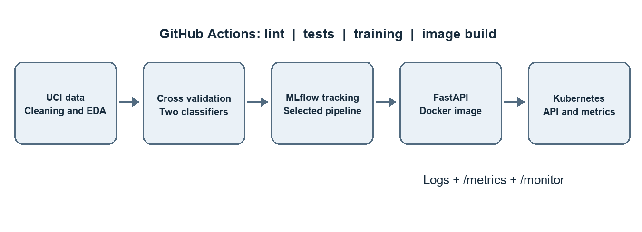
Figure 1 Assignment system architecture
Training creates a fitted preprocessing and classifier pipeline. MLflow records model comparisons and artifacts. The selected pipeline is serialized and included in the Docker image. Docker Desktop Kubernetes hosts one API replica behind a LoadBalancer Service. Prometheus format metrics and structured request logs describe service activity.

2 Data source and preparation
The source is the UCI processed Cleveland Heart Disease file, with 303 rows, 13 predictors, and the original 0–4 target. The download script verifies a SHA-256 digest. Numeric parsing converts the source's question mark missing marker to null; cleaning removes incomplete and duplicate records and maps targets 1–4 to class 1.
Data check | Observed result
Raw rows | 303
Rows after cleaning | 297
Rows removed | 6
Absent / present | 160 / 137

The resulting CSV and summary JSON are committed as reusable inputs. The model pipeline still includes imputation for future inputs. No imputation statistics or scaling factors are learned from the held out test set or validation fold.
Feature groups: age, resting blood pressure, cholesterol, maximum heart rate, and ST depression are treated as numeric; the other eight predictors are encoded as categorical values. The target is excluded from all feature transformations.

3 Exploratory data analysis
The cleaned classes are moderately balanced: 160 records with absence and 137 with presence. The plots show the target distribution and numeric feature ranges before fitting any model.
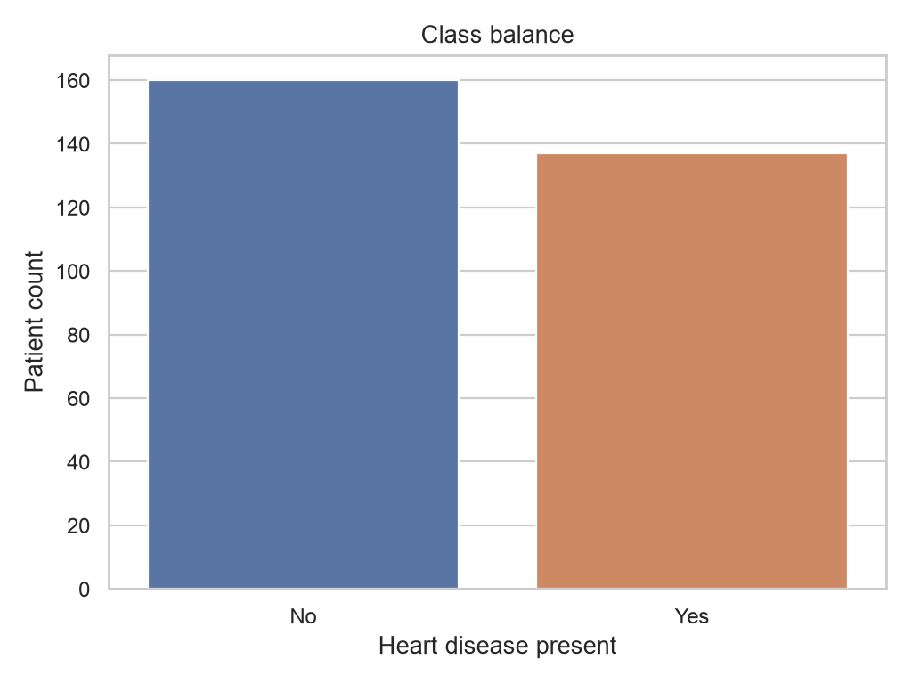
Figure 2 Cleaned dataset class balance
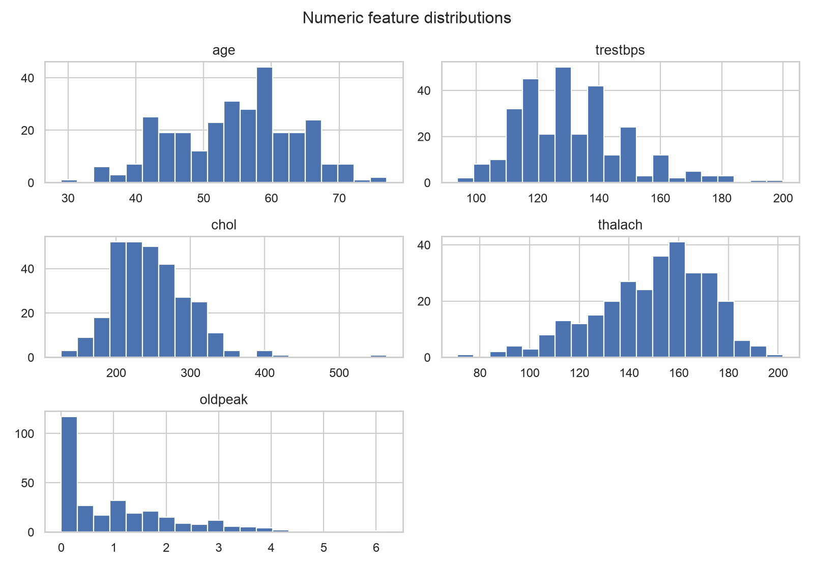
Figure 3 Numeric predictor distributions

4 Feature engineering and visual findings
The correlation heatmap is descriptive rather than a feature selection rule. Correlation does not establish clinical causation, and the small dataset makes visual differences uncertain. Box plots provide a compact comparison of age and maximum heart rate by target class.
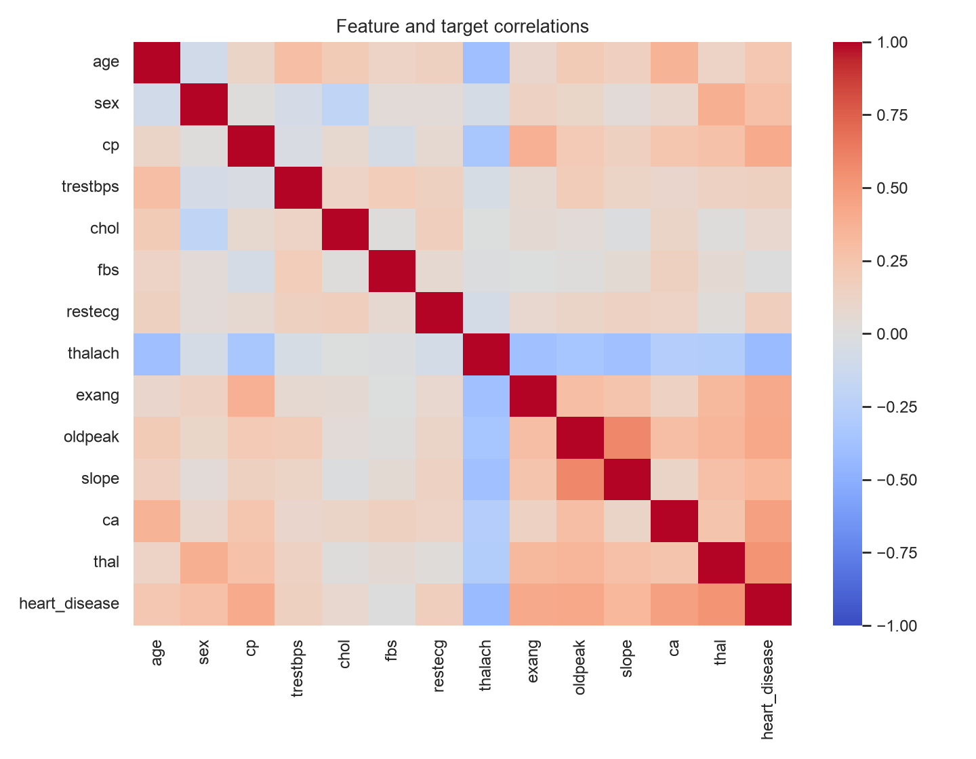
Figure 4 Pairwise numeric correlations
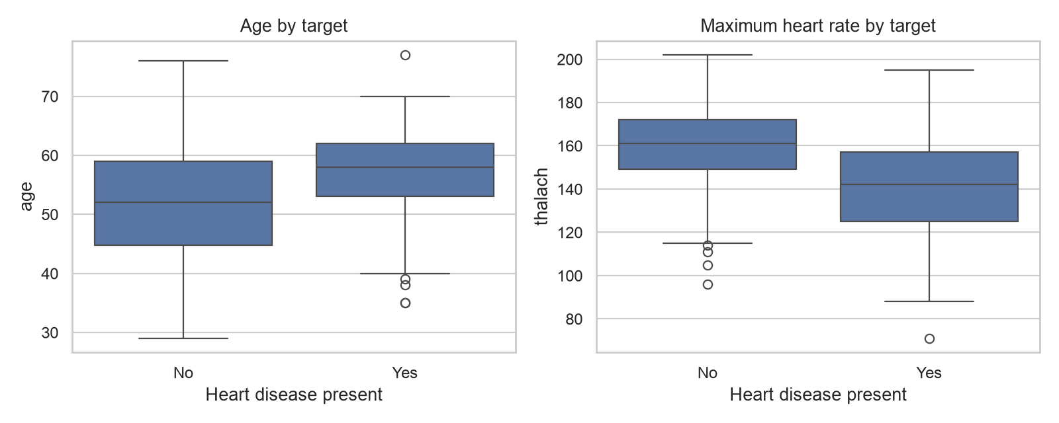
Figure 5 Age and maximum heart rate by class

5 Model design and selection
The cleaned data is stratified into 80% training and 20% test partitions with seed 42. Each model's hyperparameters are evaluated by five stratified cross validation folds on the training partition. The pipeline fits imputation, scaling, and categorical encoding inside each fold, preventing preprocessing leakage.
Logistic Regression offers an interpretable linear baseline. Random Forest provides a nonlinear comparison. The highest mean validation ROC-AUC selects the final model. Accuracy, precision, and recall are also recorded to show different error tradeoffs.
Model | Accuracy | Precision | Recall | ROC-AUC
Logistic Regression | 0.822 | 0.839 | 0.769 | 0.902
Random Forest | 0.823 | 0.840 | 0.769 | 0.907

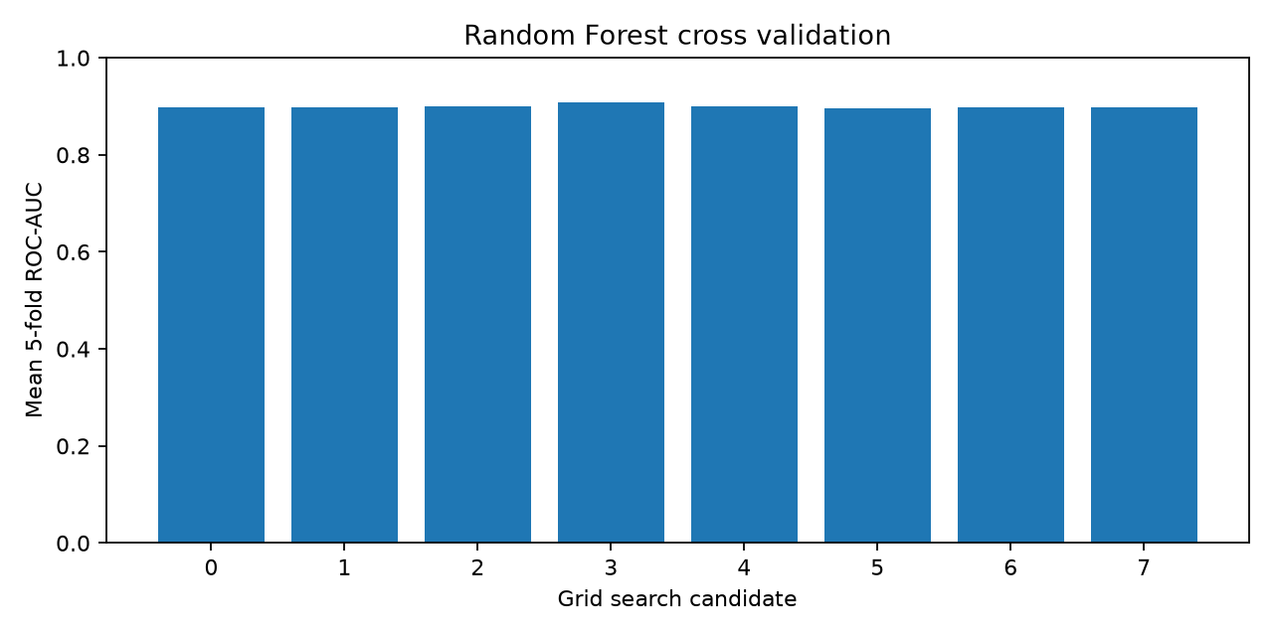
Figure 6 Random Forest candidate validation scores

6 Held out test evaluation
After cross validation chose random forest, the held out test partition was evaluated once. The test split contains 60 records. The confusion matrix shows 28 true negatives, 4 false positives, 7 false negatives, and 21 true positives.
Metric | Test result
Accuracy | 0.817
Precision | 0.840
Recall | 0.750
ROC-AUC | 0.943

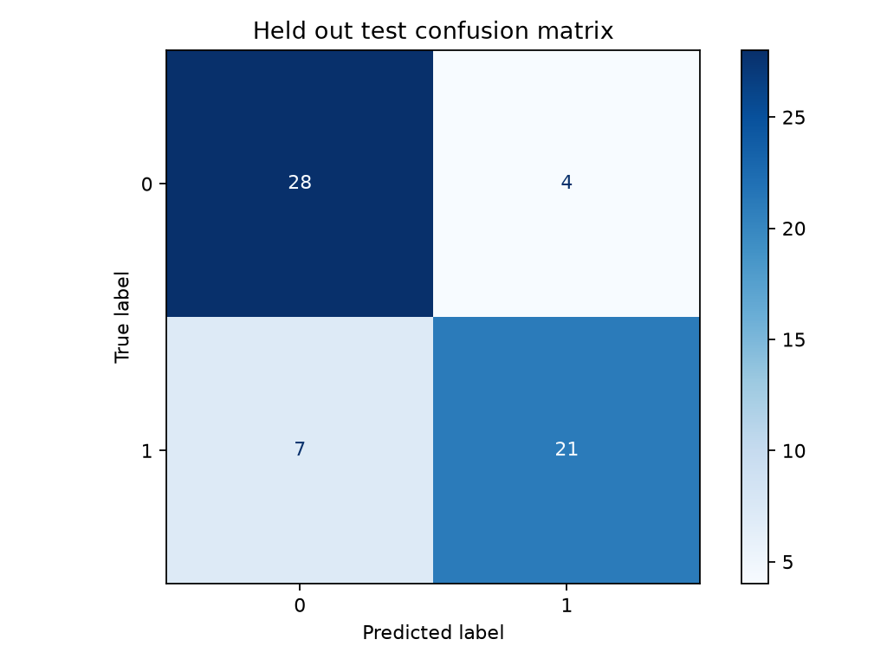
Figure 7 Test confusion matrix
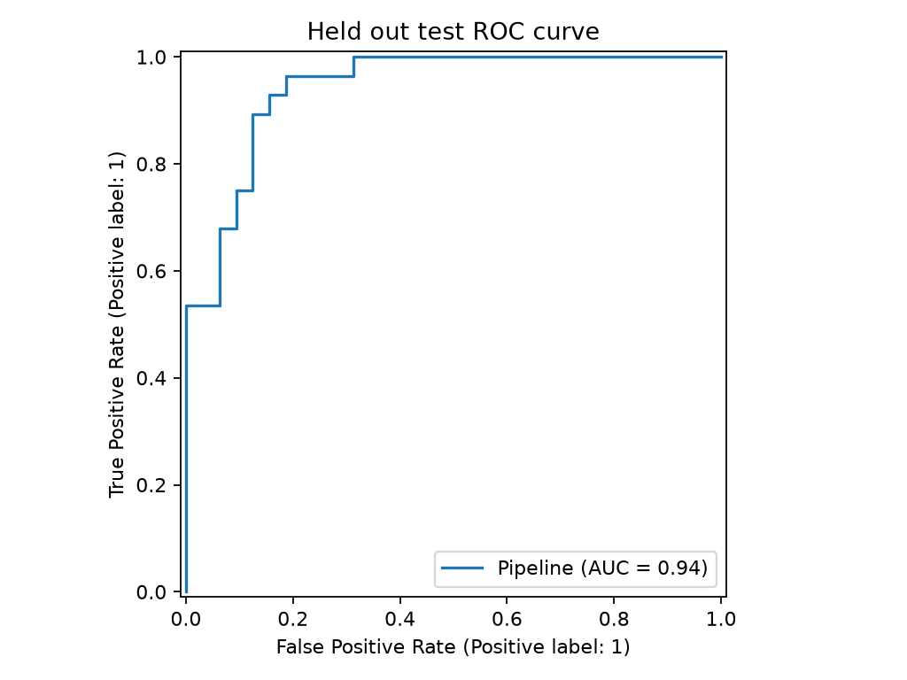
Figure 8 Test ROC curve

7 Experiment tracking and reproducibility
MLflow records a run for each candidate and a final selected model run. Each candidate run contains the best grid parameters, mean cross validation metrics, full search results, and a candidate score plot. The final run contains held out metrics, evaluation figures, metadata, and the fitted model. SQLite stores run metadata locally; CI uploads the generated store as a workflow artifact.
Windows evidence pending: Figure 9 MLflow experiment runs and logged artifacts (04-mlflow.png)
The joblib file contains the full fitted preprocessing and classifier pipeline. Model metadata records the source checksum, selected parameters, features, seed, package version, and actual test metrics. Requirements and the raw download script allow a clean rebuild.

8 Quality checks and continuous integration
Unit tests cover target mapping and missing data, invalid source targets, pipeline fitting and probability output, API input validation, readiness, and monitoring endpoints. GitHub Actions runs Ruff, Pytest, data preparation, EDA, training, and a Docker image build. A failure in any required step fails the workflow; generated model and experiment files are uploaded for inspection.
Windows evidence pending: Figure 10 Passing GitHub Actions workflow and artifact (05-tests-ci.png)
Windows evidence pending: Figure 11 Local Docker image build (06-docker.png)
The Docker image runs as a non-root user and includes the selected model. The `/health` endpoint checks that the model can be loaded before the container is considered ready.

9 Deployment monitoring and limitations
Docker Desktop Kubernetes deploys one API replica with health probes, CPU/memory limits, and a LoadBalancer Service on port 8000. The API provides `/predict`, `/health`, `/metrics`, `/monitor`, and OpenAPI documentation. Request logs contain only method, route, status, and duration; patient feature values are not logged.
Windows evidence pending: Figure 12 Ready Kubernetes pod and LoadBalancer Service (08-kubernetes.png)
Windows evidence pending: Figure 13 Live request monitoring and structured logs (10-monitoring.png)
Limitations: the dataset is small and historical, no external validation or fairness assessment was performed, and predicted probabilities are not calibrated clinical risks. The local Kubernetes endpoint is accessible from the laptop, not a public internet URL.
Repository: Add the GitHub URL after publishing the project.
Source: Janosi et al., Heart Disease, UCI Machine Learning Repository, 1988. https://doi.org/10.24432/C52P4X

