Heart Disease Classification MLOps Experimental Learning Report
This report covers model tests, experiment records, the API, and local Kubernetes deployment.
Prepared for the MLOps experimental learning assignment
Dataset: UCI processed Cleveland Heart Disease records

Project summary
This project classifies the UCI processed Cleveland heart disease records. It downloads and cleans the data, compares two models, and records the results in MLflow. FastAPI serves the selected model. Docker Desktop Kubernetes runs the API on the Windows laptop. The report includes screenshots from that run.
Measure | Windows run result
Clean records | 297
Selected model | Random Forest
Held out test accuracy | 0.817
Held out test ROC-AUC | 0.944

The Windows run used Python 3.12.3.

Deliverables and file locations
1. Code, Dockerfile, dependencies: heart_mlops/ contains the code. Dockerfile builds the API image. requirements.txt and requirements-api.txt list the packages.
2. Cleaned data and download instructions: data/processed/ has the clean CSV and data_summary.json. heart_mlops/data.py downloads and cleans the UCI file. RUNBOOK.md gives the command.
3. EDA, training, inference: heart_mlops/ has eda.py, train.py, predict.py, and api.py. reports/figures/ has the plots. artifacts/model.joblib has the fitted model.
4. Unit tests: tests/ has test_data.py, test_model.py, and test_api.py. These tests cover the data, model, and API.
5. GitHub Actions workflow: .github/workflows/ci.yml runs Ruff, Pytest, data preparation, EDA, model training, and a Docker build. It uploads the run files.
6. Deployment manifests: k8s/deployment.yaml starts the API pod. k8s/service.yaml gives it a local LoadBalancer Service on port 8000.
7. Screenshot folder: screenshots/ has the ten main Windows screenshots and extra MLflow views. screenshots/README.md lists the main images.
8. Final written report: reports/Final_Report.docx is this ten-page report. It includes the results, system diagram, and run screenshots.
9. Local API access instructions: README.md and RUNBOOK.md give the localhost:8000 URLs and test commands. The API has no public URL.

1 Objective and system architecture
This task has two classes. Target 0 means no disease. Source targets 1 through 4 mean disease is present. The API takes 13 input values. It returns a class and a model probability.
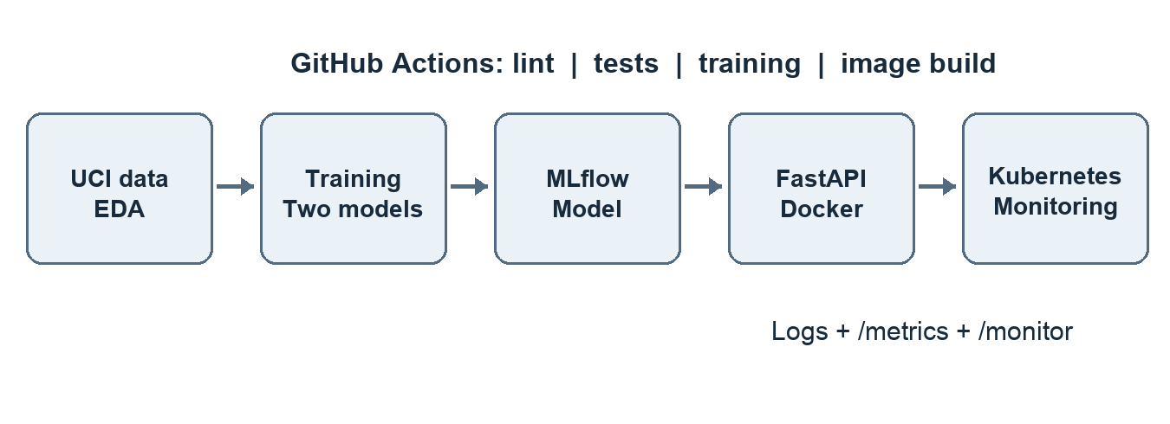
Figure 1 Assignment system architecture
The training script fits preprocessing and the classifier in one pipeline. MLflow stores the run results. The Docker image contains the selected pipeline. Docker Desktop Kubernetes runs one API pod. The service reports request counts and writes request logs.

Setup and local API access
The final run used Ubuntu 24.04 in WSL 2, Python 3.12.3, and Docker Desktop. From the repository root, run these commands in Ubuntu:
python3 -m venv ~/.venvs/heart-disease-mlops
source ~/.venvs/heart-disease-mlops/bin/activate
python -m pip install -r requirements.txt
python -m heart_mlops.data
python -m heart_mlops.eda
ruff check .
python -m pytest -q
python -m heart_mlops.train
Build the API image in WSL. Then apply the two Kubernetes files from Windows PowerShell. RUNBOOK.md gives the commands and identifies the shell for each step.
docker build --build-arg PYTHON_VERSION=3.12 -t heart-disease-api:local .
kubectl apply -f k8s\deployment.yaml
kubectl apply -f k8s\service.yaml
The service is at http://localhost:8000 while Docker Desktop Kubernetes runs. Use /health to check readiness. Send sample_request.json to POST /predict. Open /monitor for counts or /metrics for Prometheus text.

2 Data source and preparation
The UCI processed Cleveland file has 303 rows, 13 inputs, and a target from 0 to 4. The download script checks the SHA-256 digest. It converts question marks to missing values. It removes incomplete or duplicate rows. It maps targets 1 through 4 to class 1.
Data check | Observed result
Raw rows | 303
Rows after cleaning | 297
Rows removed | 6
Absent / present | 160 / 137

The repository has the clean CSV and a JSON file with row counts. The model pipeline can fill missing values in future requests. It learns these values from each training fold. The test rows do not set them.
Numeric inputs are age, resting blood pressure, cholesterol, maximum heart rate, and ST depression. The pipeline encodes the other eight inputs as categories. It does not use the target as an input.

3 Exploratory data analysis
The clean data has 160 class 0 rows and 137 class 1 rows. These plots show class counts and numeric values before model training.
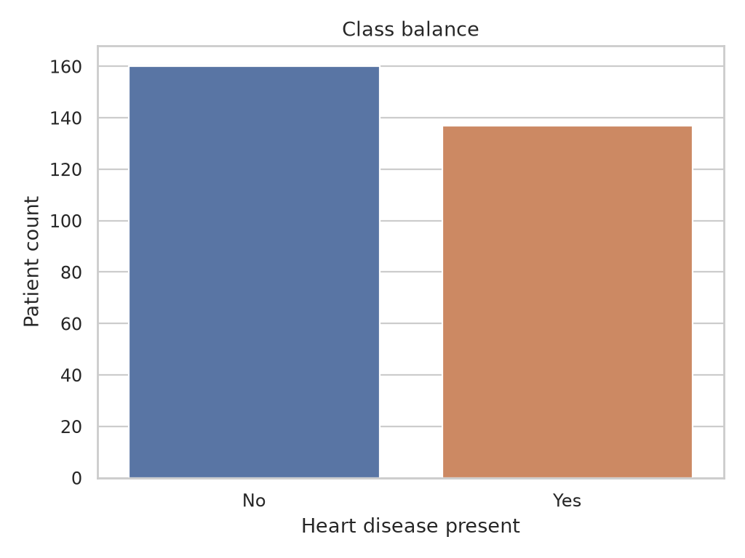
Figure 2 Cleaned dataset class balance
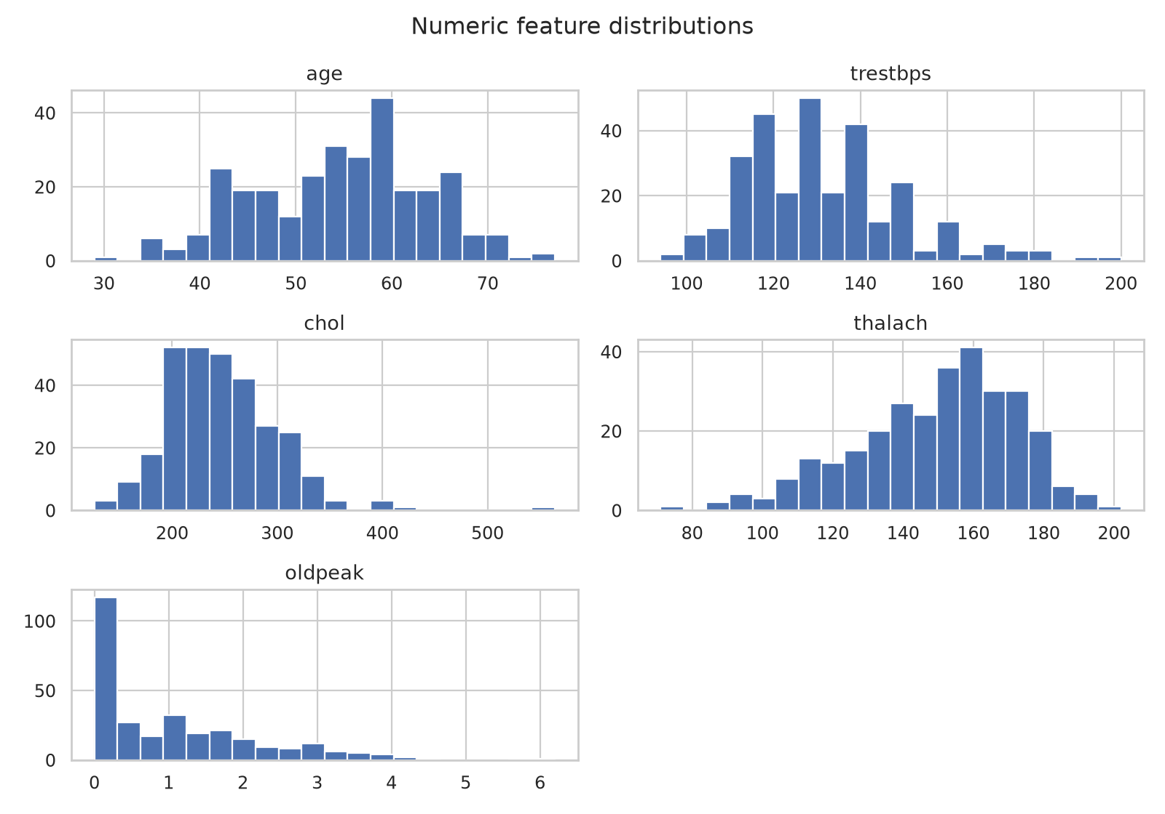
Figure 3 Numeric predictor distributions

4 Feature engineering and visual findings
The heatmap shows correlations between numeric inputs. It does not select features or show clinical cause. The box plots compare age and maximum heart rate by class. The small dataset limits these visual comparisons.
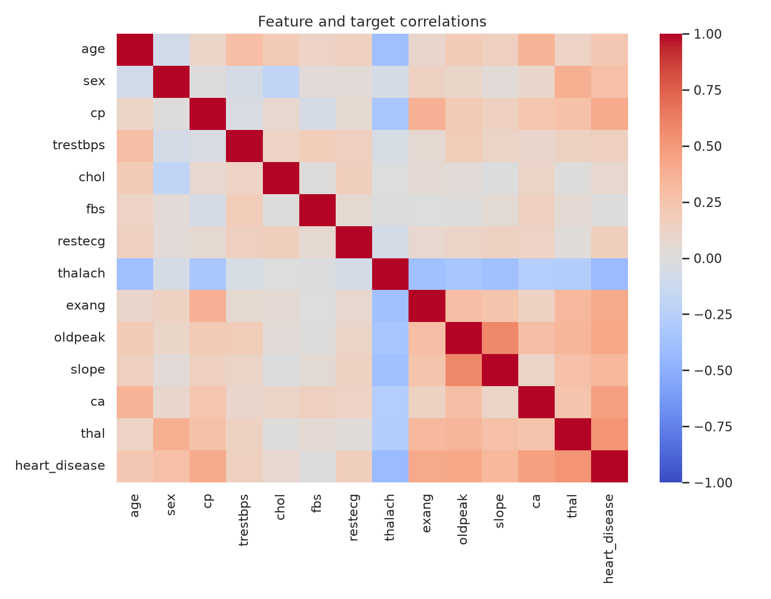
Figure 4 Pairwise numeric correlations
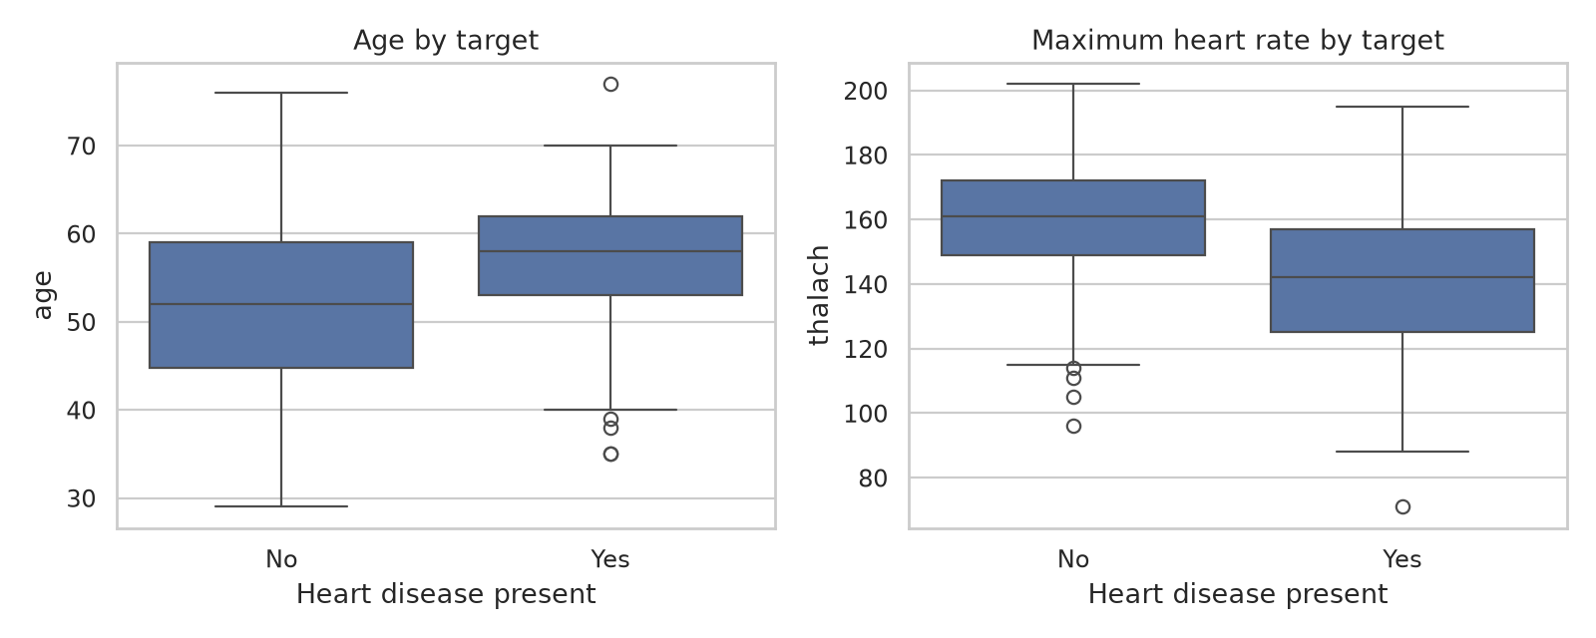
Figure 5 Age and maximum heart rate by class

5 Model design and selection
The script uses seed 42 to split the data. It puts 80% in training and 20% in testing. Five stratified folds test each parameter set. Numeric inputs use median imputation and scaling. Categorical inputs use mode imputation and one-hot encoding. The pipeline fits preprocessing inside each fold.
Logistic Regression is the linear baseline. Random Forest is the nonlinear model. The script selects the model with the highest mean validation ROC-AUC. It also records accuracy, precision, and recall.
Model | Accuracy | Precision | Recall | ROC-AUC
Logistic Regression | 0.822 | 0.839 | 0.769 | 0.902
Random Forest | 0.823 | 0.840 | 0.769 | 0.906

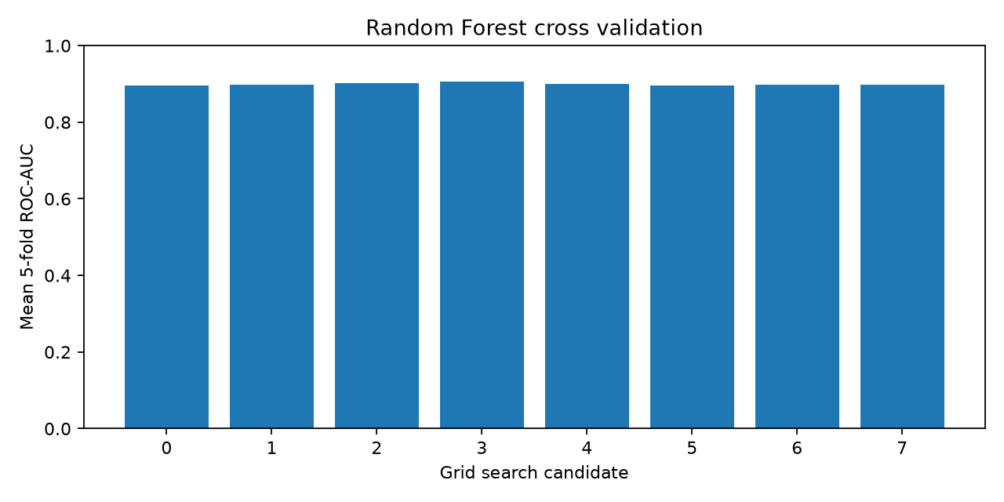
Figure 6 Random Forest candidate validation scores

6 Held out test evaluation
Cross validation selected random forest. The script then tested it once on 60 held-out rows. The confusion matrix shows 28 true negatives, 4 false positives, 7 false negatives, and 21 true positives.
Metric | Test result
Accuracy | 0.817
Precision | 0.840
Recall | 0.750
ROC-AUC | 0.944

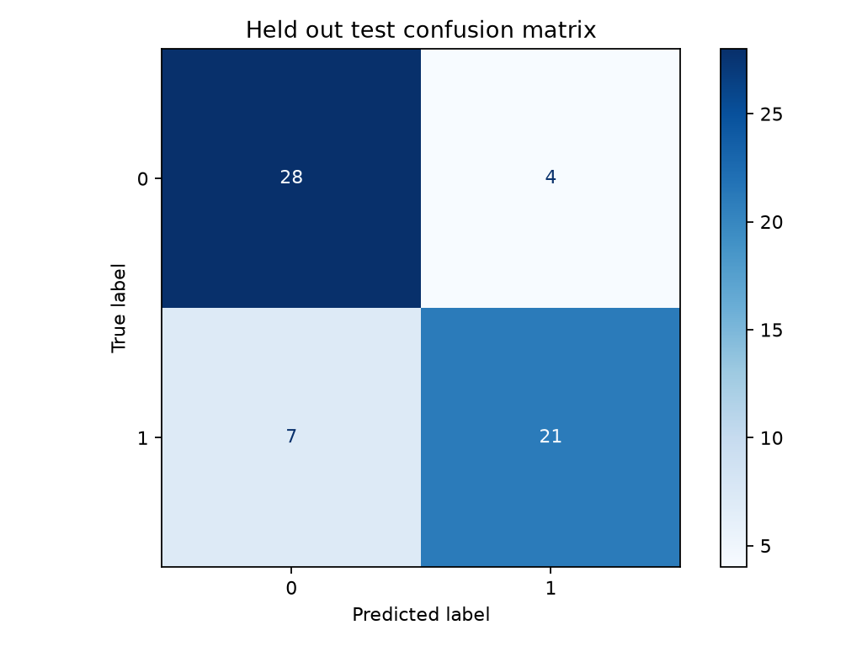
Figure 7 Test confusion matrix
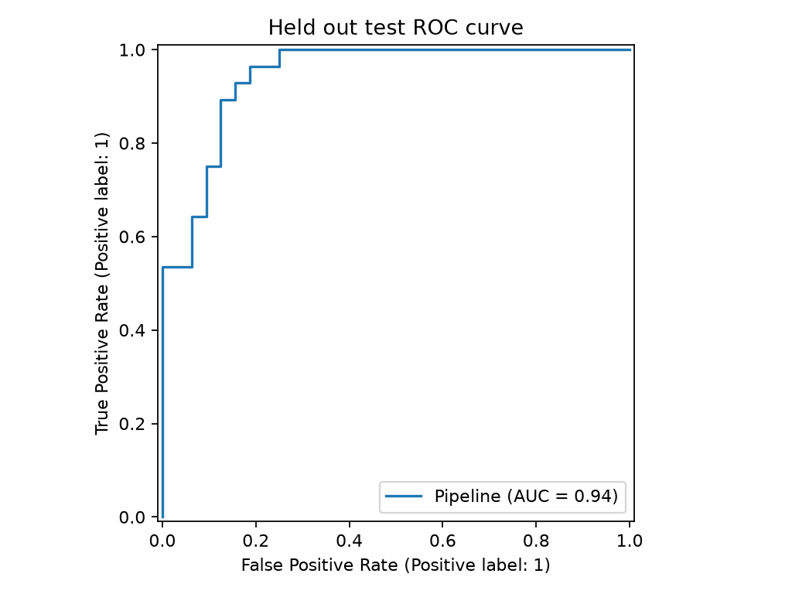
Figure 8 Test ROC curve

7 Experiment tracking and reproducibility
MLflow stores one run for each candidate model and one run for the selected model. Candidate runs include parameters, validation scores, search results, and plots. The selected run includes test scores, figures, metadata, and the fitted model. SQLite stores run metadata. Artifact files remain on disk. GitHub Actions uploads both.
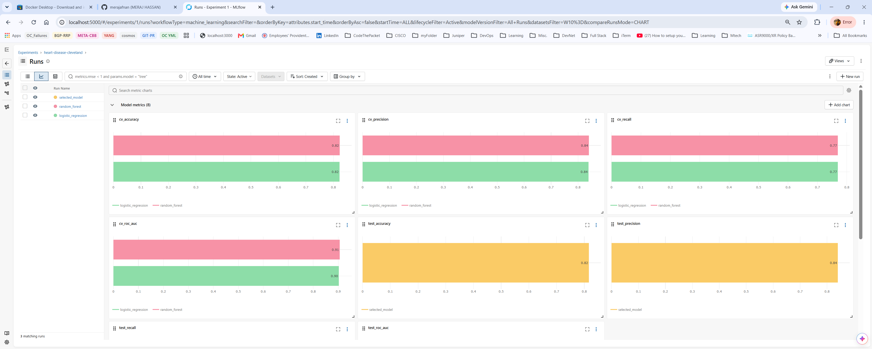
Figure 9 MLflow candidate and selected run metrics
The joblib file contains the fitted preprocessing and classifier. Model metadata lists the source checksum, selected parameters, inputs, seed, package version, and test scores. The requirements and download script support a new run.

8 Quality checks and continuous integration
Unit tests check target mapping, missing data, invalid targets, model output, API inputs, readiness, and monitoring endpoints. GitHub Actions runs Ruff, Pytest, data preparation, EDA, model training, and a Docker build. A failed required step marks the job as failed. The upload step still saves model and experiment files.
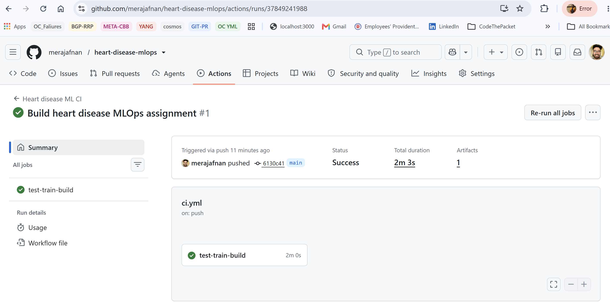
Figure 10 Passing GitHub Actions workflow

Figure 11 Uploaded workflow artifact
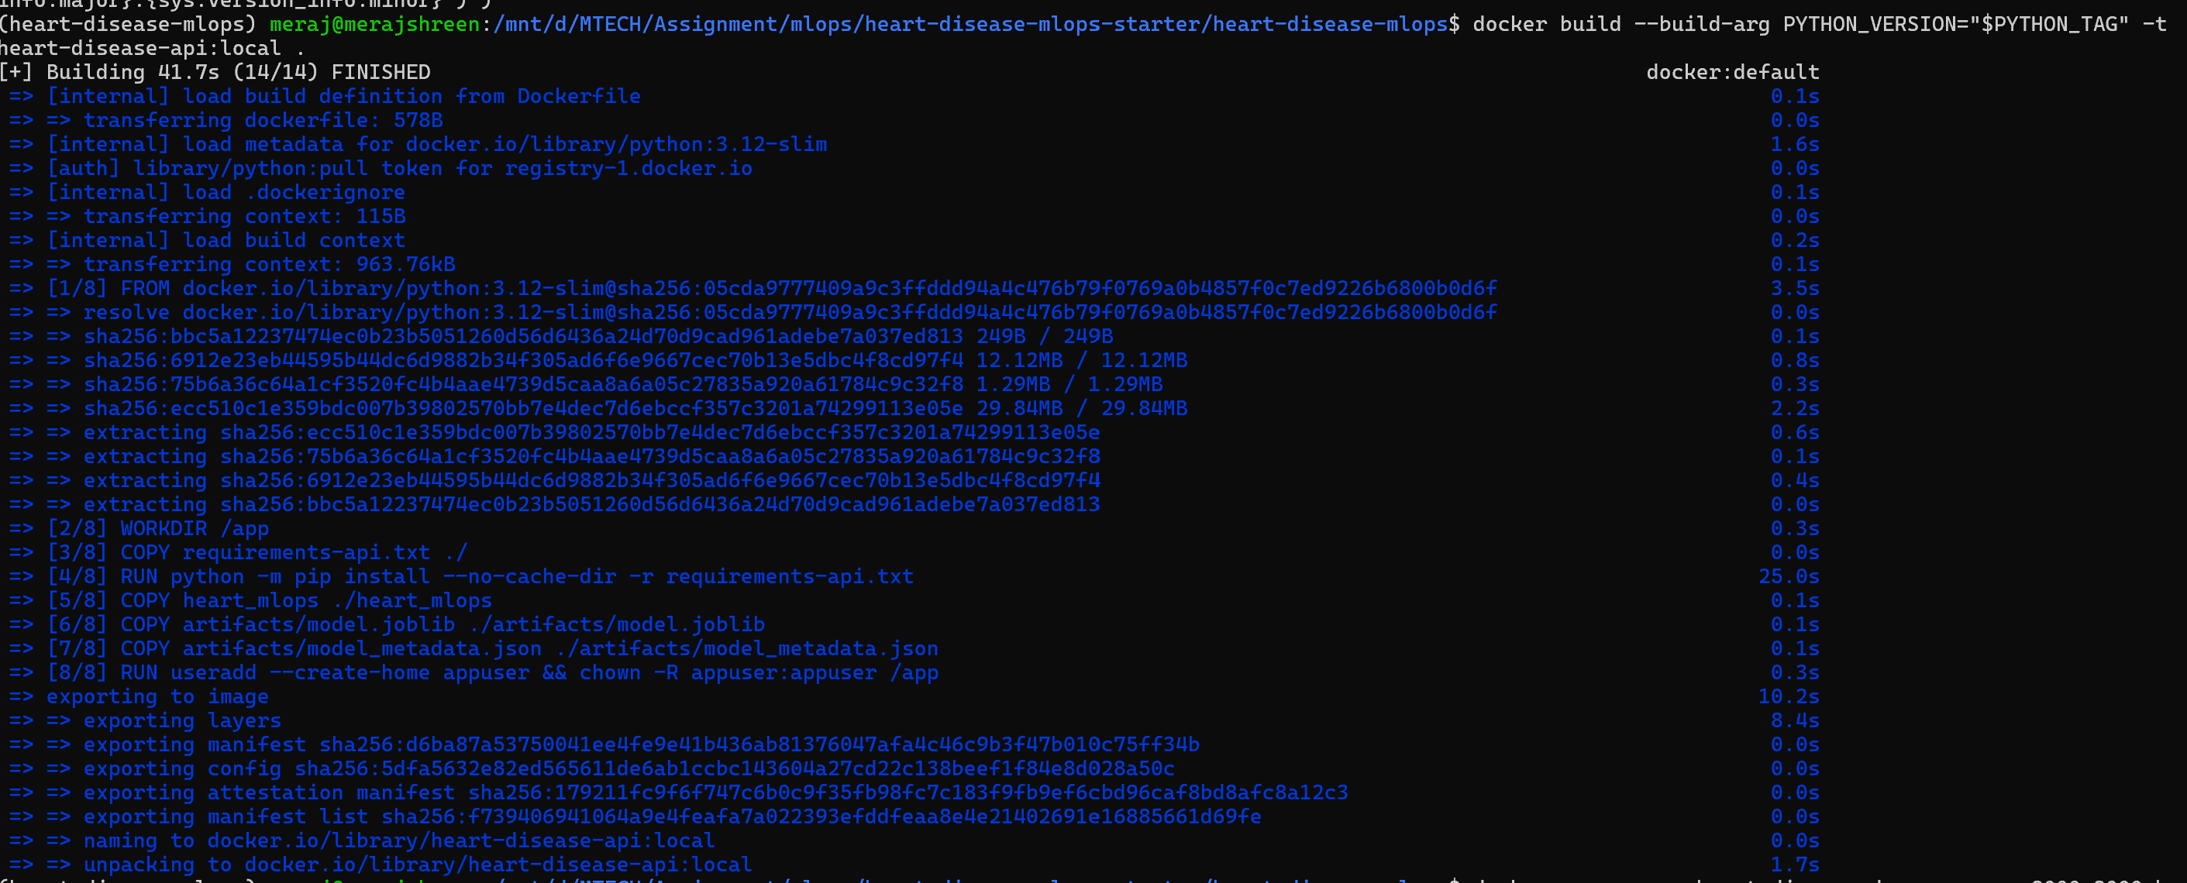
Figure 12 Local Docker image build
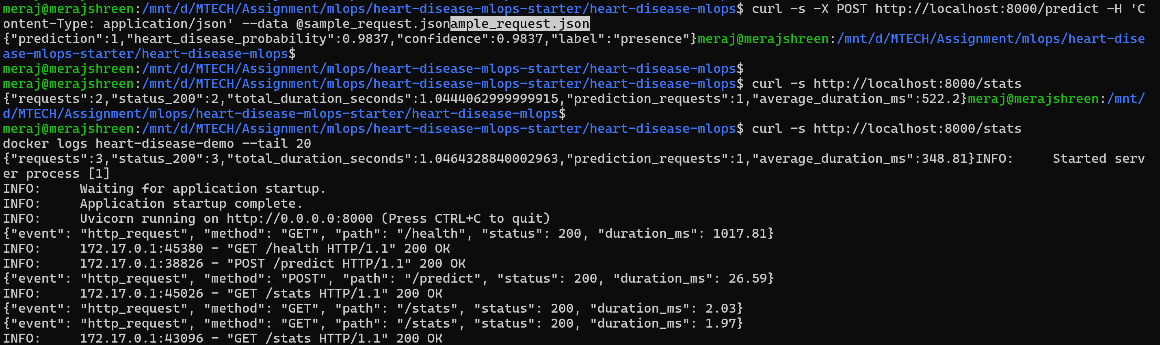
Figure 13 Local container prediction and request logs

9 Deployment monitoring and limitations
Docker Desktop Kubernetes runs one API pod. The deployment sets health probes and CPU and memory limits. A LoadBalancer Service uses port 8000. The API has /predict, /health, /metrics, /monitor, and OpenAPI documentation. Logs contain method, route, status, and duration. They omit patient values.
The sample request returned class 1 from both the container and Kubernetes service. Its positive-class probability and confidence were 0.9837. This score is not a validated clinical risk estimate.
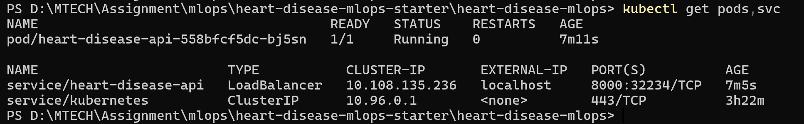
Figure 14 Ready Kubernetes pod and LoadBalancer Service
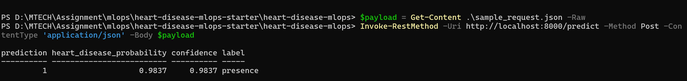
Figure 15 Prediction from the deployed Kubernetes API
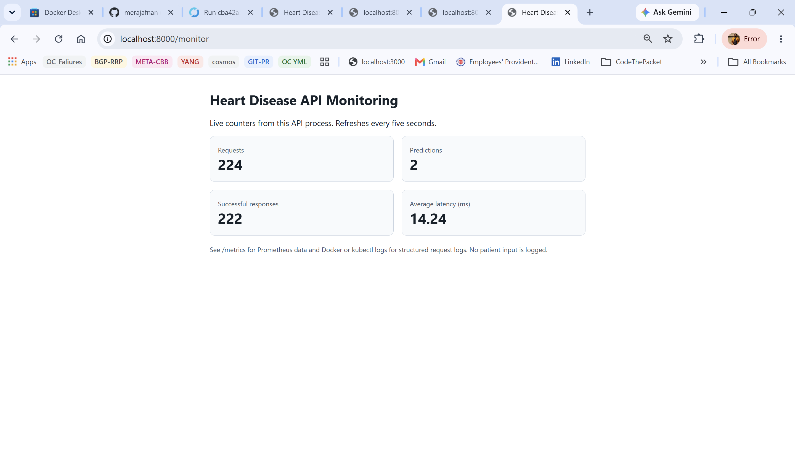
Figure 16 Live API monitoring dashboard
The dataset is small and historical. This work has no external validation or fairness assessment. Model probabilities are not calibrated clinical risks. The Kubernetes API is available only on the local laptop.
Repository: https://github.com/merajafnan/heart-disease-mlops
Source: Janosi et al., Heart Disease, UCI Machine Learning Repository, 1988. https://doi.org/10.24432/C52P4X

