**Course Code [CSE -260]**

[Data and Telecommunication]

**LAB Report [03]**

[Amplitude and Frequency Modulation and Demodulation (AM and FM)]

**Date of Submission: 21.12.2021**

**Submitted by**

**Name**: Meraj al Maksud

**Class Roll:** 2247

**Submitted to**

Dr. Abu Sayed Md. Mostafizur Rahaman

Professor

Department of Computer Science and Engineering

Jahangirnagar University

Savar, Dhaka



**Department of Computer Science and Engineering**

**Jahangirnagar University**

**Savar, Dhaka, Bangladesh**

**Title:** Experiment on Amplitude and Frequency Modulation and Demodulation (AM and FM)

1. **Statement of the Problem:**

Modulate a baseband signal according to Amplitude and Frequency.

1. **Hypothesis:**

There will be given a baseband signal and we have to modulate the signal according to Amplitude modulation and Frequency modulation. Then demodulate the amplified signal into baseband signal with filter to pass the signal through a transmission medium.

1. **Materials:**

MatLab

Google Colab

1. **Procedure:**

We have written the codes given below on Matlab and Google Colab. Then recorded the outputs.

1. **Results in MATLAB (Code with figure):**

**Step 1: AM of sinusoidal wave**

**Code:**

t=0:0.01:2*pi;

x=2*sin(pi*t);

Fs=18000;

Fc=1000;

in_phase = 0;

y=ammod(x,Fc,Fs,in_phase);

subplot(2,2,1)

plot(x, 'k');

title('Baseband signal');

grid on

subplot(2,2,2)

plot(y, 'k')

title('AM signal');

grid on

z=demod(y,Fc,Fs,'am');

subplot(2,2,3)

plot(z, 'k')

grid on

title('Demodulated signal');

subplot(2,2,4)

[b,a]=butter(8, 0.1);

r=filter(b, a, z);

plot(r)

title('Filtered signal');

grid on

**Output in MATLAB**:

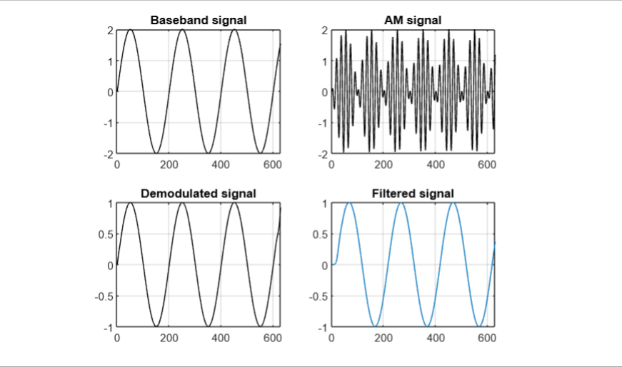

**Step-2: AM of audio signal**

**Code:**

load mtlb

in=mtlb;

x=in(1:500);

Fs=18000;

Fc=8000;

in_phase = 0;

y=ammod(x,Fc,Fs,in_phase);

subplot(2,2,1)

plot(x, 'k');

title('Base band signal');

grid on

subplot(2,2,2)

plot(y, 'k')

title('AM signal');

grid on

z=demod(y,Fc,Fs,'am');

subplot(2,2,3)

plot(z, 'k')

grid on

title('Demodulated signal');

subplot(2,2,4)

[b,a]=butter(8, 0.1);

r=filter(b, a, z);

plot(r)

title('Filtered signal');

grid on

**Output in MATLAB:**

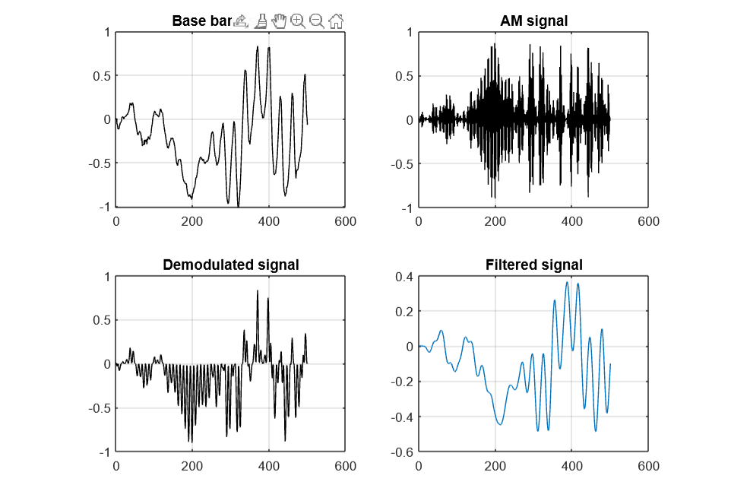

**Step-3: Vary the Fs and Fc such that Fs>2*Fc and listen to the recovered signal**

**Code:**

clear all

close all

load handel

x=y;

sound(x);

Fs=18000; Fc=8000; in_phase = 0; y=ammod(x,Fc,Fs,in_phase);

z=demod(y,Fc,Fs,'am');

[b,a]=butter(8, [0.1 0.95]); r=filter(b, a, z);

sound(r)

**Step-4 FM of sinusoidal wave**

**Code:**

%FM modulation

fs = 1000;

ts = 1/fs;

fd = 25;

t = 0:ts:2;

t=t';

x = sin(2*pi*2*t);

M_s = comm.FMModulator('SampleRate',fs,'FrequencyDeviation',fd);

y = step(M_s,x);

subplot(3,1,1)

plot(t,[x real(y)])

% Demodulation

DEMOD = comm.FMDemodulator('SampleRate',fs,'FrequencyDeviation',fd);

z = step(DEMOD,y);

subplot(3,1,2)

plot(t,z,'r')

xlabel('Time (s)')

ylabel('Amplitude')

title('Demodulated signal')

grid on

%psd of FM

subplot(3,1,3)

periodogram(real(y),[],512,fs);

**Output in MATLAB:**

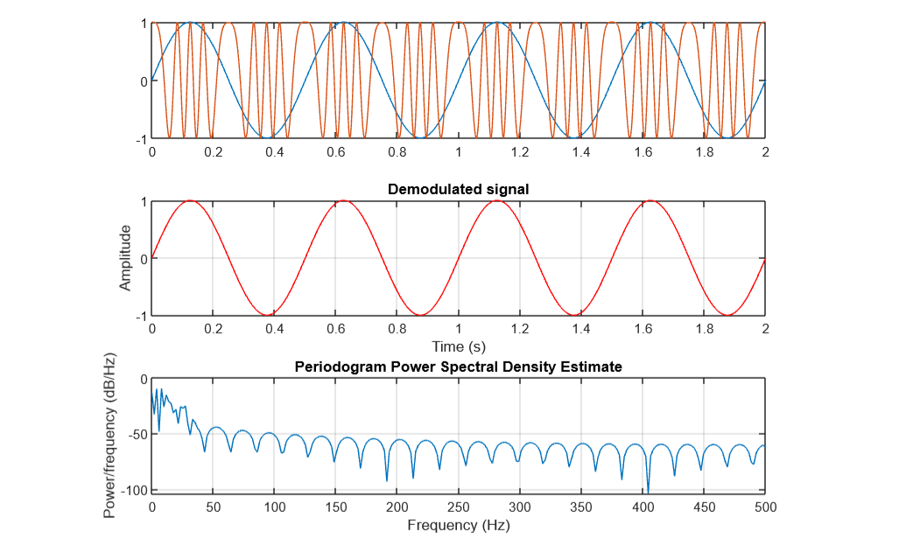

**Step 5: Vary the fs and listen to the recovered signal and compare with AM case**

%FM modulation and demodulation

clear all

close all

load handel

x=y;

sound(x)

fs = 18000; ts = 1/fs; fd = 50;

t = 0:ts:2; t=t';

M_s = comm.FMModulator('SampleRate',fs,'FrequencyDeviation',fd);

y = step(M_s,x);

DEMOD = comm.FMDemodulator('SampleRate',fs,'FrequencyDeviation',fd);

z = step(DEMOD, y);

sound(z)

1. **Results in PYTHON (Code with figure):**

**Code:**

**import** matplotlib.pyplot **as** plt

**import** numpy **as** np

**from** math **import** pi

**from** scipy.signal **import** butter,lfilter

Fs=10000

Ts=1/Fs

t=np.arange(0,1,Ts)

Ac=2

Fc=100

m=0.2

carrier_signal=Ac*np.cos(2*pi*Fc*t)

*# Message Signal*

Am=1

Fm=2

msg_signal=Am*np.cos(2*pi*Fm*t)

*# AM Signal*

AM_signal=(Ac+Am*np.cos(2*pi*Fm*t))*np.cos(2*pi*Fc*t)

*# DM Signal*

dmod=2*carrier_signal*AM_signal

nyq=0.5*Fs

normal_cutoff=(Fc/2)/nyq

b,a=butter(6,normal_cutoff,btype='low',analog=False)

AM_DM_signal=lfilter(b,a,dmod)

plt.subplot(3,1,1)

plt.title('Message Signal')

plt.xlabel('Time')

plt.ylabel('Amplitude')

plt.grid(True)

plt.plot(t,msg_signal,'b')

plt.subplot(4,1,1)

plt.title('Message Signal')

plt.xlabel('Time')

plt.ylabel('Amplitude')

plt.grid(True)

plt.plot(t,msg_signal,'b')

plt.subplot(4,1,2)

plt.title('Carrier Signal')

plt.xlabel('Time')

plt.ylabel('Amplitude')

plt.grid(True)

plt.plot(t,carrier_signal,'b')

plt.subplot(4,1,3)

plt.title('AM Signal')

plt.xlabel('Time')

plt.ylabel('Amplitude')

plt.grid(True)

plt.plot(t,AM_signal,'r')

plt.subplot(4,1,4)

plt.title('De Modulated Signal')

plt.xlabel('Time')

plt.ylabel('Amplitude')

plt.grid(True)

plt.plot(t,AM_DM_signal,'b')

plt.rc('font,size=15')

fig=plt.gcf()

fig.set_size_inches(16,20)

**Output in Python:**

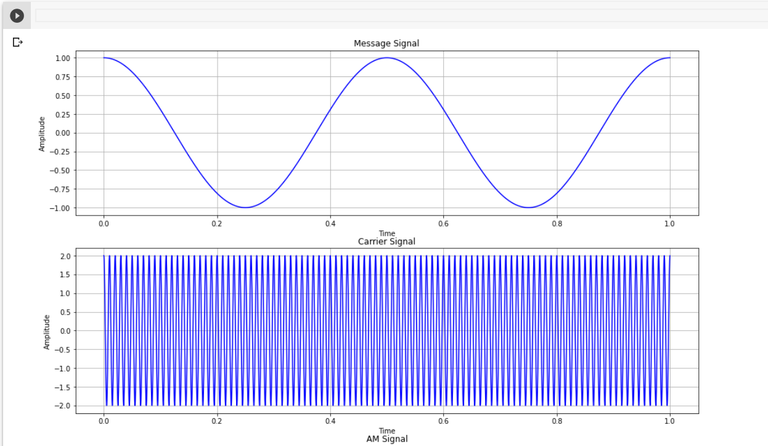

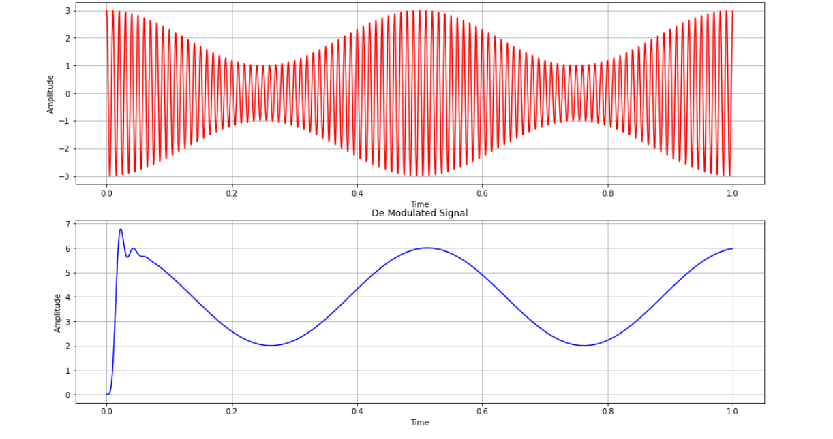

1. **Conclusions:** I accept my hypothesis because the experiment was successful as it has modulated the baseband signal and also demodulated the signal perfectly.