**Spatial patterns of cortical tau pathology differ by age, sex, and type II diabetes status in a multiethnic study of cognitively impaired older adults**

**Authors:**

Brandon Hall1, Meral Tubi1, Noelle Lee1,Victoria Tennant1, Koral Wheeler1, Arthur W Toga2,, Leigh Johnson4, Rajesh Nandy4*,* Raul Vintimilla4, Rocky Vig5, Sid E. O’Bryant4, Kristine Yaffe3, Meredith N Braskie1 for the HABS-HD Study Team

1. Imaging Genetics Center, Mark and Mary Stevens Neuroimaging and Informatics Institute, Keck School of Medicine, University of Southern California, Marina del Rey, CA, USA.
2. Laboratory of Neuro Imaging USC Stevens Neuroimaging and Informatics Institute Keck School of Medicine of USC University of Southern California Los Angeles California USA.
3. Department of Psychiatry, Neurology, and Epidemiology and Biostatistics University of California San Francisco California USA.
4. Institute for Translational Research University of North Texas Health Science Center Fort Worth Texas USA.
5. Imaging Midtown Medical Imaging Fort Worth Texas USA.

**Keywords**: Alzheimer’s disease, Mild Cognitive Impairment, heterogeneity, tau, diabetes, sex, subtype

**Background**

Neurofibrillary tau accumulation is a pathological hallmark of Alzheimer’s disease (AD). The spatial pattern of tau varies and has been categorized into 4 patterns: typical, limbic predominant (LP), hippocampal sparing (HS), and sub-median tau (SMT)2. These patterns differ by age of onset, mean age, disease duration, and symptom profiles2. Some metabolic risk factors for AD, such as type 2 diabetes (T2DM), have also correlated with increased tau neuropathology3. To study how these factors may relate to tau patterns in AD, we created classification models to identify differences in BMI, hypertension, and T2DM between tau patterns in older adults with MCI and AD.

**Method**

We examined PI2620 tau PET images for 222 participants diagnosed with MCI or AD from the Health and Aging Brain – Health Disparities cohort (**Table 1**). We used Freesurfer v5.3 to segment T1 MRI and generated regional standard uptake value ratio values with the inferior cerebellar gray matter as a reference region. Based on previous studies4,, we categorized participants’ tau pathology into patterns (**Figure 2**). In separate multinomial logistic regression models adjusting for age and sex (using R 4.2), we measured whether hypertension, T2DM, and BMI differentiated the participants’ tau patterns. Welch’s t-tests were used to directly compare factors that were significant predictors in a given pairwise comparison (eg, HS vs LP).

**Results**

See **Table 1** for the sample distribution of tau patterns. HS participants were more likely to have T2DM (44% vs 25%, p = 0.009) (**Figure 2**) and had a higher BMI (36.0 vs 31.3; t = 2.0, p = 0.0496) compared to typical participants (**Table 1**). LP and HS patterns differed in both age (LP: 67.7 vs HS: 62.2, t = -2.3, p = 0.03) and sex (LP: 35% female vs HS: 67% female) (**Figure 2**).

**Conclusion**

This study suggests that in an ethnically diverse cohort of older adults with cognitive impairment, sex and T2DM are important features for the differentiation of cortical tau deposition patterns. The HS pattern is of particular interest, as it has the highest proportion of females, the lowest mean age, the highest mean BMI, and the highest proportion of T2DM participants. To better understand why female sex, T2DM diagnosis, and BMI are risk factors for AD, it may be beneficial to focus on this pattern of tau pathology.

**Figures**

| **Table 1** | | | | | |
| --- | --- | --- | --- | --- | --- |
| Category | Total | Typical | Limbic Predominant | Hippocampal Sparing | Sub-median Tau |
| **Demographics** |  |  |  |  |  |
| N | 222 (100%) | 95 (43%) | 30 (13%) | 27 (12%) | 70 (32%) |
| Age | 64.7 (±8.5) | 65.9 (±8.9) | 67.7 (±9.4) | 62.2 (±9.2) | 62.9 (±6.5) |
| Sex (Female) | 117 (53%) | 59 (62%) | 10 (33%) | 18 (67%) | 30 (43%) |
| **Race/Ethnicity** |  |  |  |  |  |
| Hispanic | 62 (28%) | 34 (36%) | 10 (33%) | 3 (11%) | 15 (22%) |
| Non-Hispanic White | 61 (28%) | 25 (26%) | 6 (20%) | 13 (48%) | 17 (24%) |
| Hispanic Black | 3 (1%) | 2 (2%) | 0 (0)% | 0 (0%) | 1 (1%) |
| Non-Hispanic Black | 96 (43%) | 34 (36%) | 14 (47%) | 11 (41%) | 37 (53%) |
| **Cognitive diagnoses** |  |  |  |  |  |
| MCI | 170 (77%) | 73 (77%) | 23 (77%) | 18 (67%) | 56 (80%) |
| AD | 52 (23%) | 22 (23%) | 7 (23%) | 9 (33%) | 14 (20%) |
| **Metabolic factors** |  |  |  |  |  |
| BMI | 31.6 (±8.0) | 31.3 (±8.4) | 31.5 (±6.0) | 36.0 (±10.9) | 30.2 (±6.2) |
| Hypertension + | 162 (72%) | 65 (68%) | 25 (83%) | 23 (85%) | 49 (70%) |
| Diabetes + | 67 (30%) | 24 (25%) | 11 (37%) | 12 (44%) | 20 (29%) |
| **Table 1**: a demographics table that summarizes the characteristics of the sample from the HABS-HD cohort. Acronyms: MCI -- Mild Cognitive Impairment, AD -- Alzheimer's Disease, Typical -- the classic progression of AD pathology from medial temporal to cortical regions, Sub-median tau -- where tau accumulation is below the median of a larger HABS cohort sample in both the hippocampal and neocortical regions (see Figure 1). | | | | | |

| **Figure 1** |
| --- |
|  |
| **Figure 2**: a decision tree representing the algorithm used to categorize participants’ tau pathology into the sub-median tau, typical, limbic predominant, and hippocampal sparing patterns. Median tau is based on a larger cohort of HABS-HD participants that includes 281 cognitively unimpaired, 174 MCI, and 53 AD. These 281 cognitively intact participants were not included in the current study. Of the 227 MCI or AD participants, 4 (4 MCI, 1 AD) were excluded from the study due to incomplete data. |

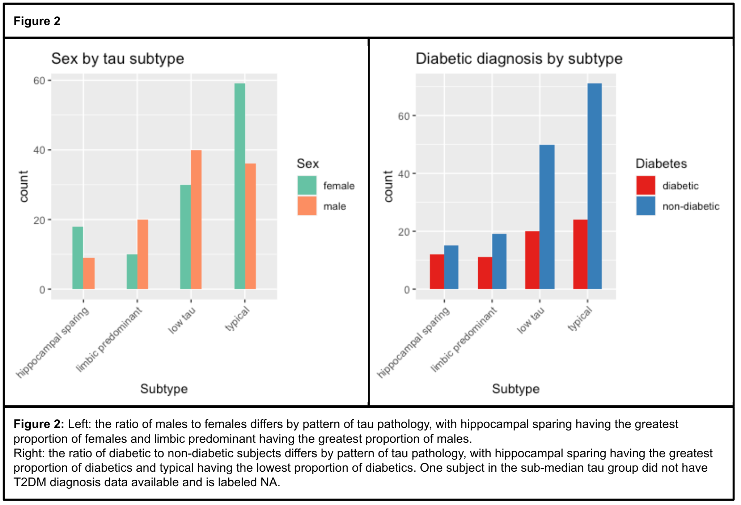

**References**

1. Abdulrahman, H., van Dalen, J. W., den Brok, M., Latimer, C. S., Larson, E. B., & Richard, E. (2022). Hypertension and Alzheimer's disease pathology at autopsy: A systematic review. *Alzheimer's & Dementia*, *18*(11), 2308-2326.
2. Charil, A., Shcherbinin, S., Southekal, S., Devous, M. D., Mintun, M., Murray, M. E., Miller, B. B., & Schwarz, A. J. (2019). Tau Subtypes of Alzheimer’s Disease Determined in vivo Using Flortaucipir PET Imaging. *Journal of Alzheimer’s Disease*, *71*(3), 1037–1048.<https://doi.org/10.3233/JAD-190264>
3. Michailidis, M., Moraitou, D., Tata, D. A., Kalinderi, K., Papamitsou, T., & Papaliagkas, V. (2022). Alzheimer’s disease as type 3 diabetes: Common pathophysiological mechanisms between Alzheimer’s disease and type 2 diabetes. *International Journal of Molecular Sciences*, *23*(5), 2687.
4. Murray, M. E., Graff-Radford, N. R., Ross, O. A., Petersen, R. C., Duara, R., & Dickson, D. W. (2011). Neuropathologically defined subtypes of Alzheimer’s disease with distinct clinical characteristics: A retrospective study. *The Lancet Neurology*, *10*(9), 785–796.<https://doi.org/10.1016/S1474-4422(11)70156-9>
5. Ratnakumar, A., Zimmerman, S. E., Jordan, B. A., & Mar, J. C. (2019). Estrogen activates Alzheimer’s disease genes. *Alzheimer’s & Dementia : Translational Research & Clinical Interventions*, *5*, 906–917.<https://doi.org/10.1016/j.trci.2019.09.004>