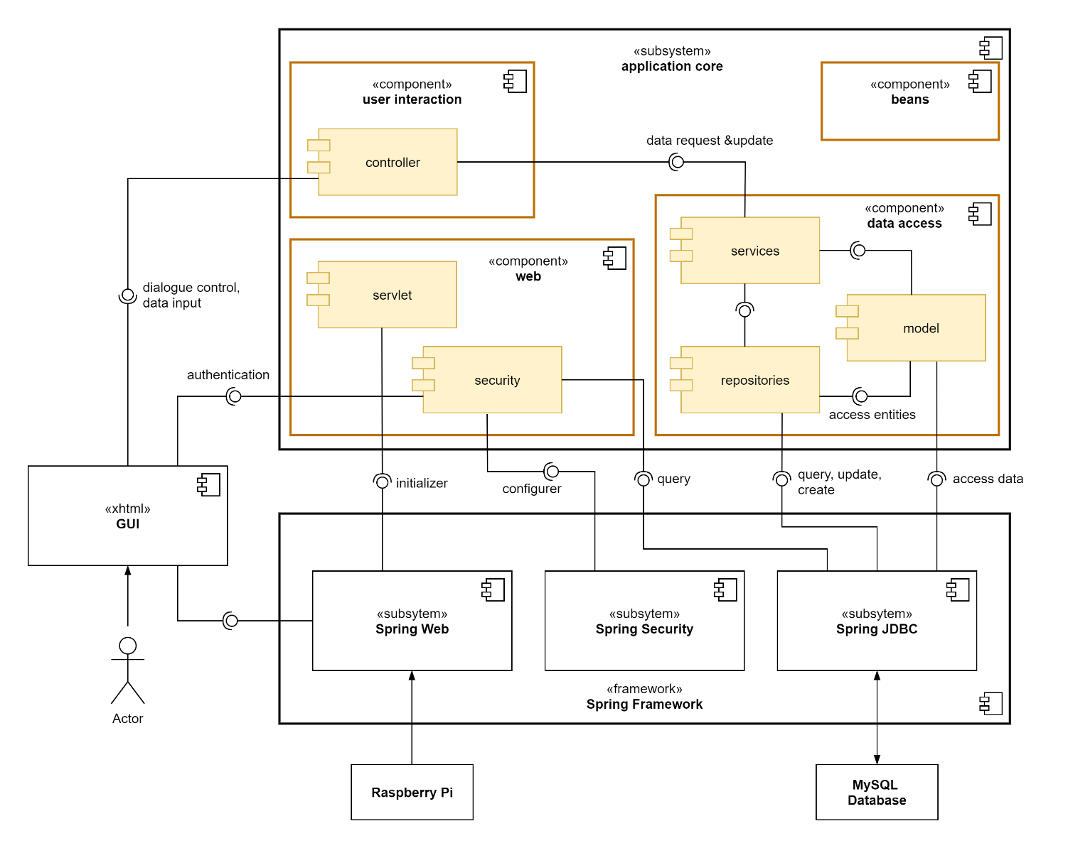

The system can be divided into the spring framework it is built upon, the graphical user interface, which is realised via XHTML, and the core of the application, which holds the actual implementation of the business logic. The application core is further broken down in the following table.

|  |  |
| --- | --- |
| component | role |
| data access | retrieves, creates and updates the persisted data from the MySQL database via spring’s JDBC interface |
| ▸ model | models the persisted data as Java objects (entities) |
| ▸ repositories | used to query, create, delete and update data in the database |
| ▸ services | supplies methods to other components for all operations that need to access or modify persisted data, using the repositories and model modules |
| web | initiates and configures the web application |
| ▸ servlet | initiates the web application |
| ▸ security | manages authentication and error handling when somebody wants to access the web application  needs to query user data from the database and receives user input from the user interface |
| user interaction | interface between GUI and the data model |
| ▸ controller | responsible for dialogue control of the GUI, implement the business logic initiated by the user input, retrieve the data to display from the database and modify the persisted data by communicating with the services-module |
| beans | contains independently usable components that implement additional features |