Maven

Download Maven and Gradle

Set Env variable as:

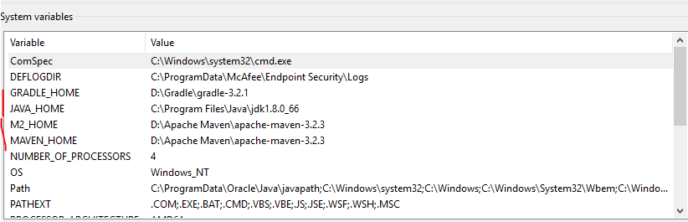

Edit Path as:

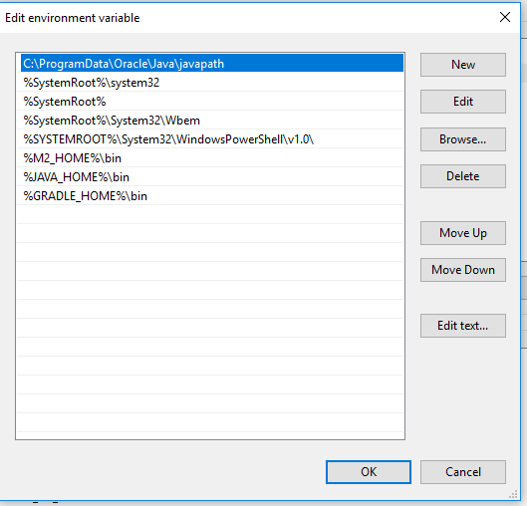

Verify version:

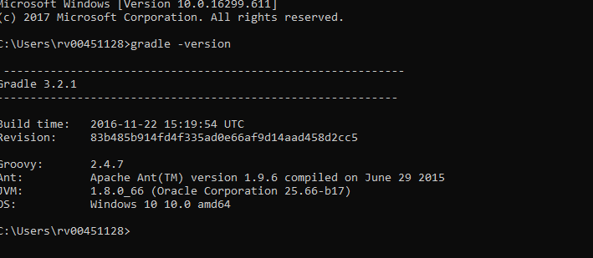

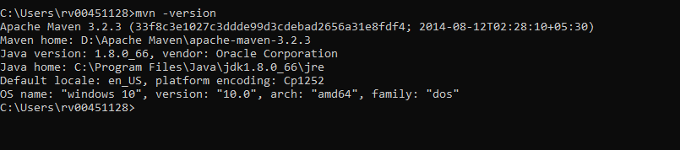

Copy and paste the seeting.xml file in user/.m2 folder

C:\Users\rv00451128\.m2

