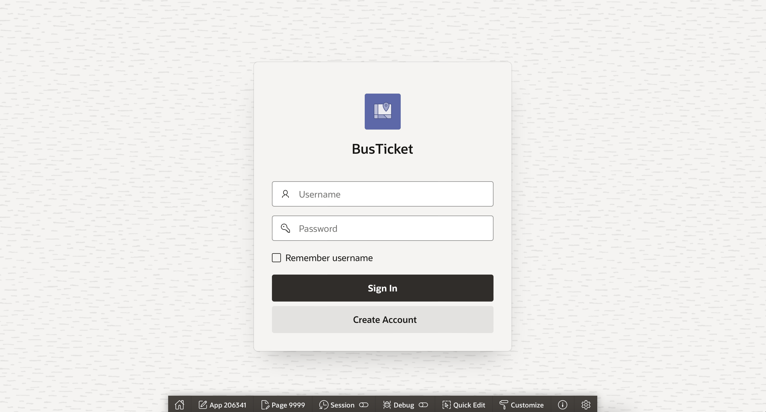

Login page e duita function kaj kortese jokhon sign in kora hoy. Ekta authentication and arekta authorization er jonne. (login page er pore oi duita function sob gula page ei call hoy before page loading).

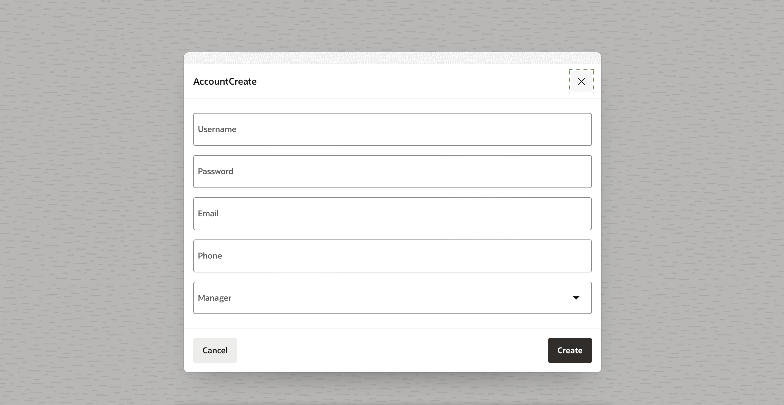

Create account page ta apex er default procedures and triggers use kore database a account create kore. And default user is a customer. Manager role just managers rai create korte parbe.

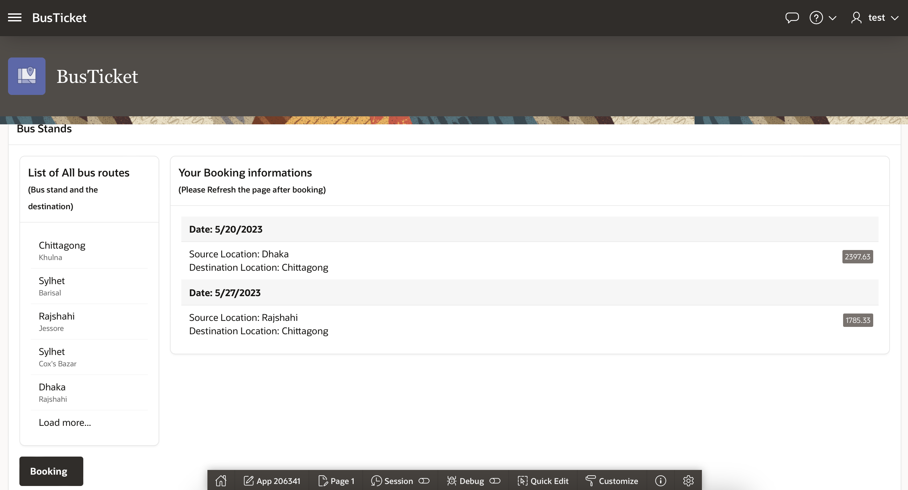

Jodi user customer hoy then homepage emon dekhte hobe. Ekta simple and basic homepage.



Basic navigations gula holo blue marker dekhaytese booking information or history. Eikhane oi user er booking history deya thake list akare. Right side e oi box er moddhe ticket price deya. Left e source location and destination location deya. Brown marker diye bus gular routes deya. Like kotha theke kothay bus jay. Top e navigation bar. Navigation bar e feedback and account sign out drop down ase. Then green marker diye booking button indicate kore. Oita click korle booking er form asbe.   
Eikhane booking information and list of all bus routes duita apex default list function use kore. Feedback ta trigger and procedure use kore. Booking button ta ekta event. 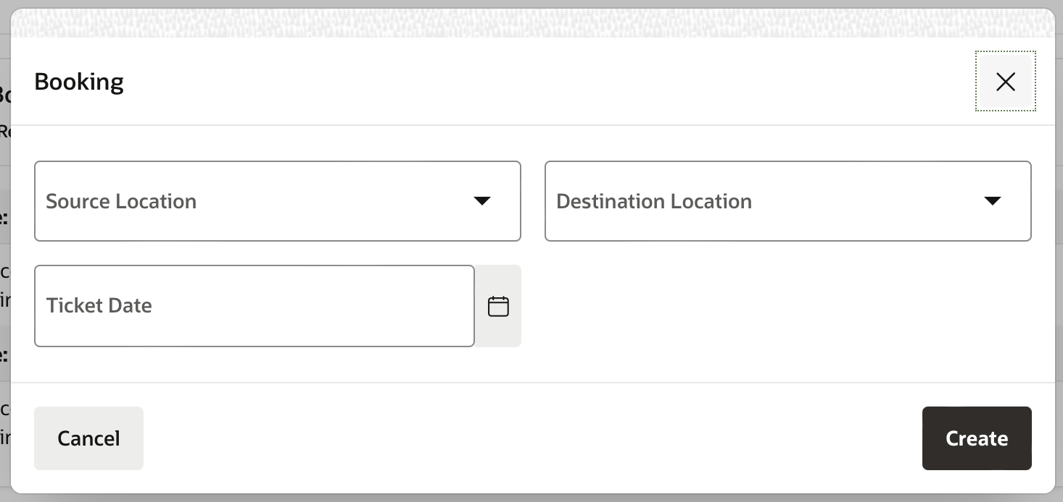

Booking button click korle ei uprer eita ase. Eikhan theke sob select kore then ekta ticket buy korte hobe.

and feedback form ta emon.

Ei hocche customer er jonne sob. Ekhon manager er jonne manager account e login korte hobe.   
meraz1 ekta manager account jar password holo 1234. So try kori.

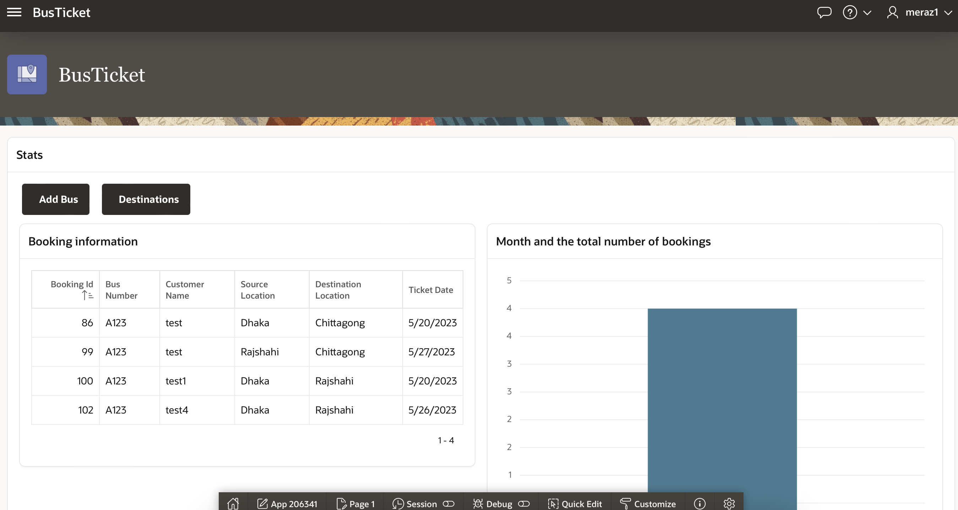meraz1 account e login korle homepage ta emon dekhay. Eita hocche manager er homepage. Scroll korle aro stat information payajabe. Sob gulai select statement diye kora. Then upore duita button ase, add bus and destinations. Add bus e new buses add kora jabe list e. eita ekta procedure er maddhome kaj kortese, abr existing buses edit kora jabe. Then destinations oh same, existing gula change and new routes create kora jabe.

ei menu te click korle manager er khete arekta page ase, admin page.

Admin page emon. Left side er full column er sob gula trigger and functions use kortese. Default apex triggers and functions.   
First e theme style selection, oikhan theke full app er theme change kora jabe. The dashboard e application er activity graphs akare dekhai.

Cayle timeframe change kore dekha jay.

Then to users e users er report dey, users er page views report.

Then application error log e sob error log kore rakhe. Then page performance e report dey page er performance er. Then page views ei same, ekta report dey.page views er action drop down ta onek kisui korte pare. Eita use kore managers ra analyse korte parbe application ta and save o korte parbe in different formats.

eikhan theke feedback manage kora jay. Eikhaneo oi actions drop down ase.

Project er sobtheke hard parts gula first e silo authentication and authorization. After those two, 2nd hardest part silo booking er part ta. And 3rd hocche ‘Your booking information’ list ta.