

Cacique
Installation Guide

Index

1. Introduction 3
2. What is Cacique? 3
3. Installation 3
3.1 Step 1 3
3.2 Step 2 3
3.3 Step 3 5
4. Processes 5
5. VMs to Run........................................................................................................................................... 6
5.1 Remote Execution...........................................................................................................................6
5.2 Ejecucion CaciqueOnMyComputer................................................................................................6
6. Contacts..................................................................................................................................................6

1. Introduction
The purpose of this manual is to explain the steps for proper Cacique installation. Define hardware requirements, explain the different processes that exist and their roles within the architecture of the tool.

2. What is Cacique?
Cacique is a Web tool for automating tasks developed on the language Ruby on Rails. For there functioning is necessary a web server running constantly.
We recommend and ensure its proper function in Firefox.

As an initial requirement will need a computer with Ubuntu or Debian operating system, to which we refer to as server of Cacique.

3. Installation

3.1 Step 1
On the server you must install a series of packages that are specified in installer.sh file in the root directory of Cacique.
To run the installer open a terminal, move to the root folder of the tool and run the command ./installer.sh
The console will display the gems and packages are being installed.

In the list of packages to install we find the database engine Mysql. When the installation starts it will ask you the password for the root user. Remember this password, it will be used in the future.

If any package can not be installed is logged in a file called installer.log in the same folder where we can find the installer. In this case we must try to rerun the installer, or proceed with the installation of the failure package manually.

Once installation finished, it will have all needed packaged to run Cacique.

3.2 Step 2
In this step we will generate the Cacique db which stores all the information.
In the installer executed in step 1 was installed MySQL database, but if you wish to use any other database the next steps would be the same.

First we must configurate the database file, to do that open the file config/database.yml and modify the user and password "cacique" by a user that we created in MySql. Save the change.

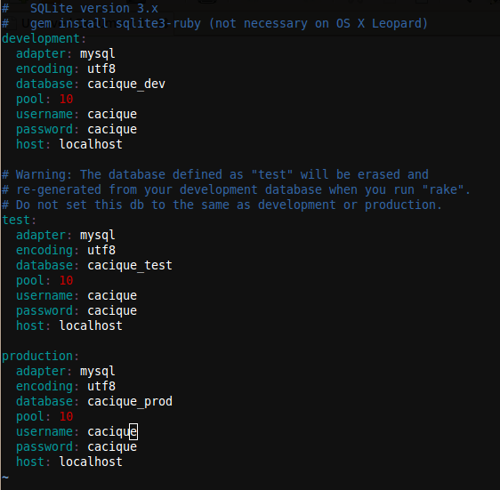

Once this change is made open a terminal, move to the root folder of Cacique and run rake db: create RAILS_ENV = production
This command is peculiar to a Rails application and create the database with the configuration that is specified in the config/database.yml

Once you create the database should run the migrations to generate the tables, to do this you must run the command rake db:migrate RAILS_ENV=production

In the console will be shown the executed migrations:
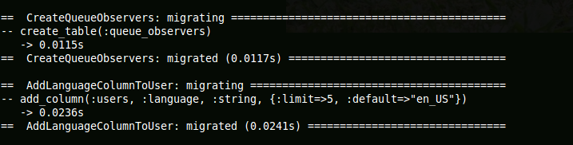

Once we complete the migrations will have the database ready.

It is also important to properly configure the time zone in which the server is located, for that go to config/environment.rb and change the default time zone, Buenos Aires.

3.3 Step 3
As a last step in the installation we only need to configure your web server, in this case Apache with Passenger, but can be any other such as Mongrel.

For this follow the instructions on the page http://www.modrails.com/install.html

At this point we are able to startup the Cacique server:
- If we use Apache with Passenger open a terminal and run the command sudo /etc/init.d/apache start

- If we use Mongrel open a terminal, login as root with the command su, enter the password and then execute the command script/server -e production -p 80

Now you can navigate Cacique in the url http://<ip_server>/

4. Processes
In this section we give a brief explanation of the role that each process within the architecture of Cacique.

Apache/Passenger: Server Cacique Web page.

MySql: Database engine uses to store the information.

Memcached: Cache that uses the Rails application.
To startup this service use the command line:
/usr/bin/memcached -u cacique -d

Starling: Process that manages the queues and the Workers. Get the executions that are generated in "Cacique", the queues and sends them to the various Workers connected.
To startup this service use the command line:
<project_path>/script/starling.rb

Workling: Process that runs in the background that is used to run all task generated with Cacique.
To startup this service use the command line:
<project_path>/script/workling_client start
Run this command as many times as many Workers who want to startup.

Selenium-Grid: Process used to run the scripts of "Selenium" in different browser settings.
To startup this service go to the folder <project_path>/extras/selenium-grid-1.0.8 and run the command:
ant launch-hub
For more documentation of Selenium-Grid visit: http://selenium-grid.seleniumhq.org/

Jobs: Rails process that executes scheduled suites.
To startup this service go to the folder <project_path> and run the command:
rake jobs:work RAILS_ENV=production

Every process of Cacique is completely detachable, can be found all on the same server, or distributed in different.

5. VMs to Run

5.1 Remote Execution
Cacique run your tests on remote machines or on the user's machine.
For remote execution is required:
1- Have a machine installed with the OS and the browser in which you want to run the test.
2- Startup "Selenium" client. Copied to the remote machine the folder is in /extras/selenium-grid-1.0.8, open a console, move to the copied folder and run the following command:
ant -Dport=<port> -Denvironment="<label>" -DseleniumArgs="-singleWindow -trustAllSSLCertificates " -Dhost=<ip_remote> -DhubURL=http://<ip_server>:4444 launch-remote-control

Replace in the command the values that are between <>, where:
<port>: Any free port where the agent is connected.
<label>: Name to represent the agent. For example: Firefox3 on Windows.
<ip_remote>: Ip of the remote machine, is used along with the label to identify an agent.
<ip_server>: Ip of the computer where is the server Cacique.

After doing these two steps Cacique is ready to run a script on the remote machine.
To view the active agents http://<ip_server>:4444/console

You should take care that cacique is working with his own custom labels, cacique's workers are looking for that valid labels and selenium hub s
hould understand those labels. Those labels could be customized editing <project-folder>/extras/selenium-grid-1.0.8/grid_configuration.yml

5.2 CaciqueOnMyComputer Execution
For the execution of a script in the user's machine is necessary to startup a Selenium client in this machine. This requires:
1- Download the. zip is on the link Cacique on My Computer on the home of Cacique and extract the contents.
2- Run the script runIE.bat or runFirefox.bat, depending on the browser to use. It will open a console and the client show up. You can have both agents simultaneously, IE and FF.

After doing these two steps Cacique is in a position to run a script on a user's machine.

6. Contacts

For more information visit http://cacique.mercadolibre.com

