|  |  |  |  |
| --- | --- | --- | --- |
| *Version* | *Date* | *Author* | *Comment* |
| 0.1 | 09.05.2023 | Samara Dominik | Created, set up basic structure |
| 0.2 | 09.05.2023 | Marcel Hintze | Added Implementation |
| 0.3 | 10.05.2023 | Samara Dominik | Added Scope, Glossary |
| 0.4 | 10.05.2023 | Samara Dominik | Added Design |
| 0.5 | 10.05.2023 | Martin Rittmann | Added Module Requirements, Analysis |
| 0.6 | 10.05.2023 | Tom Engelmann | Added Module Tests |

*Supplier*

Project Leader: Samara Dominik (inf21001@lehre.dhbw-stuttgart.de)

Product Manager: Martin Rittmann (inf21157@lehre.dhbw-stuttgart.de)

System Architect: Marcel Hintze (inf21056@lehre.dhbw-stuttgart.de)

Test-Manager: Anja Niedermeier (inf21097@lehre.dhbw-stuttgart.de)

Developer: Severin Helms (inf21047@lehre.dhbw-stuttgart.de)

Technical Documentation: Tom Engelmann (inf21010@lehre.dhbw-stuttgart.de)

Rotebühlplatz 41, 70178 Stuttgart

*Project*

AAS-Webclient

**MOD02: Display Assets**

TINF21C, Software Engineering I Praxisproject 2022/23

Business Case

*Customer*

Markus Rentschler, Christian Holder

Rotebühlplatz 41, 70178 Stuttgart

**CONTENTS**

1 Scope 3

2 Glossary 3

3 Module Requirements 3

3.1 User View 3

3.2 Requirements 3

/REQ40/ Display content in a clear way 3

/REQ50/ Display digital twin 3

/NF10/ Intuitive GUI 3

/NF40/ Usability 3

3.3 Module Context 3

4 Analysis 3

5 Design 3

6 Implementation 4

7 Module Tests 4

# 1 Scope

The primary focus of the 'Display Assets' module is to handle the rendering and presentation of assets and their associated data obtained from a JSON file provided by the AAS server

# 2 Glossary

* AAS: Asset Administration Shell
* AASX: file format to store an asset

# 3 Module Requirements

## 3.1 User View

The user can see all the assets of the server in a listed view. Every item can be clicked after what the detail asset view is shown including a picture and essential information about the asset. For more information there are drop down menus for a intuitive and clear presentation of the information.

## 3.2 Requirements

### /REQ40/ Display content in a clear way

The entries including the digital twins are shown in a clear and readable way as a list one entry under the other while more information can be seen when clicking on the asset.

### /REQ50/ Display digital twin

The user should be able to see more information about the digital twin.

### /NF10/ Intuitive GUI

The webpage shall display a graphical user interface (GUI) to the user. This GUI must display every function provided to the user in a simple and intuitive way. It will be the only way to interact with the application.

### /NF40/ Usability

A user searching a specific product shall find that product as fast as possible, intuitively know how the webpage works and there shall be enough online documentation for new users. No further training or experience is required.

## 3.3 Module Context

This modules main functionality is to display the data received from MOD01 in a user friendly and intuitive way to build the foundation for further functionalities as seen in MOD03.

# 4 Analysis

One of the main reasons for this project was the bad usability of the yet exisiting mainly technical focused websites for AAS servers. This aspect is covered in this module, because here the assets are displayed in the web application. Therefore this module has the function to style the website as well as bringing the JSON files from MOD01 in a useful order to display them. The information must be broken down in categories and loaded in the GUI.

# 5 Design

Once the AASX server is loaded, the assets can be displayed in two different ways. The first option is a sidebar on the left that provides a overview of all the assets available on the server. The second option allows the user to access more specific information about an asset by clicking on it. When the user clicks on an asset, the relevant details are displayed on the right-centred side of the screen, presented in a logically structured manner, to help the user find informations faster. 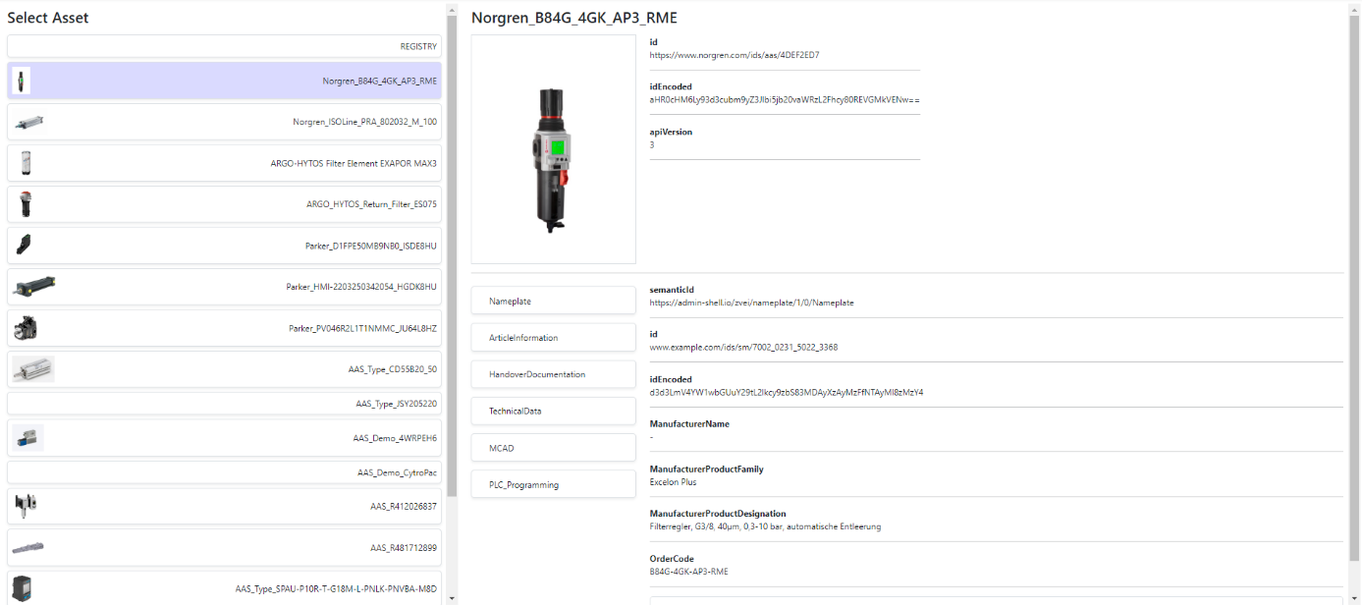

Additional details on our Usability Concept can be found on the Usability-Concept-page.

# 6 Implementation

The assets are stored in a JSON including the asset-data and submodels.

{

"idShort": "Norgren_B84G_4GK_AP3_RME",

"id": "https://www.norgren.com/ids/aas/4DEF2ED7",

"idEncoded": "aHR0cHM6Ly93d3cubm9yZ3Jlbi5jb20vaWRzL2Fhcy80REVGMkVENw==",

"apiVersion": 3,

"Nameplate": {"Data"},

"ArticleInformation": {"Data"},

"...More Submodles"

}

Every asset in the JSON is mapped to a button. These buttons are listed one below the other on the website. Every submodel of one asset is mapped to a button with the submodels name on it. Theses buttons are on the detail view of the associated asset.

# 7 Module Tests

The functionalities have been tested in the test suite TS-Asset with the test cases TC-Asset-Browse-001 and the the test suite TS-Server with the test case TC-Server-Load-003.

In TC-Server-Load-003 the functionality of displaying all assets has been tested. It passed the test and produced the expected results.

In TC-Asset-Browse-001 the functionality of selecting one of the displayed assets to see more information about it has been tested. It passed the test and produced the expected results.