|  |  |  |  |
| --- | --- | --- | --- |
| *Version* | *Date* | *Author* | *Comment* |
| 0.1 | 26.10.2022 | Samara Dominik | Created, added structure |
| 0.2 | 28.10.2022 | Samara Dominik | Project assignment |
| 0.3 | 01.11.2022 | Samara Dominik | Project context, Project organization, WBS, Risks, Gantt chart, Project Milestone Plan, List of Operations and responsible persons |
| 1.0 | 05.11.2022 | Samara Dominik | Final Version |

*Supplier*

Project Leader: Samara Dominik (inf21001@lehre.dhbw-stuttgart.de)

Product Manager: Martin Rittmann (inf21157@lehre.dhbw-stuttgart.de)

System Architect: Marcel Hintze (inf21056@lehre.dhbw-stuttgart.de)

Test-Manager: Anja Niedermeier (inf21097@lehre.dhbw-stuttgart.de)

Developer: Severin Helms (inf21047@lehre.dhbw-stuttgart.de)

Technical Documentation: Tom Engelmann (inf21010@lehre.dhbw-stuttgart.de)

Rotebühlplatz 41, 70178 Stuttgart

*Project*

AAS-Webclient

**Projekthandbuch**

TINF21C, Software Engineering I Praxisproject 2022/23

Business Case

*Customer*

Markus Rentschler, Christian Holder

Rotebühlplatz 41, 70178 Stuttgart

**CONTENTS**

Project assignment 3

Project context 4

Project organization 5

Work breakdown structure 6

Risks 7

Gantt chart 8

Part 1 8

Part 2 8

Outlook 8

Project milestone plan 9

First half of the project 9

List of operations and responsible persons 10

# Project assignment

|  |
| --- |
| **Project assignment** |
| Project goal (Output)  The goal is to design a user-friendly frontend page for a reactive asset administration shell. The frontend application is supposed to be based on React and has to be able to communicate with any ASS-Server over REST-API. The opportunity to search for and filter contents should be possible across several ASS-server. To reach this goal, a usability concept for significant use cases will be designed in advance. |
| Project use (Outcome)  A human orientated frontend helps the user to find and understand information and date faster than a technical orientated tool. This will save time and simplifies the training of new employees, which leads all together to a reduction in costs. |
| Project Clients  Markus Rentschler; Christian Holder |
| Team members   * Dominik, Samara * Engelmann, Tom * Helms, Severin * Hintze, Marcel * Niedermeier, Anja * Rittmann, Marcel |
| Main tasks   * Analysis * Design * Coding * Testing * Documentation |
| Start of project  Introductory lecture, 09.11.2022 |
| End of project  Final presentation and project delivery, May 2023 |

# Project context

|  |
| --- |
| **Initial situation** |
| In the context of the project, we have to create a human- orientated asset administration shell. There is no previous project, which means that the code for the frontend must be written completely new. However, we have three asset administrations shells, that can be used as reference, even though we need to be cautious since these are more technically orientated. We also have to add the connection of frontend and the various ASS-server, as well as the possibility to search for and filter content. For this purpose, there is no given logic, which means, that all needed methods still need to be developed. |

|  |  |  |
| --- | --- | --- |
| **Temporal context** | | |
| **Pre-project phase** | **Project phase** | **Post-project phase** |
| * No previous project. Introduction into asset administration shells during lectures | * Other projects, lectures, tasks, and exams during theory phase * Full-time working on company projects during praxis phase | * Increased usability of an asset administration shell * possibility to search for and filter content * still more functions to be implemented to increase the usability even more |

|  |  |  |  |
| --- | --- | --- | --- |
| **Social context** | | | |
| **Stakeholder** | **Chances** | **Risks** | **Actions** |
| Client | * Satisfied with the end product | * Not satisfied with the product after the deadline * Additional change requests during the project | * Clear communication with the client * Asking for clarifications when needed |
| Supplier | * Client is satisfied, could stay a customer * Reusable solution for a problem | * Misjudgements (time, financially,…) * Internal problems (miscommunications, diseases, bad team dynamic) | * Meetings, regular talks among team members * Structured project leading * Team members already worked together |
| User | * Better usability of an asset administration shell | * Usability worsened | * Usability concept * Testing |

# Project organization

|  |  |  |
| --- | --- | --- |
| Project Role | Description | Name |
| Client | Provides project | Markus Rentschler,  Christian Holder |
| Project leader | Leads project, keeps the overview over the project | Samara Dominik |
| Team members | Specialized on different tasks:   * System architect * Product Manager * Test Manager * Developer * Technical Documentation | Marcel Hintze  Martin Rittman  Anja Niedermeier  Severin Helms  Tom Engelmann |

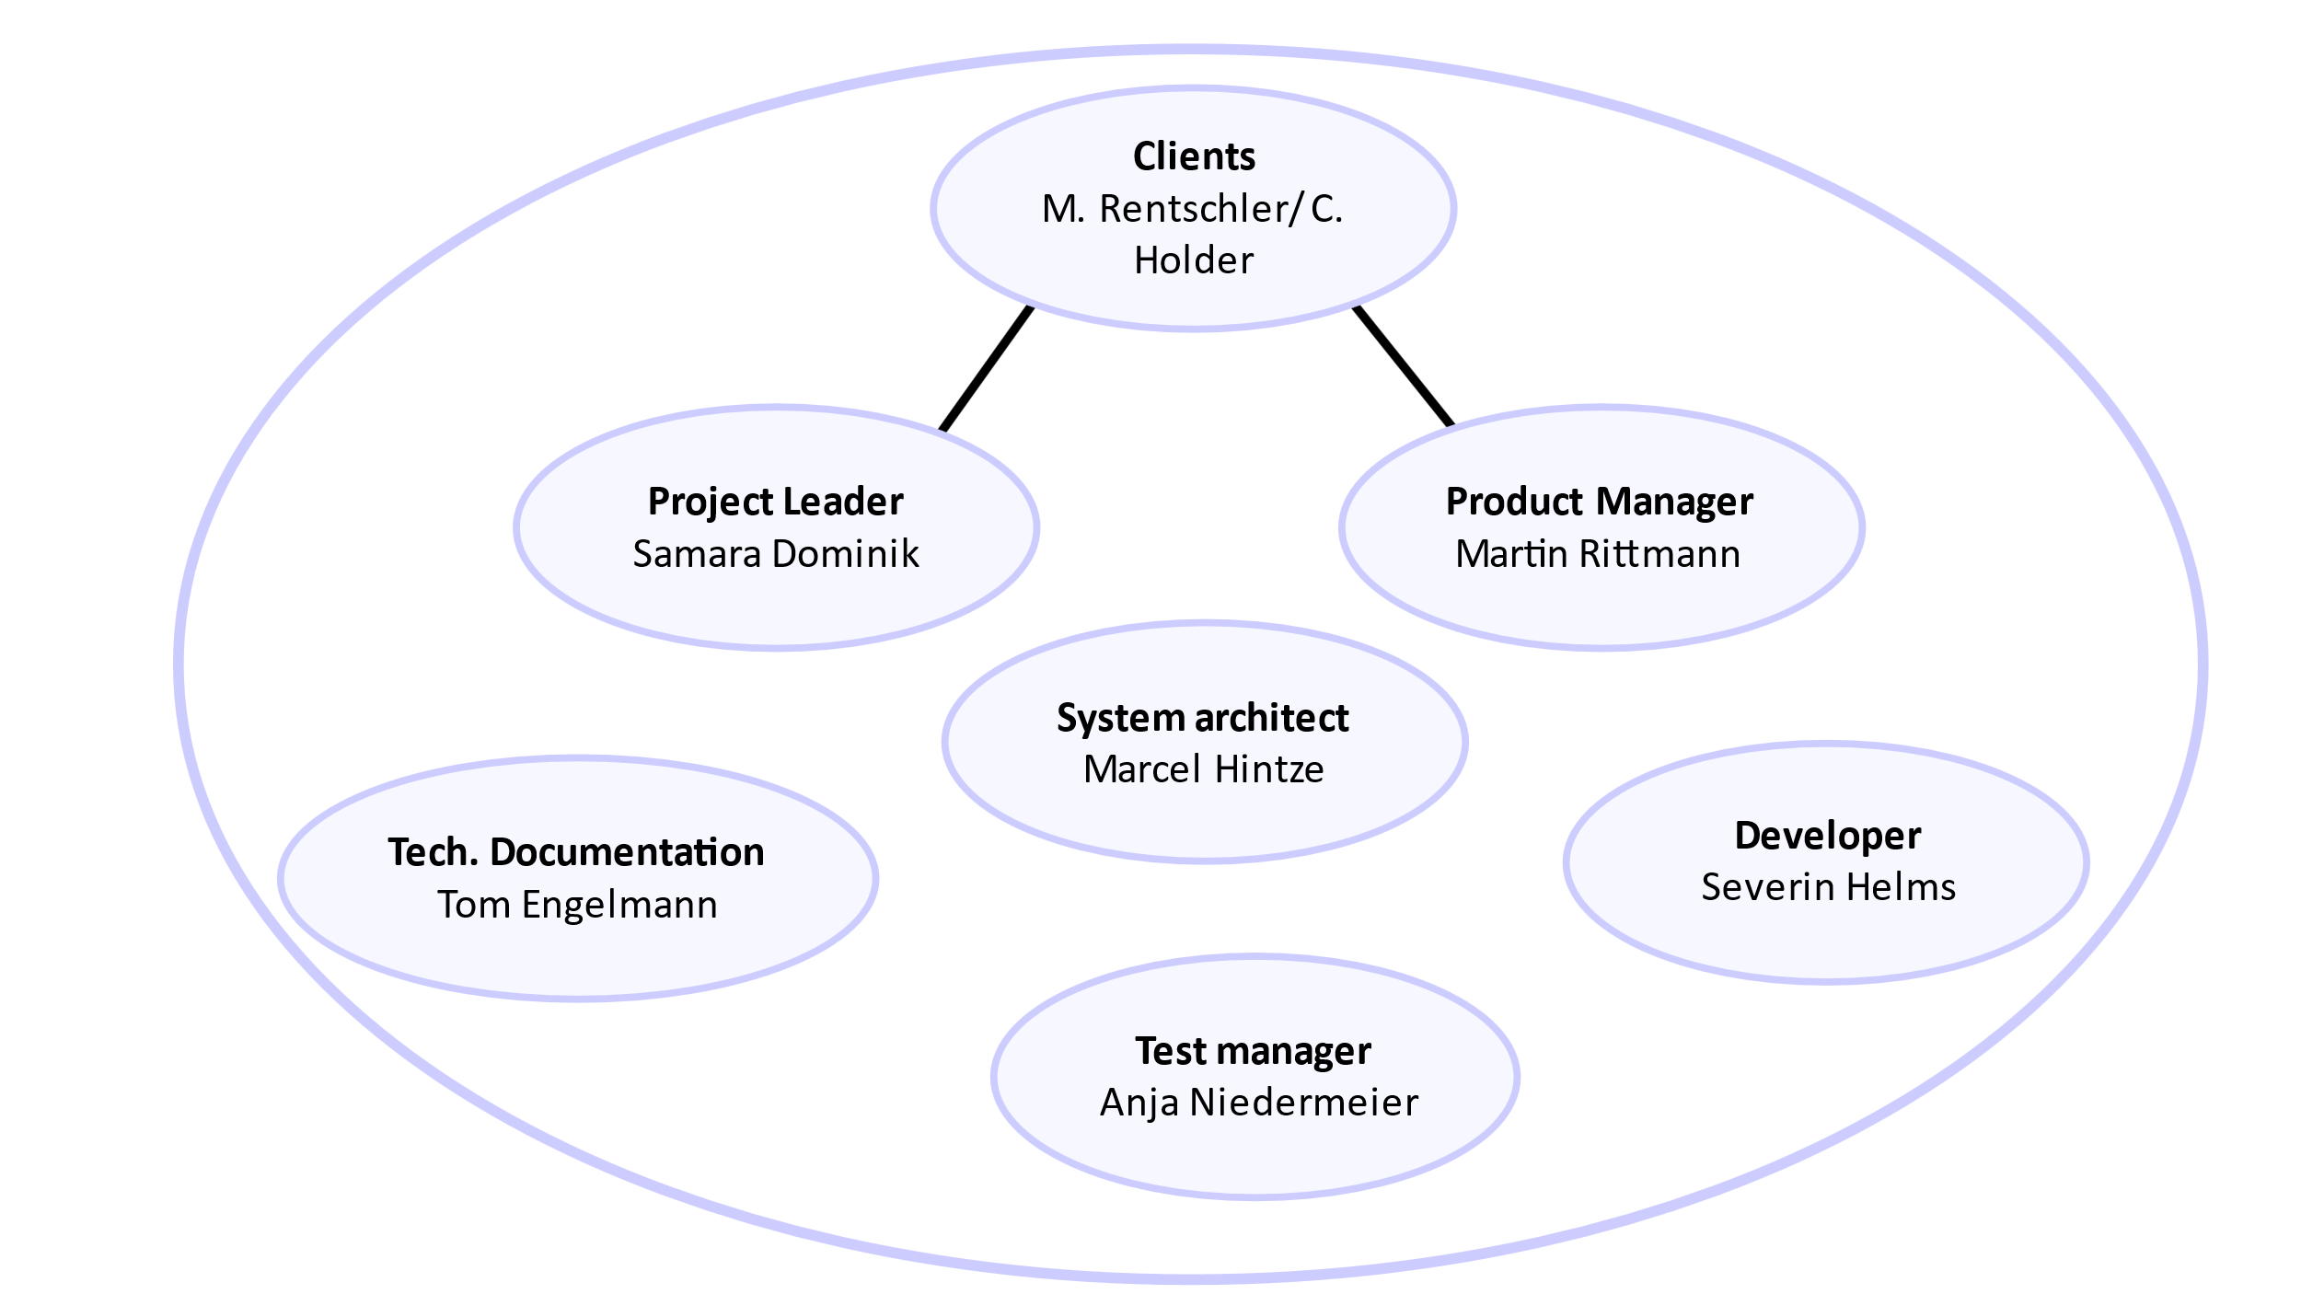

# Work breakdown structure

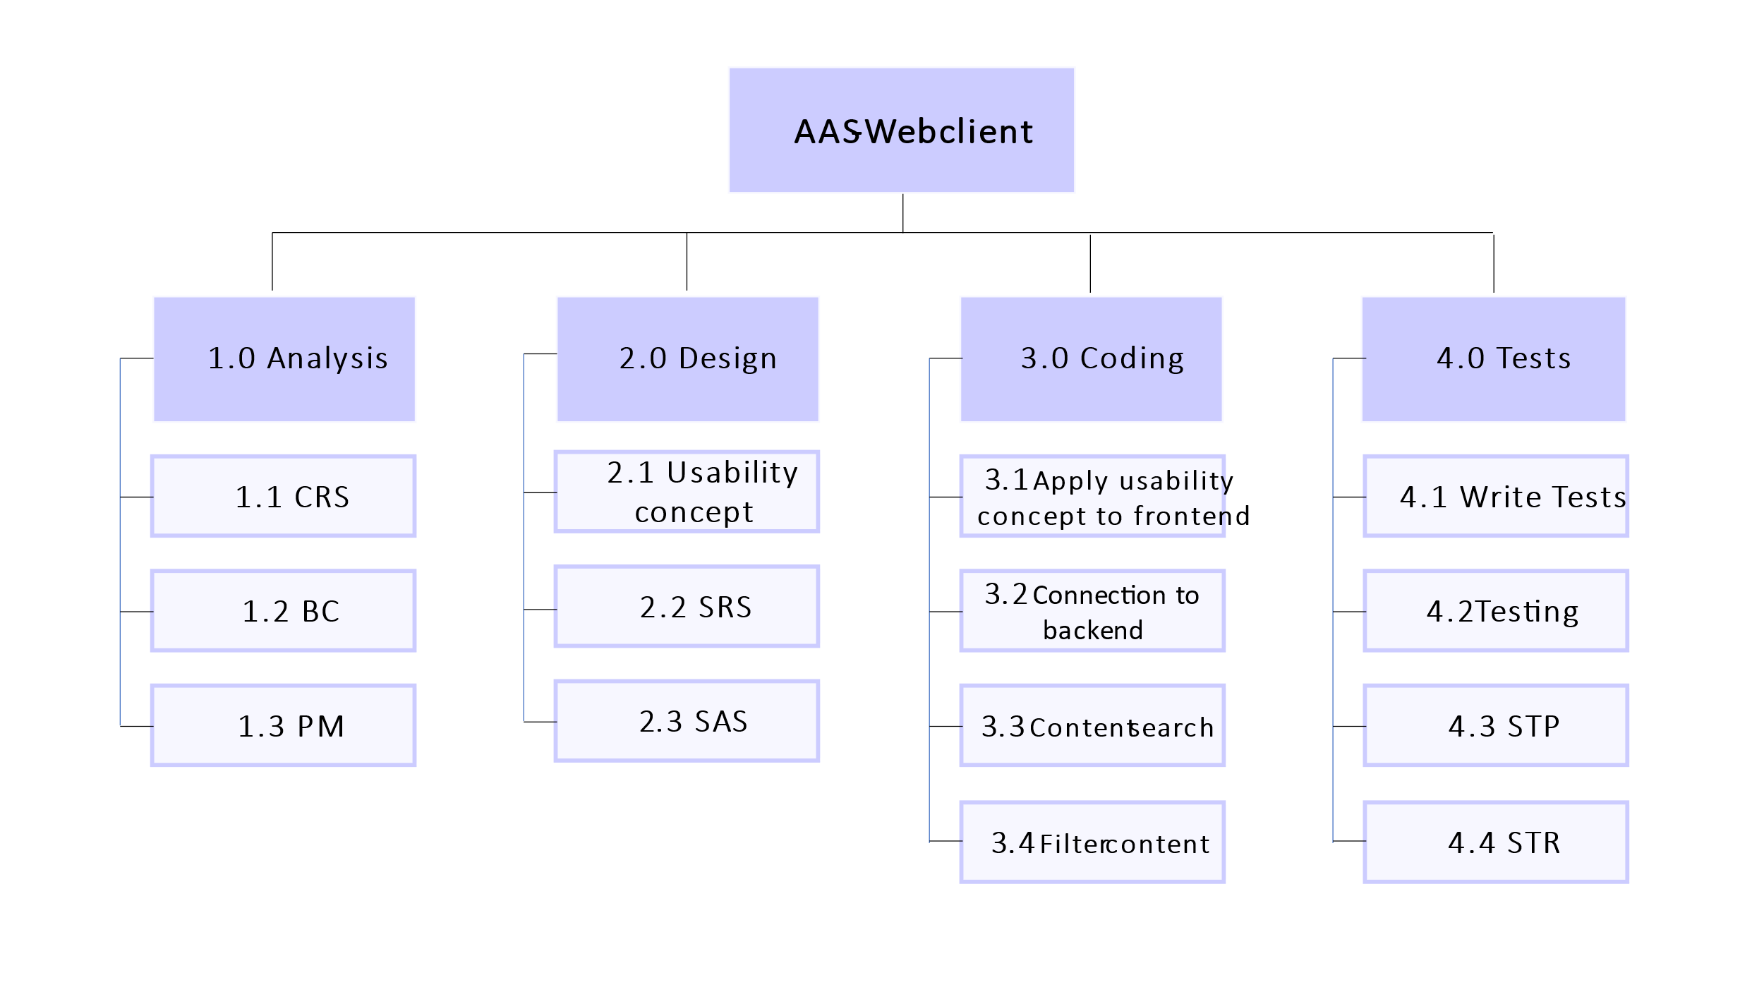

# Risks

|  |  |  |  |  |
| --- | --- | --- | --- | --- |
| **Risk** | **Description** | **Probability of occurrence** | **Severity** | **Action** |
| Personal risk | Member leaves the course | Extremely low | Medium | * All time scopes possess buffers, so that the loss of a team member can be compensated by others with a little more time |
| Personal risk | Member is ill | Medium | Low | * All tasks have several weeks time to be competed. * At least two people work on a task that is directly related to the end product (design, coding, testing) |
| Planning risk | Milestones are not achieved in time | Medium | Medium | * Including enough buffers in the time schedule and efficient task planning |
| Planning risk | Forgotten important documents | Low | High | * Double checking |
| Financial risk | Team members work more or in different areas than originally planned ->Expenses are too high for original offer | Low | High | * Letting the team members pick their parts -> everyone is doing what they can do and like best, no need to change roles |
| Financial risk | Miscalculation of the additional costs | Medium | Medium | * Research and use experience of previous projects |
| Communication risk | Miscommunication within the team members | Medium | Medium-High | * Regular meetings, direct clarification in case of problems/ questions |
| Communication risk | Miscommunication with clients | Low | High | * Direct clarification in case of problems/ questions * Rather ask than guess the requirement |
| Knowledge risk | Many team members first need to get familiar with the technologies they work with | High | Medium | * Every member is assigned to the task they are most likely to perform well at * Unexperienced members work together with more experienced ones |

# Gantt chart

## Part 1

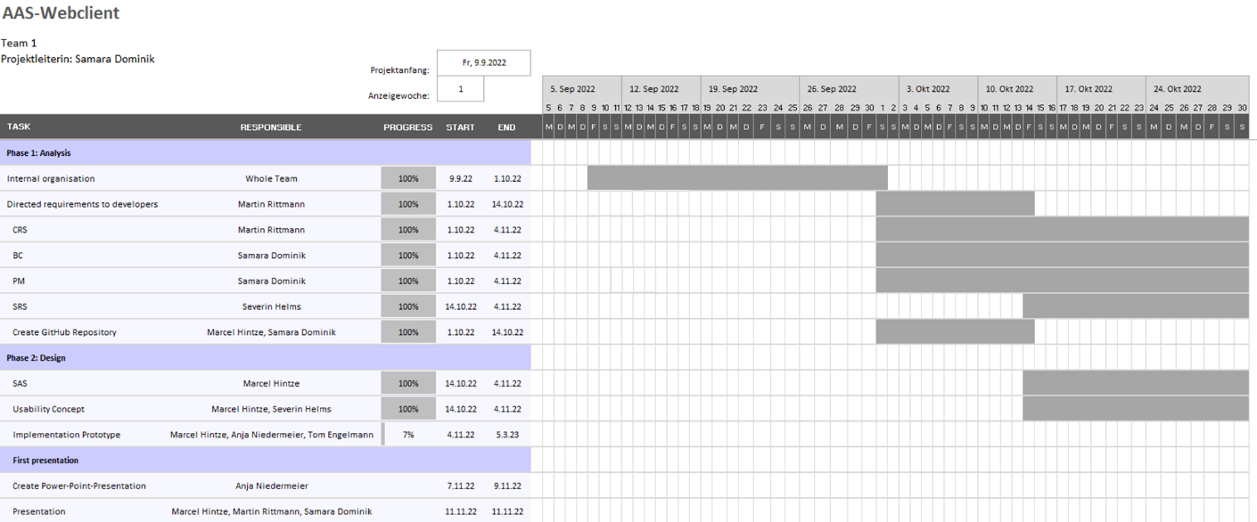

## Part 2

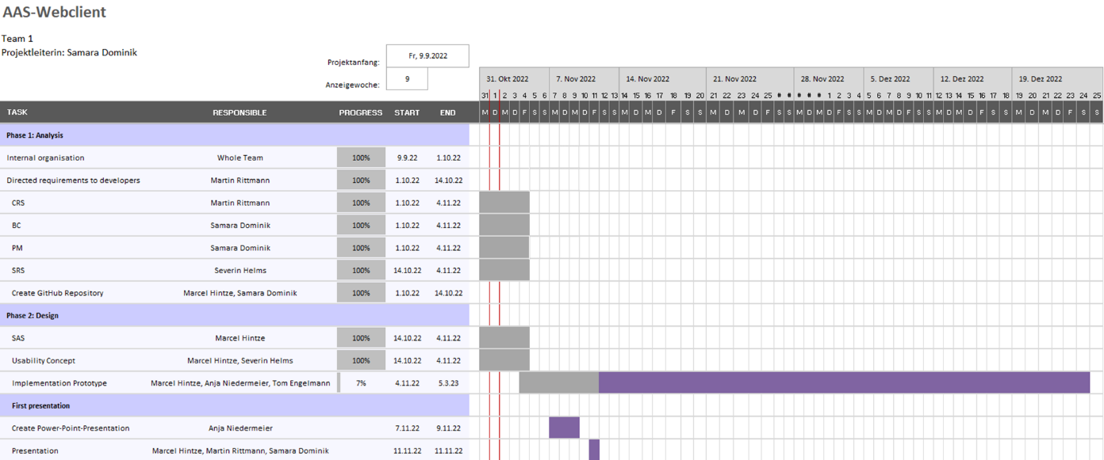

## Outlook

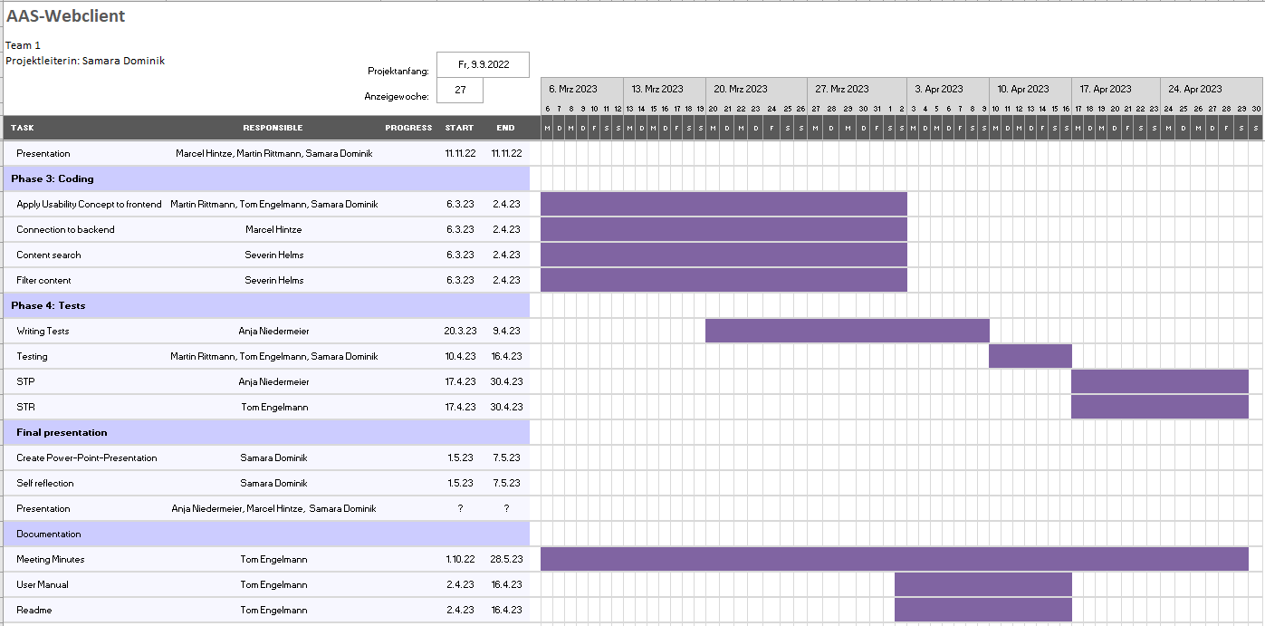

# Project milestone plan

## First half of the project

|  |  |  |
| --- | --- | --- |
| **Date** | **Milestone** | **Responsible** |
| Week 1: 26.09- 02.10 | Analysis   * Official project start for the team * First Meeting, distribution of tasks done | All |
| Week 2:  03.10- 09.10 | Analysis   * Build up internal project structure, create rough time scope | Samara Dominik |
| Week 3:  10.10- 16.10 | Analysis   * Collect all requirements, clarify open questions, and hand them over to the system architect and the project leader * Start analysing the requirements, thinking of first ideas for the website * Set up GitHub repository | Martin Rittmann  Marcel Hintze, Severin Helms  Marcel Hintze,  Samara Dominik |
| Week 4:  17.10- 23.10 | Analysis/ Design   * Create CRS in the first version * Create BC and PM in the first versions | Martin Rittmann  Samara Dominik |
| Week 5:  24.10- 30.11 | Design   * Complete Design phase * Create usability concept * Create SRS and SAS in the first versions | Martin Hintze,  Severin Helms |
| Week 6:  31.10- 06.11 | Buffer |  |
| Week 7:  07.11-13.11 | First Presentation   * Create Power-Point * Prepare for presentation * CRS, BC, PM, SRS, SAS, and documentation in final version and pushed in the GitHub repository | All |
| Week 8:  14.11- 20.11 | Design   * Started implementing first prototypes | Marcel Hintze,  Anja Niedermeier, Tom Engelmann |

# List of operations and responsible persons

|  |  |  |
| --- | --- | --- |
| **Person** | **Work package** | **Task** |
| Samara Dominik  Role: Project leader  E-Mail:  MatrikelNr.: 1047506 | * Analysis * Coding * Testing | * Project organisation * Maintaining GitHub Repository * BC * PM * Presentation * PowerPoint (final presentation) * Help in coding+ testing, if needed |
| Martin Rittmann  Role: Product manager  E-Mail:  MatrikelNr.: 8461817 | * Analysis * Coding * Testing | * CRS * Presentation * Apply usability concept to frontend webpage * Testing |
| Marcel Hintze  Role: System architect  E-Mail:  MatrikelNr.: 3932152 | * Analysis * Design * Coding | * SAS * Presentation * Created GitHub Repository * Usability concept * Implementation of prototype * Code connection to backend |
| Anja Niedermeier  Role: Test manager  E-Mail:  MatrikelNr.: 5697407 | * Analysis * Design * Testing | * STP * PowerPoint (first presentation) * Presentation * Implementation of prototype * Write tests |
| Severin Helms  Role: Developer  E-Mail:  MatrikelNr.: 3391129 | * Analysis * Design * Coding | * SRS * Usability concept * Code to be able to search for content * Code to be able to filter content |
| Tom Engelmann  Role: Technical Documentation  E-Mail:  MatrikelNr.: 1594643 | * Coding * Testing * Documentation | * STR * Apply usability concept to frontend webpage * Testing * Meeting Minutes * User Manual * Readme |