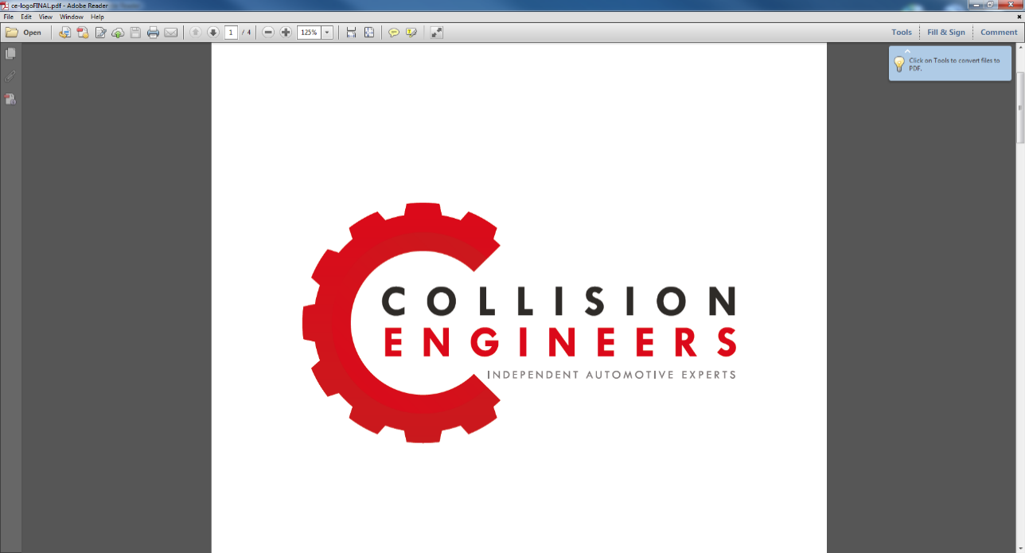

Appendix A – Anticipated Defendant Insurer Arguments and Expert Response

The following points are addressed proactively within this report in anticipation of common counter-arguments advanced by defendant insurers:

- "There is no recognised head of loss for inherent diminution"
This report does not advance diminution as a separate or automatic head of loss. The opinion expressed is that diminution in value is a matter of market fact, forming part of the overall diminution in value arising from the collision, assessed by reference to observed buyer and trade behaviour.
- "The vehicle has been restored to its pre-accident condition"
The report distinguishes clearly between physical condition and market condition. While physical repairs may be satisfactory, market valuation reflects accident history, disclosure obligations, and transactional reality.
- "Any alleged loss is speculative without a sale"
Market value exists independently of sale. The valuation reflects what a reasonable and informed purchaser would pay at the relevant time, not whether a transaction has occurred.
- "Any reduction reflects normal depreciation"
All age-related depreciation, mileage changes, and general market movements have been expressly excluded. The assessed diminution relates solely to accident history.
- "This amounts to double recovery"
Repair costs address physical damage. Diminution reflects market perception. These address different aspects of loss and are not duplicative.

Appendix B – Standard Inherent Diminution Assessment Framework

When assessing whether a repaired vehicle has sustained a continuing diminution in market value, the following structured considerations are applied:

- Vehicle type, age and mileage at the time of loss
- Pre-accident market position and buyer expectations
- Scale of repair cost relative to pre-accident value
- Extent, nature and visibility of repaired damage
- Disclosure requirements and provenance history
- Typical private, trade and retail buyer behaviour for comparable vehicles

Appendix C – Cross-Examination Notes

The opinions expressed in this report are capable of being tested under cross-examination on the following bases:

- The expert does not assert a legal entitlement to diminution; the opinion is confined to valuation evidence.
- The absence of a completed sale does not prevent an assessment of market value.
- The quantum is derived from professional judgment informed by market behaviour, not arbitrary percentages.
- The expert accepts that some repaired vehicles may suffer no diminution; this opinion relates to this specific vehicle, damage profile, and market segment.

