

FAO The court
C/o Client name

INDEPENDENT EXPERT REPORT – DIMINUTION IN VALUE

Road traffic Accident: 15/09/2025
Vehicle: Suzuki Swift – Registration LV25 KLZ
VIN: JSAZCEDS500154737
Mileage at Loss: 3,791 miles
Diminution in value: £1,300.00

1. Instructions and Scope

I have been instructed to provide an independent expert opinion as to whether the subject vehicle has sustained a diminution in market value as a consequence of the road traffic accident of 15/09/2025, and if so, to assess the appropriate quantum.

This report addresses diminution in value as a matter of market valuation, not as a legal submission. Any reference to case law is limited to contextual background and does not stray into legal conclusions, which remain a matter for the Court. This report should be read in conjunction with our original vehicle damage assessment report, which confirms the pre-accident value and the repairs in detail.

2. Vehicle and Accident Overview

The vehicle is a relatively new Suzuki Swift (Just X months old) with low mileage of (X miles) at the time of loss. It sustained damage in a nearside collision and was subsequently assessed and repaired within ABC repair network. The repair cost amounted to £10,565.10 inclusive of VAT.

3. Chattel damage and repairs

The exact damage sustained and extent of repairs are detailed within the attached Engineers vehicle damage assessment report.

The repairs were carried out competently, authorised in accordance with accepted repair standards/methods, and have been signed off via the owner/client satisfaction notice. I do not criticise the quality of workmanship. However, even where repairs are carried out to a good physical standard, it does not follow that a vehicle is restored to an identical market position as an accident-free equivalent.

Furthermore, the repairer will be unable to simulate some features such as paint finishes or the joining & sealing of seams to the exact factory specification or processes of the manufacturer’s robotic machines.

4. Market Condition Versus Physical Condition

It is important to distinguish between:

- Physical condition: whether the vehicle is roadworthy and visually acceptable following repair; and
- Market condition: how the vehicle is perceived, priced, and negotiated within the used vehicle market.

While repairs may restore physical usability, the market consistently differentiates between vehicles with and without recorded accident damage. This differentiation is observable in trade buying behaviour, retail pricing strategy, and negotiation outcomes.

The requirement for disclosure of previous accident damage when asked, the presence of repair documentation, and the likelihood of accident history checks all contribute to a measurable effect on market value.

5. Diminution in Value – Market Assessment

The Diminution considered in this report forms part of the overall Diminution in value caused by the collision, persisting after physical repair due to market perception and transactional behaviour. It is not presented as a separate or automatic head of loss. The diminution assessed does not duplicate the cost of repairs, which address physical damage only; it reflects the continuing effect of accident history on market valuation.

In assessing whether this vehicle has suffered a continuing diminution, I have considered:

- The vehicle’s age and mileage at the time of loss
- The relationship between repair cost and pre-accident value, noting that the repair cost represents a substantial proportion of the vehicle’s market value and would be perceived by the market as significant rather than minor
- The extent and visibility of the repairs
- The expectations of purchasers in this sector of the market
- Typical private, dealer and trade buyer responses to accident history

In my professional experience as both a Motor Engineer and used vehicle dealer, vehicles of this age and mileage are particularly sensitive to accident history. In the present case, the subject vehicle is a low-mileage, relatively new example in a market segment where purchasers typically expect an accident-free history. Vehicles of this type are commonly retailed with express or implied representations of having no prior accident damage, and any departure from that expectation materially affects buyer confidence and pricing.

Prospective purchasers are therefore less willing to pay parity with accident-free equivalents and typically expect a price adjustment to reflect perceived risk, reduced desirability, and the existence of a recorded repair history. This market behaviour is not speculative; it is a routine and well-established feature of used vehicle transactions, reflected in reduced trade bids, increased negotiation leverage for buyers, and more cautious retail pricing for repaired vehicles.

6. Exclusion of Depreciation and Other Factors

In arriving at my opinion, I have expressly excluded:

- Normal age-related depreciation
- Mileage accumulation after the date of loss
- General market fluctuations unrelated to the collision

The diminution assessed relates solely to the impact of the accident and subsequent repair history on market value.

7. Valuation and Quantum

Pre Accident Market Value: £18,713

Having regard to the factors outlined above, and applying my professional judgment to observed market behaviour for comparable vehicles, it is my opinion that a reasonable and informed purchaser would attribute a lower value to this vehicle than to an accident-free equivalent.

I therefore assess the post repair market value of the vehicle at £17,413, reflecting a diminution in value of £1,300 attributable to the accident history. For context, this would equate to around 7% of the pre-accident value.

This figure represents my reasoned opinion based on market trends and experience, rather than the application of any fixed formula or arbitrary percentage. In my experience, vehicles of this type do not attract the level of discount associated with structural write-offs (generally discounted by at least 20%) or severe provenance issues, but neither are they treated by the market as equivalent to accident-free examples. The assessed diminution therefore reflects a modest but material adjustment consistent with typical trade and retail pricing behaviour for comparable repaired vehicles.

8. Timing and Recoverability (Valuation Perspective)

From a valuation standpoint, market value is assessed at the point in time when the vehicle acquires an accident history, namely the time of accident. At that point, the vehicle’s position in the market changes, irrespective of when or whether a subsequent sale occurs.

A sale is not required in order to assess market value; value exists independently of realisation. The diminution assessed reflects the market impact arising at the time the vehicle became an accident-damaged vehicle.

Whether and when such loss is recoverable is a matter for the Court.

Statement of Truth

I declare that I understand my duty in providing this report to the court and I confirm that I have complied with that duty. I understand that this duty overrides any other obligation. The report is based upon instructions received.

I confirm that I have made clear facts and matters referred to in this report are within my own knowledge and which are not. Those are within my own knowledge I confirm to be true. The opinions I have expressed represent my true and complete professional opinion on the matters to which they refer.

I confirm that I am a qualified and experienced motor engineer / vehicle examiner. In addition, I have substantial experience as a used motor dealer, purchasing and selling both previously damaged and non-previously damaged vehicles. I have relied heavily on my experience to assist me with my report.

We appreciate your instructions and enclose our fee note for your kind attention, which we confirm remains payable irrespective of the outcome of this case. Please ensure this is passed to your accounts department.

Yours faithfully


A Patterson M.Inst.AEA, M.FIEA
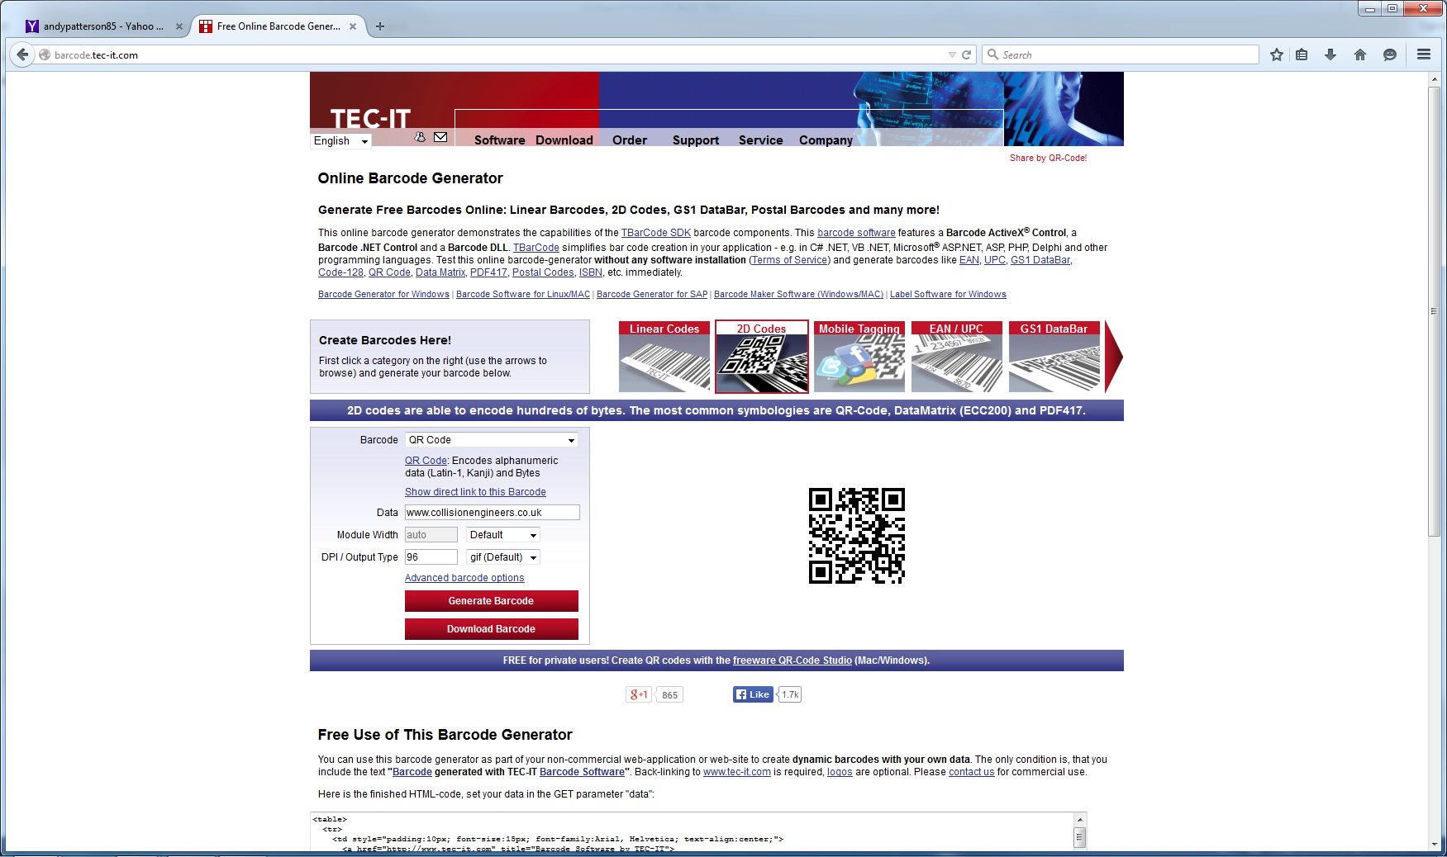
Engineers@CollisionEngineers.co.uk


Fee Note

Consideration of fact, law and evidence.
Calculation of diminution in value
Produce expert report.
Cloud based Storage of all material case files and images.

Agreed fee: £300.00
Sub Total: £300.00
VAT: £60.00
Total Due: £360.00

Payment
Please make cheques payable to Collision Engineers and quote reference 123 Diminution
This is not a tax invoice – a receipted invoice will follow upon payment. We will not accept any reduction to our fee through the detailed assessment process.
Any requests for addendum reports or letters including those required for clarification, plus Counsel, Court or other meetings will be subject to a further charge & subject to Civil Procedure Rule 35.6.
Terms: As per our agreement, following which we reserve the right to claim statutory interest at 8% above the Bank of England reference rate in force on the date the debt becomes overdue and at any subsequent rate where the reference rate changes and the debt remains unpaid in accordance with the Late Payment of Commercial Debts (Interest) Act 1998 as amended and supplemented by the Late Payment of Commercial Debts Regulations 2002. In addition, for unpaid debts up to £999.99 we are allowed to claim compensation of £40.00.

