GUIDELINES FOR PREPARATION OF PAPERS

**by**

*Anne Cann1, A.N. Author*2 *and A. Nother*3

Congratulations for having your paper selected for presentation at the PIANC World Congress Panama 2018 and for inclusion in the Proceedings.  As you are aware, an extended two-page abstract of your paper will be published in the Book of Abstracts. This document should be used as a guideline for developing your paper.

**A full paper is not mandatory (even if expected) and can be replaced by an extended abstract (2 pages) and your PPT presentation, which will be compiled in a specific proceeding.**

The Conference Proceedings will be published in one compact disk or memory stick.  Every paper will be published in PDF format and the papers may be submitted in PDF format or as an MSWord file (Word 2000 or earlier versions).  We prefer you to submit the papers in PDF format and we expect the Authors to take full responsibility for the quality of the paper. In the case of a paper being submitted in Word format, we will return the PDF format file to the Author for his/her approval before publication.

The full paper will only be published on Compact Disk or memory stick.  It will not be necessary, therefore, to include a long Abstract as a preamble to the paper.  The Abstract presented here should be brief (maximum half a page, preferably less) and contain the relevant facts and an overview of the paper.

**ABSTRACT**

The abstract must not exceed 1000 words.

1. **INTRODUCTION**

The introduction presents a statement of your work.

1. **PREPARATION OF THE TEXT**

**2.1 General**

These instructions are prepared to help you to prepare the paper. The instructions contain details for preparation of tables, figures, equations and references.

**2.2 Title**

A short title of not more than 75 letters should be provided at the head of the document.  The title should be centered and in capital letters, in ARIAL font size 14.

The authors’ full names must be given below the title.  Authors’ titles, designations, institutional affiliations and the email address of the corresponding author are if possible to be displayed as footnotes at the bottom of the title page.

_______________________

1 U.S. Army Corps of Engineers, Institute for Water Resources,R.Anne.Cann@usace.army.mil

2 Designation, main affiliation, country

3 Designation, main affiliation, country

**2.3 Length**

The total length of the paper, including figures, tables, equations and references, should not exceed 20 pages.  The size of the file (in PDF format) shall not exceed 5 MB under any circumstances.

**2.4 Format and Fonts**

The paper should be prepared on A4 paper size, portrait layout, with margin settings on MSWord as shown in Table 1.

|  |  |  |  |  |
| --- | --- | --- | --- | --- |
| **Paper format:** | A4 portrait | 297 x 210 mm | Single page | One-column |
| **Page margins** | **top** | **Bottom** | **right** | **Left** |
|  | 2.5 cm | 2 cm | 2.5 cm | 2.5 cm |

**Table 1: Paper format**

Fonts should be:

* Section headings are to be bold, capital letters, ARIAL 12,
* Sub-section headings to be bold, normal text, ARIAL 10
* Main text of the paper is to be in ARIAL 10

Use full justification. Numbering of sections is optional.

Line spacing is to be as follows for normal text and paragraphs:

Single line spacing with 6pt spacing before and 0pt spacing after (each paragraph) are to be set in MSWord menu *format/paragraph/indents and spacing/.*  Double line feed must be used before the end of one section and the title of the next section or sub-section.  The 6 pt. spacing can be removed within tables and lists, if necessary.

**2.5 Figures and Photographs**

All figures should be embedded in the MSWord file so that you send only one file for inclusion in the Proceedings; an example is given as Fig. 1. Figures should be always referred to in the paper.

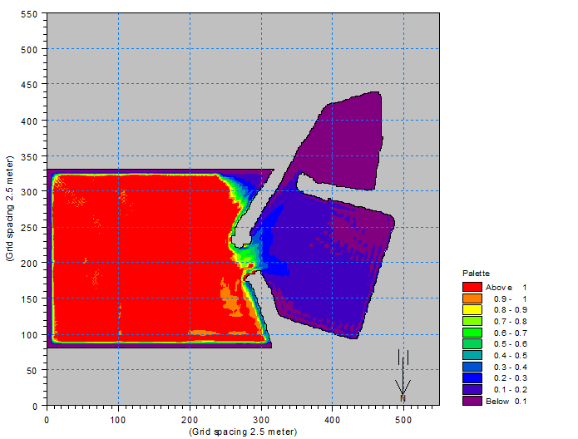

**Figure 1: Northeast Monsoon Waves**

Color images are permitted and care should be taken in using an appropriate resolution to stay within the 5MB size limit for the PDF version of your paper.  Photographs need to be very sharp.

Text in the figures should be legible when viewed on a computer screen at 100% zoom view.  Figure captions should be set text size and centered below the figure and in bold type. All figures to be numbered sequentially, i.e. **Figure 1: Northeast Monsoon Waves**.  Leave one line space between caption and text.

**2.6 Tables and Equations**

Tables must be pasted or printed in place, with the caption (e.g. **Table 1: Paper format for Abstracts)** centered at the bottom of the table in bold type. All tables are to be numbered sequentially.

*A2 + B2 = C2                                                                           (1)*

Equations are to be in italics and centered with the equation number flush right.  Throughout the paper only the equation number *(1)* is used in the text, enclosed in parenthesis, (without the prefix Eq.), except at the beginning of a sentence where the word Equation will be used.

**2.7 Page Numbering and Header**

The pages of the paper should be numbered consecutively, with the numbers placed at the center bottom of each page. The header of the paper should include centered in bold type: **PIANC-World Congress Panama City, Panama 2018** (Arial Font Size 9).

**2.8 Keywords**

A list of 5 keywords must be supplied on a separate page in the cover letter. At least one keyword shall be taken from the Conference Themes.

1. **PAPER SUBMISSION**

The paper shall be submitted online at: <https://www.conference-service.com/pianc-panama> or <http://www.pianc2018.com/>

We prefer you to submit the papers in PDF format and we expect the Authors to take full responsibility for the quality of their paper. Papers may be submitted in PDF format or as an MSWord file. When creating the PDF it is essential that all fonts are embedded. In the case of a paper being submitted in Word Format, we will return the PDF format file to the Author for his/her approval before publication.

**Papers exceeding 5 MB in size will be returned.** Every paper received will be acknowledged. You may assume that any unacknowledged paper has gone astray.

**PAPERS TO BE SUBMITTED BY MARCH 16, 2018**

Please note that if the submitted paper does not conform to the above guidelines, the author will be requested to correct and re-submit the paper (if time permits).

The organizers reserve the right to reject papers, which do not present information as cited in the abstract reviewed by the Paper Selection Committee.

1. **REFERENCES**

References in alphabetical order are to be listed in a final section. Only the literature quoted in paper shall be listed. Only the author´s name(s) and date of publication shall be included in the text of the paper, e.g. BURT, N.J. & REES, A. (2011). Author(s), year of publication, title of book, page range, publisher, place of publication and ISBN number may be included in the list of references.

1. **COPYRIGHT**

Papers accepted become the copyright of PIANC. The proceedings should be referenced and have ISBN code (to be provided by PIANC HQ).

**References**

Burchfield, R.W.(2004). Fowler´s Modern English Usage (Revised 3rd ed.). Oxford University Press. ISBN 978-0-19-861021-2.

Burt, N.J. & Rees, A. (2001). Guidelines for the Assessment & Planning of Estuarine Barrages Thomas Telford 2001.

PIANC (1986) Final Report of the International Commission for the Study of Locks, PIANC, Brussels.

PIANC (2009), Report No.106, Innovations in Navigation Lock Design, PIANC, Brussels.