MerchantOS-Highrise-Sync
Functional Specification & Design Documentation
Author: Erika Ellison
Last Updated: 2012-06-04

Functional Specification

Overview:
MerchantOS-Highrise-Sync syncs contact data stored in MerchantOS, a point-of-sale web application, and Highrise, a customer relations management web application.
The user signs up for the service by entering their Highrise username and API key into a form on a web page accessible through MerchantOS's account management. The form sends the new subscriber's information to be stored on a server.
An initial sync is performed on sign-up, moving any Customer contact information from MerchantOS into Highrise, and any People contact information from Highrise into MerchantOS.
At regular intervals (likely every night), an incremental sync is performed for all subscribers, which looks for any new or modified contacts in either system to update in the other.

Scenarios/Use Cases:
A user would like to start using Highrise with the contact data in their existing MerchantOS account.
A new user signs up for a MerchantOS account and wants to import their contacts from their existing Highrise account.

Non-Goals:
- checking for duplicate contacts (contact data that is already entered in both applications).
- merging changes made to the same contact in both applications in the same period between syncs.
For the above reasons, it is strongly encouraged that users of this service add and modify contact data in only one of the two applications.

Desirable Additional Features:
- automatic notification when a sync attempt fails due to invalid API credentials.
Design Documentation

Requirements:
A web server running PHP 5.3 or newer (with curl module installed and xsl enabled), and MySQL 5.1 or newer.

Assumptions:
The sync will be run when the user is not making changes to any of the contact data.
The user will only make changes to a particular contact in one application or the other between syncs.

Data Mapping:
See Figure 1.
Highrise requires a location for each address. Valid values are [work, home, other]. MerchantOS has no analogous field and only allows one address per Customer. The MerchantOS-Highrise-Sync app maps the Highrise address with the location “work” to the single MerchantOS address.
Highrise requires a location [work, home, other] for email addresses. MerchantOS uses a useType [primary, secondary] for email addresses. The MerchantOS-Highrise-Sync app maps primary to work, secondary to home, and does not map Highrise's other to MerchantOS.
MerchantOS can only accept two email addresses per Customer. Highrise can have an unlimited number of email address per Person. If there are more than two email addresses for a contact in Highrise, the MerchantOS-Highrise-Sync app transfers only the email addresses with locations “work” and “home”.
MerchantOS customers that have been flagged noEmail/noPhone/noMail will still have their contact information transferred to Highrise by the MerchantOS-Highrise-Sync app, but these MerchantOS fields will have no analogous values in Highrise.

Architecture
See Figure 2 for a class diagram and Figure 3 for an activity diagram of account_management.php.
insert here, plain english description of how program works

Possible Problems:
Scaling: An initial sync of 8 contacts total takes approximately 2 seconds.

Figure 1, Data Mapping

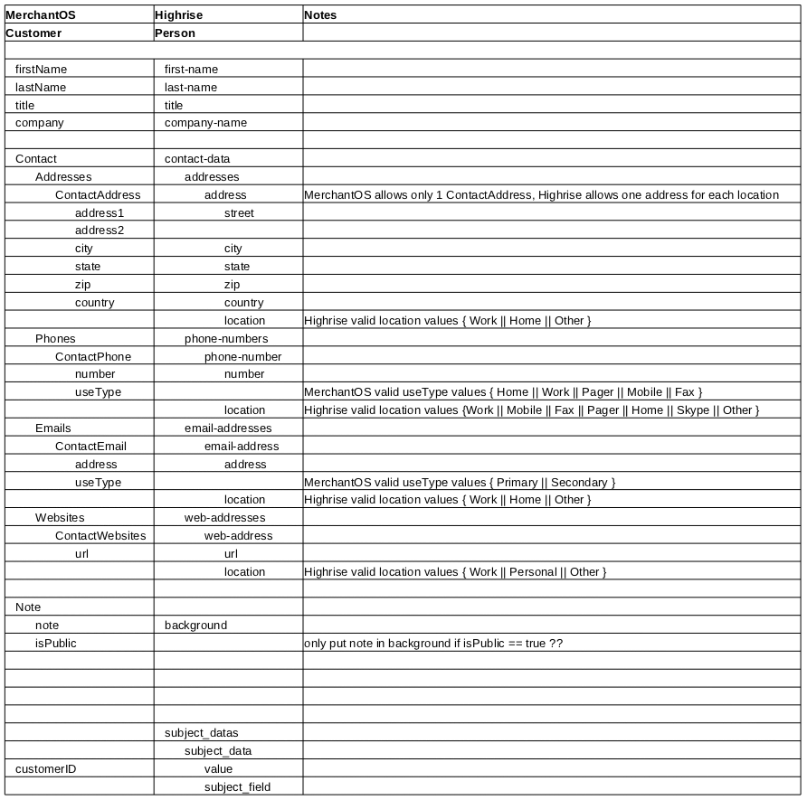

Figure 2
Class Diagram

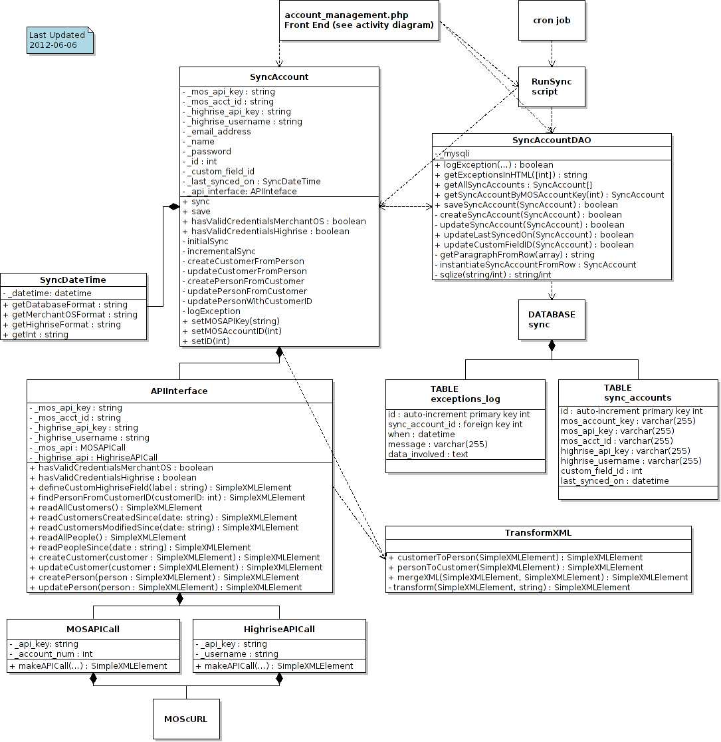
Figure 3
Acitivty Diagram of account_management.php

