Winstar Display Co., LTD

CUSTOMER
MODEL | WH1602B-YGK-CP
APPROVAL | BY: | DATA:

SALES BY | APPROVED BY | CHECKED BY | PREPARED BY

華凌光電股份有限公司
住址：台中市中清路163號
NO.163 CHUNG CHING RD.
TAICHUNG, TAIWAN, R.O.C
TEL：886-4-4262208 FAX：886-4-4262207

Contents
1.Module Classification Information
2.Precautions in use of LCD Modules
3.General Specification
4.Absolute Maximum Ratings
5.Electrical Characteristics
6.Optical Characteristics
7.Interface Pin Function
8.Contour Drawing & Block Diagram
9.Function Description
10.Character Generator ROM Pattern
11.Instruction Table
12.Timing Characteristics
13.Initializing of LCM
14.Quality Assurance
15.Reliability
16.Backlight Information

1.Module Classification Information
W H 1 6 0 2 B－Y G K－ CP
① ② ③ ④ ⑤ ⑥ ⑦ ⑧
① | Brand：WINSTAR DISPLAY CORPORATION
② | Display Type：H→Character Type, G→Graphic Type
③ | Display Font：Character 16 words, 2Lines.
④ | Model serials no.
⑤ | Backlight Type： | N→Without backlight  B→EL, Blue green  D→EL, Green  W→EL, White  F→CCFL, White  Y→LED, Yellow Green | A→LED, Amber  R→LED, Red  O→LED, Orange  G→LED, Green
⑥ | LCD Mode： | B→TN Positive, Gray T→FSTN Negative  N→TN Negative,  G→STN Positive, Gray  Y→STN Positive, Yellow Green  M→STN Negative, Blue  F→FSTN Positive
⑦ | LCD Polarize Type/ Temperature range/ View direction | A→Reflective, N.T, 6:00  D→Reflective, N.T, 12:00  G→Reflective, W. T, 6:00  J→Reflective, W. T, 12:00  B→Transflective, N.T,6:00  E→Transflective, N.T.12:00 | H→Transflective, W.T,6:00  K→Transflective, W.T,12:00  C→Transmissive, N.T,6:00  F→Transmissive, N.T,12:00  I→Transmissive, W. T, 6:00  L→Transmissive, W.T,12:00
⑧ | Special Code | CP : English and Cyrillic standard font

2.Precautions in use of LCD Modules
(1)Avoid applying excessive shocks to the module or making any alterations or modifications to it.
(2)Don’t make extra holes on the printed circuit board, modify its shape or change the components of LCD module.
(3)Don’t disassemble the LCM.
(4)Don’t operate it above the absolute maximum rating.
(5)Don’t drop, bend or twist LCM.
(6)Soldering: only to the I/O terminals.
(7)Storage: please storage in anti-static electricity container and clean environment.

3.General Specification
Item | Dimension | Unit
Number of Characters | 16 characters x 2 Lines | －
Module dimension | 80.0 x 36.0 x 13.2(MAX) | mm
View area | 66.0 x 16.0 | mm
Active area | 56.21 x 11.5 | mm
Dot size | 0.56 x 0.66 | mm
Dot pitch | 0.60 x 0.70 | mm
Character size | 2.96 x 5.56 | mm
Character pitch | 3.55 x 5.94 | mm
LCD type | STN, Positive, Transflective, Grey
Duty | 1/16
View direction | 12 o’clock
Backlight Type | LED Yellow Green

4.Absolute Maximum Ratings
Item | Symbol | Min | Typ | Max | Unit
Operating Temperature | T_{OP} | 0 | － | +50 | ℃
Storage Temperature | T_{ST} | -20 | － | +60 | ℃
Input Voltage | V_{I} | V_{SS} | － | V_{DD} | V
Supply Voltage For Logic | VDD-V_{SS} | -0.3 | － | 7 | V
Supply Voltage For LCD | V_{DD}-V₀ | -0.3 | － | 13 | V

5.Electrical Characteristics
Item | Symbol | Condition | Min | Typ | Max | Unit
Supply Voltage For Logic | V_{DD}-V_{SS} | － | 4.5 | － | 5.5 | V
Supply Voltage For LCD | V_{DD}-V₀ | Ta=-20℃  Ta=25℃  Ta=70℃ | －  －  3.4 | 3.8 | 5.2  －  － | V  V  V
Input High Volt. | V_{IH} | － | 2.2 | － | V_{DD} | V
Input Low Volt. | V_{IL} | － | － | － | 0.6 | V
Output High Volt. | V_{OH} | － | 2.4 | － | － | V
Output Low Volt. | V_{OL} | － | － | － | 0.4 | V
Supply Current | I_{DD} | V_{DD}=5V | － | 1.2 | － | mA

6.Optical Characteristics
Item | Symbol | Condition | Min | Typ | Max | Unit
View Angle | (V)θ | CR≧2 | 10 | － | 105 | deg
View Angle | (H)φ | CR≧2 | -40 | － | 40 | deg
Contrast Ratio | CR | － | － | 3 | － | －
Response Time | T rise | － | － | 150 | 200 | ms
Response Time | T fall | － | － | 150 | 200 | ms

Definition of Operation Voltage (Vop) Definition of Response Time ( Tr , Tf )

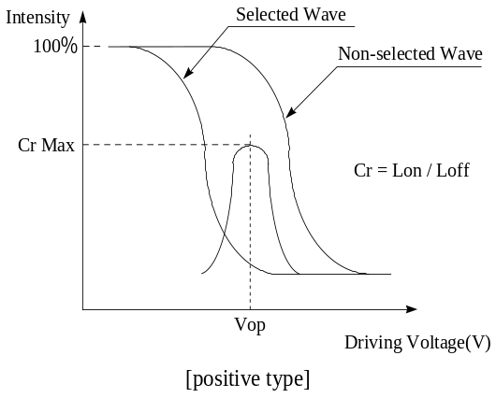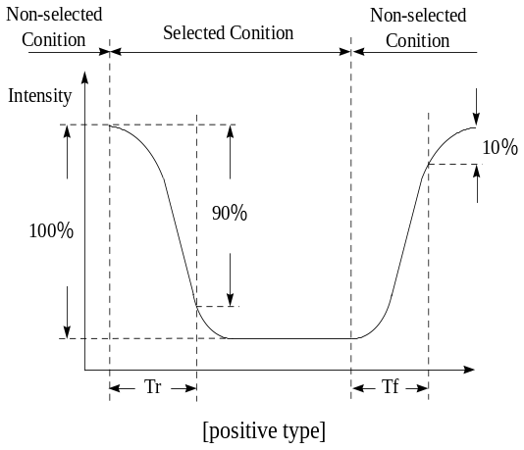
Conditions :
Operating Voltage : Vop Viewing Angle(θ，φ) : 0°， 0°
Frame Frequency : 64 HZ Driving Waveform : 1/N duty , 1/a bias
Definition of viewing angle(CR≧2)
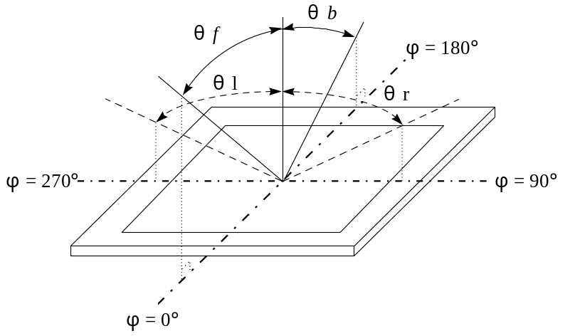

7.Interface Pin Function
Pin No. | Symbol | Level | Description
1 | V_{SS} | 0V | Ground
2 | V_{DD} | 5.0V | Supply Voltage for logic
3 | VO | (Variable) | Operating voltage for LCD
4 | RS | H/L | H: DATA, L: Instruction code
5 | R/W | H/L | H: Read(MPU→Module) L: Write(MPU→Module)
6 | E | H,H→L | Chip enable signal
7 | DB0 | H/L | Data bit 0
8 | DB1 | H/L | Data bit 1
9 | DB2 | H/L | Data bit 2
10 | DB3 | H/L | Data bit 3
11 | DB4 | H/L | Data bit 4
12 | DB5 | H/L | Data bit 5
13 | DB6 | H/L | Data bit 6
14 | DB7 | H/L | Data bit 7
15 | A | － | LED +
16 | K | － | LED－

8.Contour Drawing &Block Diagram
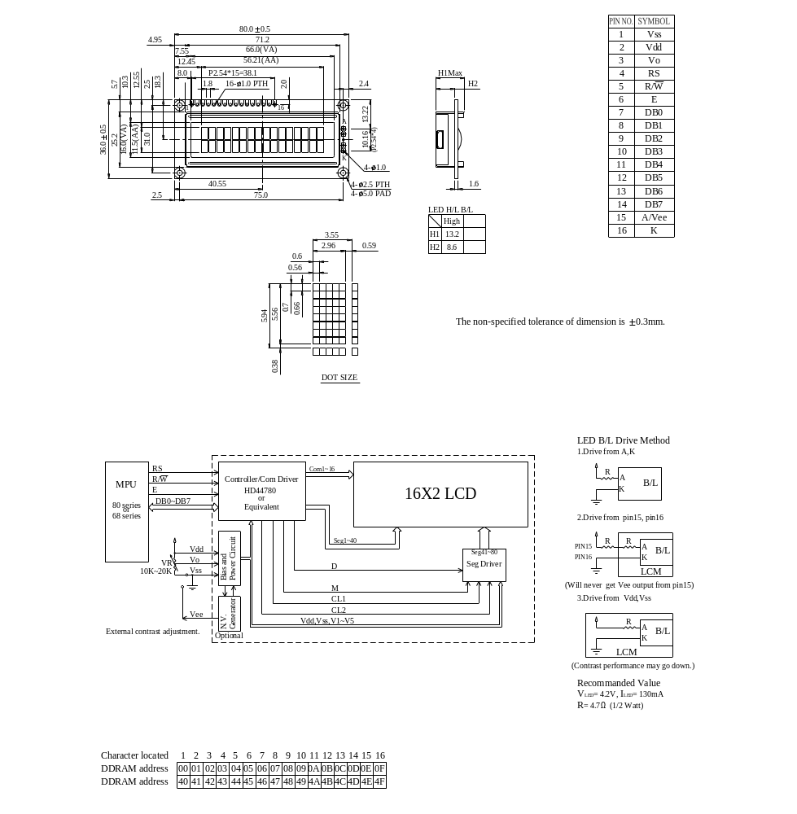

9.Function Description
The LCD display Module is built in a LSI controller, the controller has two 8-bit registers, an instruction register (IR) and a data register (DR).
The IR stores instruction codes, such as display clear and cursor shift, and address information for display data RAM (DDRAM) and character generator (CGRAM). The IR can only be written from the MPU. The DR temporarily stores data to be written or read from DDRAM or CGRAM. When address information is written into the IR, then data is stored into the DR from DDRAM or CGRAM. By the register selector (RS) signal, these two registers can be selected.

RS | R/W | Operation
0 | 0 | IR write as an internal operation (display clear, etc.)
0 | 1 | Read busy flag (DB7) and address counter (DB0 to DB7)
1 | 0 | Write data to DDRAM or CGRAM (DR to DDRAM or CGRAM)
1 | 1 | Read data from DDRAM or CGRAM (DDRAM or CGRAM to DR)

Busy Flag (BF)
When the busy flag is 1, the controller LSI is in the internal operation mode, and the next instruction will not be accepted. When RS=0 and R/W=1, the busy flag is output to DB7. The next instruction must be written after ensuring that the busy flag is 0.

Address Counter (AC)
The address counter (AC) assigns addresses to both DDRAM and CGRAM

Display Data RAM (DDRAM)
This DDRAM is used to store the display data represented in 8-bit character codes. Its extended capacity is 80×8 bits or 80 characters. Below figure is the relationships between DDRAM addresses and positions on the liquid crystal display.

AC
(hexadecimal)
High bits
Low bits
Example: DDRAM addresses 4E
AC6 | AC5 | AC4 | AC3 | AC2 | AC1 | AC0 |  | 1 | 0 | 0 | 1 | 1 | 1 | 0

Display position DDRAM address
1 2 3 4 5 6 7 8 9 10 11 12 13 14 15 16
00 | 01 | 02 | 03 | 04 | 05 | 06 | 07 | 08 | 09 | 0A | 0B | 0C | 0D | 0E | 0F
40 | 41 | 42 | 43 | 44 | 45 | 46 | 47 | 48 | 49 | 4A | 4B | 4C | 4D | 4E | 4F
2-Line by 16-Character Display
Character Generator ROM (CGROM)
The CGROM generate 5×8 dot or 5×10 dot character patterns from 8-bit character codes. See Table 2.

Character Generator RAM (CGRAM)
In CGRAM, the user can rewrite character by program. For 5×8 dots, eight character patterns can be written, and for 5×10 dots, four character patterns can be written.
Write into DDRAM the character code at the addresses shown as the left column of table 1. To show the character patterns stored in CGRAM.
Relationship between CGRAM Addresses, Character Codes (DDRAM) and Character patterns

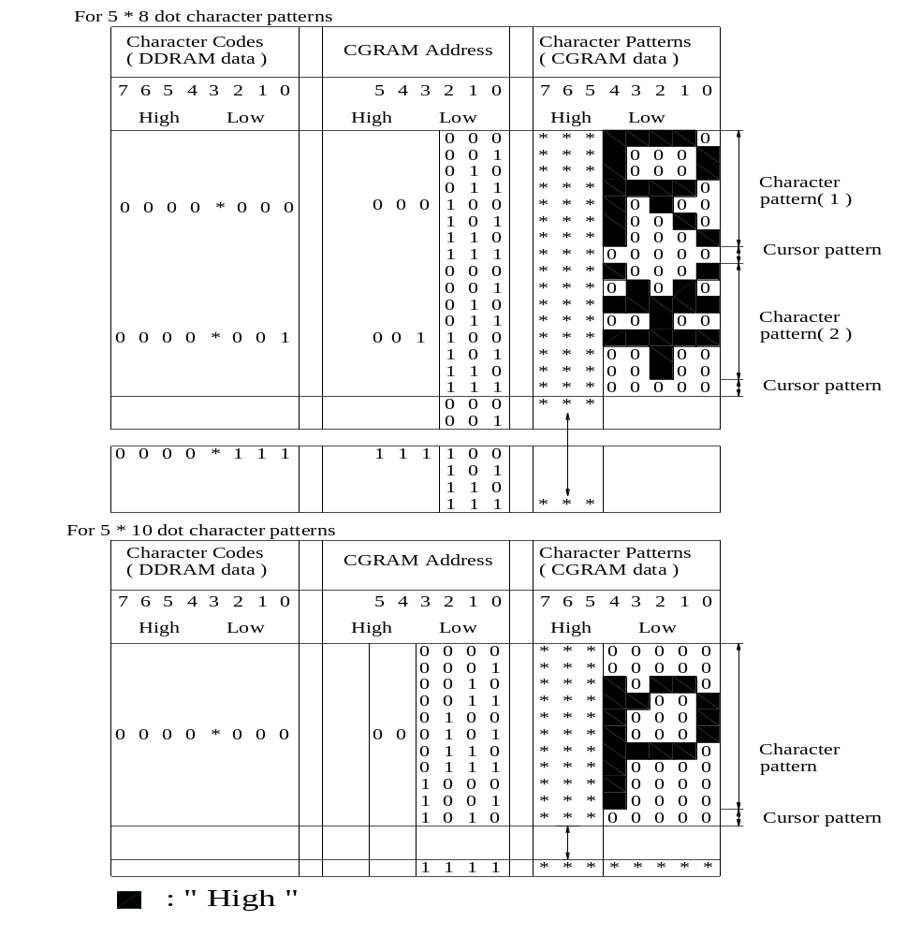 Table 1.

10.Character Generator ROM Pattern

Table.2
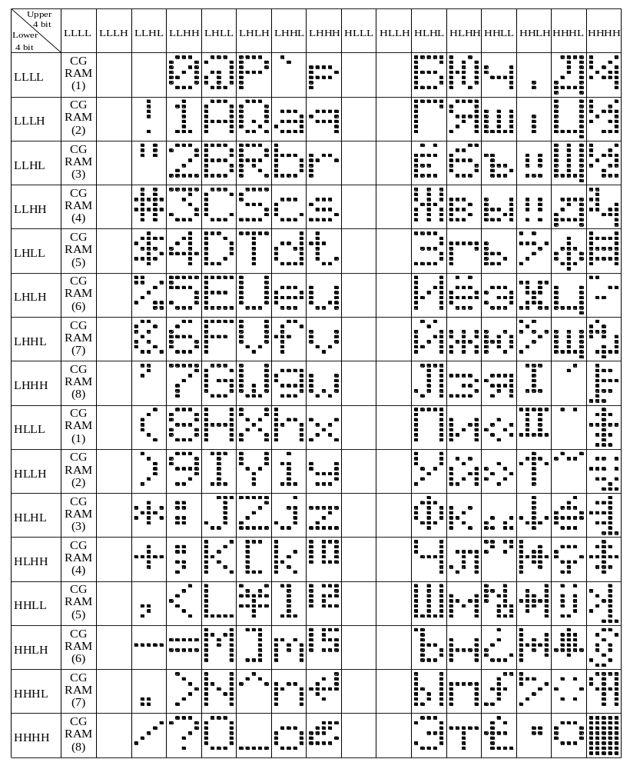

11.Instruction Table

Instruction | Instruction Code |  |  |  |  |  |  |  |  |  | Description | Execution time (fosc=270Khz)
Instruction | RS | R/W | DB7 | DB6 | DB5 | DB4 | DB3 | DB2 | DB1 | DB0 | Description | Execution time (fosc=270Khz)
Clear Display | 0 | 0 | 0 | 0 | 0 | 0 | 0 | 0 | 0 | 1 | Write “00H” to DDRAM and set DDRAM address to “00H” from AC | 1.53ms
Return Home | 0 | 0 | 0 | 0 | 0 | 0 | 0 | 0 | 1 | － | Set DDRAM address to “00H” from AC and return cursor to its original position if shifted. The contents of DDRAM are not changed. | 1.53ms
Entry Mode Set | 0 | 0 | 0 | 0 | 0 | 0 | 0 | 1 | I/D | SH | Assign cursor moving direction and enable the shift of entire display. | 39μs
Display ON/OFF Control | 0 | 0 | 0 | 0 | 0 | 0 | 1 | D | C | B | Set display (D), cursor (C ), and blinking of cursor (B) on/off control bit. | 39μs
Cursor or Display Shift | 0 | 0 | 0 | 0 | 0 | 1 | S/C | R/L | － | － | Set cursor moving and display shift control bit, and the direction, without changing of DDRAM data. | 39μs
Function Set | 0 | 0 | 0 | 0 | 1 | DL | N | F | － | － | Set interface data length (DL:8-bit/4-bit), numbers of display line (N:2-line/1-line)and, display font type (F:5×11 dots/5×8 dots) | 39μs
Set CGRAM Address | 0 | 0 | 0 | 1 | AC5 | AC4 | AC3 | AC2 | AC1 | AC0 | Set CGRAM address in address counter. | 39μs
Set DDRAM Address | 0 | 0 | 1 | AC6 | AC5 | AC4 | AC3 | AC2 | AC1 | AC0 | Set DDRAM address in address counter. | 39μs
Read Busy Flag and Address | 0 | 1 | BF | AC6 | AC5 | AC4 | AC3 | AC2 | AC1 | AC0 | Whether during internal operation or not can be known by reading BF. The contents of address counter can also be read. | 0μs
Write Data to RAM | 1 | 0 | D7 | D6 | D5 | D4 | D3 | D2 | D1 | D0 | Write data into internal RAM (DDRAM/CGRAM). | 43μs
Read Data from RAM | 1 | 1 | D7 | D6 | D5 | D4 | D3 | D2 | D1 | D0 | Read data from internal RAM (DDRAM/CGRAM). | 43μs
＊ ”－”：don’t care

12.Timing Characteristics
12.1 Write Operation

DB0~DB7
RS

V_{IH1}
V_{IL1}
t_{su1}
t_{h1}
R/W
V_{IL1}
V_{IL1}
t_{w}
t_{h1}
E
t_{f}
V_{IH1}
V_{IL1}

V_{IH1}
V_{IL1}
t_{su2}
V_{IL1}
t_{h2}
t_{r}
V_{IH1}
V_{IL1}
Valid Data
V_{IH1}
V_{IL1}
t_{c}

(V_{DD}=4.5V~5.5V , Ta=-30~+85℃)
Mode | Characteristic | Symbol | Min. | Typ. | Max. | Unit
Write Mode | E cycle Time | tc | 500 | － | － | ns
Write Mode | E Rise/Fall Time | t_{R}, t_{F} | － | － | 20 | ns
Write Mode | E Pulse Width (High, Low) | tw | 230 | － | － | ns
Write Mode | R/W and RS Setup Time | tsu1 | 40 | － | － | ns
Write Mode | R/W and RS Hold Time | t_{H1} | 10 | － | － | ns
Write Mode | Data Setup Time | tsu2 | 80 | － | － | ns
Write Mode | Data Hold Time | t_{H2} | 10 | － | － | ns

12.2 Read Operation

RS

V_{IH1}
V_{IL1}
t_{su}
t_{h}
R/W
V_{IH1}
V_{IH1}
t_{w}
t_{h}
E
t_{f}
V_{IH1}
V_{IL1}

V_{IH1}
V_{IL1}
V_{IL1}
t_{DH}
t_{r}
V_{IH1}
V_{IL1}
Valid Data
V_{OH1}
V_{OL1}
t_{c}
t_{D}

DB0~DB7

(V_{DD}=4.5V~5.5V , Ta=-30~+85℃)
Mode | Characteristic | Symbol | Min. | Typ. | Max. | Unit
Read Mode | E cycle Time | tc | 500 | － | － | ns
Read Mode | E Rise/Fall Time | t_{R}, t_{F} | － | － | 20 | ns
Read Mode | E Pulse Width (High, Low) | tw | 230 | － | － | ns
Read Mode | R/W and RS Setup Time | tsu | 40 | － | － | ns
Read Mode | R/W and RS Hold Time | t_{H} | 10 | － | － | ns
Read Mode | Data Output Delay Time | t_{D} | － | － | 120 | ns
Read Mode | Data Hold Time | t_{DH} | 5 | － | － | ns

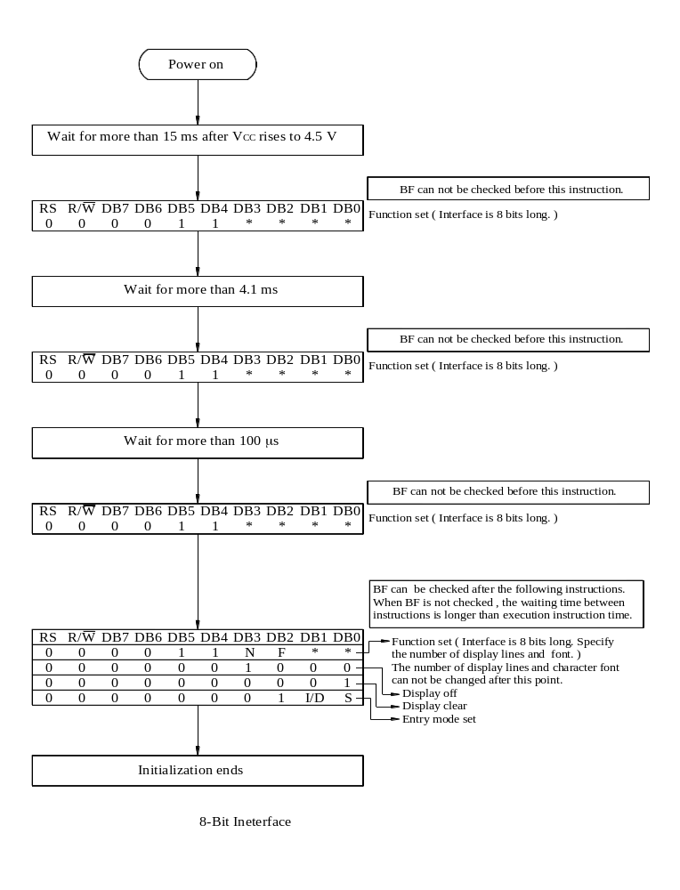13.Initializing of LCM
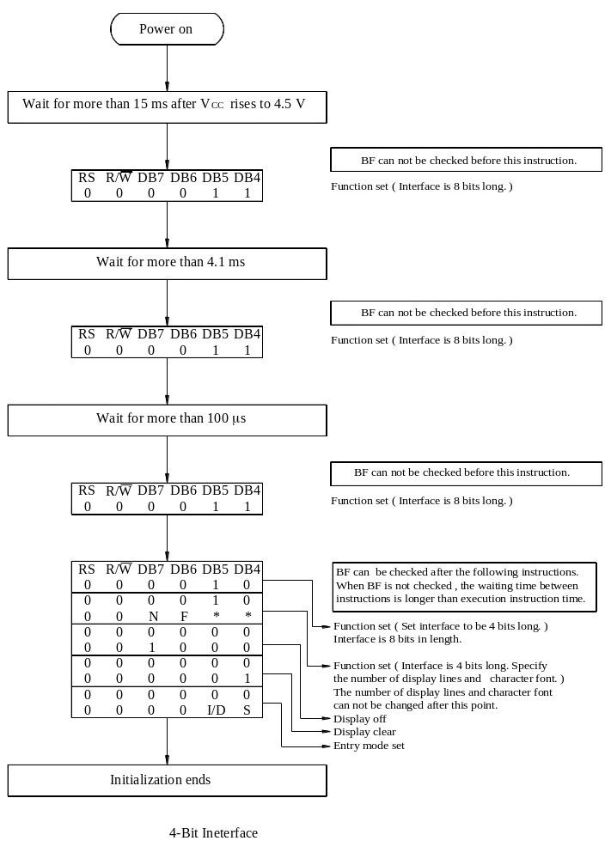
14.Quality Assurance
Screen Cosmetic Criteria
Item | Defect | Judgment Criterion | Partition
1 | Spots | A)Clear  Size: d mm Acceptable Qty in active area  d ≦0.1 Disregard  0.1<d≦0.2 6  0.2<d≦0.3 2  0.3<d 0  Note: Including pin holes and defective dots which must be within one pixel size.  B)Unclear  Size: d mm Acceptable Qty in active area  d ≦0.2 Disregard  0.2<d≦0.5 6  0.5<d≦0.7 2  0.7<d 0 | Minor
2 | Bubbles in Polarize | Size: d mm Acceptable Qty in active area  d≦0.3 Disregard  0.3<d≦1.0 3  1.0<d≦1.5 1  1.5<d 0 | Minor
3 | Scratch | In accordance with spots cosmetic criteria. When the light reflects on the panel surface, the scratches are not to be remarkable. | Minor
4 | Allowable Density | Above defects should be separated more than 30mm each other. | Minor
5 | Coloration | Not to be noticeable coloration in the viewing area of the LCD panels.  Back-light type should be judged with back-light on state only. | Minor

15.Reliability

Content of Reliability Test
Environmental Test
Test Item | Content of Test | Test Condition | Applicable  Standard
High Temperature storage | Endurance test applying the high storage temperature for a long time. | 80℃  200hrs | ——
Low Temperature  storage | Endurance test applying the high storage temperature for a long time. | -30℃  200hrs | ——
High Temperature  Operation | Endurance test applying the electric stress (Voltage & Current) and the thermal stress to the element for a long time. | 70℃  200hrs | ——
Low Temperature  Operation | Endurance test applying the electric stress under low temperature for a long time. | -20℃  200hrs | ——
High Temperature/  Humidity Storage | Endurance test applying the high temperature and high humidity storage for a long time. | 80℃,90%RH  96hrs | ——
High Temperature/  Humidity Operation | Endurance test applying the electric stress (Voltage & Current) and temperature / humidity stress to the element for a long time. | 70℃,90%RH  96hrs | ——
Temperature Cycle | Endurance test applying the low and high temperature cycle.  -20℃ 25℃ 70℃  30min 5min 30min  1 cycle | -20℃/70℃  10 cycles | ——
Mechanical Test
Vibration test | Endurance test applying the vibration during transportation and using. | 10~22Hz→1.5mmp-p  22~500Hz→1.5G  Total 0.5hrs | ——
Shock test | Constructional and mechanical endurance test applying the shock during transportation. | 50G Half sign  wave 11 msedc  3 times of each direction | ——
Atmospheric pressure test | Endurance test applying the atmospheric pressure during transportation by air. | 115mbar  40hrs | ——
Others
Static electricity test | Endurance test applying the electric stress to the terminal. | VS=800V,RS=1.5kΩ  CS=100pF  1 time | ——
***Supply voltage for logic system=5V. Supply voltage for LCD system =Operating voltage at 25℃

16.Backlight Information
Specification

PARAMETER | SYMBOL | MIN | TYP | MAX | UNIT | TEST CONDITION
Supply Current | ILED | ─ | 130 | ─ | mA | V=4.2V
Supply Voltage | V | － | 4.2 | 4.6 | V | －
Reverse Voltage | VR | － | － | 8 | V | －
Luminous Intensity | IV | 10 | － | － | CD/M² | ILED=130mA
Wave Length | λp | ─ | 573 | － | nm | ILED=130mA
Life Time | － | － | 100000 | － | Hr. | V≦4.6V
Color | Yellow Green

