THE MASTER THESIS TEMPLATE

This document has been set up to assist students in preparing the text for their Master thesis in Systems Biology. It is NOT intended as a document to guide you through your research proposal development, but to assist you in setting out the thesis, in terms of text layout, section headings and sub-sections.

The Master thesis is a complete description of the research conducted under the supervision of the assigned supervisor. Through the thesis, the student needs to demonstrate convincingly that the study will contribute with new findings to the Systems biology field. The full Master thesis must be is 30-100 pages.

How to use this template:
The template provides ALL the sections, headings and subheadings that you will require in your proposal, as well as the line and paragraph spacing, page breaks, page numbering, referencing system and referencing styles. You should simply edit the text where appropriate and insert your own text as per your proposal, i.e simply type into the document. Do not attempt to change the styles for the headings or subheadings, and do not attempt to use more than three level headings (i.e a main heading, a sub-heading and a sub-sub-heading).

Use heading 1 from the selection above for your main heading. Use all caps, do not use anything else as the table of contents has been automated to use this setting.
Use Heading 2 from the selection of styles on the menu bar above. Do NOT use all capitals, but write as is shown above. Do not use anything else as the Table of Contents has been automated to include this style for a subheading.
Use Heading 3 from the selection of styles on the menu bar above. Do NOT use all capitals, but write as is shown above. Do not use anything else as the Table of Contents has been automated to include this style for a sub-subheading.

WHEN YOU ARE DONE, DELETE THIS FRONT INSTRUCTION PAGE FROM YOUR PROPOSAL.

Collagen Fiber Extraction and Analysis in the
Hematoxylin and Eosin Stained Cancer Tissue Images
Master Thesis
Systems biology master program
Vilnius university

STUDENT NAME: Marius Latinis
STUDENT NUMBER: 1268095

SUPERVISOR: Povilas Treigys

SUPERVISOR DECISION: ……………………………….

FINAL GRADE ……………………….

DATE OF SUBMISSION: DD MMMM 20YY
CONTENTS
List of abbreviations 4
INTRODUCTION 5
AIM and tasks 6
literature review 7
METHODS 8
RESULTS 9
DISCUSSION 10
conclusions 11
REcommendation 12
acknowledgements 13
references 14
summary 15
Summary in Lithuanian 16
appendices 17

List of abbreviations
It is advised to include if there are more than 10 abbreviations; listed in alphabetical order; in the text at a first mention the abbreviated phrase has to be fully expressed and abbreviation given in the brackets afterwards as for example: differentially expressed genes (DEG).

Hematoxylin and Eosin (H&E).

INTRODUCTION
Visual examination of a tissue is a major part in cancer diagnosis. A trained
pathologist is given a sample of a tissue to inspect. By looking at the tissue
placed under a microscope or inspecting its digital image a pathologist diagnoses
the severity of cancer and makes a prediction about the further treatment.

Different components of the tissue must be coloured with different colours so
that the visual image of a tissue can be analysed. Hematoxylin and eosin (H&E) stain
is one of the principal tissue stains used in histology [1]:
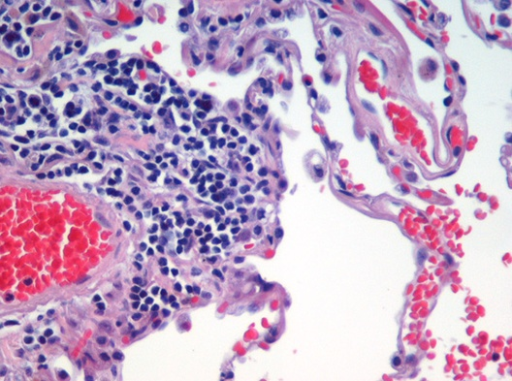

The hematoxylin stains cell nuclei blue whereas eosin stains the extracellular
matrix pink, with other structures taking on different shades, hues and combi-
nations of these colors. The stain shows the general layout and distribution of
cells and provides a general overview of a tissue sample’s structure. It is the
most widely used stain in medical diagnosis. When a pathologist looks at a
biopsy of a suspected cancer, the histological section is likely to be stained with
H&E.

Unfortunately, manual image inspection is prone to error and inter-observer variability
(e.g. different pathologists are trained differently). This creates an interest to
investigate whether a computer can perform tissue inspection and provide
predictions. Furthermore, in this project, we are given a dataset of images, for which pathologists at the State Pathology Centre do not have a clear decision on how to assess them. Thus, this project aims to propose a new method that can inspect the H&E stained images automatically and generate a prediction about the patients’ fate.

Short description and argument (1-2 pages) why the thesis project was performed, why it is important; the introduction leads into one aim and several tasks.

AIM and tasks
The aim: present a method that automatically analyses a digital H&E image and generates a prediction about the patient’s fate.

Since the analysis is based on the extracellular protein collagen, the aim breaks into the following tasks:
- gather data: a list of patients with information (e.g. survival time) and a digital image per patient;
- write a method that extracts collagen from the image;
- compute features using the extracted collagen;
- use the computed features to make a prediction;
- evaluate the whole pipeline that makes a prediction;

literature review
Aim of the literature review is to show and argue for the necessity of your project; headings not more than three levels deep; at least 40-60 papers reviewed; make interim conclusions/summaries by the end of each part of literature review.

METHODS
Collagen extraction

The first step in this project is to take the H&E stained image containing all
tissue components and extract only the shape of a collagen present in the image.
This is known as the image segmentation problem. In this case a pixel re-presenting
the collagen will be labelled as a foreground (bit with value 1), whereas
any other pixel will be labelled as a background (bit with value 0). Machine
learning was used to solve this problem. A model is created and provided with
the training data. The model learns to separate pixels into collagen and back-
ground classes and can be applied to unseen images. The training data was
provided by the National Centre of Pathology, Vilnius. Large H&E images were
tiled into tiles of 256 × 256 pixels and for each tile a collagen mask was manually
extracted with a paint software:
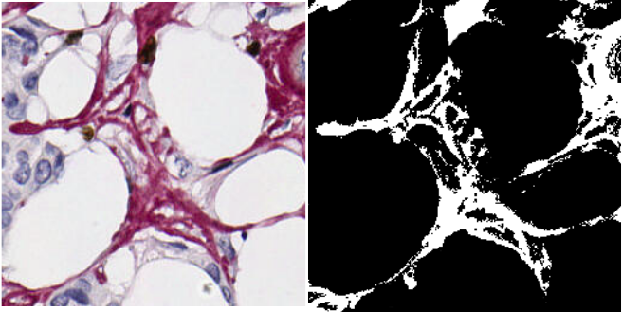

In total 43 image-mask pairs were used to train the model. A convolutional
neural network U-net was chosen as a model [8]. The model takes a full 256×256
(x3 for each of the RGB colour) image as an input and performs a few downsam-
pling procedures to infer the deep features from the image. Each downsampled
layer is then upsampled and connected to the layer above to apply the inferred
features on the image. Eventually the model predicts the 256 × 256 mask. We
tried to construct the network with different depth (i.e. the number of down-
sampling layers). We found that for 256 × 256 size images a data generated in
the 5-th and deeper layers becomes redundant. Thus, a U-net with 4 layers was
chosen as the final neural network for the collagen segmentation problem:
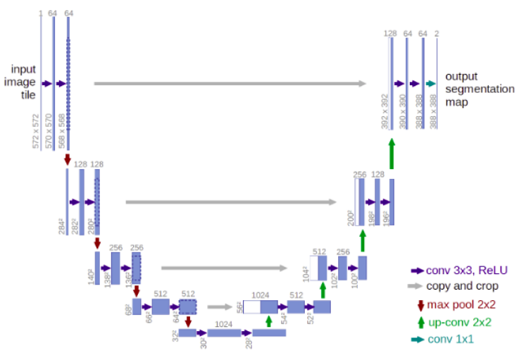

The neural network was trained on the 43 image-mask pairs using the cross-
validation technique. Binary crossentropy was used as a loss function. Accuracy
(i.e. proportion of correct foreground / background pixels) metric was used to
test the model. All code was written in python using Keras neural network API
[9]. After the model was trained, it was applied on a new larger scale image
to test its validity. The larger image was divided into 256 × 256 tiles and the
model was applied to each tile to extract a collagen mask. The extracted masks
were then merged into a large mask to obtain the following result:
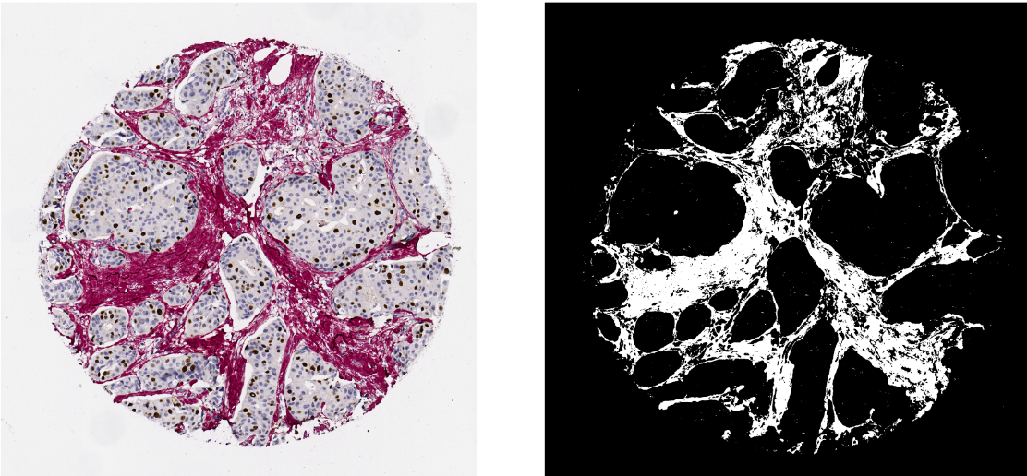

Features Generation

After the collagen is extracted, the next step is to analyse it and compute the
features that can allow to diagnose the patients. More specifically, a H&E
stained image is given corresponding to one patient. We wish to inspect the
image and predict the cancer severity stage for that person. The following
prediction pipeline is executed for this task:

• A collagen mask is computed from the image. For that the image is split
into 256 × 256 tiles and the trained model is applied to each of the tile.
The tiles are then merged into a single mask. Each cluster of connected
pixels (using 8-connectivity [10]) that has less than 50 pixels is considered
a noise and removed from the mask.
• A skeletonization function [11] is applied on the mask. This transforms white
collagen regions into 1 pixel wide representations. The skeleton tree
is chopped into individual edges and each edge gets assigned a unique id.
• A breath first search algorithm [12] is then applied to find for each collagen
pixel in the mask its closest skeleton edge. In this way the collagen is
divided into regions and for each region we can compute its features.
• For each region we compute 17 statistics and average them over all regions.
The statistics include region length (computed as the length of
the corresponding skeleton edge), width (computed as the total number of
pixels in the region divided by length), collagen to area ratio (computed as
the total number of pixels in the region divided by the area of the small-
est rectangle enclosing the region), curvature (divided as the distance between skeleton endpoints divided by the length) and 13 haralick parameters (excluding
the 14th due to its instability) [13,14]. We then use these parameters as
features to predict the severity stage of cancer for each patient.

RESULTS

The results section presents main results obtained in the project. This section is structured and contains evidence that supports conclusions. Each smaller part of the results starts with text. The results part contains figures, tables and text. It is recommended to make interim conslusions/summary after each results part.

DISCUSSION
The discussion part is structured according the results part. It discusses your findings with respect to the Literature and most important – explains discrepancies. New figures can be used to aid the discussion. The discussion shows how parts of your project interacts and makes a whole project and delivers the main “take home message” of the master project. It is encouraged to discuss limitations of your project.

conclusions
The conclusions part has to answer questions raised by the tasks. The conclusions have to be short, clear and concise; please avoid abbreviations in conclusions; there should be no more than five conclusions.

REcommendation
If your project leads to some recommendations, please include them separately under Recommendations section. It should be a short structured one or two paragraphs.

acknowledgements
The acknowledgements section lists and thanks organizations and sources of funding that supported your project; here you thank people whom you wish to thank, whose help was essential to your project.

references
Use Harvard style for references and citation; references are sorted alphabetically by the first letter of the first author surname and numbered; in the main text the references are cited by their numbers; websites in the reference list must have a “last accessed” statement providing the date of the last visit.

Information about Harvard Style of referencing:
https://www.mendeley.com/guides/harvard-citation-guide

summary
Includes Institution, study program, name, surname, title of thesis, and a short abstract what, why, how it was done and short conclusion (abstract max 300 words).

Summary in Lithuanian
The summary translated to Lithuanian language.

appendices
The appendices must be numbered and have titles; they must be cited in the main text. The appendices can include questionnaires, additional computations, tables, scripts, protocols, some raw data, published articles or conference papers on the subject of the thesis project.

