**EVENT REPORT**

|  |  |  |
| --- | --- | --- |
| Academic Year | : | **2023 – 2024** |
| Name of the Event | : | **A Hands-On Workshop on Working with Excel** |
| Organised By | : | **BioInformatics**  **Biotechnology**  **Botany** |
| Date | : | **10 April 2025** |
| Number of Participants | : | **500** |
| Theme | : | **Innovation (3.3.1)** |

|  |  |
| --- | --- |
|  |  |
|  |  |

Invite of the Event

**OBJECTIVES OF THE EVENT**

ndent: { left: -1440 },

alignment: AlignmentType.CENTER,

spacing: {

line: 260, // Adjust as needed

before: 200, // Increase this value for more space above the footer image

after: 0,

},

}),

**EVENT DESCRIPTION**

ndent: { left: -1440 },

alignment: AlignmentType.CENTER,

spacing: {

line: 260, // Adjust as needed

before: 200, // Increase this value for more space above the footer image

after: 0,

},

}),

**OUTCOME OF THE EVENT**

before: 200,

ndent: { left: -1440 },

e,

Mr. Wadkar started with an introduction to some of the uses of Microsoft Excel in our everyday life. He then continued with explaining the MS-Excel work area and related terms. Sample data were given to all the participants to work along with Mr. Wadkar. Basic Excel functions such as =sum(), =average(), =count(), =max(), =min() etc. were taught. This was followed by advanced functions such as =sumif(), =averageif(), =vlookup(), =textjoin() which are imperative in basic data analytics. A detailed explanation of most of the date functions such as =today(), =now(), =date() were also covered. Mr. Wadkar also showed a demo on how to incorporate ChatGPT Engine using the official API from OpenAI website. This feature allows the users to ask doubts related to Excel to ChatGPT for quick answers. Another important topic covered in the session was data validation of cells. Other general topics relating to Page Layout, Forms were also covered. ; spacing: {

line: 260, // Adjust as needed

before: 200, // Increase this value for more space above the footer image

after: 0,

},

}),

**GEO-TAGGED PICTURES**

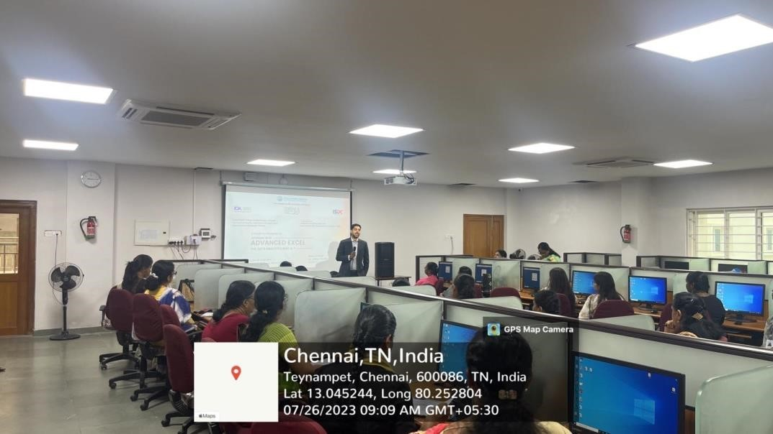

session 1

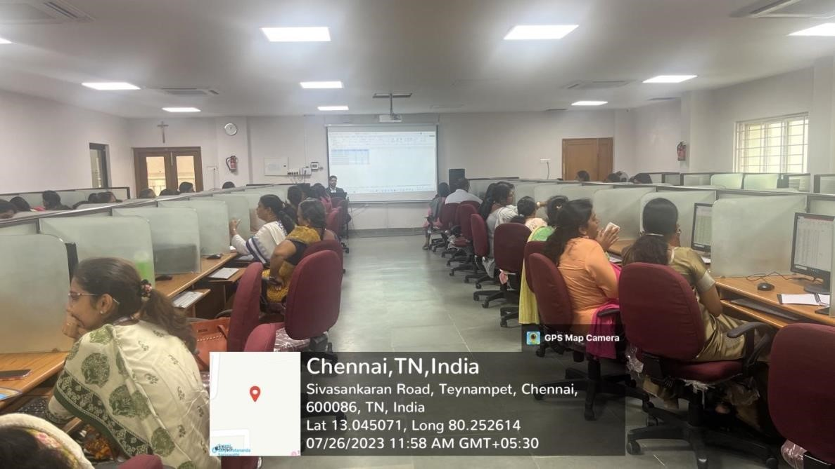

session 2

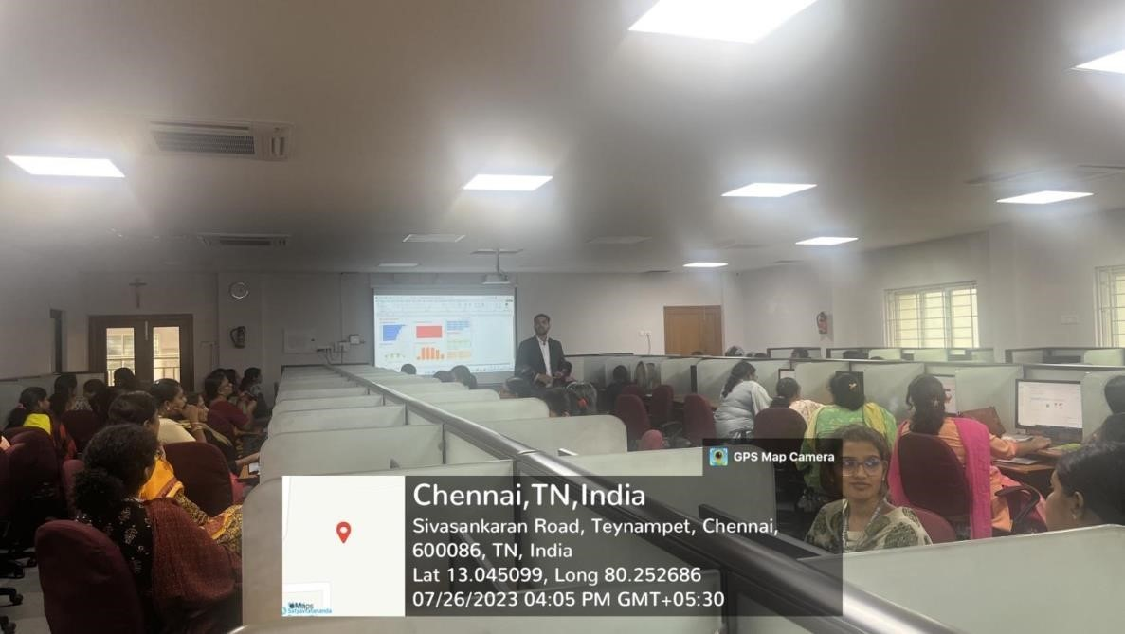

Tea beak

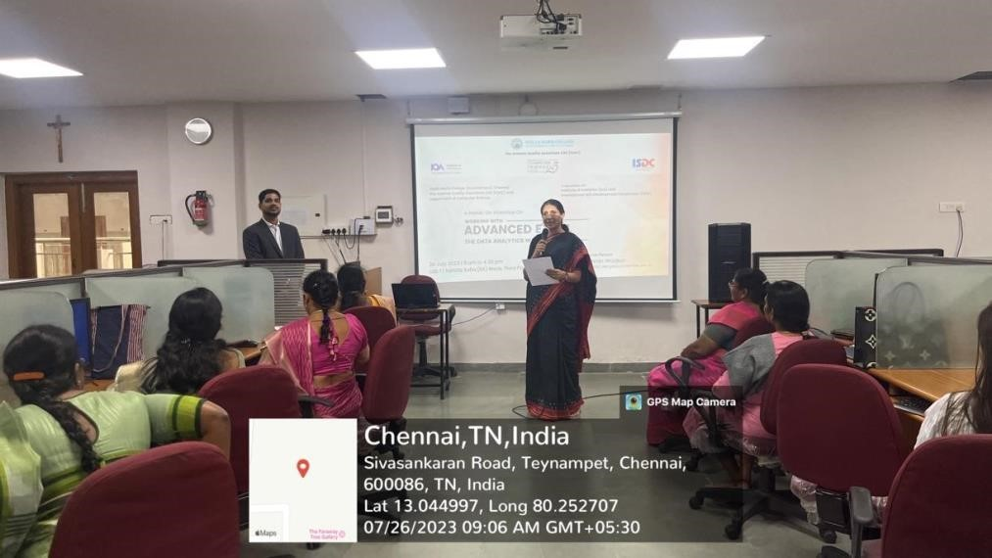

session 4

**PARTICIPANT LIST**

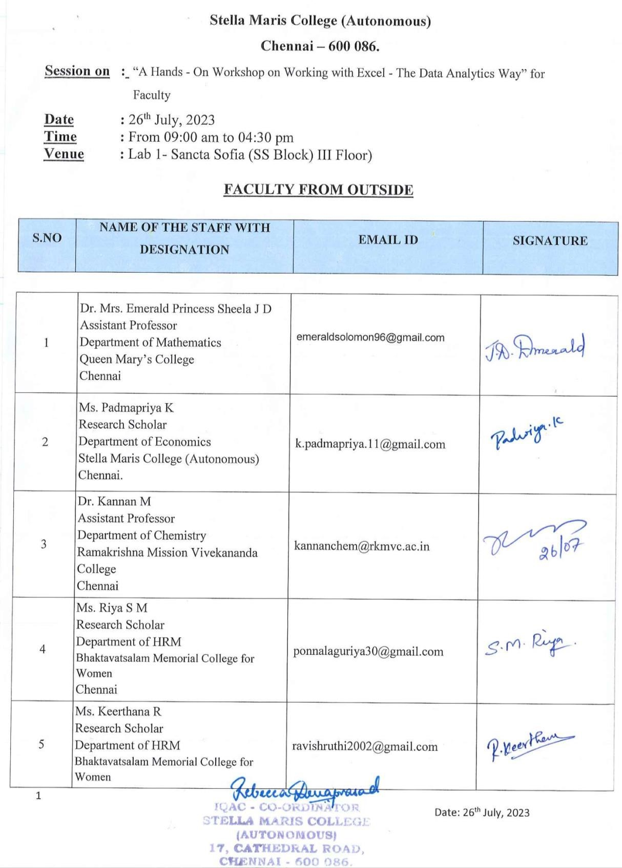

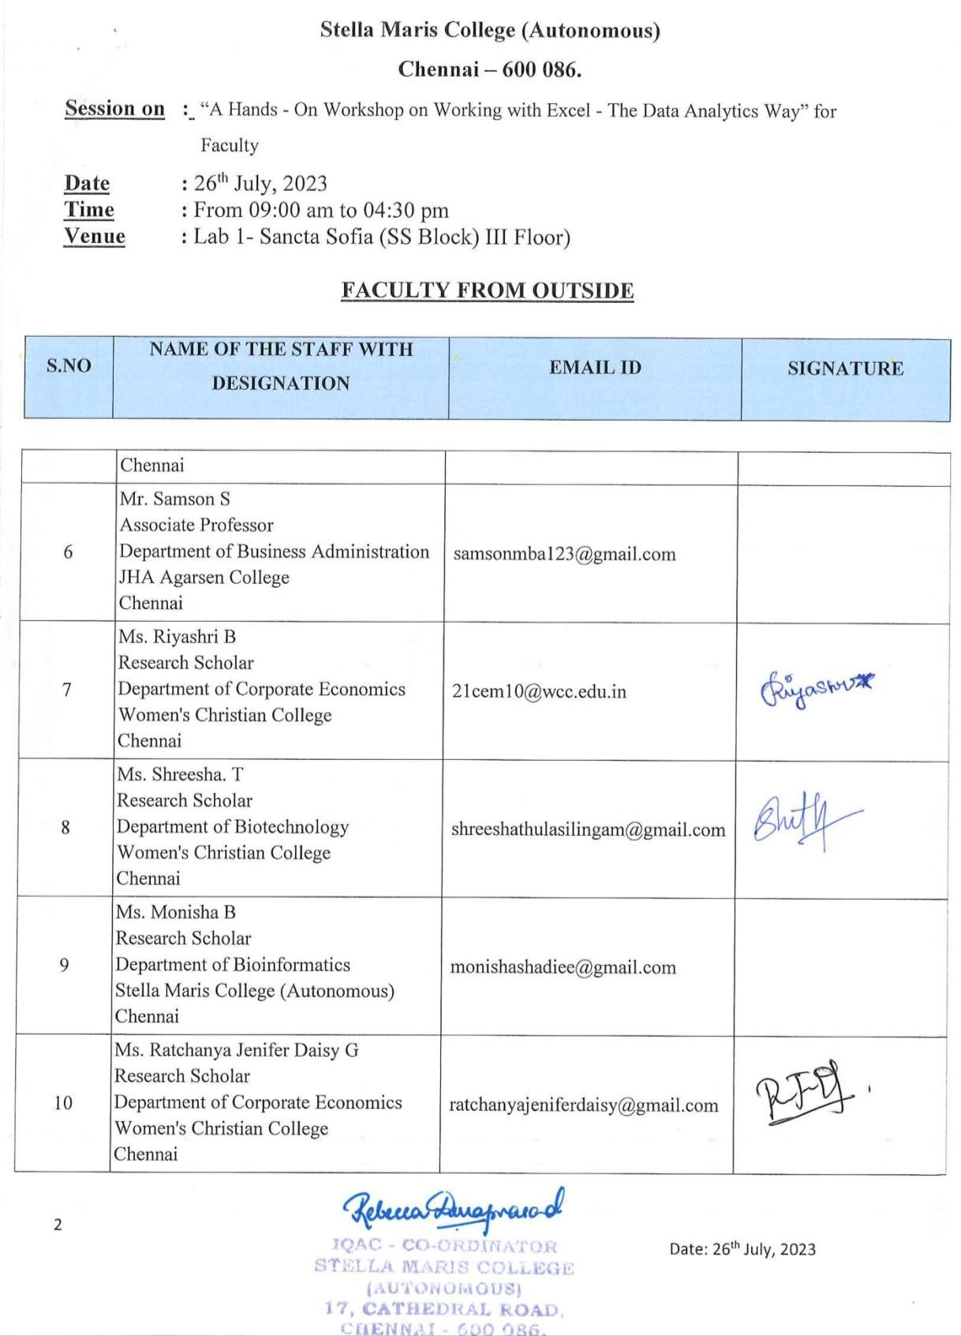

**FEEDBACK OF THE EVENT**

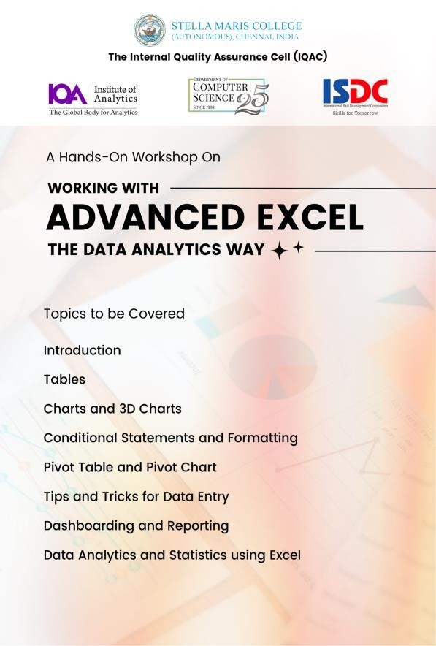

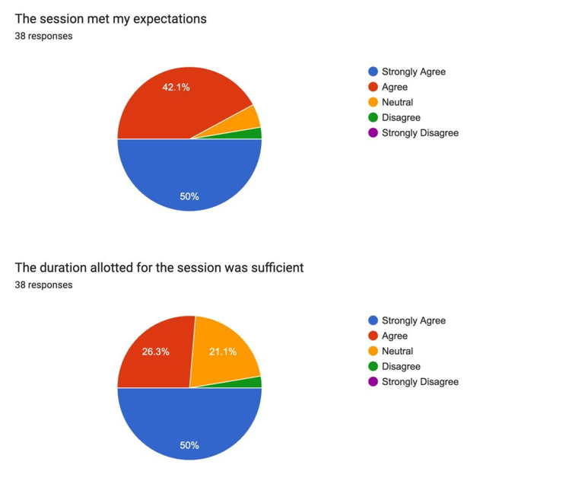



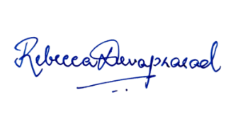 **dr. sister stella mary fmm**