**EVENT REPORT**

|  |  |  |
| --- | --- | --- |
| Academic Year | : | **2023 – 2024** |
| Name of the Event | : | **A Hands-On Workshop on Working with Excel** |
| Organised By | : | **Biotechnology**  **Botany**  **Chemistry** |
| Date | : | **26 April 2025** |
| Number of Participants | : | **500** |
| Theme | : | **Programme for Advanced Learners (2.2.1)** |

|  |  |
| --- | --- |
|  |  |

Invite of the Event

**OBJECTIVES OF THE EVENT**

* To introduce participants to essential and advanced Excel functions, data validation, statistical techniques, and the creation of dynamic dashboards
* To introduce participants to essential and advanced Excel functions, data validation, statistical techniques, and the creation of dynamic dashboards
* To introduce participants to essential and advanced Excel functions, data validation, statistical techniques, and the creation of dynamic dashboards

**EVENT DESCRIPTION**

The Internal Quality Assurance Cell (IQAC) of Stella Maris College organised a hands-on workshop on Advanced Excel: The Data Analytics Way in association with the Department of Computer Science, Stella Maris College (Autonomous), IOA and ISDC. The workshop was held in Lab 1, Sancta Sofia (SS) Block, Third Floor on 26 July 2023 from 9 am to 4.30 pm.

This programme was open to outside participants and also was attended by MQC faculty members from Shift I and Shift II of the College. The workshop began with Ms. Janet Sabina X., Assistant Professor, Department of Chemistry and IQAC Core Member, invoking God’s blessings through a prayer. Dr. Rebecca Devaprasad, Assistant Professor, Department of Economics and IQAC Coordinator, then introduced the resource person Mr. Imran Wadkar and handed the session over to Mr. Imran Wadkar.

Mr. Wadkar started with an introduction to some of the uses of Microsoft Excel in our everyday life. He then continued with explaining the MS-Excel work area and related terms. Sample data were given to all the participants to work along with Mr. Wadkar. Basic Excel functions such as =sum(), =average(), =count(), =max(), =min() etc. were taught. This was followed by advanced functions such as =sumif(), =averageif(), =vlookup(), =textjoin() which are imperative in basic data analytics. A detailed explanation of most of the date functions such as =today(), =now(), =date() were also covered. Mr. Wadkar also showed a demo on how to incorporate ChatGPT Engine using the official API from OpenAI website. This feature allows the users to ask doubts related to Excel to ChatGPT for quick answers. Another important topic covered in the session was data validation of cells. Other general topics relating to Page Layout, Forms were also covered.

A detailed dataset was also provided to the participants to convert into a Table and apply table related functions such as Slicing, Pivot tables, 2D and 3D charts with live data mapping, plotting histograms, applying data filters, generating descriptive statistics such as correlation etc. were covered in detail. In the post lunch session, various statistical techniques were taught. Creating Dashboards for our data was also taught to the participants to gain quick insight into the data present. The session concluded with Dr. Faustina Joan S. P., Assistant Professor, Department of Computer Science and IQAC Core Member, providing the vote of thanks. The feedback was collected from all the participants.

**OUTCOME OF THE EVENT**

1. Professor, Department of Computer Science and IQAC Core Member, providing the vote of thanks. The feedback was collected from all the participants
2. Professor, Department of Computer Science and IQAC Core Member, providing the vote of thanks. The feedback was collected from all the participants
3. Professor, Department of Computer Science and IQAC Core Member, providing the vote of thanks. The feedback was collected from all the participants

**GEO-TAGGED PICTURES**

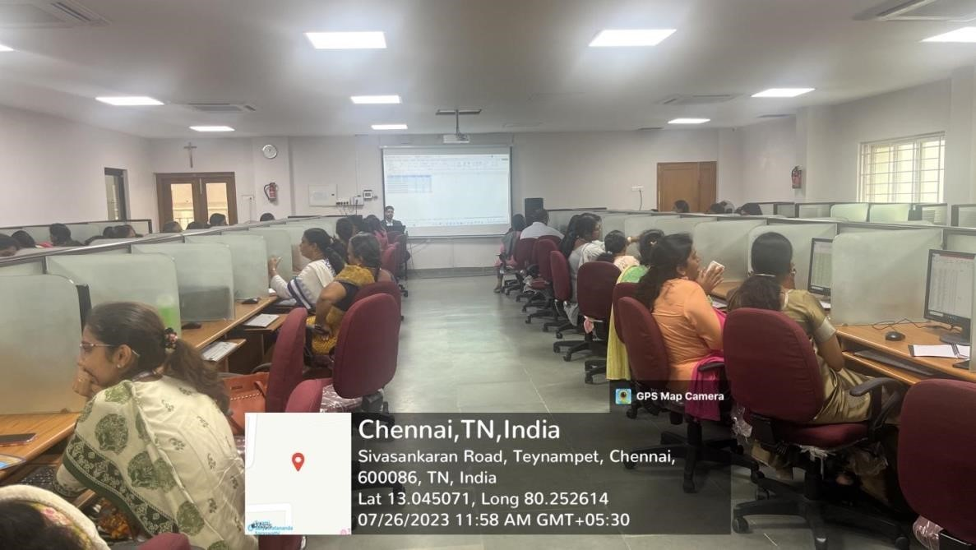

session 1

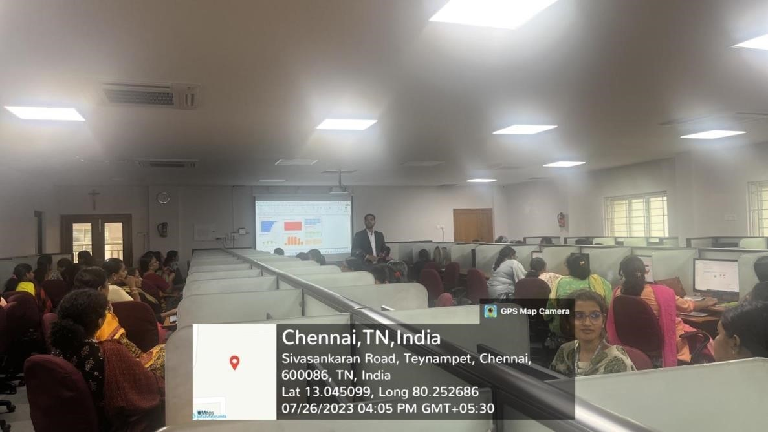

session 2

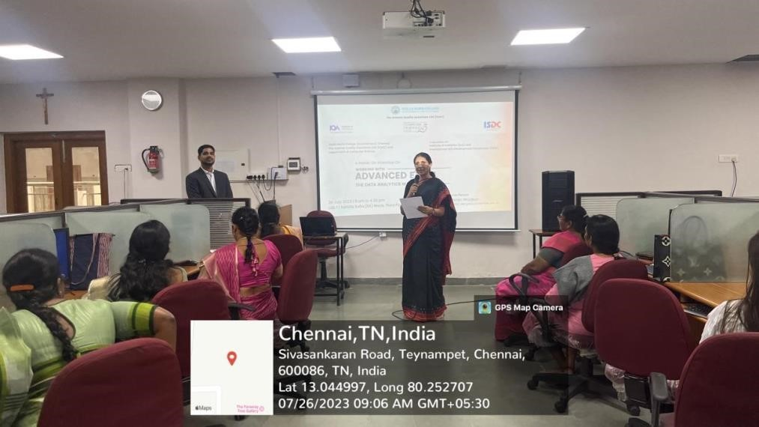

Tea beak

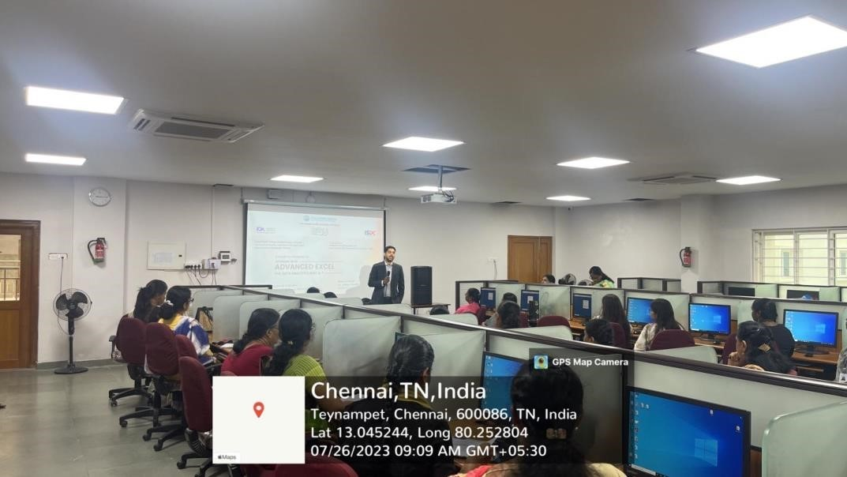

session 4

**PARTICIPANT LIST**

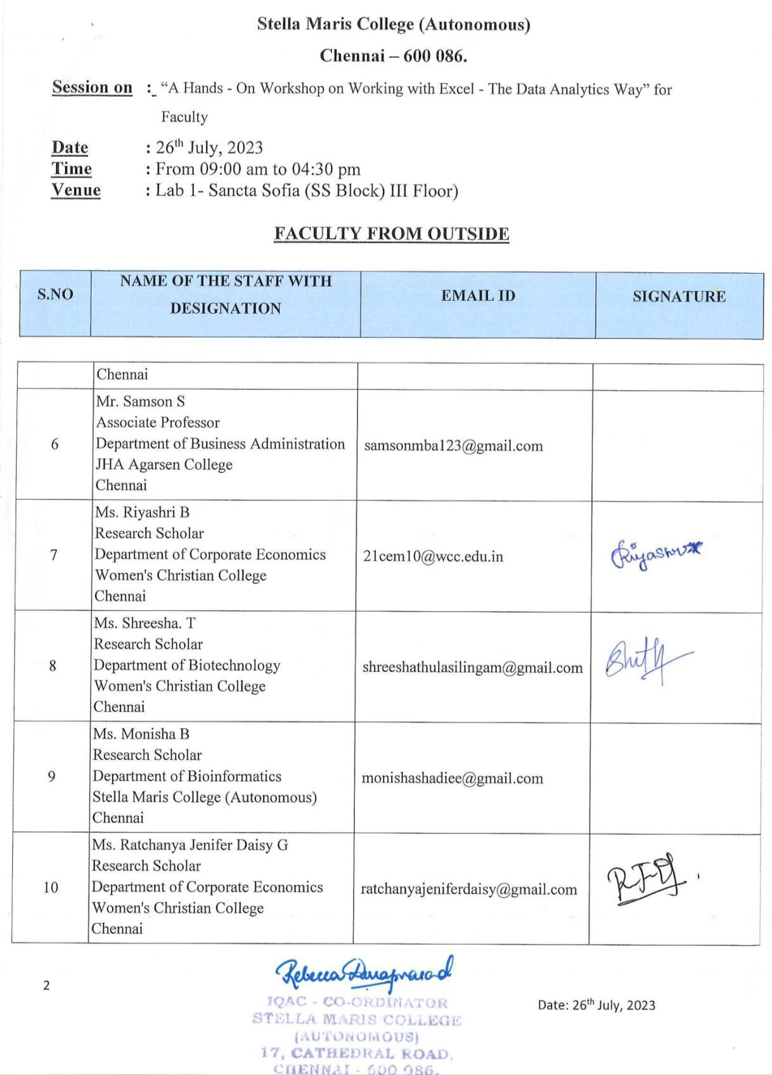

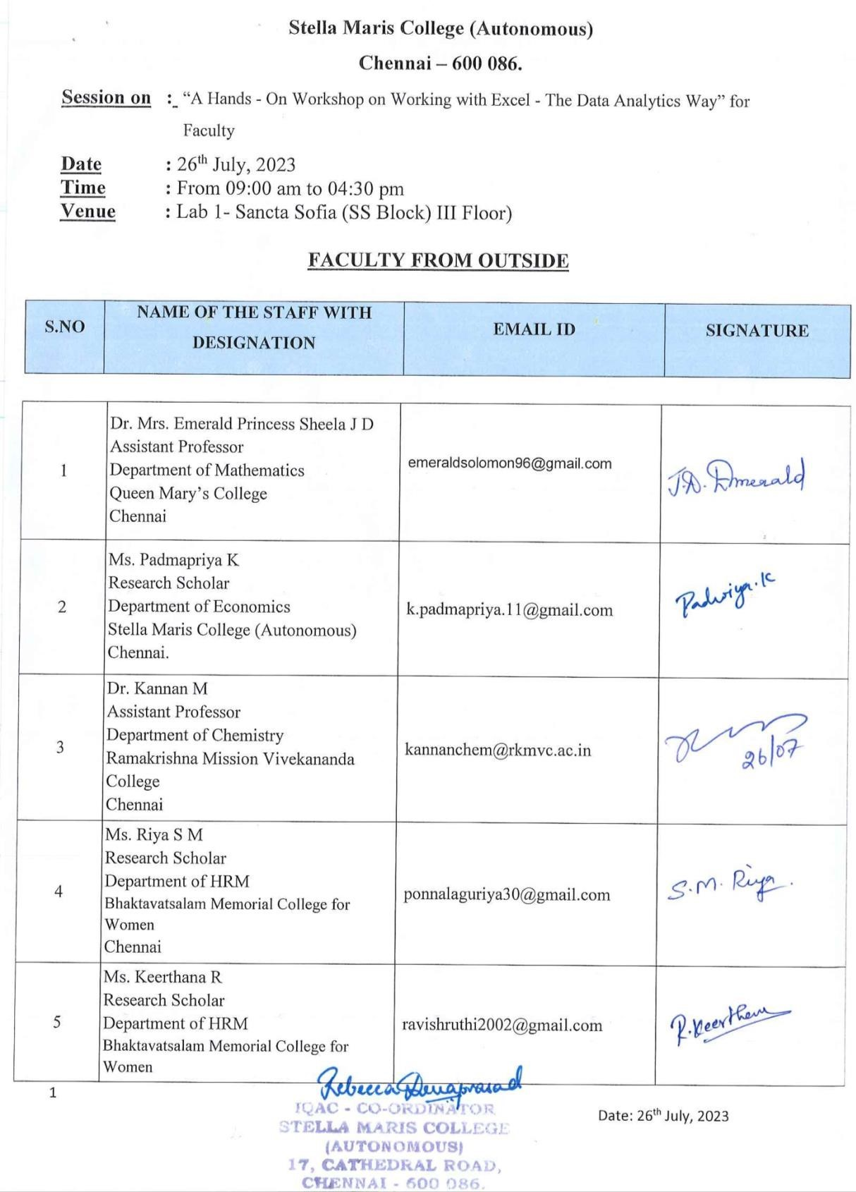

**SAMPLE CERTIFICATE**

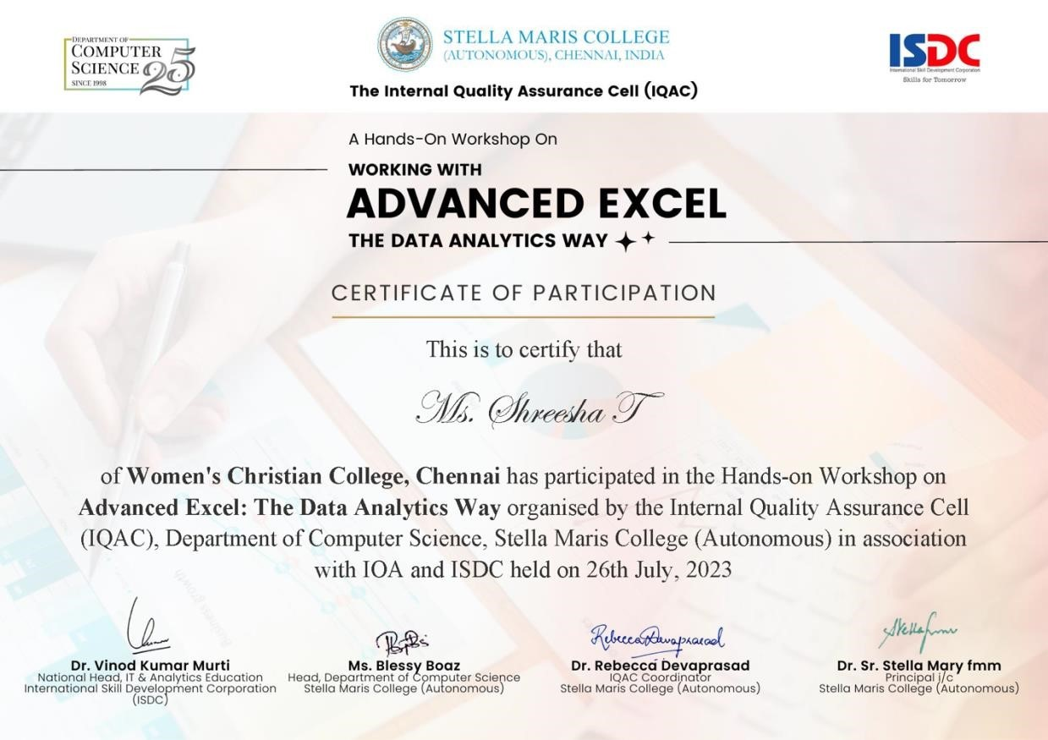

**FEEDBACK OF THE EVENT**

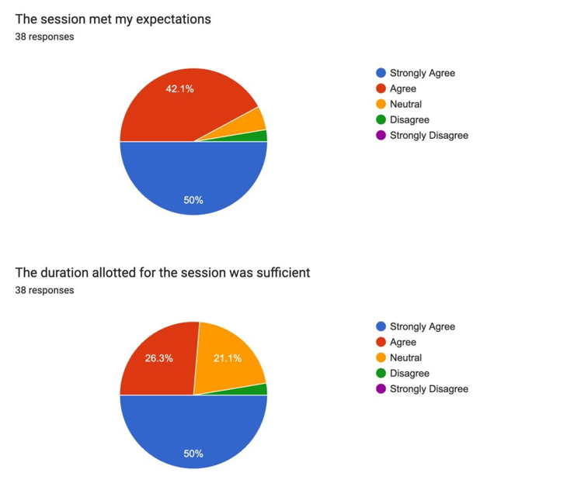



 **Assistant Professor Swathi MCA NET**