# **Q1.**Create a webpage to call external js file to make the changes with text elements of your webpage during page load event.

## Font js.js:

function change_formats()

{

document.getElementById("para1").style.fontSize="30pt"; document.getElementById("para1").style.fontFamily="Times New Roman"; document.getElementById("para1").style.borderBlockStyle="dotted"; document.getElementById("para1").style.color='red';

}

function reset()

{

document.getElementById('adv').innerHTML="";

}

## Font js.html:

<!DOCTYPE html>

<html>

<head>

<title> External js </title>

<script src="font js.js" type="text/javascript">

</script>

</head>

<body onload="change_formats()">

<h1>Java Script </h1>

<br>

<h2>Advantages of Js</h2>

<p id="adv"> </p>

<br>

<br>

<p id="para1">

Js is used to create interactive and reponsive webpages.

</p>

</body>

</html>

**Output**:

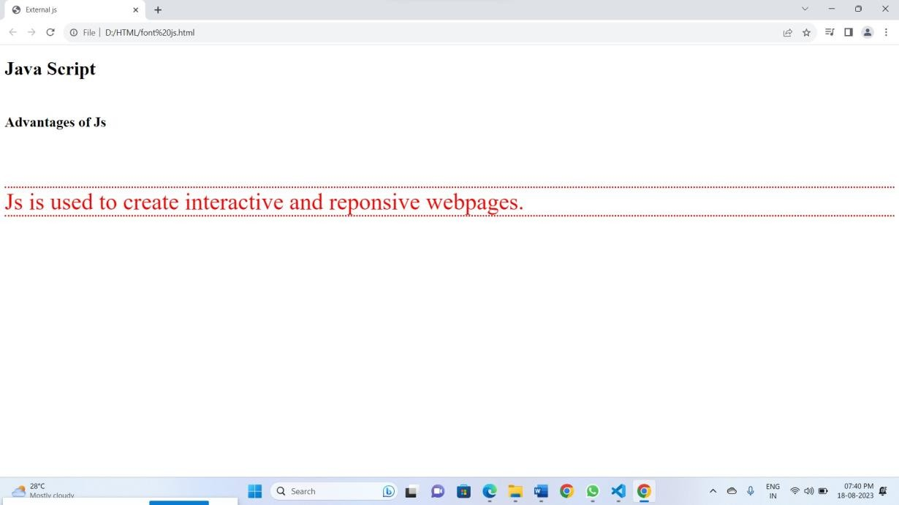

# **Q2.**with the above example when you place cursor in the h1 elements, it has to show description about js advantages**.**

## External js.js:

function change_formats()

{

document.getElementById("para1").style.fontSize="30pt"; document.getElementById("para1").style.fontFamily="Times New Roman"; document.getElementById("para1").style.borderBlockStyle="dotted"; document.getElementById("para1").style.color='red';

}

function showuses()

{

document.getElementById('adv').innerHTML="<ul type='square'>" + "<li> JavaScript was designed to add interactivity to HTML pages</li>" + "<li>JavaScript is a scripting language</li> " +

"<li>A scripting language is a lightweight programming language</li> "+ "<li>JavaScript is usually embedded directly into HTML pages </li>"+ "<li>JavaScript is an interpreted language (means that scripts execute without preliminary compilation)</li> "

}

function reset()

{

document.getElementById('adv').innerHTML="";

}

## External js.html:

<!DOCTYPE html>

<html>

<head>

<title> External js </title>

<script src="External js.js" type="text/javascript">

</script>

</head>

<body onload="change_formats()">

<h1 id="head1" onmouseover="showuses()" onmouseout="reset()"> Java Script </h1>

<br>

<p id="adv"> </p>

<br>

<br>

<p id="para1">

Js is used to create interactive and reponsive webpages.

</p>

</body>

</html>

**Output:**

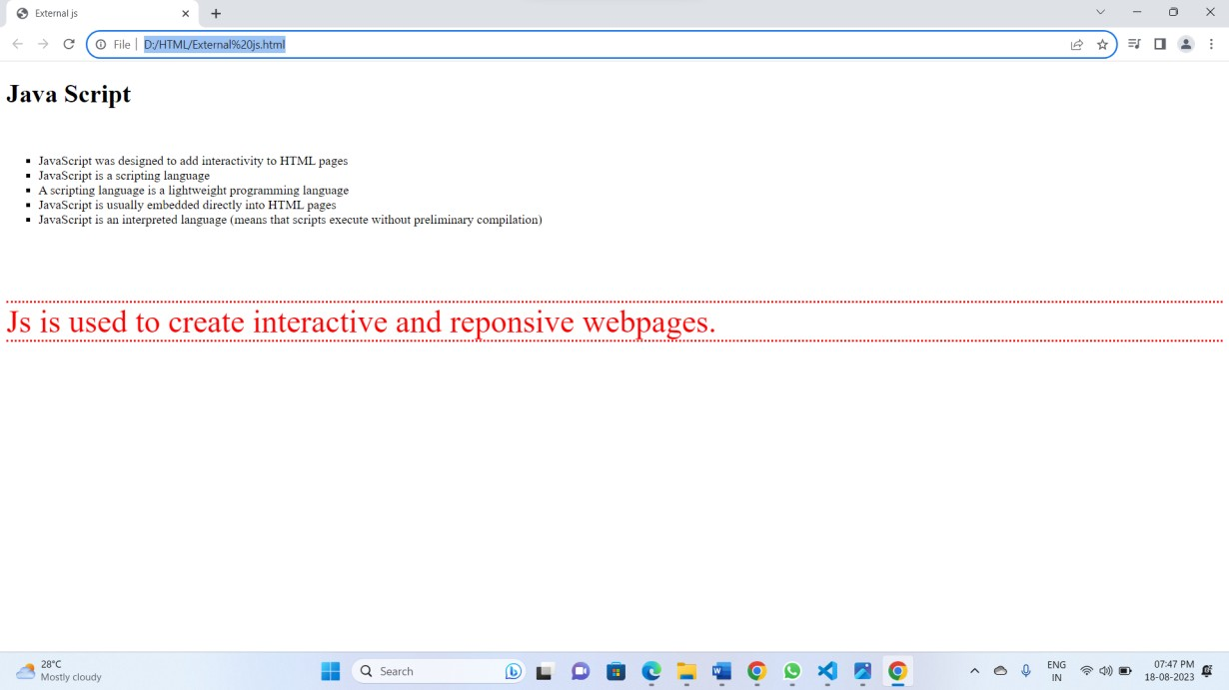

# **Q3.**Create a employee class with idno, name, job, salary. create an object to initialize the data member values. and display the same using form controls**.**

<!DOCTYPE html>

<html lang="en">

<head>

<meta charset="UTF-8">

<meta name="viewport" content="width=device-width, initial-scale=1.0">

<title>Employee Details</title>

<style>

.form-container { width: 500px; margin: 0 auto; padding: 20px;

border: 1px solid pink; border-radius: 10px;

box-shadow: 0 2px 4px rgba(210, 5, 5, 0.1);

}

</style>

</head>

<body>

<div class="form-container">

<h1>Employee Details</h1>

<form id="employeeForm">

<label for="idno">ID Number:</label>

<input type="text" id="idno" name="idno"><br><br>

<label for="name">Name:</label>

<input type="text" id="name" name="name"><br><br>

<label for="job">Job:</label>

<input type="text" id="job" name="job"><br><br>

<label for="salary">Salary:</label>

<input type="text" id="salary" name="salary"><br><br>

<button type="button" onclick="displayEmployee()">Display Employee</button>

</form>

<h2>Employee Data</h2>

<div id="employeeData"></div>

<script>

class Employee {

constructor(idno, name, job, salary) { this.idno = idno;

this.name = name; this.job = job; this.salary = salary;

}

}

function displayEmployee() {

const idno = document.getElementById("idno").value; const name = document.getElementById("name").value; const job = document.getElementById("job").value; const salary = document.getElementById("salary").value;

const employee = new Employee(idno, name, job, salary);

const employeeDataDiv = document.getElementById("employeeData"); employeeDataDiv.innerHTML = `

<p><strong>ID Number:</strong> ${employee.idno}</p>

<p><strong>Name:</strong> ${employee.name}</p>

<p><strong>Job:</strong> ${employee.job}</p>

<p><strong>Salary:</strong> ${employee.salary}</p>

`;}

</script>

</body>

</html>

**Output:**

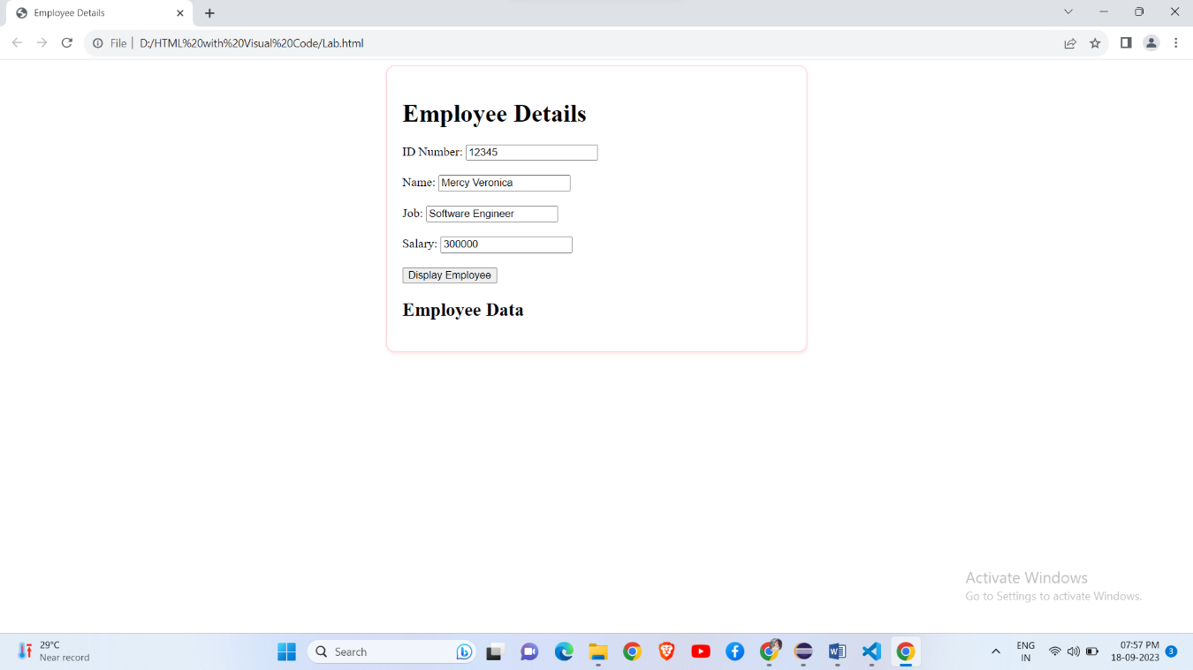

# **Q4.**Create a webpage as homepage to display about your company name, logo and menu items as services provided by the company, login button to login to your website.

<!DOCTYPE html>

<html lang="en">

<head>

<meta charset="UTF-8">

<meta name="viewport" content="width=device-width, initial-scale=1.0">

<title>Anusha</title>

<style>

body, h1, h2, p, ul, li, form { margin: 0;

padding: 0;

}

/* Basic styling */ body {

font-family: Arial, sans-serif;

}

header {

background-color: #0b3ab1; color: #110d0d;

padding: 10px; display: flex;

justify-content: space-between; align-items: center;

}

nav ul {

list-style-type: none;

}

nav ul li { display: inline;

margin-right: 20px;

}

nav a {

text-decoration: none; color: #fff;

}

section { padding: 20px;

}

form label {

display: block; margin-bottom: 5px;

}

form input { width: 100%; padding: 8px;

margin-bottom: 15px; border: 1px solid #ccc; border-radius: 3px;

}

form button { padding: 10px 15px;

background-color: #333; color: #fff;

border: none; border-radius: 3px; cursor: pointer;

}

footer {

text-align: center; padding: 10px;

background-color: #f4f4f4;

}

</style>

</head>

<body>

<header>

<img src="Anudip.jpg" alt="Anudip">

<nav>

<ul>

<li><a href="https://[www.w3schools.com/java/](http://www.w3schools.com/java/)">Home</a></li>

<li><a href="https://[www.w3schools.com/java/](http://www.w3schools.com/java/)">Services</a></li>

<li><a href="https://[www.w3schools.com/java/](http://www.w3schools.com/java/)">About Us</a></li>

<li><a href="https://[www.w3schools.com/java/](http://www.w3schools.com/java/)">Contact</a></li>

</ul>

</nav>

<script>

function fun1()

{

var name=prompt("Enter your name");

var name=prompt("Enter your password"); alert("Login Success");

document.getElementBy("header").innerHTML="welcome to "+name; document.getElementBy("header").innerHTML="Login Success";

}

</script>

<h1 id="header">

<input type="button" value="Login" id="btn1" onclick="fun1()"/>

</h1> </header>

<section id="services">

<h2>Our Courses</h2><br>

<ul>

<li>Core java</li><br>

<li>Python</li><br>

<li>HTML</li><br>

<!-- Add more service items as needed -->

</ul>

</section>

<footer>

<p>&copy; 2023 Your Company Name. All rights reserved.</p>

</footer>

</body>

</html>

**Output:**

