1.Create a webapge with Registration Form to accept the follwing details from user.

Firstname

Lastname

Mobile number

Email Id

Qualification (Drop down list) (BE, BTech, BSc, BCA)

Year of Completion Drop down List (2023, 2022, 2021, 2020)

Technicall Skills Drop down List (Web designing, Core Java, Mysql)

(Spring, spring Boot with REST API)

(core Java)

(javascript)

Intersted in Relocation (yes/No)

submit reset

read and submit the data need to be stored in javascript object and in the same page display using table.

***HTML code:***

<!DOCTYPE html>

<html>

<head>

<title>Registration Form</title>

<style>

table {

border-collapse: collapse;

width: 50%;

margin: 20px auto;

}

th, td {

border: 1px solid #dddddd;

text-align: left;

padding: 8px;

}

th {

background-color: #f2f2f2;

}

</style>

</head>

<body>

<h1>Registration Form</h1>

<form id="registrationForm">

<label for="firstname">First Name:</label>

<input type="text" id="firstname" name="firstname" required><br><br>

<label for="lastname">Last Name:</label>

<input type="text" id="lastname" name="lastname" required><br><br>

<label for="mobile">Mobile Number:</label>

<input type="tel" id="mobile" name="mobile" required><br><br>

<label for="email">Email Id:</label>

<input type="email" id="email" name="email" required><br><br>

<label for="qualification">Qualification:</label>

<select id="qualification" name="qualification">

<option value="BE">BE</option>

<option value="BTech">BTech</option>

<option value="BSc">BSc</option>

<option value="BCA">BCA</option>

</select><br><br>

<label for="year">Year of Completion:</label>

<select id="year" name="year">

<option value="2023">2023</option>

<option value="2022">2022</option>

<option value="2021">2021</option>

<option value="2020">2020</option>

</select><br><br>

<label for="skills">Technical Skills:</label>

<select id="skills" name="skills" multiple>

<option value="Web designing">Web designing</option>

<option value="Core Java">Core Java</option>

<option value="Mysql">Mysql</option>

<option value="Spring">Spring</option>

<option value="Spring Boot with REST API">Spring Boot with REST API</option>

<option value="Javascript">Javascript</option>

</select><br><br>

<label for="relocation">Interested in Relocation:</label>

<input type="radio" id="relocationYes" name="relocation" value="Yes"> Yes

<input type="radio" id="relocationNo" name="relocation" value="No"> No<br><br>

<input type="button" value="Submit" onclick="submitForm()">

<input type="reset" value="Reset">

</form>

<h2>Registered Users</h2>

<table id="userTable">

<thead>

<tr>

<th>First Name</th>

<th>Last Name</th>

<th>Mobile Number</th>

<th>Email Id</th>

<th>Qualification</th>

<th>Year of Completion</th>

<th>Technical Skills</th>

<th>Interested in Relocation</th>

</tr>

</thead>

<tbody id="userTableBody">

</tbody>

</table>

<script>

var users = [];

function submitForm() {

var formData = {

firstname: document.getElementById('firstname').value,

lastname: document.getElementById('lastname').value,

mobile: document.getElementById('mobile').value,

email: document.getElementById('email').value,

qualification: document.getElementById('qualification').value,

year: document.getElementById('year').value,

skills: Array.from(document.getElementById('skills').selectedOptions, option => option.value),

relocation: document.querySelector('input[name="relocation"]:checked').value

};

users.push(formData);

updateTable();

document.getElementById('registrationForm').reset();

}

function updateTable() {

var tableBody = document.getElementById('userTableBody');

tableBody.innerHTML = '';

for (var i = 0; i < users.length; i++) {

var user = users[i];

var row = tableBody.insertRow();

row.insertCell().textContent = user.firstname;

row.insertCell().textContent = user.lastname;

row.insertCell().textContent = user.mobile;

row.insertCell().textContent = user.email;

row.insertCell().textContent = user.qualification;

row.insertCell().textContent = user.year;

row.insertCell().textContent = user.skills.join(', ');

row.insertCell().textContent = user.relocation;

}

}

</script>

</body>

</html>

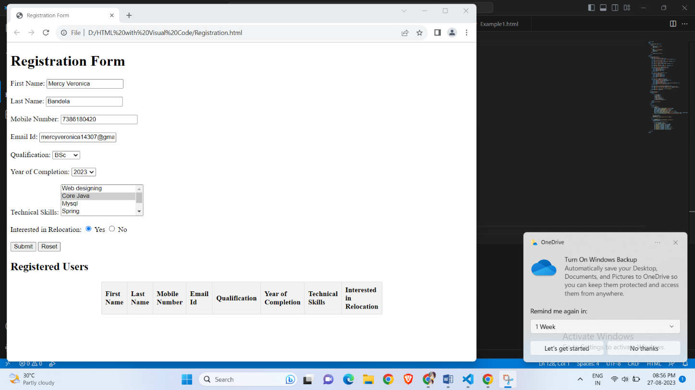

1. Create a webpage using table with Css to write the advantages of Spring boot with explanations.

***HTML CODE:***

<!DOCTYPE html>

<html>

<head>

<title>Advantages of Spring Boot</title>

<style>

body {

font-family: Arial, sans-serif;

margin: 20px;

}

h1 {

text-align: center;

}

table {

width: 80%;

margin: 0 auto;

border-collapse: collapse;

}

th, td {

padding: 10px;

text-align: left;

border-bottom: 1px solid #ddd;

}

th {

background-color: #f2f2f2;

}

tr:hover {

background-color: #f5f5f5;

}

</style>

</head>

<body>

<h1>Advantages of Spring Boot</h1>

<table>

<tr>

<th>Advantage</th>

<th>Explanation</th>

</tr>

<tr>

<td>1. Simplified Development</td>

<td>Spring Boot simplifies the development of Java applications by providing default configurations and reducing the need for boilerplate code.</td>

</tr>

<tr>

<td>2. Microservices Support</td>

<td>It is well-suited for building microservices-based architectures, making it easier to develop and deploy individual services.</td>

</tr>

<tr>

<td>3. Embedded Servers</td>

<td>Spring Boot includes embedded servers like Tomcat, Jetty, and Undertow, eliminating the need for external server setup.</td>

</tr>

<tr>

<td>4. Auto Configuration</td>

<td>Auto-configuration automatically configures beans based on project dependencies, reducing the need for manual configuration.</td>

</tr>

<tr>

<td>5. Production-Ready Features</td>

<td>It offers production-ready features like metrics, health checks, and externalized configuration, making it easier to deploy applications to production.</td>

</tr>

</table>

</body>

</html>

