1. Explain the architecture of Spring Framework

Spring could potentially be a one-stop shop for all your enterprise applications. However, Spring is modular, allowing you to pick and choose which modules are applicable to you, without having to bring in the rest. The following section provides details about all the modules available in Spring Framework.

The Spring Framework provides about 20 modules which can be used based on an application requirement.

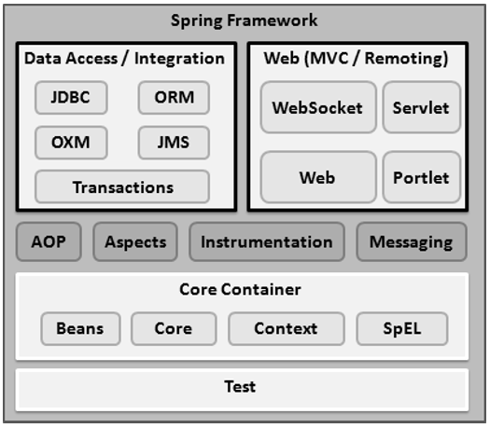

Core Container

The Core Container consists of the Core, Beans, Context, and Expression Language modules the details of which are as follows −

* The **Core** module provides the fundamental parts of the framework, including the IoC and Dependency Injection features.
* The **Bean** module provides BeanFactory, which is a sophisticated implementation of the factory pattern.
* The **Context** module builds on the solid base provided by the Core and Beans modules and it is a medium to access any objects defined and configured. The ApplicationContext interface is the focal point of the Context module.
* The **SpEL** module provides a powerful expression language for querying and manipulating an object graph at runtime.

Data Access/Integration

The Data Access/Integration layer consists of the JDBC, ORM, OXM, JMS and Transaction modules whose detail is as follows −

* The **JDBC** module provides a JDBC-abstraction layer that removes the need for tedious JDBC related coding.
* The **ORM** module provides integration layers for popular object-relational mapping APIs, including JPA, JDO, Hibernate, and iBatis.
* The **OXM** module provides an abstraction layer that supports Object/XML mapping implementations for JAXB, Castor, XMLBeans, JiBX and XStream.
* The Java Messaging Service **JMS** module contains features for producing and consuming messages.
* The **Transaction** module supports programmatic and declarative transaction management for classes that implement special interfaces and for all your POJOs.

Web

The Web layer consists of the Web, Web-MVC, Web-Socket, and Web-Portlet modules the details of which are as follows −

* The **Web** module provides basic web-oriented integration features such as multipart file-upload functionality and the initialization of the IoC container using servlet listeners and a web-oriented application context.
* The **Web-MVC** module contains Spring's Model-View-Controller (MVC) implementation for web applications.
* The **Web-Socket** module provides support for WebSocket-based, two-way communication between the client and the server in web applications.
* The **Web-Portlet** module provides the MVC implementation to be used in a portlet environment and mirrors the functionality of Web-Servlet module.

2. Create a Simple spring boot application to print hello world message to user in browser when the spring spoot app is up on your server.

package com.example.controller;

import org.springframework.web.blind.annotation.GetMapping;

@RestController

public class HomeController{

@GetMapping(“/”)

public String index()

{

return “Hello!!!”;

}

}