- Divide By Zero Exception

using System;
class Program
{
static void Main()
{
try
{
int a = 10;
int b = 0;
int result = a / b;
Console.WriteLine(result);
}
catch (DivideByZeroException)
{
Console.WriteLine("Cannot divide by zero.");
}
}
}
OUTPUT
- Format Exception

using System;
class Program
{
static void Main()
{
try
{
Console.Write("Enter a number: ");
int number = Convert.ToInt32(Console.ReadLine());

Console.WriteLine("Number = " + number);
}
catch (FormatException)
{
Console.WriteLine("Please enter a valid number.");
}
}
}
OUTPUT
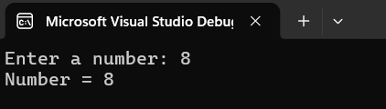
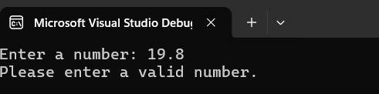
- Custom Exception
using System;
class AgeException : Exception
{
public AgeException(string message) : base(message)
{
}
}
class Program
{
static void Main()
{
try
{
int age = 15;

if (age < 18)
{
throw new AgeException("Age must be 18 or above.");
}

Console.WriteLine("Eligible.");
}
catch (AgeException ex)
{
Console.WriteLine(ex.Message);
}
}
}
OUTPUT
