Reproducible Research - Week 2 - Course Project 1

## Read in the Data

url <- "https://d396qusza40orc.cloudfront.net/repdata%2Fdata%2Factivity.zip"  
download.file(url, destfile = "repdata%2Fdata%2Factivity.zip")  
rda <- read_delim("repdata%2Fdata%2Factivity.zip", ",", na = "NA")

## Parsed with column specification:  
## cols(  
## steps = col_integer(),  
## date = col_date(format = ""),  
## interval = col_integer()  
## )

## Plot the total number of steps taken each day

bydate <- aggregate(rda$steps, by=list(Date = rda$date), FUN = sum, na.action = NULL)  
hist(bydate$x, breaks = 20, main = "Frequency of Daily Step Count",   
 xlab = "Total Daily Steps", ylab = "Frequency")

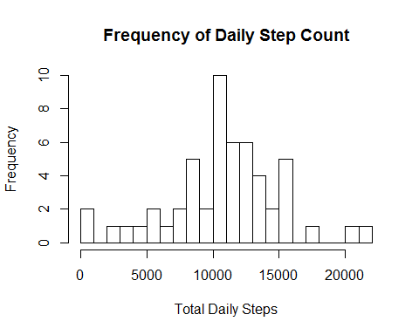

## Mean and median number of steps taken each day

mm <- aggregate(rda$steps, by = list(Date = rda$date),   
 FUN = function(x) c(mean = mean(x), median = median(x, na.action = NULL)))  
print(mm)

## Date x.mean x.median  
## 1 2012-10-01 NA NA  
## 2 2012-10-02 0.4375000 0.0000000  
## 3 2012-10-03 39.4166667 0.0000000  
## 4 2012-10-04 42.0694444 0.0000000  
## 5 2012-10-05 46.1597222 0.0000000  
## 6 2012-10-06 53.5416667 0.0000000  
## 7 2012-10-07 38.2465278 0.0000000  
## 8 2012-10-08 NA NA  
## 9 2012-10-09 44.4826389 0.0000000  
## 10 2012-10-10 34.3750000 0.0000000  
## 11 2012-10-11 35.7777778 0.0000000  
## 12 2012-10-12 60.3541667 0.0000000  
## 13 2012-10-13 43.1458333 0.0000000  
## 14 2012-10-14 52.4236111 0.0000000  
## 15 2012-10-15 35.2048611 0.0000000  
## 16 2012-10-16 52.3750000 0.0000000  
## 17 2012-10-17 46.7083333 0.0000000  
## 18 2012-10-18 34.9166667 0.0000000  
## 19 2012-10-19 41.0729167 0.0000000  
## 20 2012-10-20 36.0937500 0.0000000  
## 21 2012-10-21 30.6284722 0.0000000  
## 22 2012-10-22 46.7361111 0.0000000  
## 23 2012-10-23 30.9652778 0.0000000  
## 24 2012-10-24 29.0104167 0.0000000  
## 25 2012-10-25 8.6527778 0.0000000  
## 26 2012-10-26 23.5347222 0.0000000  
## 27 2012-10-27 35.1354167 0.0000000  
## 28 2012-10-28 39.7847222 0.0000000  
## 29 2012-10-29 17.4236111 0.0000000  
## 30 2012-10-30 34.0937500 0.0000000  
## 31 2012-10-31 53.5208333 0.0000000  
## 32 2012-11-01 NA NA  
## 33 2012-11-02 36.8055556 0.0000000  
## 34 2012-11-03 36.7048611 0.0000000  
## 35 2012-11-04 NA NA  
## 36 2012-11-05 36.2465278 0.0000000  
## 37 2012-11-06 28.9375000 0.0000000  
## 38 2012-11-07 44.7326389 0.0000000  
## 39 2012-11-08 11.1770833 0.0000000  
## 40 2012-11-09 NA NA  
## 41 2012-11-10 NA NA  
## 42 2012-11-11 43.7777778 0.0000000  
## 43 2012-11-12 37.3784722 0.0000000  
## 44 2012-11-13 25.4722222 0.0000000  
## 45 2012-11-14 NA NA  
## 46 2012-11-15 0.1423611 0.0000000  
## 47 2012-11-16 18.8923611 0.0000000  
## 48 2012-11-17 49.7881944 0.0000000  
## 49 2012-11-18 52.4652778 0.0000000  
## 50 2012-11-19 30.6979167 0.0000000  
## 51 2012-11-20 15.5277778 0.0000000  
## 52 2012-11-21 44.3993056 0.0000000  
## 53 2012-11-22 70.9270833 0.0000000  
## 54 2012-11-23 73.5902778 0.0000000  
## 55 2012-11-24 50.2708333 0.0000000  
## 56 2012-11-25 41.0902778 0.0000000  
## 57 2012-11-26 38.7569444 0.0000000  
## 58 2012-11-27 47.3819444 0.0000000  
## 59 2012-11-28 35.3576389 0.0000000  
## 60 2012-11-29 24.4687500 0.0000000  
## 61 2012-11-30 NA NA

## Average daily activity pattern

byint <- aggregate(steps ~ interval, data = rda, mean)  
  
## I added a column for the row number of the interval, as the intervals have big gaps for each hundreds  
## value - from 55 to 0 of the next hundreds value  
  
byint$row <- row(byint[1])  
plot(byint$row, byint$steps, type = "l", main = "Average daily activity pattern", xlab = "Time interval", ylab = "Average steps")

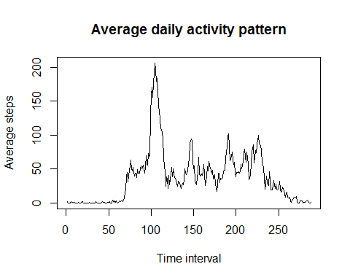

### Find interval with maximum average steps:

byint[which.max(byint$steps), 1:2]

## interval steps  
## 104 835 206.1698

## Input missing values:

## The number of missing values:  
paste("The number of missing values in the dataset is:", sum(is.na(rda)))

## [1] "The number of missing values in the dataset is: 2304"

## Replace "NA" values in the dataset with the average value for that interval

## First, the data is reshaped:  
mlt <- melt(rda, id=2:3)  
new <- cast(mlt, interval~date)  
  
## Then, NA values are replaced:  
  
for (j in 2:dim(new)[2]){ ## for each column, excluding the first one which is the interval  
 for (i in 1:dim(new)[1]){ ## for each row  
   
 if (is.na(new[i,j]) == "TRUE"){  
 new[i,j] <- byint[i,2]  
 }  
 }  
}  
  
## Verify all NA values are gone:   
paste("the number of 'NA' values in this data set is", sum(is.na(new)))

## [1] "the number of 'NA' values in this data set is 0"

## Now repeat the histogram calculations for the new dataset  
## First the dataset must be "re-melted"  
  
mlt <- melt(new, id=1)  
rownames(mlt) <- row(mlt[1])  
  
bydat <- aggregate(mlt$value, by=list(Date = rda$date), FUN = sum)  
  
hist(bydat$x, breaks = 20, ylim=c(0,20), xlim = c(0,20000),  
 main = "Frequency of Daily Step Count",   
 xlab = "Total Daily Steps", ylab = "Frequency")

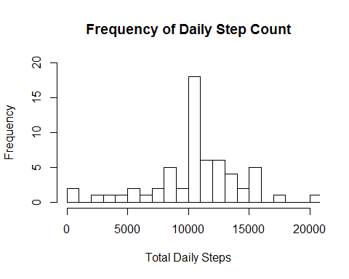

## and report the mean and median of the adjusted dataset  
  
mmm <- aggregate(mlt$value, by = list(Date = rda$date),   
 FUN = function(x) c(mean = mean(x), median = median(x)))  
print(mmm)

## Date x.mean x.median  
## 1 2012-10-01 37.3825996 34.1132075  
## 2 2012-10-02 0.4375000 0.0000000  
## 3 2012-10-03 39.4166667 0.0000000  
## 4 2012-10-04 42.0694444 0.0000000  
## 5 2012-10-05 46.1597222 0.0000000  
## 6 2012-10-06 53.5416667 0.0000000  
## 7 2012-10-07 38.2465278 0.0000000  
## 8 2012-10-08 37.3825996 34.1132075  
## 9 2012-10-09 44.4826389 0.0000000  
## 10 2012-10-10 34.3750000 0.0000000  
## 11 2012-10-11 35.7777778 0.0000000  
## 12 2012-10-12 60.3541667 0.0000000  
## 13 2012-10-13 43.1458333 0.0000000  
## 14 2012-10-14 52.4236111 0.0000000  
## 15 2012-10-15 35.2048611 0.0000000  
## 16 2012-10-16 52.3750000 0.0000000  
## 17 2012-10-17 46.7083333 0.0000000  
## 18 2012-10-18 34.9166667 0.0000000  
## 19 2012-10-19 41.0729167 0.0000000  
## 20 2012-10-20 36.0937500 0.0000000  
## 21 2012-10-21 30.6284722 0.0000000  
## 22 2012-10-22 46.7361111 0.0000000  
## 23 2012-10-23 30.9652778 0.0000000  
## 24 2012-10-24 29.0104167 0.0000000  
## 25 2012-10-25 8.6527778 0.0000000  
## 26 2012-10-26 23.5347222 0.0000000  
## 27 2012-10-27 35.1354167 0.0000000  
## 28 2012-10-28 39.7847222 0.0000000  
## 29 2012-10-29 17.4236111 0.0000000  
## 30 2012-10-30 34.0937500 0.0000000  
## 31 2012-10-31 53.5208333 0.0000000  
## 32 2012-11-01 37.3825996 34.1132075  
## 33 2012-11-02 36.8055556 0.0000000  
## 34 2012-11-03 36.7048611 0.0000000  
## 35 2012-11-04 37.3825996 34.1132075  
## 36 2012-11-05 36.2465278 0.0000000  
## 37 2012-11-06 28.9375000 0.0000000  
## 38 2012-11-07 44.7326389 0.0000000  
## 39 2012-11-08 11.1770833 0.0000000  
## 40 2012-11-09 37.3825996 34.1132075  
## 41 2012-11-10 37.3825996 34.1132075  
## 42 2012-11-11 43.7777778 0.0000000  
## 43 2012-11-12 37.3784722 0.0000000  
## 44 2012-11-13 25.4722222 0.0000000  
## 45 2012-11-14 37.3825996 34.1132075  
## 46 2012-11-15 0.1423611 0.0000000  
## 47 2012-11-16 18.8923611 0.0000000  
## 48 2012-11-17 49.7881944 0.0000000  
## 49 2012-11-18 52.4652778 0.0000000  
## 50 2012-11-19 30.6979167 0.0000000  
## 51 2012-11-20 15.5277778 0.0000000  
## 52 2012-11-21 44.3993056 0.0000000  
## 53 2012-11-22 70.9270833 0.0000000  
## 54 2012-11-23 73.5902778 0.0000000  
## 55 2012-11-24 50.2708333 0.0000000  
## 56 2012-11-25 41.0902778 0.0000000  
## 57 2012-11-26 38.7569444 0.0000000  
## 58 2012-11-27 47.3819444 0.0000000  
## 59 2012-11-28 35.3576389 0.0000000  
## 60 2012-11-29 24.4687500 0.0000000  
## 61 2012-11-30 37.3825996 34.1132075

## What was the impact of replacing the missing values?

## Plot the "before" and "after" histograms together and visually compare  
par(mfrow = c(1,2))  
hist(bydate$x, breaks = 20, main = "Frequency of Daily Step Count", ylim = c(0,20),   
 xlab = "Total Daily Steps - with NA values", ylab = "Frequency")  
 hist(bydat$x, breaks = 20, ylim=c(0,20), xlim = c(0,20000),  
 main = "Frequency of Daily Step Count",   
 xlab = "Total Daily Steps - without NA values", ylab = "Frequency")

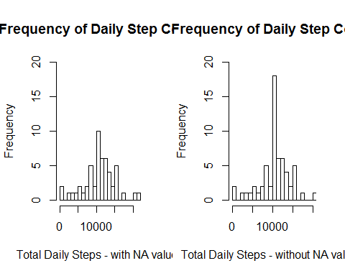

We can see that the "bell" shape of the graph has gotten narrower and higher in amplitude.  
As for the mean and median values, there are now values where there were previously not values.  
Where there were values previously, these values are unchanged.

## Are there differences between weekdays and weekends?

## Add the category for if a day is a weekday or weekend  
mlt$day <- weekdays(mlt$date, abbreviate = TRUE)  
mlt$end <- "weekday"  
mlt[grep("Sat", mlt$day),5] <- "weekend"  
mlt[grep("Sun", mlt$day),5] <- "weekend"  
mlt$end <- as.factor(mlt$end)  
  
## Aggregate the data, finding the mean over each interval and "end" factor  
byin <- aggregate(value ~ interval + end, data = mlt, mean)  
byin$row <- row(byin[1]) ## Again, the "interval" values have big gaps, so we are using rows (i.e. interval numbers) to plot  
 byin[289:576,4] <- byin[1:288, 4] ##Have to subtract 288 because rows are duplicated (for 2 factors)  
   
xyplot(value ~ row | end, data = byin, type = "l", layout = c(1,2),   
 main = "Average daily activity pattern", xlab = "Time interval", ylab = "Average steps")

