Project
https://gist.github.com/ButenkoT/a809f9695a3c55f4db54

Day plan

9/10 FRI | Search and select 2048 as project
10/10 SAT-SUN | - Lookup web resource, project analysis  -planning steps  - setup home PC with git and sublime
11/10 MON | -install sublime package  -learn sublime shortcut, emmet shortcut  - add subl link in pc bash(not working)  - finish pseudo code
12/10 TUE | - Get js file working. Leave out div  - Start HTML/CSS, game layout  - Div action start
13/10 WED | HTML/CSS  - Get div moving
14/10 THU | Debug
15/10 FRI | Due date, presentation

Game Overview
Game Strategy: https://www.youtube.com/watch?v=2aED90sMZII

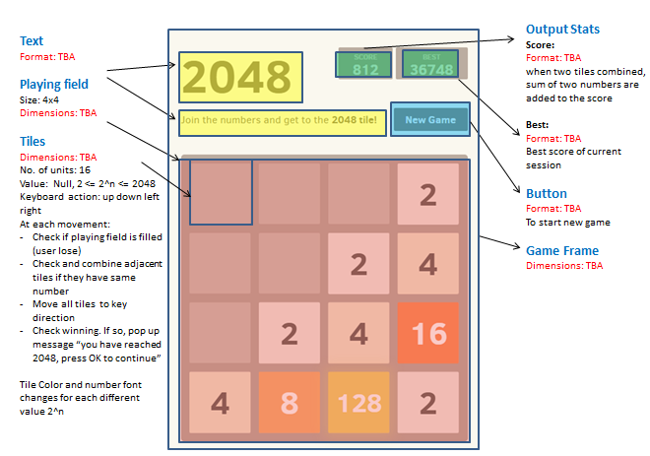
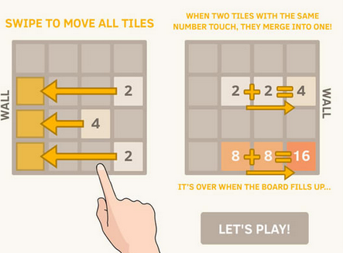

Colour Scheme
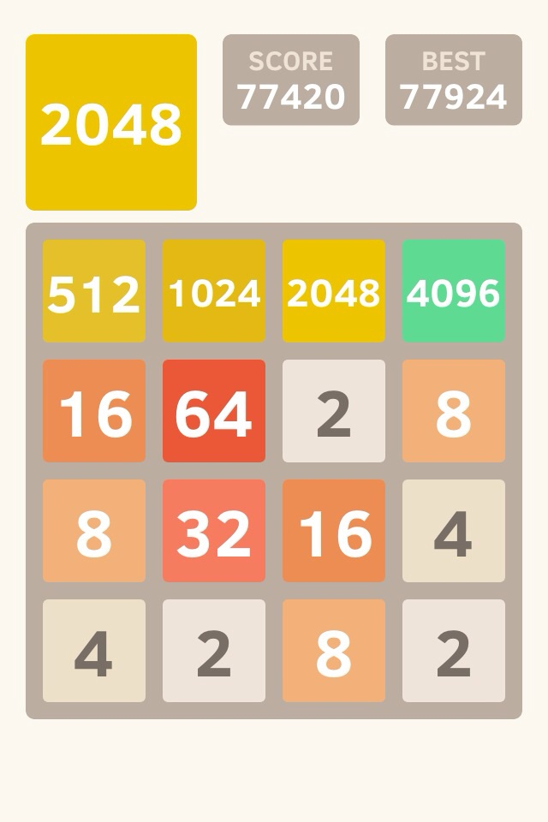

JavaScript

Pseudo
- An array to store value 4x4 store value(2,4,8,16 etc) or tile object
- tile object: .ID, .row, .column, .value, bkColor, .fontSize, color
- boolean msgCalled = false; //has current game tile value reached 2048

Functions
- function addTile()complete
  - randomly select row with empty node
  - randomly select col with empty node
  - array update: change empty node value to ‘2’
- function addDivTile()
  - create div tile block in HTML
  - formatTile(tileValue);
- function moveDivTile()
  - DIV: update tile position and create tile motion
  - formatTile(tileValue)
- function formatDivTile(tileValue);
  - given value, update color, fontsize, bkcolor, size, location
- function newGame(), complete
  - var array: update 2D array 4x4, each value = 0
  - call addTile() twice (HTML)
- function getRandNum(arrLength) complete
  - return value = [0, arrLength-1] //return array index
- function checkWinLoss()
  - if minTileValue > 0, then pop up msg
    - DIV alert (lost msg)
    - DIV link to call newGame()
  - if maxTileValue = 2048 && msgCalled === false, then return false
    - DIV alert(reached 2048)
    - msgCalled = true; //so that the winning msg only displayed once for current game
- function addScore()
  - calc score of current game
  - compare if score > bestScore, update bestScore
  - bestScore keep best game score of current session
  - Update DIV score and DIV best_score
- Function key press
  - each movement(left,right,up,down):
    - get direction and loop through 4 rows/col, if two numbers are the same
      - add sum result to score
      - update array value:
        - eg if moving to right, two tiles with same value will form into one tile, and location of rest of array move to right, index[0] value become zero
      - moveTile()
      - addTile()
    - if each row/col is full, do nothing
  - addScore()
  - checkWinLoss()

CSS/HTML
- div class game_title
- div class score
- div class best_score
- div class game_container
- div tile_container(get object ID)
  - div childnote

Github page

github pages note, you can find it in gitbook as well
Tanya Butenko[3:25 PM]
3:25- `git checkout -b gh-pages`
- `git push origin gh-pages`
That will get the copy up there. To keep the branches up to date...
- Always work in master - `git checkout master`
- Add and commit
- Switch to gh-pages - `git checkout gh-pages`
- Merge in from master - `git merge master`

