**MZUMBE UNIVERSITY**



**FACULT OF SCIENCE AND TECHNOLOGY**

**(FST)**

**PROJECT REPORT ON LEAVE MANAGEMENT SYSTEM**

**A CASE STUDY OF MZUMBE UNIVERSITY**

**PREPARED BY**

**PETRO MAKUGU**

**REG NO: 13211023/T.19**

**A PROJECT REPORT IN FULFILLMENT OF REQUIREMENT FOR THE AWARD OF DIPLOMA IN INFORMATION TECHNOLOGY**

**AUGUST 2021**

# CERTIFICATION

The undersigned certify that we have read and hereby recommend for acceptance by the Mzumbe University, a project report entitled leave management system in partial fulfillment of the requirement for an award of diploma of science in information technology and system.

**Supervisor’s name _______________________­­­­­­­­­­­­­­­________________**

**Signature _______________________________________**

**Date** _______________________________________

# DECLARATION

I, **PETRO MAKUNGU** declared that this project report is my own original work and that it has not been presented and will not be presented to any other College for similar or any other award. No part of this project may be reproduced, stored in any retrieved system, or transmitted in any form or by means without prior written permission of the Author or Mzumbe University.

**Signature** ____________________________________

**Date**  ____________________________________

# LIST OF ABBREVIATIONS

CEO Chief Executive Officer

JS JavaScript

LMS Leave Management System

HTML HyperText Markup language

RAM Random Access Memory

PHP Hypertext Preprocessor

CPU central processing unit

DBA Database administration

CSS Cascading Style sheet

# LIST OF FIGURES

Figure 1 shows all the required phase in waterfall model 15

Figure 2 Shows task that performed with admin 17

Figure 3 Shows task that performed with employee 18

Figure 4 Shows task that performed with officer 18

Figure 5 Relevant diagram for the selected methodology for system implementation 19

Figure 6 shows Home page 21

Figure 7 Shows the registration form 21

Figure 8 shows leave applied 22

Figure 9 Shows application leave form 22

Figure 10 shows database home page 23

Figure 11 Shows the tables in the database 23

# ACKNOLEDGEMENT

I would like to express my thanks to GOD for my health and give me such an excellent guidance for my studies and final year project. I take the opportunity to express my deep and sincere sense of gratitude to wards my supervisor of my final year project together with my parents whom they give my enough support and enough inspiration and encouragement, they constant help, through fall suggestions and deep interest have enabled me to complete this work.

I am also thankful to all those who have helped me in this endeavor directly or indirectly, including my friends for their support and guidance. They were the main force behind this work because of its valuable suggestions and proper guidance for this project.

Also special thanks to my project supervisor MR PAUL MUSHIwho had used his time to review my work from time to time to make sure that it is well presented, also I thanks to computing science department for giving me this opportunity to conduct this project.

However, I take this opportunity to thanks all that are not mention here in this report, hoping they would have been a good help me.

# ABSTRACT

The project is the design and implementation of an interactive World Wide Web-based Leave Management System for the Human Resources department or someone who are responsible for giving leave in the organization at any organization. The Leave Management System automates the process of managing and tracking multiple types of employee leaves. Employees are able to submit the leave form, cancel previously submitted leave requests, check the status of leave requests and view completed leave transactions. The Leave Management System maintains a database to keep a running balance of each employee’s account, accrues employee vacation and sick credits and provides individual reports on employees leave accruals.

**TABLE OF CONTENT**

CERTIFICATION i

DECLARATION ii

LIST OF ABBREVIATIONS iii

LIST OF FIGURES iv

ACKNOLEDGEMENT v

ABSTRACT vi

CHAPTER ONE 1

INTRODUCTION AND PROBLEM DESCRIPTION 1

1.1 BACKGROUND 1

1.2 PROBLEM STATEMENT 1

1.3 PROJECT OBJECTIVES 2

1.3.1 Main objective 2

1.3.2 Specific objectives 2

1.4 SIGNIFICANCE AND SCOPE 2

1.4.1 LIMITATION OF THE PROJECT 2

CHAPTER TWO 3

LITERATURE REVIEW 3

2.0 TOPIC REVIEW 3

2.1 SOFTWARE REQUIREMENT 3

2.1.1 HTML 3

1.2.2 PHP 4

1.2.3 DATABASE 4

2.2. HARDWARE REQUIREMENT: 5

2.2.1Hardware Requirements for Server 5

2.2.2CPU Speed 6

CHAPTER THREE 7

REQUIREMENT ELICITATION AND SYSTEM ANALYSIS 7

3.1 Introduction to requirement elicitation. 7

3.2 System functionalities 8

3.2.1 Functional requirement 8

3.2.2 Non Functional requirement 8

3.2.3 Characteristics of the system 9

3.2.4 Domain requirement 9

3.3 System analysis. 10

3.3.1 Requirement collection. 10

3.3.2 Feasibility study. 10

3.4 Staff shall be entitled to the following types of leaves 11

CHAPTER FOUR: 14

SYSTEM DESIGN 14

4.0. PROJECT METHODOLOGY 14

4.1. Introduction to system design 14

4.2. System Development Life Cycle (SDLC) 15

4.2.1 Project plan 15

4.2.2 Planning 16

4.2.3 Analysis 16

4.2.4 Designing 16

4.2.5 Implementation 16

4.2.6. Design 16

4.3 USER INTERFACE DESIGN 17

4.3.1 Use case of the system 17

SYSTEM ADMIN 17

EMPLOYEE 18

CHAPTER FIVE 19

SYSTEM IMPLEMENTATION 19

5.1 Introduction to system implementation 19

5.1.1 Tools used to develop the leave management system 20

5.2 functionality of the implementation. 20

5.2.1 User interface implementation 21

22

5.2.2 Database implementation 23

CHAPTER SIX 24

CONCLUSION AND RECOMMENDATIONS 24

6.1 Summary of achieved objective 24

6.2 Conclusion 24

6.3 RECOMMENDATION 24

REFERENCES 25

# CHAPTER ONE

## **INTRODUCTION AND PROBLEM DESCRIPTION**

## 1.1 BACKGROUND

Leave management system means the process of handling leaves and absences due to sickness vacation or other reasons also it can be enable the employees to maintain a record of their leaves as well as make requests for the same within the organization. The employees can apply for leave on leave system, manager will get email or username notification of employees leave application also not as much forward and backward is required when employees can submit requests instantly. Within this title there some words that I can explain. LEAVE means left or go away from, MANAGEMENT means the process of dealing with or controlling things or people. SYSTEM means a collection of elements or components that are organized to form a common purpose.

## 1.2 PROBLEM STATEMENT

In the existing system, leaves are maintained using the attendance register for staff. The staff needs to submit their leaves manually to their respective authorities. This increases the paperwork and maintaining the records becomes tedious. Maintaining notices in the records also increases the paperwork. The main objective of the proposed system is to reduce the paperwork and help in easier record maintenance by having a particular centralized Database System, where Leaves and Notices are maintained. The proposed system modernizes and automates the existing system. It decreases the paperwork and enables easier record maintenance. It also reduces chances of Data loss.

## 1.3 PROJECT OBJECTIVES

### 1.3.1 Main objective

To design and implement an automated leave management system that can allow employee to apply leave within the organization.

### 1.3.2 Specific objectives

The following are the specific objectives in leave management system.

1. To gather by requirements for leave management system design and development
2. To design the system models and database of leave management system
3. To implement objective number two
4. To test the system developed

## 1.4 SIGNIFICANCE AND SCOPE

This system can be used in any organization in order to help employees to apply leaves in a certain organization. In use at Mzumbe university this system also can be used in order to help employees to apply different leave to human resource or to one who its concern to give leave to employees.

### 1.4.1 LIMITATION OF THE PROJECT

This application is used within the organization and not outside. All employees that are be registered by admin are allowed to use this system and not vise verse

# 

# CHAPTER TWO

# LITERATURE REVIEW

## 2.0 TOPIC REVIEW

In this chapter including the different explanation definition and their importance of some terms that used to develop this system.

## 2.1 SOFTWARE REQUIREMENT

Software Requirements deal with defining software resource requirements and pre-requisites that need to be installed on a computer to provide optimal functioning of an application. These requirements or pre-requisites are generally not included in the software installation package and need to be installed separately before the software is installed.

### 2.1.1 HTML

HTML stands for Hyper Text Markup Language.HTML is the standard markup language for creating Web pages. HTML describes the structure of a Web page. HTML consists of a series of elements. HTML elements tell the browser how to display the content. HTML elements are represented by tags. HTML tags label pieces of content such as "heading", "paragraph", "table", and so on. Browsers do not display the HTML tags, but use them to render the content of the page

THE BASIC STRUCTURE OF AN HTML DOCUMENT

<!DOCTYPE html>  
<html>  
<head><title>Page Title</title></head>  
<body></body>  
</html>

**Importance of html**

A significant benefit of HTML it is free of charge and no need to install any software.

HTML is simple to use and understand. and high speed loading time.

All browsers support HTML.

Most development tools whatever they are paid or free all support HTML.

### 1.2.2 PHP

PHP is an acronym for "PHP: Hypertext Preprocessor". PHP is a widely-used, open source scripting language. PHP scripts are executed on the server

**Basic PHP Syntax**

<?php and ends with ?>:

<?php  
// PHP code   
?>

**Importance of PHP**

PHP used to generate dynamic page content can create, open, read, write, and close files on the server, can collect form data, can send and retrieve cookies, can add, delete, modify data on your database.

### 1.2.3 DATABASE

A database is a collection of related data or information that is organized so that it can easily to be accessed. Also a database can be divided into two part which are Server based (Multiuser) and Desktop based (single user). A database also is a back-end of an application. A DBMS receives instruction from a database administrator (DBA).

**Importance of Database**

Save time: this is the one of the importance of database. A database it save time like when a user want to enter a specific keywords in order to recall information. The database becomes a more efficient solution than paper files held in a file folder.

More secured: The database management system can ensure only authorized users are allowed to access the information.

Modularity: The system can be modified, added, and removed from the distributed database without affecting other modules (system).

## 2.2. HARDWARE REQUIREMENT:

The most common set of requirements defined by any operating system or software application is the physical computer resources, also known as hardware. A hardware requirements list is often accompanied by a hardware compatibility list (HCL), especially in case of operating systems. An HCL lists tested, compatibility and sometimes incompatible hardware devices for a particular operating system or application. The following sub-sections discuss the various aspects of hardware requirements.

### 2.2.1Hardware Requirements for Server

Processor : Intel dual Core, Core i3 Ram : 1 GB Hard Disk :80 GB CPU Speed : 2.6 GHz Monitor : EGA / SVGA (display), 800 × 600 24 bits True Color.

Processor

: The “brains” of a server, most servers contain multi

-core processors so they can attack computing tasks with greater speed and efficiency. In general, the faster our processors, and the more threads that are devoted to our server instance, the better our complex programs and applications will run

Hard Disk

: A disk space is the amount of storage space which is required for our website. The disk space is offered in different ways by manufacture, it can primarily be on the dedicated server or on shared server or you can also opt for virtual private server (VPS). Bandwidth is the amount of data which is transferred through the system at one time. Bandwidth has a user attribute attached wherein the disk space requirement is solely based on the system

owner’s perspective.

### 2.2.2CPU Speed

The CPU resources will be split. The requests will be processed in the order they are received. However, the CPU will be able to process multiple requests at once, and can use time sling to ensure the requests are handled very

quickly. Still, CPUs can get overloaded. If there’s a large surge in traffic, or a huge amount of scripting requests, then the performance of our system will suffer. If we have a large, or high traffic, we recommend choosing a higher

# 

# CHAPTER THREE

# REQUIREMENT ELICITATION AND SYSTEM ANALYSIS

## 3.1 Introduction to requirement elicitation.

Requirement elicitation (requirement gathering), is the process of deriving the system requirement from stakeholders (somervile,2011). In the process of collecting requirements all stakeholders (food customers) were actively consulted.

Requirement elicitation analysis, is a process of interacting with the customer and all end user of the system to find out about the domain requirement, what services should the system provide and the other constraints. In the requirement elicitation system requirements, there are two parts to consider these are;

* Functional requirements
* Non-functional requirements.
* Domain requirement.

These two requirements will describe to us the capabilities of the system based on the objectives and goals, and what physical software requirements are necessary for the system to work. This chapter will mostly cover on the analysis of the system as well as general requirements of the system for the both domain, functional and non-functional requirements. The chapter will also show how the system together with diagram showing how they flows from the user to the system and back again to the user.

Requirement analysis, is the first and important step in the software development activity for building robust and user -friendly ordering. I have started working on determining the functionalities that the system should provide, I have done a good amount of research on existing systems and the disadvantages of those system once the functional requirement is finalized, I make research on the current technologies that are widely used in the industry.

## 3.2 System functionalities

### 3.2.1 Functional requirement

The functional requirement of the project is define under two modules .the first modules allow the system administrator to log into his account and has the privileges to do multiple thing some of the include adding new employee, accepting employee leave and modifying employee information like deleting of employees

The second modules of the project allow the employees to login into the system and making leave application, also the project allow the employees to view feedback of their leave application from admin; no other privileges are given to the user this mean that any phase in the development process begins only if the previous phase is complete in waterfall

### 3.2.2 Non Functional requirement

**Reliability**, the system shall always give accurate inventory status and notification to the user.

**Performance**, the system shall respond in time to the user request in such that the user do not have to wait for a long time when accessing the information.

**Compatibility**, the system should be compatible to the other related system on the market.

**The system user friendly**: the system have developed specific for the user in order to accomplish their basic wanted so its user friendly because the retrieval of data is very faster and data maintained efficiently It’s not difficult in report generating the user require more calculation to generate the report so it generate at the begin of the session

**Computerized control:** All employees required to generate, is done automatically to system through computer system so the chance of error does not exist

**Security:** The security of data in this system have strong login password to the user who have no authorized pass in order to access the information your must first register to form register to avoid wrong password or user name

**Time:** The system its faster to generate the report after the user require at a specific time to avoid duplication of process of data to system

Not more use of a paperwork: the paper does not exist for each work to the system because the user after apply the report come in form of softcopy.

### 3.2.3 Characteristics of the system

User friendly: The system proposal is user friendly because the retrieval and storing of data is faster and data is maintained

Efficiently: moreover the graphical user interface is provided is provided in the proposal system, which provide user to deal with system very faster

Report are easily generate:-report are easily generate in the proposal system so user can generate the report as per the requirement middle of the session, user can give the notice to system so he/she become regular

Very less paper works:-the proposal system requires very less paper works. All the data is fitted into the computer immediately and report can be generating through computer. Moreover work become very easy because there is no need to keep data on paper

Computer operator control:- Computer operator control will be there so on chance of error. Moreover storing and retrieving of information is easy .so work can be done speed dilly and in time

### 3.2.4 Domain requirement

This is place or area where the system is going to be used or applicable. According to my system leave management system will be applicable to any organization in Tanzania depending on the organization’s customer needs.

## 3.3 System analysis.

The system should involve the undertaking feasibility study and an investigation of the project of the system. It also looks at the scope and objectives of the intended system, the purpose of investigating is to find out how the user requirement will be met by the purpose of the system.

### 3.3.1 Requirement collection.

Is the technique of obtaining the requirement from the stakeholder, in requirement collection I used the following method;

* Interview
* Questioner
* Observation

### 3.3.2 Feasibility study.

In many aspect problems seems to be feasible, some aspect of feasibility study are discussed below in details;

Technical feasibility, due to rapid advancement in IT technical devices are available everywhere in affordable prices, also it can be used by any person not limited to some people who had little knowledge about computer and internet.

Economic feasibility, it is related with issue of cost effectiveness of the system, this include all cost that will be incurred for resources that is used to develop a system such as hardware (CPU, storage, printer).

Social and other aspect, project is feasible from social aspect. Intention of developing online food ordering system is Cleary social matter as referred that it is mostly used and needed by the community.

Time feasibility, the project is to developed by the individual effort without hiring other help it is very difficult to complete project with in time. But due to the kind of support of project supervisor can be accomplished in specified time.

Legal issues, this project is for ordering food online therefore there will not any illegal issues as compared that is used online, hence there is security.

## 3.4 Staff shall be entitled to the following types of leaves

**Annual leave**: The University shall grant 28 consecutive days’ leave in respect of each leave cycle on full salary for all categories of staff except, for those staff serving on contract terms whose leave shall be earned and calculated as stipulated in their contracts. In granting leave the following shall be obscene:

Annual leave will be granted to staff after completing 8 months of service from the date of first appointment.

The University will not pay any amount of money in substitution for the annual leave to which that employee is entitled, whether or not the employee agrees to such payment. However, staff may be permitted to accumulate leave on grounds of exigencies of service over a two year period, but under no circumstances shall any accumulation beyond the two year period be allowed. The accumulated leave may either have to be taken or be paid in lieu thereof.

The number of annual leave days must be reduced by the number of days during the leave cycle which, at the request of the employee, the University granted that employee leave for non, official duties.

The University will pay leave travel assistant (the most convenient transport) once in every two years in the form of a cash grant calculated on the basis of the prevailing fare rate by available surface or water transport to staff with his/her spouse and four dependants of less than 18 years of age to the place of domicile.

**Maternity leave:** The University shall grant 84 days’ maternity leave on full salary once in three years from the date a staff completed her last maternity leave or 100 days if the employee gives birth to more than one child at the same time. The Staff is entitled to an additional 84 days maternity leave within the leave cycle if the child dies within a year of birth. Maternity leave shall not be carried forward and shall be exclusive of her annual leave for the calendar year in which maternity leave is taken. The following will also be considered in the line with the maternity leave.

The University will grant six weeks maternity leave inclusive annual leave to a female staff who does not qualify for maternity leave but whose annual leave is due by the time she is about to deliver.

The University will grant six weeks maternity leave to a female staff who does not qualify for maternity leave and whose annual leave is not due by the time she is about to deliver. The leave shall be deducted from her proceeding leave cycle.

The University will grant six months after maternity leave to a female staff to breast-feed her child for two hours a day.

**Paternity leave:** The University shall grant 3 days paternity leave within the first seven days of the birth of a child and the employee must be the father of the child.

**Compassionate leave:** The University shall grant 14 days for death of the employee's child; employee's spouse and parents which shall not count against ordinary leave entitlement. The following should also be considered with respect to compassionate leave:

Granting five days for death of the employee's grandparent, grandchild or siblings which shall not count against ordinary leave entitlement

Granting five days for sickness of the employee's child; employee's spouse, parents, grandparent, grandchild or siblings which shall not count against ordinary leave entitlement

**Sick Leave:** Granting six months sick leave; the first 6 months shall be paid full wages; the second six months shall be paid half wages as stipulated in relevant Government circulars

**Study leave:** Granting study leave with full salary pay (Refer to Staff Training and Development Program for further details)

**Leave without pay:** Granting leave without pay to staff upon approval of the Permanent Secretary (Establishments) provided that;

A staff wishes to pursue studies that are not in line with the Staff Development Program and staff wishes to join a spouse who is attending a course of study outside the country of not less than two years duration.

**Sabbatical leave:** Granting sabbatical leave with full salary pay for staff to join or to attach to other Institutions for the purpose of research or academic work. The leave shall be limited to twelve consecutive months and shall be granted once in every four years and the eligible staff shall be those employed on permanent and pensionable terms.

**Post-doctoral leave:** Granting postdoctoral study leave of a maximum of two years. The University shall pay full salary for two years only. Eligibility shall be twelve months from the date of completion of PhD studies or upon securing the appostanity. However the postdoctoral study cannot be granted to a staff three years after completion of PhD studies.

**Special Leave of Absence:** Granting leave of absence of not more than five consecutive days for staff with urgent personal issues other than the above that must be deducted from staff annual leave days. Leave for official issues approved by the University shall not count in the ordinary annual leave.

# CHAPTER FOUR:

# SYSTEM DESIGN

## 4.0. PROJECT METHODOLOGY

## 4.1. Introduction to system design

This chapter explains about population, sample which will be used to get information of the project whereby the study include population, sample size, sample technique, instruments and data collection procedures used to implement on the project study.

The methodology that used throughout the development process is varied on the waterfall life cycle. As the requirements for the project are unlikely to change dramatically this methodology will fit the project. If the project looked like the requirements would be changing often a more agile methodology would have been chosen.

The waterfall lifecycle works by following a strict path through the development process not moving on to the next stage until the previous stage has been completed. The stages for this project will be:

The first stage of the project will involve researching into existing systems, user expectation and then drawing up the requirements of the project. Once we have the functional requirements have been decided upon the second stage will involve research into the nonfunctional requirements of the project for instance security and accessibility.

Once the functional and non-functional requirements have been decided upon and the technologies to be used has been decided the system will be design. Once the design process has been completed the implementation stage can

Begin, although there will be no formal test driven development for this project when new features are added or code is edited the system will be tested to ensure that no bugs have been introduced into the program. Once the implementation has been completed the entire system will be thoroughly tested.

## 4.2. System Development Life Cycle (SDLC)

According to Jeffrey, Lonnie & Kevin (2001), The Systems Development Life Cycle (SDLC) is a conceptual model used in project management that describes the stages involved in an information system development project from an initial feasibility study through maintenance of the completed application.

System Development Life Cycle approach used in this project is the waterfall model. Waterfall model is the method that involves separation and distinct phases of specification and development such as requirements analysis and definition, testing, system design, implementation, operation and maintenance. The advantage of using Waterfall model approach is that, the cost of specification, design, implementation and integration are measured separately. In waterfall model, the documentation is produced at each stage, below is the Waterfall model diagram that shows all the required phase

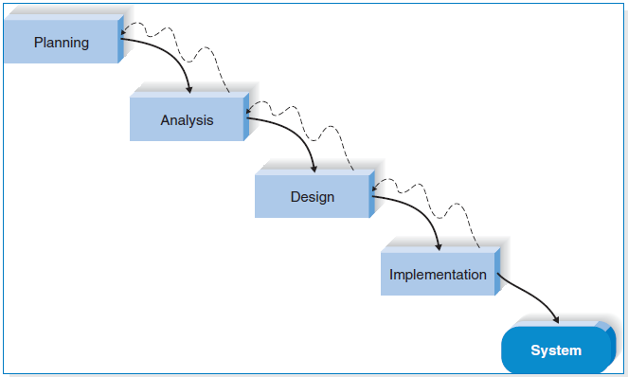

Figure 1 shows all the required phase in waterfall model

### 4.2.1 Project plan

Refer to the guidelines for system development such as Arrange tasks into phases (groups of activities),Involve users (anyone for whom system is being built),Develop clearly defined standards (Procedures Company expects employees to follow)

### 

### 4.2.2 Planning

Review project requests, Prioritize project requests, Allocate resources, Identify project development team and this was a first phase we passed through and I spent one week

### 4.2.3 Analysis

In this phase two weeks were spent, and studied the current system that use programs like Microsoft excel and I found that it is not current compare to time that we have. Interview, Questionnaire and observation to get together condition.

### 4.2.4 Designing

In this phase two weeks were spent, in this phase user interface was design, specific programs, database that will be needed. Programs like PHP language for system development and in database we used Microsoft access

### 4.2.5 Implementation

In this phase the system was built by writing code in the program used PHP Language which was linked with Database stored in MySQL.

### 4.2.6. Design

1. MySQL database keeps the information and data storage
2. PHP,CSS,HTML,bootstraper and JavaScript languages

## 4.3 USER INTERFACE DESIGN

### 4.3.1 Use case of the system

Use case diagram, is a graphical representation of the interaction among the elements that is methodology used in system analysis for identifying, clarifying, and organization requirements. User case diagram contains actor’s system and goals.

**Actors**

The actors could be anyone who interact with the system, and can be personal anybody used in the system who utilized information or services of system. Therefore, use case diagram is a person who are interacting with the system.

**System:** System is alike scenario with which actors interact to perform certain task depending to their authorization.

**Goals** : This represents end result of task that actor tries to gain after interacting with the system, below is the user case diagram;

### SYSTEM ADMIN

### 

Figure 2 Shows task that performed with admin

### 

### EMPLOYEE

Figure 3 Shows task that performed with employee

**OFFICER (Someone who accept/reject leave applied)**

Figure 4 Shows task that performed with officer

### 

**KEY**

Actor System boundary Arrow

# CHAPTER FIVE

# SYSTEM IMPLEMENTATION

## 5.1 Introduction to system implementation

Leave management system will make use of the existing web browser such as internet explorer. The user interface of the system shall be designed as shown in the user interface prototypes.

The most important and fundamental requirements are bundled into the first version of the system. The analysis phase then leads into design and implementation, but only with the set of requirements identified for version 1.

Once version 1 is implemented, work begins on version 2 and follows the steps, and so on.

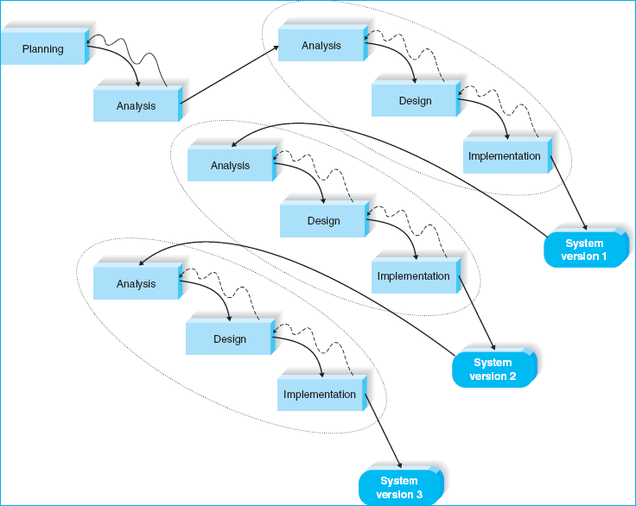

Figure 5 Relevant diagram for the selected methodology for system implementation

#### **5.1.1 Tools used to develop the leave management system**

The leave management system due to their development we use many different tools. Below are the tools used on development;

* Processor: Intel(R) Atom(TM) CPU N270 @1.60GHZ 1.60GHZ
* Installed memory (RAM): 2.00 GB
* System type: 32-bit operating system
* Windows 10 Operating System
* XamppBitnami 5.5.38-1 1.60GHZ
* Html markup language
* Notepad ++
* Browser
* Php scripting language
* Bootstrap
* Jquery
* Javascript (js)

## 5.2 functionality of the implementation.

Leave management system consist of several functionalities and system services that are implemented which are;

### 5.2.1 User interface implementationC:\Users\KAIJAGE\Desktop\Capture.PNG

Figure 6 shows Home page

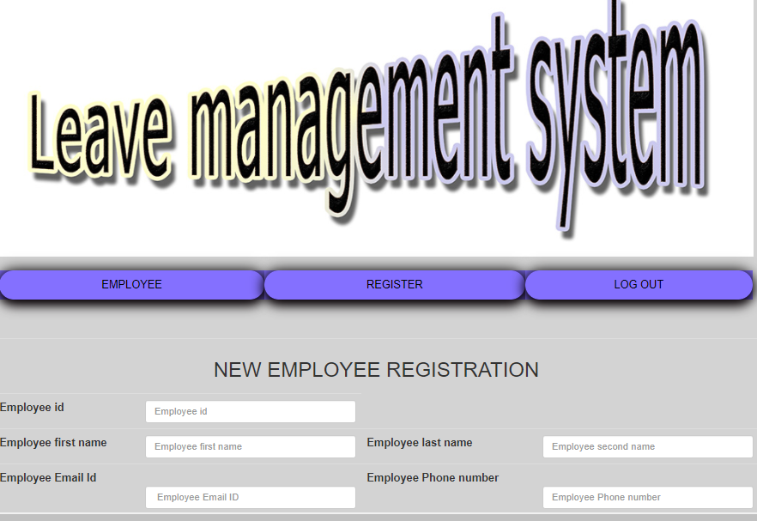

Figure 7 Shows the registration form

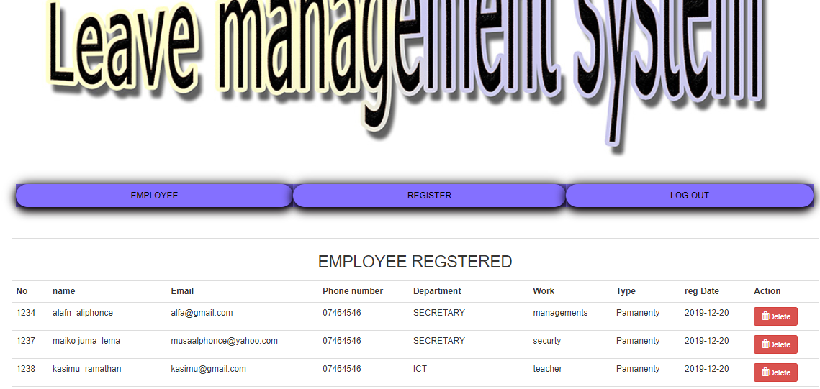

### 

Figure 8 shows leave applied

### ll.PNG

Figure 9 Shows application leave form

### 5.2.2 Database implementation

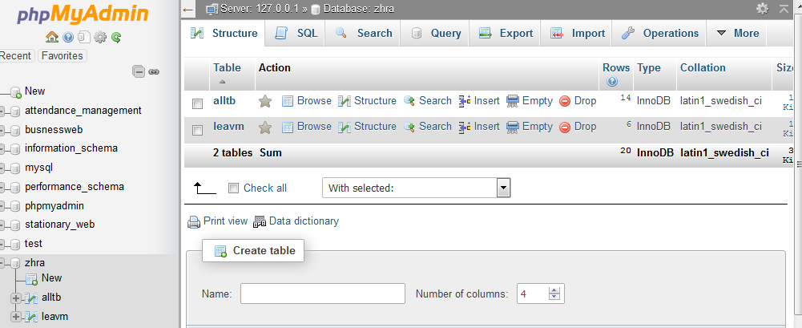

Figure 10 shows database home page

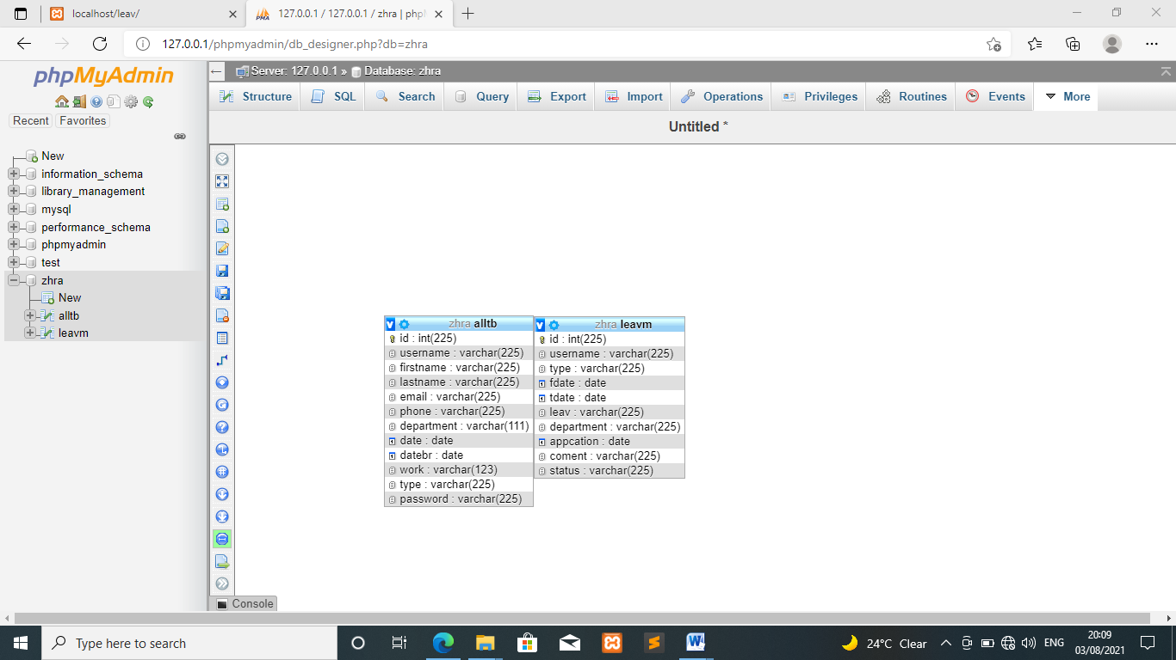

Figure 11 Shows the tables in the database

# CHAPTER SIX

# CONCLUSION AND RECOMMENDATIONS

## 6.1 Summary of achieved objective

The system of leave management marking and report generating becomes easy .less chance of malfunctioning are there. The system has reached a steady state where all bugs have been eliminated. The system is operated at high level of efficiently and admin and user associate the system understand its advantage. It was intended to solve as requirement specification. In future this system is can be implemented to automate most of education system

## 6.2 Conclusion

Leave system it’s very important system for any organization because its reduce time consuming, it reduce paper transmission (movement of paper from one office to another), it reduce paper work. The leave management system deals with the employee registration within the organization, and leave application for the employees. The admin of this system are able to see all leave that are applied by employees and to and to answer all leaves.

Therefore Leave management system is the system that can be enable the employees to maintain a record of their leaves as well as make requests for the same from anywhere. The employees can apply for leave on leave system, manager will get email or username notification of employees leave application also not as much forward and backward is required when employees can submit requests instantly

## 6.3 RECOMMENDATION

I recommend that any organization should have a leave system that can perform functionality within in order to escape with manually system. the system can allow future adjustments to integrate future demands. The project will serve as a knowledge base to other researchers and interested parties. Also it will be used as a template for developing the real database system for Mzumbe University. So I hope that the system will help any organization to minimize the problems that can occur in manual recruitment system.

# REFERENCES

* Adamson and Veronica. (2008). JISC & SCONUL Leave Management Systems Study. Sheffield
* Adomi, E. E., &Anie, S. O. (2006). An Assessment of Computer Literacy Skills of Professionals in Nigerian University libraries. Library Hi Tech News, Vol.23 (2) pp.10-14.
* Ashutosh, T and Ashish,S. (2012). Online Leave Management System. IOSR Journal of Engineering (IOSRJEN). Vol. 2 (2), pp. 180- 186.
* http://www.ifla.org/files/hq/papers/ifla75/126-dasgupta-en.pdf.
* DeSpautz, Joseph; Kenneth S. Kovacs; Gerhard Werling (2008). GAMP Standards for Validation of Automated Systems. Pharmaceutical Processing. Retrieved 28 February 2012.UK: Sero Consulting. p. 51. Retrieved on 06 August 2015.