**Mert Okumus**

**214110822**

**Introduction**

Before starting to do my project, I decided to learn how to play baseball. I watched lots of baseball videos and matches and a movie (moneyball). I saw some important staff hitting running, catching and pitching. But the most important things to do running and hitting. Because when you pitch well, your opponent can not hit well, they will not get a point so I decided to research pitching number.So, my question is, “Is there any relationship between pitching and winning and lossing number?”

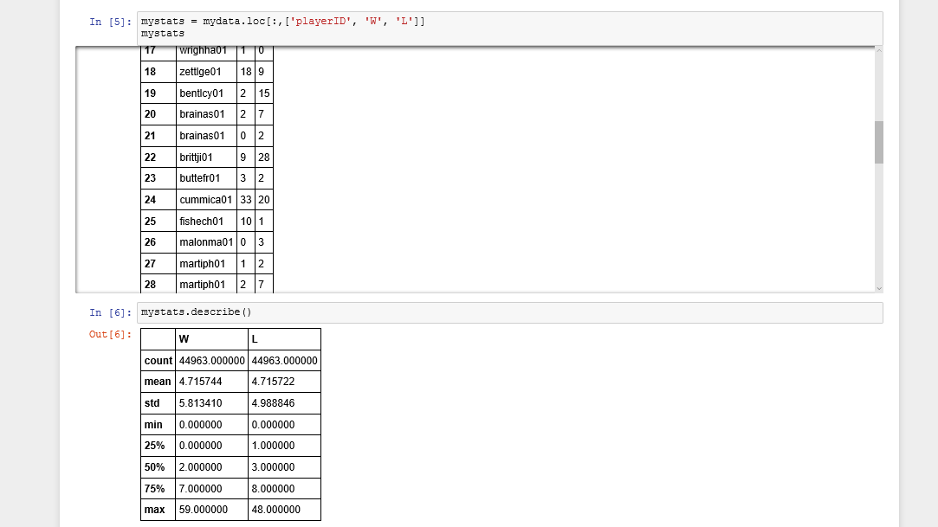

Standard deviation

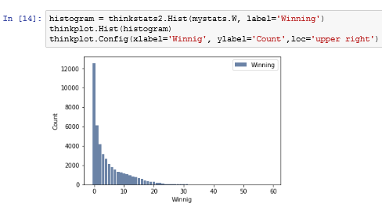

Number of winning

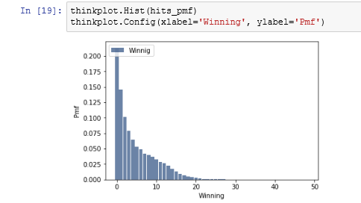

Probability mass function of winning

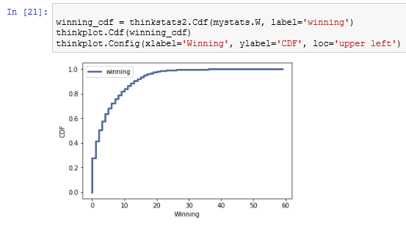

Cumulative distribution function of winning

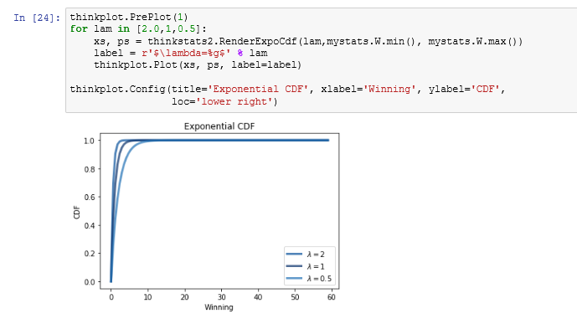

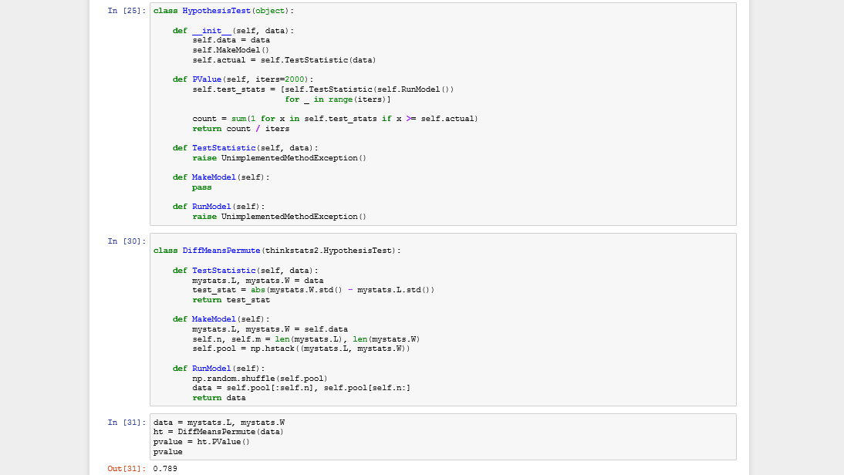

I did these step which is above. I got final p value which is 0.789. P value closes to 0. It means positive relationship between these two variable. Before ending my report, number of pitching affect the number of winning.If pitching well, number of winning is increasing.