First Apartment Budget Comparator

Project by Meredith Makowsky – Accounting Major

Overview:
This Excel tool helps young adults compare apartment rental options by calculating true monthly and annual costs, including utilities (whether included or not). It supports up to 3 apartments and includes fixed costs like groceries and transportation.

Key Features:
- Interactive inputs with dropdowns
- Automatic calculations (rent + utilities + fixed expenses)
- Comparison of total costs
- Visual charts (bar for comparison, pie for breakdown)
- Scenario-ready for rent increases

Accounting Skills Demonstrated:
- Financial modeling and cost-benefit analysis
- Formula design (IF, SUM, references)
- Data validation and sensitivity analysis
- Budget forecasting (monthly → annual)

AI Skills Demonstrated:
I used AI (ChatGPT) to accelerate development without coding:
- Generated all complex formulas
- Suggested chart layouts and improvements
- Helped structure the workbook efficiently

Example AI Prompt Used:
Prompt 1-
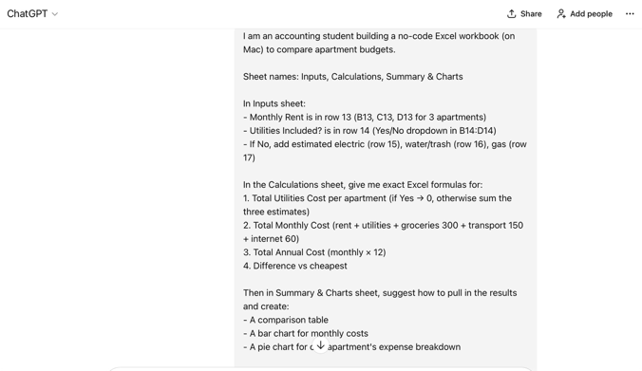
Response 1-
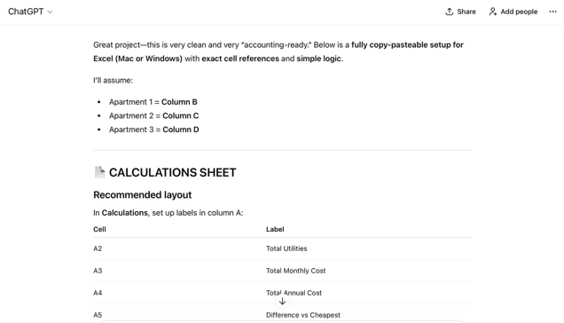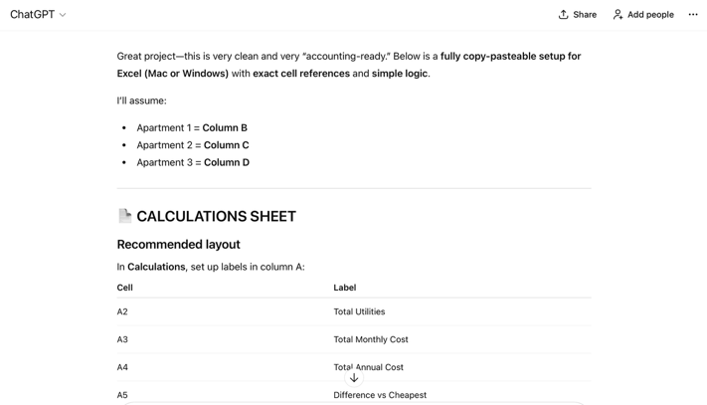
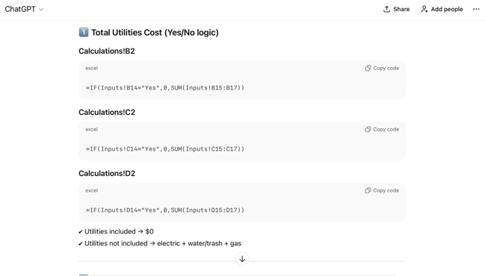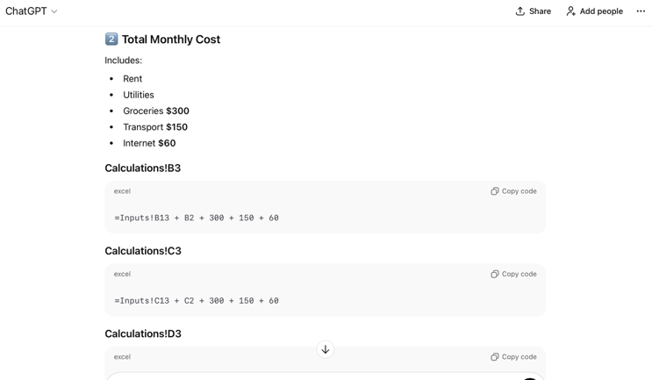
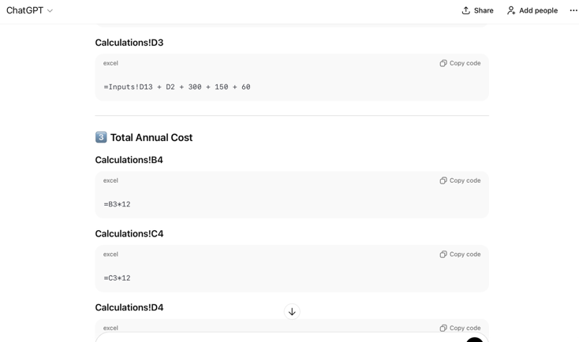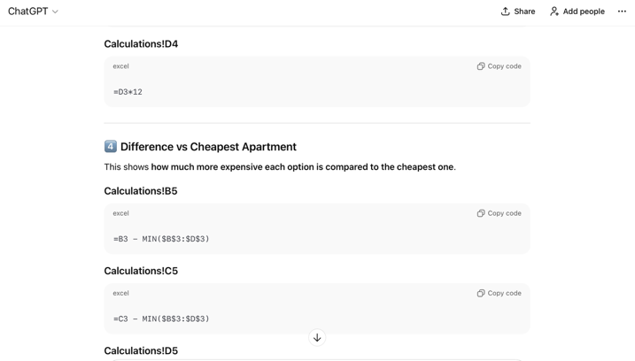
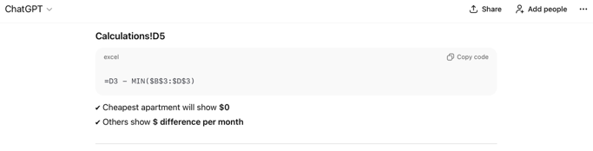
Prompt 2-
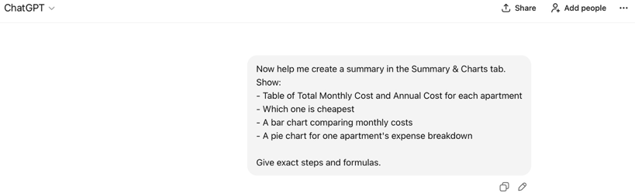
Response 2-
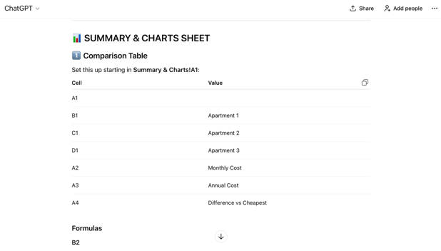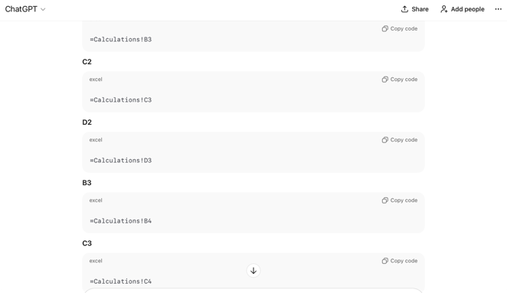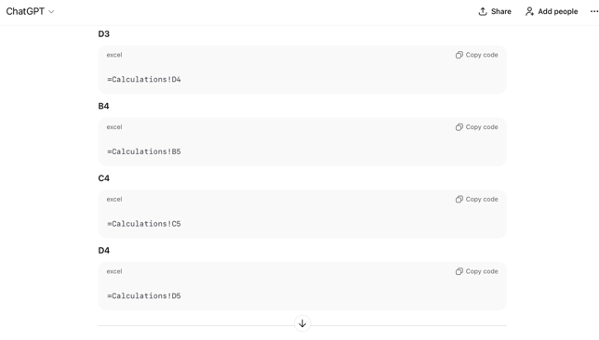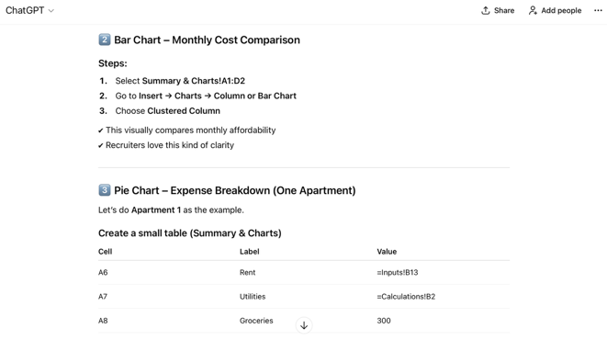
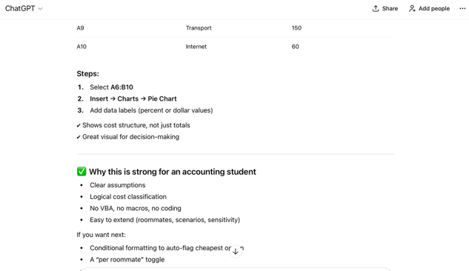

How to Use:
1. Open the Excel file
2. Go to Inputs sheet
3. Enter apartment details
4. View automatic results and charts in Summary & Charts

Sample Results:
Thank you for viewing my project!

