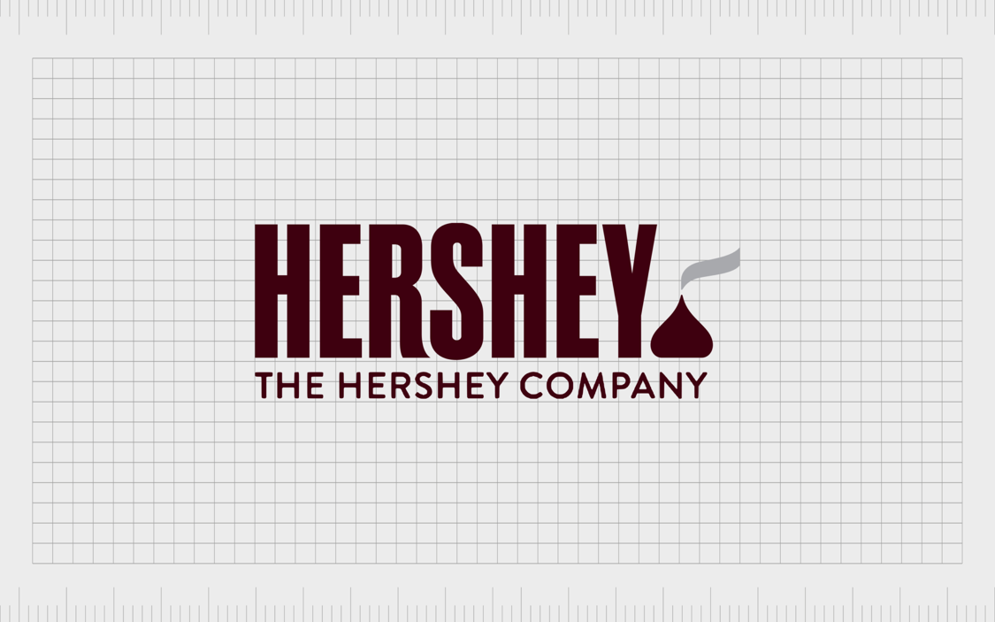

A Company Report
Prepared by: Meredith Villaluz
BUSM301 – 04
October 17, 2025

EXECUTIVE SUMMARY
The Hershey Company (NYSE: HSY), a recognized major player in the confectionary and snacking industry demonstrated a steady financial performance between fiscal years 2023 and 2024, maintain profitability amid modest revenue growth and challenging market conditions. While revenues increased marginally from $11.14 billion in 2023 to $11.20 billion in 2024, improvements in operational efficiency and cost management led to stronger margins and returns to shareholders.
Key Findings
- Financial Health
  - Revenue Growth: Sales slightly increased from $11.17 billion (2023) to $11.20 billion (2024), showing steady market performance.
  - Profitability: Net profit margin rose from 17% to 20%, reflecting effective cost management and pricing strategies.
  - Liquidity: The current ratio (0.96) and Quick ratio (0.64) remain below industry average (2.26 and 1.06), indicating low short-term liquidity.
  - Leverage: Total Debt-to-Capital = 0.57, high than the industry average (0.42). suggesting a reliance on debt financing.
  - Interest Coverage: Time-Interest-Earned (TIE) = 9.47x, showing Hershey can comfortably meet interest obligations.
  - Profitability Strength
    - ROE = 47%, ROA = 17%, both exceeding industry ratio.
    - Operating Margin improved significantly from 0.19% to 2.67%.
  - Market Valuation
    - P/E =15.09 and M/B = 7.27 declined from 2023, indicating potential undervaluation.
    - Enterprise Value (EV) for 2024 was estimated at $39.1 billion, signaling continued investor confidence.
- Risk Profile
  - Market Risk: Vulnerability to changes in coca and sugar prices, and consumer demand fluctuations.
  - Financial Risk: High debt levels could pressure future earnings if interest rates rise.
  - Operational Risk: Supply chain sustainability and ESG compliance challenges in cocoa sourcing regions.
- Industry Comparison
  - Hershey outperforms peers in profitability and returns, but struggles in liquidity and leverage control
  - Its strong brand portfolio offsets cyclical market risks, ensuring long-term stability.
Recommendations
- Investment Decision:
  - Recommendation: HOLD/MODERATE BUY
Hershey’s solid profitability, brand dominance, and consistent returns make it an attractive long-term investment despite short-term liquidity challenges.
- Financial Strategy Improvements:
  - Strengthen liquidity by increasing cash reserves and improving working capital management.
  - Gradually reduce leverage to align with industry capital structure standard and mitigate interest risks.
- Operational and Strategic Focus:
  - Continue optimizing cost management and production efficiency to sustain margin growth.
  - Expand product innovation and global diversification to offset slow U.S. market growth.
  - Enhance Environmental, Social and Governance (ESG) initiatives to address sustainability risks and strengthen investor confidence.
COMPANY OVERVIEW
- Company Background
The Hershey Company was founded by Milton S. Hershey in 1894. The Hershey Company is a located at Hershey, Pennsylvania. The company is U.S. based confectionary and snacking company that is recognized as one of the largest chocolate manufacturers in North America. The Hershey Company is also known for their famous chocolates such as Hershey’s, Reese’s, KitKat (U.S.), Twizzlers and Ice Breakers. Over the years, Hershey has expanded into non-chocolate snacks, including SkinnyPop and Dot’s Pretzels.
- Mission, Vision and Core Values
The Hershey Company’s mission is to “Making more moment of goodness.” The company’s mission in bringing moments of goodness is set to be achieved through quality, and innovation.
Milton Hershey’s vision for the company is to make “chocolate accessible to everyone.” While their vision is to make chocolate accessible to everyone, they also prioritize sustainability through ethical cocoa sourcing, environmental stewardship and well-being.
The Hershey Company is also inspired by their “long-standing values of togetherness, integrity, making difference and excellence.” Their values strive to make more positive difference in communities.
- Business Strategy
The Hershey Company’s strategy is to expand their snacks portfolio, managing input cost volatility, and maintaining market leadership in North American confectionary. The company’s strategic pillars include pricing power, brand innovation and product diversification into a “better-for-you” snacks. The Hershey Company also continually pursue global expansion and operational efficiency.
- Recent News
The recent news about the Hershey Company ranges from September to October 2025.
- In National Association of Convenience Stores Expo that will be held on October 15-17, 2025. The Hershey Company will introduce their new product innovations such as Reese’s OREO Cup, Jolly Rancher Ropes Tropical Flavor, Shaq-A-Licious XL Gummies in Sneaker Shapes, Dot’s Homestyle Pretzels Buffalo Flavor, and SkinnyPop Popcorn White Cheddar and Butter.
- The Hershey Company announced price increase for chocolate products due to high cocoa costs. The company raised the prices by roughly two digits. They also change the packets into smaller products and lesser chocolates in a pack.
- In complying with the Health Department, the Hershey company committed to eliminate the use of synthetic Dyes by 2027.
- The Hershey Company appointed a new president and CEO last August 2025. Kirk Tanner succeeds Michele Buck as a CEO.
- Interesting 10-K Items
- Commodity Hedging: Hershey’s 10-K details extensive use of derivatives to manage cocoa price volatility. Despite the hedging, the company remains exposed to extreme cost swings in raw materials.
- Sustainability Commitments: Hershey’s 10-K outlines increasing investments in sustainable packaging, ethical sourcing, and climate resilience-highlighting regulatory and consumer pressures on environmental responsibility.
FINANCIAL STATEMENT ANALYSIS
Income, Expenses and Profit Trends
- Revenue Growth:
  - 2023: $11.17 billion
  - 2024: $11.20 billion
    - Slight increase (0.3%), indicating mature but stable market performance.
- Operating Income (EBIT):
  - Improved slightly, reflected by an increase in operating margin (0.19% to 2.67%), suggesting better cost management and pricing efficiency.
- Net Income:
  - Rose from 17% to 20% of sales, indicating improved profitability despite inflationary pressures and higher ingredient costs in 2023.
- Overall Trend
  - Modest revenue growth but strong bottom-line improvement – likely driven by cost discipline and premium product pricing.
Key Financial Ratios and Commentary
- Liquidity Ratios
Ratio | 2024 | 2023 | Industry Avg | Commentary
Current Ratio | 0.96 | 0.97 | 2.26 | Below industry standard – Hershey relies on efficient cash flow and short-term financing; liquidity is tight.
Quick Ratio | 0.64 | 0.52 | 1.06 | Slight improvement but still low, indicating limited ability to cover short-term obligations without selling inventory.

- Asset Management Ratios
Ratio | 2024 | 2023 | Industry Avg | Commentary
Inventory Turnover | 8.93 | 8.33 | - | Inventory efficiency improved slightly – stronger demand forecasting.
Days Sales Outstanding (DSO) | 26.08 days | 26.93 days | 27 days | Close to the industry average – steady collection efficiency.
Fixed Assets Turnover | 1.22 | 1.24 | - | Minor decline, consistent with small capex expansion in 2024.
Total Assets Turnover | 0.87 | 0.94 | - | Slight drop, implying asset base grew faster than sales.

- Debt Management Ratios
Ratio | 2024 | 2023 | Industry Avg | Commentary
Total Debt to Total Capital | 0.57 | 0.59 | 0.42 | High leverage compared to peers – dependence on debt financing.
Time Interest Earned (TIE) | 9.47x | 15.19x | - | Decrease shows interest coverage fell due to higher debt or interest expenses.

- Profitability Ratios
Ratio | 2024 | 2023 | Industry Avg | Commentary
Operating Margin | 2.67% | 0.19% | 3.6% | Rebound sharply - improved operational control post inflation spikes.
Profit Margin | 205 | 17% | -3.2% | Strong profitability compared to peers.
Return on Total Assets (ROA) | 17% | 16% | -4.5% | Efficient asset utilization – significantly above industry.
Return on common equity (ROE) | 47% | 45% | 20% | Outstanding return to shareholders; boosted by leverage.
Return on invested Capital (ROIC) | 17% | 26% | - | Strong but declined – suggests reduced capital efficiency.
Basic Earning Power (BEP) | 15% | 22% | - | Lower BEP – possible rise in total assets or decline in EBIT.

- Market Value Ratios

Ratio | 2024 | 2023 | Industry Avg | Commentary
P/E Ratio | 15.09 | 20.03 | - | Valuation dropped – could indicate undervaluation or investor caution.
Market-to-Book (M/B) | 7.27 | 9.30 | - | Decline shows market sentiment cooled; shares cheaper relative to book value.
EV/EBITDA | 16434.41 | 13597.52 | - | Higher EV/EBITDA implies investors still expect long-term stability.

Strengths and Weaknesses
- Strengths
  - Strong profitability: High ROE (47%) and profit margin (20%)
  - Operational Efficiency: Stable inventory and receivables management.
  - Market leadership: Strong brand power and pricing resilience.
  - Consistent dividend payouts and stable cash flow generation.
- Weaknesses
  - Low liquidity: Current and quick ratios below industry averages.
  - High leverage: Debt-to-capital ratio (0.57) exceeds industry average.
  - Slight decline in asset utilization and return on invested capital.
Risk and Investment Analysis
- Key Company Risks
  - Market Risk:
    - Chocolate demand is stable but sensitive to consumer spending and inflation.
    - Commodity price fluctuations (cocoa and sugar) directly affect margins.
  - Financial Risk:
    - Elevated debt levels could increase vulnerability to interest rate hikes.
  - Operational Risk:
    - Supply chain challenges and sustainability concerns in cocoa sourcing.
    - Potential disruptions from weather and political instability in sourcing regions.
  - Regulatory and ESG Risk:
    - Growing focus on sustainability and fair trade could increase costs.
- Investment Recommendations
Evaluation Area | Summary
Profitability | Excellent (ROE 47%, Profit Margin 20%)
Liquidity | Weak (Current Ratio < 1)
Leverage | High but manageable
Market Valuation | Moderately undervalued (lower P/E and M/B)
Outlook | Steady growth, strong cash generation, global brand power.

- Recommendation: HOLD/ MODERATE BUY
  - Hershey remains financially strong with excellent profitability and brand equity.
  - Short-term risk: Rising debt and tight liquidity.
  - Long-term potential: Stable earning, dividend reliability, and undervalued share price.
- Investment View
  - For risk-tolerant investors seeking stable returns and dividends, Hershey is a solid long-term hold. Conservative investors may prefer to wait for leverage reduction or liquidity improvement before adding more shares.
OTHERS
- Use of AI
  - I used AI to make a draft and format of this company report such as usage of tables to present the data and commentary effectively.
  - I used AI to find sources such as financial statements, news, industry ratio for confectionary industry.
  - I used AI to check some of the grammar so I can present and put ideas into words professionally.
- References:
  - Attached EXCEL file for computations and data gathered from
  - https://finance.yahoo.com/quote/HSY/financials/

  - https://www.thehersheycompany.com/en_us/home/newsroom/press-release/2025-10-09-The-Hershey-Company-Highlights-New-Products-and-Drives-Retail-Growth-at-2025-NACS-Show.html
  - https://www.ktvu.com/money/hershey-raising-prices-cocoa
  - https://www.reuters.com/business/healthcare-pharmaceuticals/hershey-drop-synthetic-dyes-its-snacks-by-2027-bloomberg-news-reports-2025-07-01/
  - https://www.thehersheycompany.com/en_us/home/newsroom/press-release/2025-07-08-Kirk-Tanner-Appointed-President-and-Chief-Executive-Officer-of-The-Hershey-Company,-effective-August-18,-2025.html
  - https://investors.thehersheycompany.com/en_us/home/reports-and-filings/annual-reports.html
  - https://www.sec.gov/Archives/edgar/data/47111/000004711125000014/hsy-20241231.htm
  - https://www.thehersheycompany.com/en_us/home/about-us.html#:~:text=Making%20More%20Moments%20of%20Goodness,with%20our%20iconic%2C%20beloved%20brands.
  - https://www.readyratios.com/sec/industry/206/

