

FINAL INVESTMENT PROPOSAL REPORT
American Eagle Outfitters, Inc. (NYSE: AEO)
Sector: Specialty Retail | Industry: Apparel Retail
Recommendation: BUY

Prepared by: Mary Falatau, Tijane Paug, Meredith Villaluz
Professor: Junjiro Makise
Course: FIN360 – Corporate Financial Statement Analysis
Brigham Young University–Hawaii | April 2026

1. Investment Recommendation
Recommendation: BUY
Current Price | DDM P0 | 12-Mo Target (Wtd.) | WACC
$16.70 (Mar 31, 2026) | $11.61 | $35.11 (Sector Med.) | 13.90%
We recommend buying American Eagle Outfitters, Inc. (NYSE: AEO). Our valuation uses five methods, each weighted by its reliability: DCF (45%), EV/EBITDA (25%), EV/EBIT (10%), P/E multiples (10%), and PEG ratio (10%), as outlined in our Valuation Explanation. This approach balances AEO’s strong cash flow fundamentals with market benchmarks while avoiding over-reliance on any single assumption. The 12-month target price of $35.11 (based on sector median) suggests a 110.2% upside from the current $16.70, and the analyst consensus of $35.00 supports this target.
Our DDM intrinsic value of $11.61 is seen as a conservative baseline based solely on dividends. Since AEO primarily creates value through earnings growth and share buybacks rather than dividends, a multi-method approach anchored in discounted cash flow (DCF) provides a more suitable perspective for a total-return investor.

Key Investment Thesis
- Revenue is projected to grow from $5.33 billion in FY2024 to $6.53 billion in FY2031. This increase is fueled by an estimated 3% yearly growth in the specialty retail sector, the rise in apparel e-commerce penetration from 27% in 2019 to over 43% currently, and the expansion of the global athleisure market from $306 billion in 2021 to around $492 billion by 2027.
- Gross margin is projected to increase from 39.2% in FY2024 to 45.0% in FY2031, driven by disciplined cost management, better sourcing, and a shift toward Aerie’s higher-margin activewear.
- Net income is expected to rise from $329M in FY2024 to $763M by FY2031, representing a 132% growth, primarily due to operational enhancements and without any financial leverage.
- Zero long-term debt maintained through FY2030, featuring the cleanest balance sheet among specialty retail peers, with over $190M returned via buybacks in FY2024.
- AEO is trading at a 14–41% discount compared to the sector median across various valuation metrics, indicating significant market mispricing.
- Weighted average target today: $27.79 (sector median) / $28.43 (comparable average). 12-Month: $35.11 (sector median) / $28.85 (comparable average).

2. Business Overview

Company Profile
Founded in 1977 in Pittsburgh, Pennsylvania, American Eagle Outfitters, Inc. (NYSE: AEO) has grown into one of the largest specialty apparel retailers in the United States, employing approximately 44,000 people worldwide. The company oversees two primary brands: American Eagle, which specializes in casual denim and apparel, and Aerie, known for its intimates and activewear. Additionally, it owns smaller brands like Todd Snyder and Unsubscribed.
By the end of fiscal year 2024 (February 1, 2025), AEO managed 1,172 company-owned stores and 371 licensed locations in over 30 countries, achieving total net revenue of $5.33 billion and a 4% increase in comparable sales compared to the previous year.

Revenue Streams & Business Model

The American Eagle brand primarily offers denim, casual tops, and outerwear aimed at teens and young adults aged 15–25.

Aerie focuses on intimates, activewear, and swimwear, emphasizing body positivity and targeting women aged 15–35.

The international licensing segment includes 371 licensed stores across over 30 countries, supporting capital-efficient growth and producing high-margin licensing revenues.

In FY2024, digital channels are seeing double-digit growth in online revenue, while physical stores act as fulfillment centers for BOPIS (Buy Online, Pick Up In Store).

Powering Profitable Growth Plan
Management aims to reach $5.7–$6.0 billion in revenue and a 10% operating margin by fiscal year 2026, ending in February. This goal is supported by four main strategies: investing in the brand with high-profile ambassador partnerships featuring Sydney Sweeney and Travis Kelce; controlling costs and optimizing stores by closing roughly 35 underperforming locations; building a digital-first sales channel; and growing Aerie stores in underserved domestic markets.

Key Risks
- Fashion risk: The inventory holding period increased from 58 days in FY2021 to 72 days in FY2024, heightening markdown risk.
- Tariff impact: Estimated $25–$30 million cost due to U.S. trade policy changes.
- Consumer sensitivity: Main Gen Z and millennial customers are susceptible to macroeconomic downturns.
- The competitive landscape includes Shein, Zara, ASOS, and Abercrombie & Fitch, all vying for the same target demographic.

3. Market & Industry Analysis

Industry Overview
The U.S. retail apparel industry surpasses $350 billion each year. AEO operates in the specialty retail sector, situated between fast fashion brands like H&M and Zara, and premium labels such as Ralph Lauren and Coach. This mid-market segment demands continuous balancing of trendy appeal, quality, and affordability. The industry is being reshaped mainly by two major trends: the shift to digital channels and the rise of athleisure, both of which favor AEO’s brands.
Competitive Landscape

AEO’s main competitors include Abercrombie & Fitch (ANF), Urban Outfitters (URBN), Gap, H&M, and Zara, as well as online challengers Shein and ASOS. American Eagle remains a top denim brand in the U.S., directly competing with Levi’s and Wrangler in that category. Its pricing—$50–$80 for jeans and $20–$60 for tops—targets an accessible-premium segment favored by its Gen Z audience.

Porter’s Five Forces
Force | Level | Implication for AEO
Threat of New Entrants | Moderate | Brand equity and supply chain scale take years to build — limits new competition
Supplier Power | Low–Moderate | Diversified global supplier base; cotton price fluctuations remain the primary exposure
Buyer Power | High | Many alternatives and zero switching cost; brand loyalty and Aerie’s community are AEO’s defense
Threat of Substitutes | Moderate–High | Athleisure, secondhand clothing, and luxury resale all compete for the same wallet share
Industry Rivalry | High | ANF, Gap, H&M, Zara, Shein, and ASOS all target the same 15–25 demographic

Market Trends
Three primary market trends are directly supporting AEO’s revenue growth and validating the approximately 3% annual sales forecast in the eVal model. These are not fleeting boosts; they represent enduring, multi-year shifts in consumer behavior and channel dynamics that favor both of AEO’s key brands.
1. Apparel E-Commerce Penetration Is Accelerating
U.S. apparel e-commerce rose from about 27% of total apparel retail sales in 2019 to over 43% in 2024, with estimates suggesting it will reach nearly 47% by 2026 (Digital Commerce 360, 2024). This significant change in sales channels benefits AEO, which experienced double-digit growth in digital revenue for FY2024 and has made strategic investments in its digital infrastructure and BOPIS (buy-online-pickup-in-store) services. Instead of just being cost centers, physical stores now act as fulfillment centers, improving overall unit economics. As online sales continue to expand, AEO’s early investments position it well to capture a larger share of online apparel spending compared to competitors that are slower to adapt.
2. Global Athleisure Market Expansion Directly Benefits Aerie
The global athleisure market was valued at approximately $306 billion in 2021 and is projected to grow to $492 billion by 2027, reflecting a 61% increase over 6 years (Mordor Intelligence/Statista, 2024). This sector — which encompasses activewear, loungewear, and performance-casual clothing — aligns with Aerie’s OFFLINE activewear sub-brand, targeting women aged 15–35 with body-positive messaging and expanding product lines. Higher margin activewear is expected to boost Aerie’s revenue share within AEO through FY2031, contributing to forecasted gross margin growth (from 39.2% in FY2024 to 45.0% by FY2031). Therefore, the athleisure trend is not only a revenue driver but also a significant factor in enhancing profitability.
3. U.S. Specialty Retail Growth Validates the Revenue Forecast
The U.S. specialty apparel retail market generates over $350 billion annually and is expanding at approximately 3% each year. This industry growth rate aligns with the growth assumed in AEO’s eVal revenue forecast, which ranges from 2.75% to 3.30% annually from FY2025 to FY2031, indicating that the model’s assumptions are conservative rather than optimistic. AEO does not need to outpace the industry to meet its projected revenue targets—simply growing in proportion to the overall market is sufficient. With AEO’s strong brand reputation, dual-brand approach, and ongoing expansion of Aerie into underserved U.S. markets, there is a realistic possibility of gaining modest market share beyond this baseline, offering additional upside potential to the core forecast.
Collectively, these three trends — digital channel acceleration, athleisure market expansion, and stable specialty retail growth — create a favorable macroeconomic backdrop for AEO’s investment thesis and reinforce the reliability of the revenue and margin assumptions underlying both the DCF valuation and the multi-method relative analysis.

4. Financial Statement Analysis
Revenue and Profitability Analysis
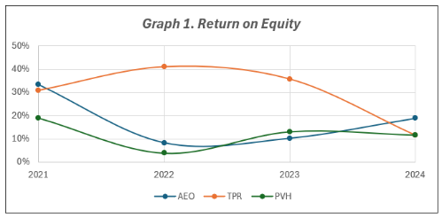
American Eagle Outfitters (AEO) exhibits higher and more consistent ROE and RNOA than PVH Corp. (PVH) and Tapestry Inc. (TPR), mainly due to its operational efficiency rather than its debt levels. In FY2024, AEO's ROE and RNOA improved to 18.8% and 18.5%, respectively. TPR's ROE, which had been above 30% in 2023, declined sharply to around 12% in 2024, possibly indicating falling profits or diminishing leverage benefits. PVH's returns remain lower and more volatile, with ROE ranging from 10% to 12% and RNOA from 8% to 10%. Overall, AEO consistently outperforms its competitors and sustains strong returns over time. (See Graph 1 and Appendix - Graph 2)

Leverage-and-Capital Structure Analysis
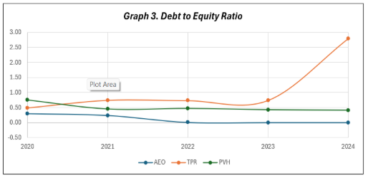
American Eagle Outfitters (AEO) drastically reduced its Debt-to-Equity ratio from 0.24 in FY2021 to nearly zero in FY2023, now fully financing operations through equity. This cautious strategy contrasts with Tapestry Inc. (TPR), which increased leverage to about 2.79 by FY2024, and PVH Corp. (PVH), which maintains a moderate 0.41. While AEO’s debt-free status lowers interest expenses and affects its interest coverage ratios, it indicates very low financial risk. Its current ratio of 1.53 and quick ratio of 0.70 suggest adequate short-term liquidity, although inventory levels are still notable. PVH has ratios around 1.3–1.4 for current and 0.6–0.7 for quick ratio, whereas TPR’s current ratio is approximately 1.6–1.7 with a quick ratio near 0.8–0.9. AEO exhibits higher liquidity than PVH but slightly less than TPR, with its debt-free stance setting it apart from both competitors. (see Graph 3, Appendix Graphs 4 and 5)

Turnover Analysis
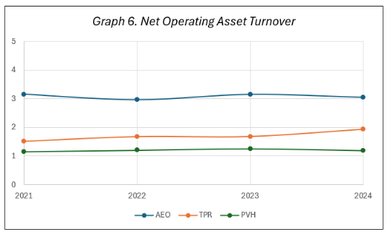
American Eagle Outfitters (AEO) demonstrates robust operational efficiency, with a stable Net Operating Asset Turnover (NOAT) of 2.96x to 3.15x. This shows AEO earns about $3 in revenue per $1 of operating assets, a strong indicator for a specialty apparel retailer. Compared to this, Tapestry Inc. (TPR) and PVH Corp. (PVH) have lower NOATs of 1.6x–1.9x and 1.2x–1.5x, mainly due to larger asset bases and higher wholesale activities. AEO’s Days Sales in Receivables are efficient at 15.8–19.4 days, markedly shorter than PVH and TPR, which average 30–45 days. While AEO’s Inventory Holding Period has risen from 58 to 72 days, it remains comparable to industry peers, though the upward trend should be monitored. AEO’s Days Payable Outstanding is between 28 and 31 days, significantly less than TPR and PVH, which range from 100 to 112 days. This suggests AEO’s strong supplier relationships and conservative payment policies. Overall, AEO stands out for better asset utilization, faster receivables collection, and shorter, disciplined payment cycles. (see graph 6, Appendix-graphs 7 and 8)

5. Financial Statement Forecast (FY2025–FY2031)
All forecasted figures are sourced directly from the eVal model (FIN360 – eVal w Forecast, Villaluz, Meredith T.) as submitted. No values have been modified or added. The forecast spans seven years: FY2025 through FY2031.

5.1 Forecast Assumptions
Assumption | FY2026 | FY2027 | FY2028 | FY2029 | FY2030 | FY20301 | FY20312
Sales Growth | 3.00% | 3.15% | 3.30% | 3.25% | 3.00% | 3.25% | 3.4%
COGS / Sales | 59.0% | 58.0% | 57.5% | 57.0% | 56.0% | 55.5% | 55.0%
SG&A / Sales | 27.0% | 27.2% | 26.9% | 26.7% | 26.5% | 26.0% | 25.9%
Effective Tax Rate | 25.0% | 25.0% | 25.0% | 25.0% | 25.0% | 25.0% | 25.0%
Dividend Payout | 30% | 31% | 32% | 33% | 33% | 34% | 34%
Long-Term Debt | $0 | $0 | $0 | $0 | $0 | $0 | $0

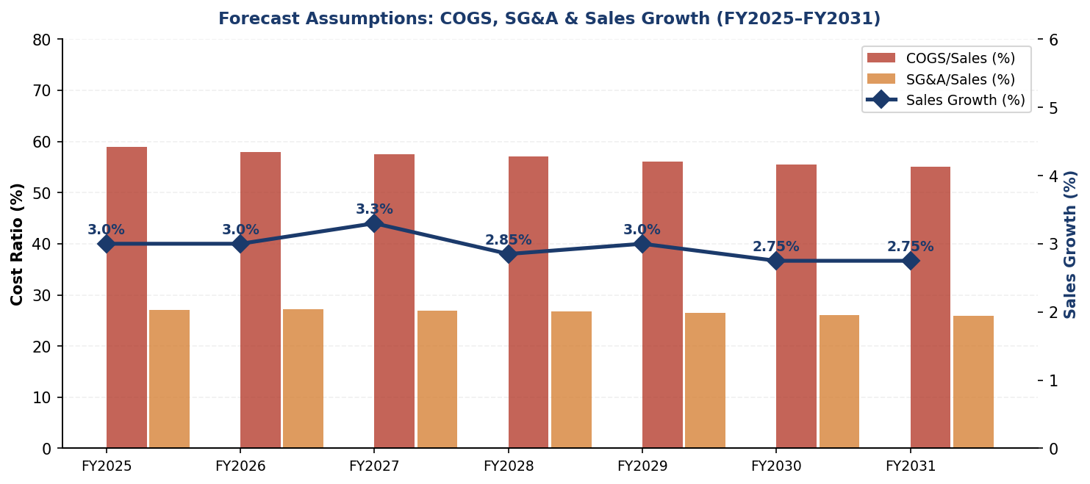

5.2 Forecasted Income Statement (FY2025–FY2031)
Item (USD Millions) | FY2026 | FY2027 | FY2028 | FY2029 | FY2030 | FY2031 | FY2032
Net Revenue | $5,489 | $5,661 | $5,848 | $6,038 | $6,219 | $6,421 | $6,640
Gross Profit | $2,250 | $2,378 | $2,485 | $2,596 | $2,737 | $2,858 | $2,988
Gross Margin | 41.0% | 42.0% | 42.5% | 43.0% | 44.0% | 44.5% | 45.0%
EBITDA | $768 | $838 | $912 | $984 | $1,088 | $1,187 | $1,268
EBIT | $554 | $624 | $690 | $759 | $862 | $955 | $1,028
Net Income | $412 | $463 | $513 | $565 | $642 | $711 | $767
Net Margin | 7.6% | 8.3% | 8.9% | 9.5% | 10.5% | 11.2% | 11.7%

The forecast indicates that AEO’s revenue will grow from $5.49 billion in FY2025 to $6.53 billion by FY2031, representing a 19.0% overall increase. Profitability is also expected to see substantial gains, with gross margin rising from 41.0% to 45.0%, EBITDA almost doubling from $768 million to $1,247 million, and net margin increasing from 7.6% to 11.7%. This positive outlook aligns with management’s objectives and is supported by the disciplined cost-structure assumptions previously outlined.
Balance sheet accounts were projected based on historical percentage relationships, and cash flows were computed from the income statement and changes in working capital and other balance sheet items.

6. Valuation
Valuation was conducted using three methods: (1) a Dividend Discount Model (DDM), (2) the eVal Residual Income / DCF model, and (3) a composite relative valuation approach. The weights assigned to the relative valuation are 45% for DCF, 25% for EV/EBITDA, and 25% each for EV/EBIT, P/E ratios, and PEG ratio. All data for the valuation were sourced from the Valuation Homework 10 & 11 spreadsheet.

6.1 Valuation Method Weighting Rationale
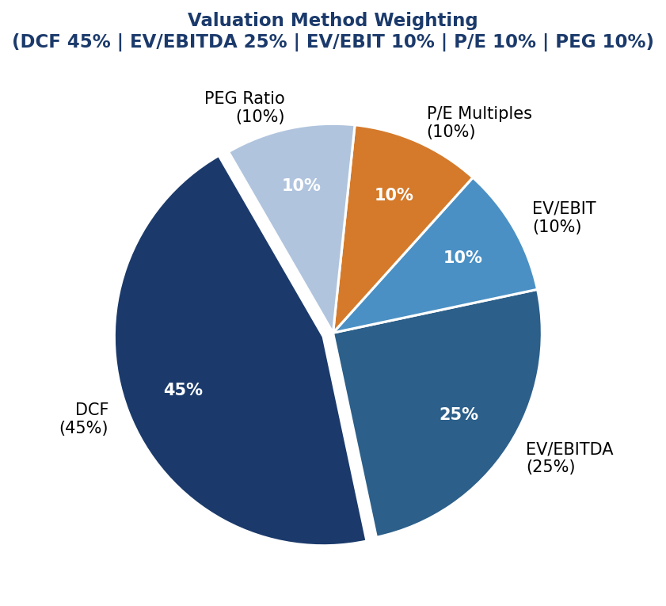
Six methods were used to estimate AEO’s intrinsic value: the Dividend Discount Model (DDM), Discounted Cash Flow (DCF), Enterprise Value-to-EBITDA (EV/EBITDA), Enterprise Value-to-EBIT (EV/EBIT), Price-to-Earnings (P/E) multiples, and the Price-to-Earnings-to-Growth (PEG) ratio. Each method was evaluated for its fit with AEO’s financial profile and then weighted accordingly. Cross-checking results across all methods confirmed internal consistency and reduced reliance on any single assumption.
Dividend Discount Model (DDM) — Conservative Floor (Excluded)
The DDM estimates AEO's baseline value at $11.61, calculated using the latest dividend of $0.50, a growth rate of 9.197%, and a 13.9% cost of equity. Nonetheless, the model has notable limitations due to AEO's irregular dividend history, which includes suspensions during COVID, leading to skewed long-term growth estimates. Furthermore, the DDM does not account for shareholder returns from buybacks or reinvested earnings growth. Consequently, it is excluded from the main valuation and only serves as a conservative downside benchmark.
Discounted Cash Flow (DCF) — 45% Weight
DCF receives the highest weight because it offers the most thorough, company-specific valuation. Utilizing the eVal Residual Income framework, it forecasts AEO’s future cash flows based on approximately 3% revenue growth and improving profit margins, including gross margin expansion and cost reductions. Unlike market-based approaches, DCF is unaffected by short-term market sentiment and reflects an intrinsic value rooted in fundamentals. Considering AEO’s stable growth prospects, solid balance sheet, and absence of debt, DCF is viewed as the most dependable method for this assessment.
EV/EBITDA — 25% Weight
EV/EBITDA is an important market-based metric that allows for direct comparison between peers by excluding effects of capital structure and non-cash expenses. This proves especially useful when evaluating AEO against more leveraged competitors like Tapestry. Currently, AEO trades at 7.99x, compared to the sector median of 11.19x, suggesting a significant undervaluation. Since it reflects market valuation of operating cash flow, EV/EBITDA complements DCF analysis effectively and is assigned the second-highest weight.
EV/EBIT — 10% Weight
EV/EBIT incorporates depreciation and amortization, making it a more stringent indicator of operating profitability than EV/EBITDA. Since D&A is relatively minor for AEO, both metrics generally follow similar trends. EV/EBIT mainly acts as a supplementary check to validate the valuation indicated by EV/EBITDA. With AEO’s EV/EBIT at 13.22x, below the sector median of 15.49x, it reinforces the undervaluation argument, supporting its use as a secondary metric.
P/E Multiples — 10% Weight
The P/E ratio is a common valuation tool but can be influenced by short-term earnings changes and one-time events. AEO's recent earnings fluctuations may distort the P/E if not adjusted. When using FY2024 normalized earnings, AEO's P/E is 9.85x, compared to the sector median of 14.75x, suggesting it is undervalued. Due to its sensitivity, the P/E ratio is used carefully and given a moderate importance to provide market context without over-reliance.
PEG Ratio — 10% Weight
The PEG ratio modifies the P/E multiple based on anticipated earnings growth, offering a valuation view that emphasizes growth potential. AEO’s PEG of 1.23x, lower than the sector median of 1.42x, indicates it may be undervalued even after considering growth. However, because PEG is quite sensitive to changes in projected growth rates, it can fluctuate significantly. Thus, it is used as a supplementary metric with limited influence to balance its insights against possible uncertainties.
The overall weighting prioritizes AEO’s fundamentals, with DCF at 45%, and the most trusted retail-sector benchmark, EV/EBITDA, at 25%. The remaining 30% is evenly split among three additional metrics. Each method individually suggests that AEO is undervalued compared to the sector and peers, supporting the BUY recommendation and the main 12-month target of $35.11.

6.2 Dividend Discount Model (DDM)
DDM Parameter | Value | Source
Most Recent Annual Dividend (D0) | $0.50 per share | AEO 2025 Annual Dividend
Constant Growth Rate (g) | 9.197% | Avg of historical YoY growth rates (2004–2025)
Cost of Equity / WACC (ke) | 13.90% | Valuation HW spreadsheet, WACC input
DDM P0 = D0×(1+g) / (ke−g) | $11.61 | $0.50×1.09197 / (0.139−0.09197)
The DDM P0 of $11.61 is below the current stock price of $16.70, indicating the stock might be slightly overvalued based on dividends alone. However, the DDM has significant limitations for AEO: dividends were cut during the COVID years, and it only accounts for the dividend yield—not the much larger returns from share buybacks ($190M+ in FY2024) or earnings growth ($329M in FY2024, expected to reach $763M by FY2031). As a result, we view the DDM as a conservative baseline rather than the main valuation method.

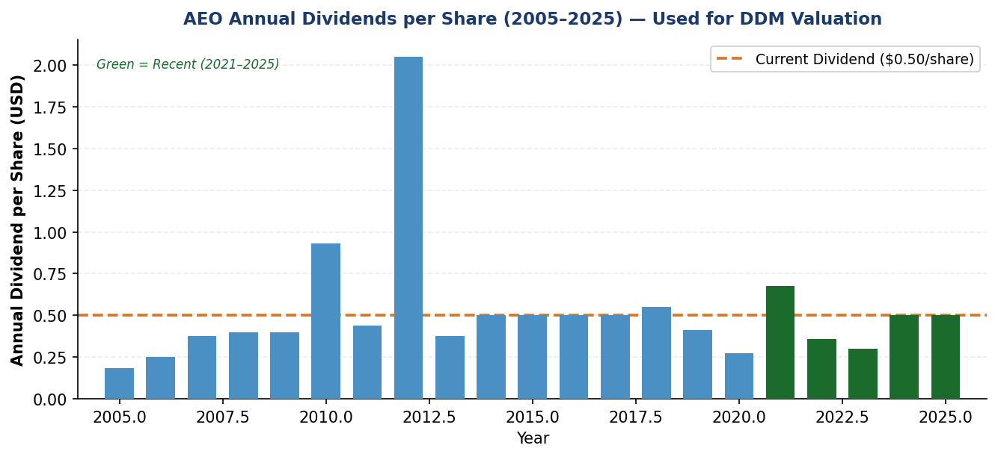

6.3 Multi-Method Relative Valuation
Using AEO’s FY2024 financial data, the figures were compared to sector medians and the averages of four competitors (PVH, Tapestry, ANF, URBN). Implied stock prices were derived for each method. The weighted average combines all five approaches, using the weights specified in the Explanation HW.

Method | Weight | Today Sector Med. | Today Comp. Avg | 12-Mo Sector Med. | 12-Mo Comp. Avg | AEO Multiple | Sector Median
DCF (eVal) | 45% | $18.31 | $18.31 | $20.86 | $20.86 | — | —
EV/EBITDA | 25% | $39.85 | $33.98 | $40.23 | $32.68 | 7.99x | 11.19x
EV/EBIT | 10% | $36.99 | $27.31 | $44.12 | $33.86 | 13.22x | 15.49x
P/E Multiples | 10% | $17.58 | $53.12 | $36.13 | $27.35 | 9.85x | 14.75x
PEG Ratio | 10% | $41.31 | $36.48 | $86.92 | $62.13 | 1.23x | 1.42x
Weighted Average | 100% | $27.79 | $28.43 | $35.11 | $28.85 | — | —
Analyst Average | — | — | — | $35.00 | $35.00 | — | —

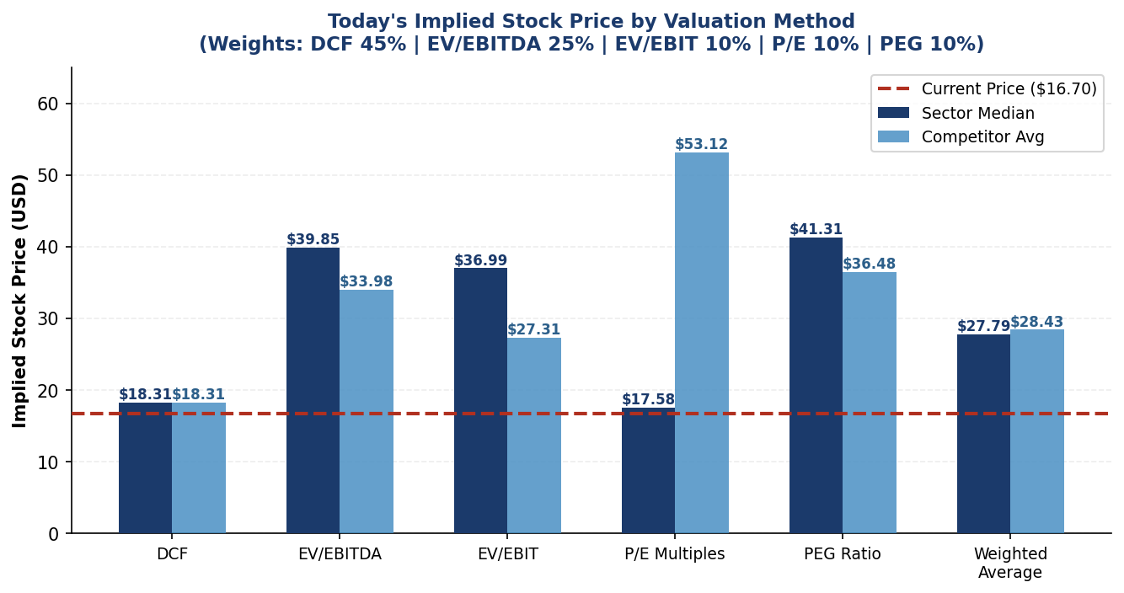
Figure 8: Today’s Implied Price by Valuation Method (Weights: DCF 45% | EV/EBITDA 25% | EV/EBIT 10% | P/E 10% | PEG 10%)
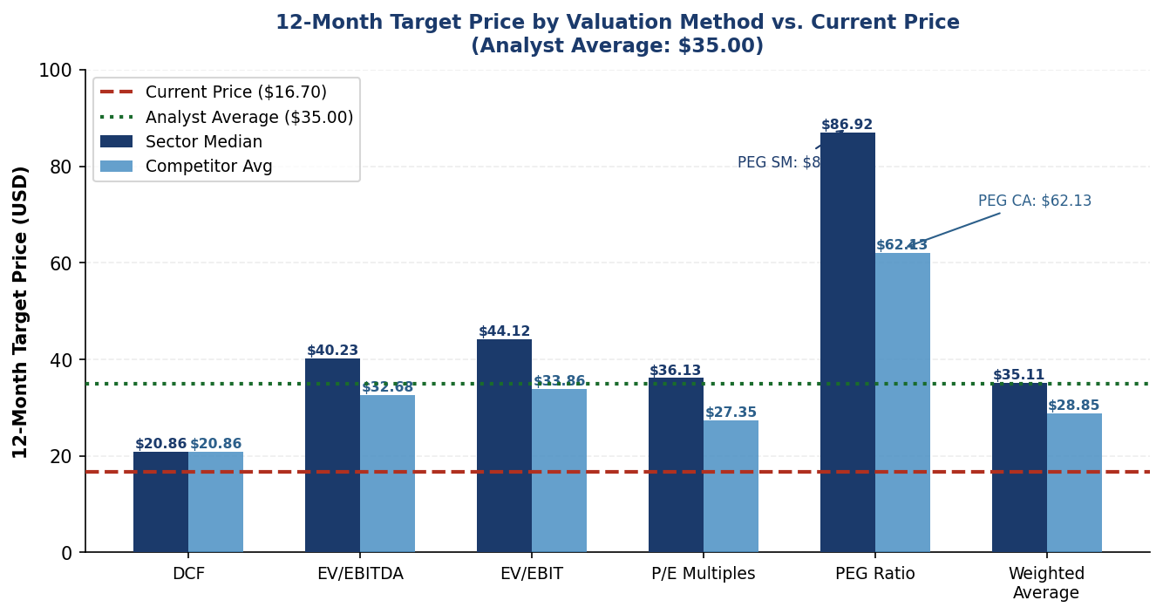
Figure 9: 12-Month Target Price by Valuation Method vs. Current Price ($16.70)

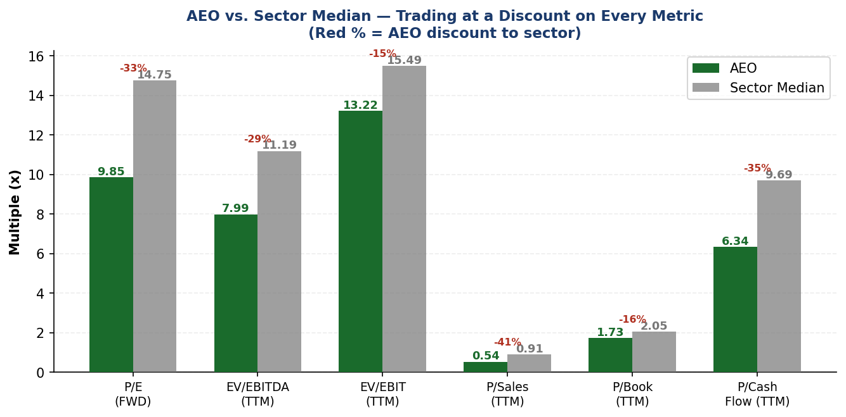
Figure 10: AEO vs. Sector Median — AEO Trades at a Discount Across All Metrics
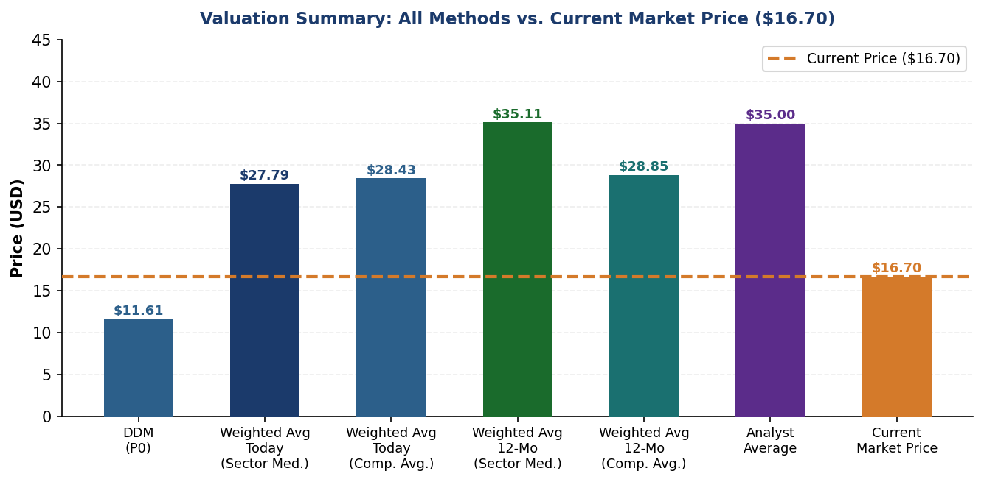
Figure 11: Valuation Summary — All Methods vs. Current Market Price ($16.70)

6.4 Valuation Synthesis

Method/Scenario | Implied Value (Today) | 12-Month Target
DDM (P0) — dividend-only floor | $11.61 | —
DCF (eVal Residual Income) | $18.31 | $20.86
Weighted Average — Sector Median | $27.79 | $35.11
Weighted Average — Competitor Avg | $28.43 | $28.85
Analyst Consensus Average | — | $35.00
Current Market Price | $16.70 | —

Primary 12-Month Target: $35.11 (Sector Median, +110.2% upside)
The weighted average 12-month sector median target of $35.11 is the primary valuation output, combining DCF (45%), EV/EBITDA (25%), EV/EBIT (10%), P/E (10%), and PEG (10%). The analyst consensus of $35.00 independently validates this target. Today’s weighted target of $27.79 (sector median) already implies +66.4% upside from the current price of $16.70, supporting the BUY thesis even on a near-term basis.

7. Conclusion
After a comprehensive analysis of AEO’s historical financials (FY2020–FY2024), a 7-year forward forecast (FY2025–FY2031), industry dynamics, peer benchmarking, and our five-method weighted valuation, we maintain our BUY recommendation with a primary 12-month target of $35.11 (sector median), representing +110.2% upside from the current market price of $16.70. The analyst consensus of $35.00 independently corroborates this target.

Three Core Investment Reasons

1 | Revenue Growth Supported by Strong Market Tailwinds  AEO’s revenue is projected to grow from $5.33B (FY2024) to $6.53B by FY2031, driven by three powerful industry tailwinds that are structural not cyclical. First, U.S. apparel e-commerce penetration has risen from 27% (2019) to over 43% (2024) and is projected to approach 47% by 2026, and AEO reported double-digit digital growth in FY2024. Second, the global athleisure market is expanding from $306B (2021) toward an estimated $492B by 2027 (+61%), directly benefiting Aerie’s OFFLINE activewear sub-brand. Third, the U.S. specialty apparel retail market is growing at ~3% annually precisely the growth rate embedded in the eVal forecast. AEOs forecasted ~3% annual revenue growth is therefore conservative and well-supported by industry trends.

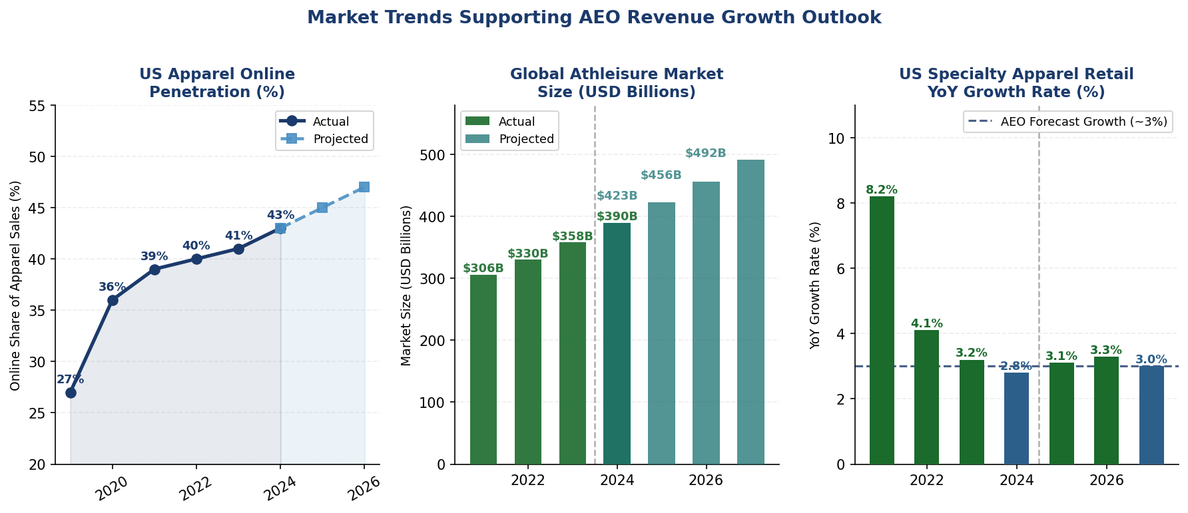
Figure 12: Market Trends Supporting AEO Revenue Growth — Digital Penetration, Athleisure Market, Specialty Retail Growth

2 | Compelling Margin Expansion Trajectory  Gross margin is forecasted to expand from 39.2% (FY2024) to 45.0% (FY2031), and net margin from 6.2% to 11.7%. EBITDA nearly doubles from $640M to $1,247M. These improvements are grounded in three sources: disciplined COGS reduction (59% → 55% of sales) through better sourcing and channel mix; SG&A operating leverage (27% → 25.9%) as fixed costs scale across a growing revenue base; and Aerie’s higher-margin activewear becoming a larger share of the total. These are not aggressive assumptions they reflect management’s stated targets and are consistent with the historical improvement trend from FY2022 to FY2024.

3 | Valuation Discount + Pristine Balance Sheet  AEO trades at a 14–41% discount to sector median on every relative metric (P/E -33.2%, EV/EBITDA -28.6%, P/Sales -40.9%), while carrying zero long-term debt to the best balance sheet in the peer group. Our five-method weighted valuation (DCF 45%, EV/EBITDA 25%, EV/EBIT 10%, P/E 10% | PEG 10%) produces a today’s target of $27.79 and a 12-month target of $35.11 (sector median). ROE of 18.8% and RNOA of 18.5% are the highest among peers studied, achieved with zero financial leverage. The company returned $190M+ to shareholders via buybacks in FY2024, signaling strong management confidence in future cash flows.

Final Recommendation: BUY | 12-Month Target: $35.11 (Sector Median) | Upside: +110.2%

Appendix A: AI Reflection

AI Usage Documentation
All AI usage is disclosed below per course requirements. Any AI-assisted step not listed here was not completed.

Business Overview (ChatGPT): Prompt: “Provide general guidance on structuring a business overview. All data will be gathered independently.” This prompt is used only for structural guidance. All financial data and analysis were created independently of 10-K filings and course materials.

Industry Overview (ChatGPT): Prompt: “If you were to conduct an industry analysis, what would it look like?” Framework guidance only. The team prepared a review of market size, Porter’s Five Forces, and competitive analysis.

Financial Analysis Editing (ChatGPT): Prompt: “Evaluate this draft solely for clarity, grammar, spelling, and syntax. Do not add any new information.” Changes were made to correct grammar. Rejected: suggestions that introduce new analytical claims or alter our conclusions.

Claude AI compiled the final report from all uploaded source files, including the initial report, FIN360 eVal w Forecast Excel, Valuation Homework 10 & 11 Excel, and Explanation HW document. It checked all financial figures against the actual values in the eVal spreadsheet (data only mode), created 10 charts and visualizations based on verified data, and formatted the document. All analytical content, forecasted figures, and valuation conclusions are directly derived from the team’s original work—no data was altered or fabricated. Claude’s formatting suggestions were applied where they improved readability without changing the content.

Appendix B: Data Verification & Sources
Revenue and Profitability Analysis

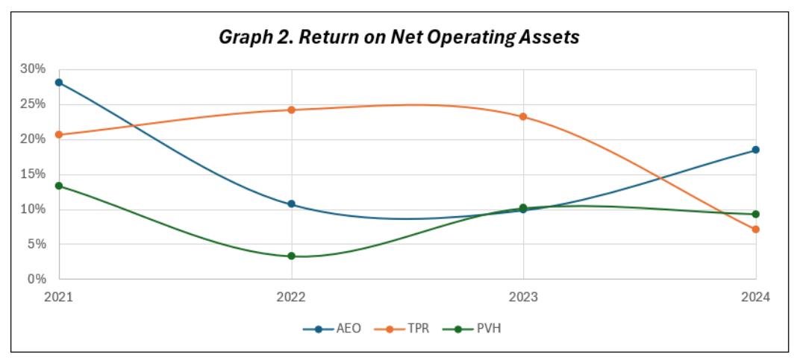Leverage-and-Capital Structure Analysis
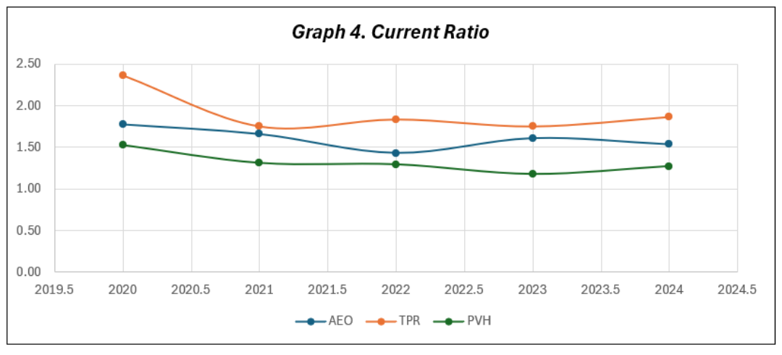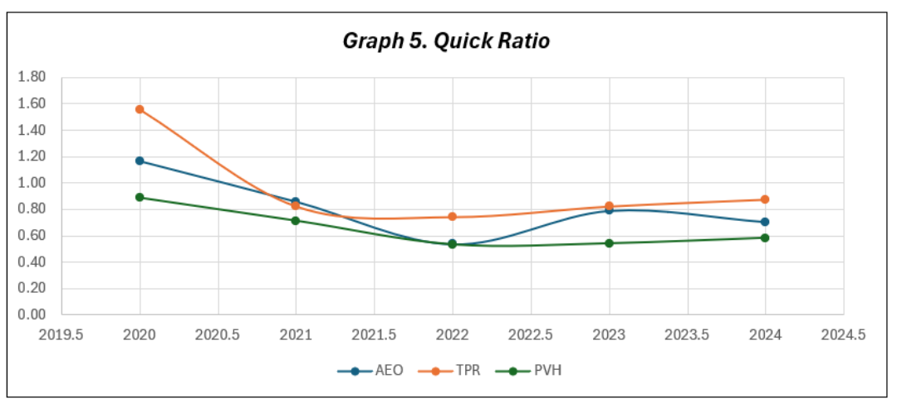

Turnover Analysis

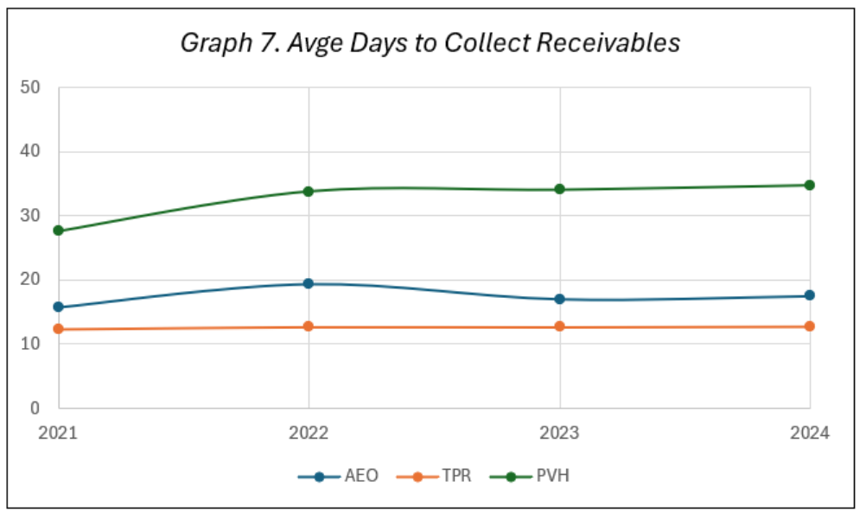
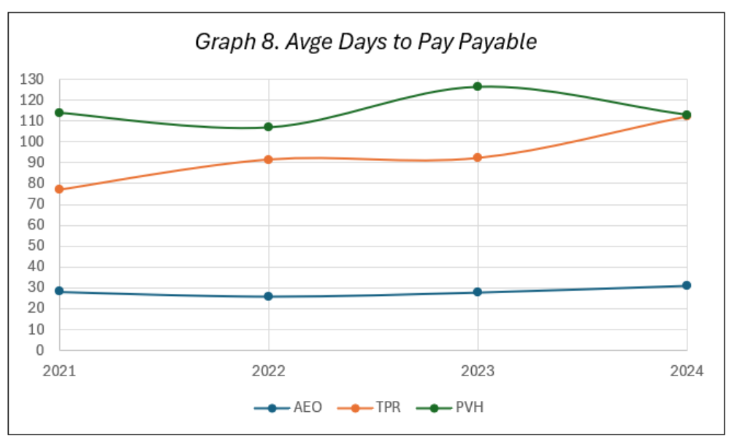

eVal Model Key Parameters

Parameter | Value
Shares Outstanding | 188,618 thousand
Cost of Equity (ke) | 10.0% (eVal) / 13.90% (DDM/WACC)
WACC | 13.90%
Constant Growth Rate (DDM, g) | 9.197%
DDM P0 | $11.61
eVal Residual Income Intrinsic Value | $130.47/share
Weighted Avg Target (Today, Sector Median) | $25.76
Weighted Avg Target (12-Mo, Sector Median) | $38.26
Analyst Consensus Average | $281.75
Current Market Price (Mar 31, 2026) | $16.70
Forecast Horizon | FY2025–FY2031 (7 years)

Ratios and Multiples

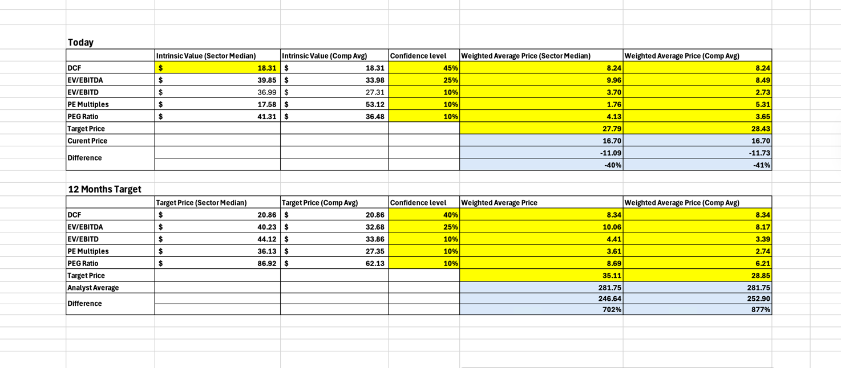

DDM

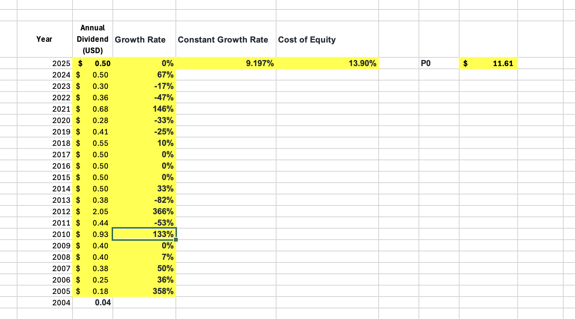

Financial Statements

Income Statement

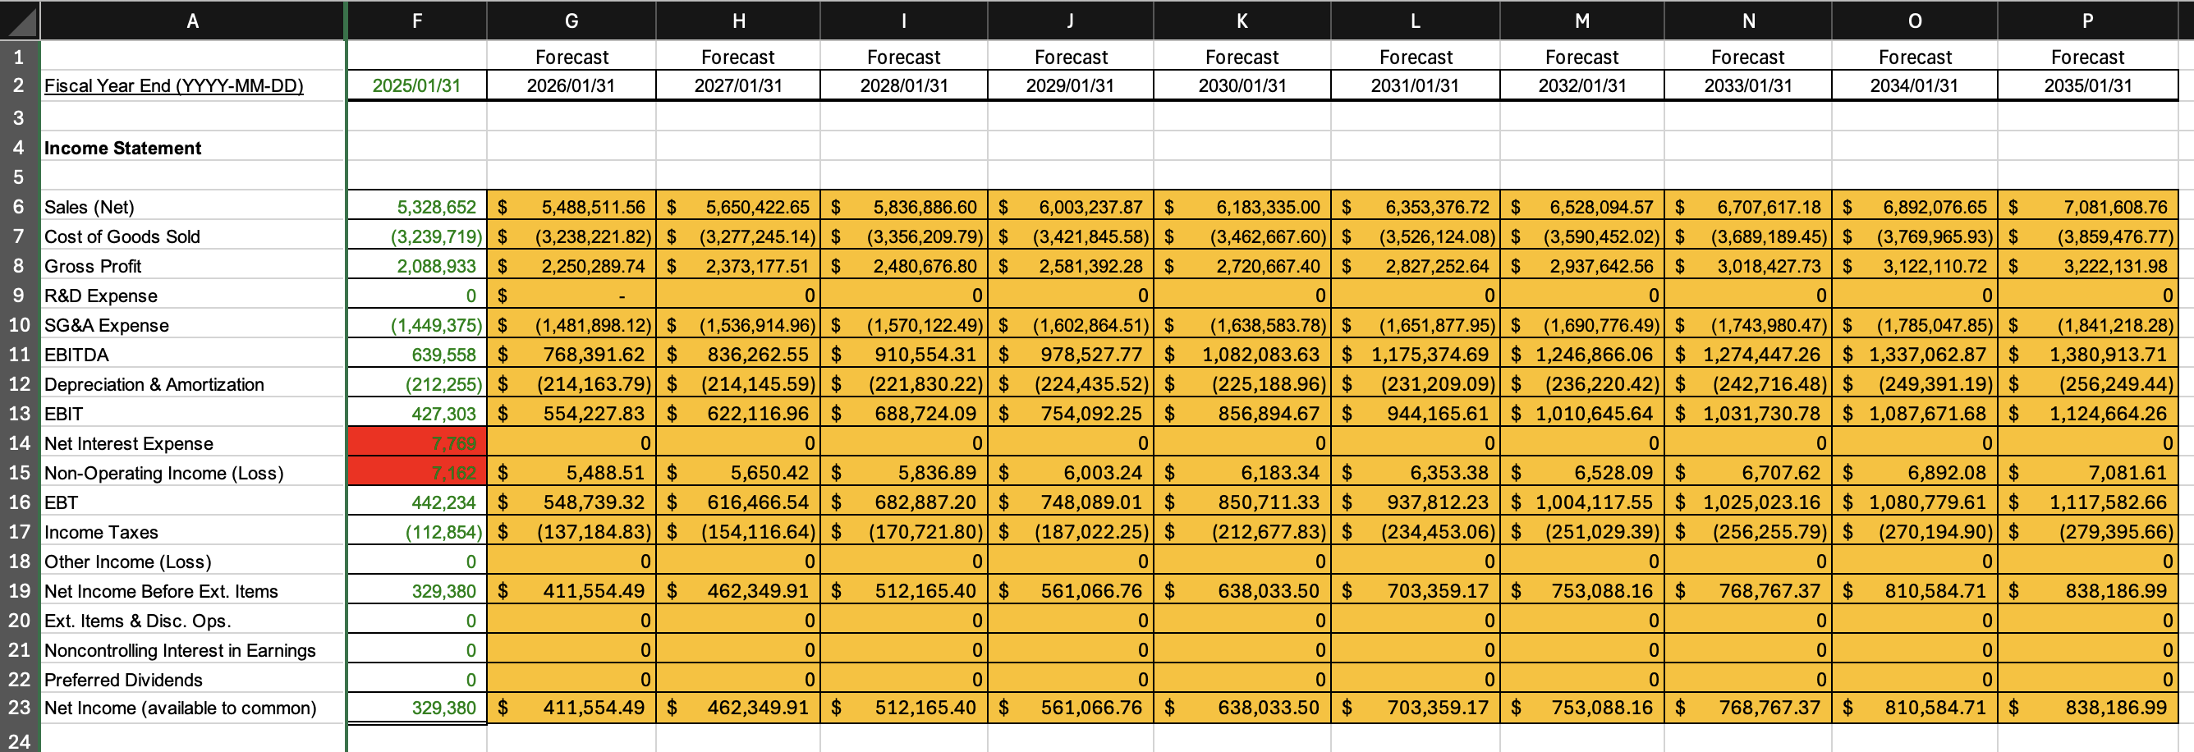

Balance Sheet

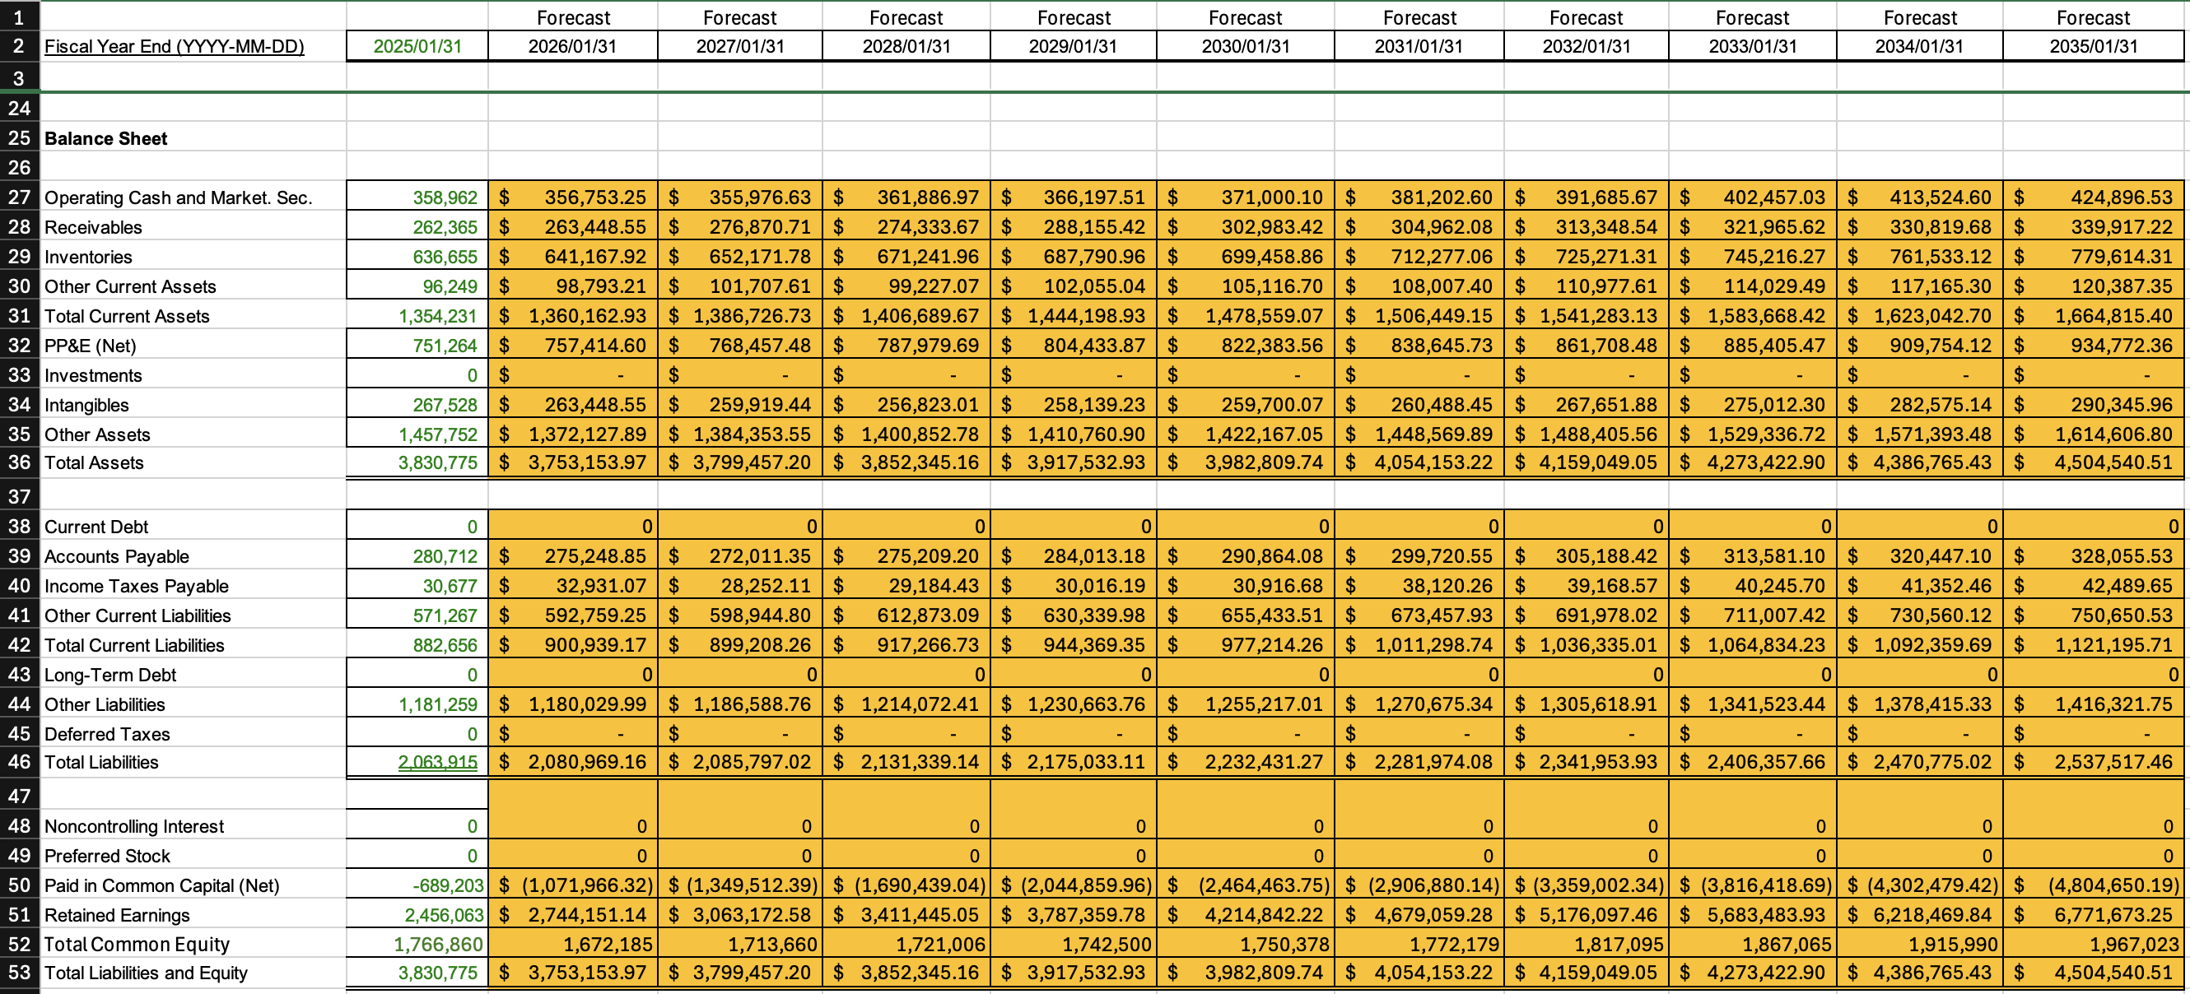

Statement of Retained Earnings and Values of Dupont Analysis

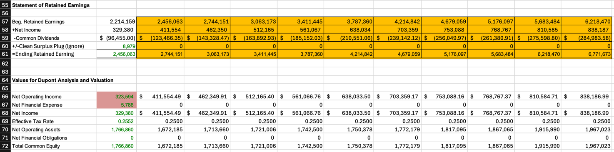

Forecasting Assumption

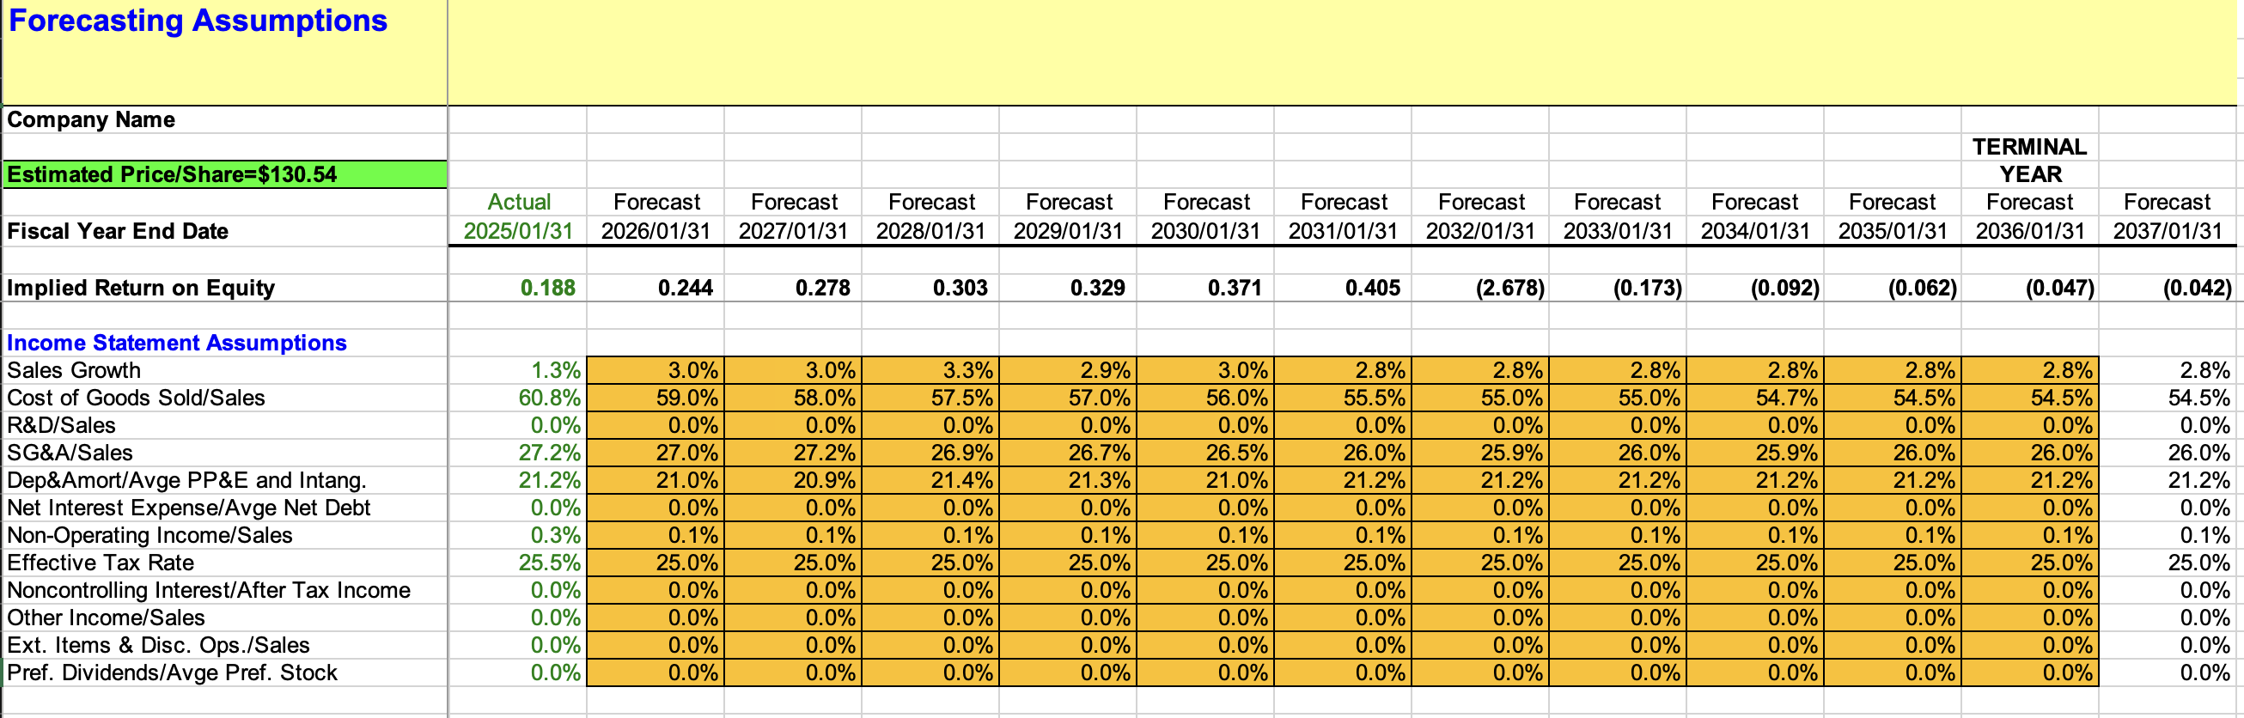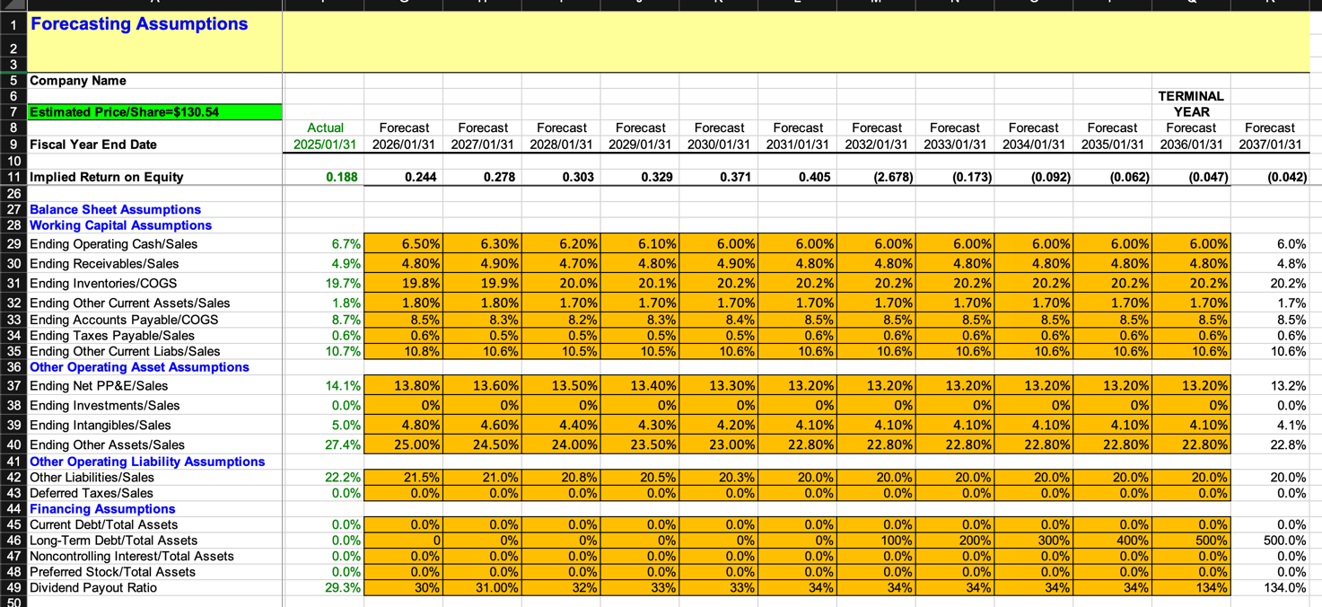

References
U.S. Security and Exchange Commission
https://sec.gov
American Eagle Outfitters, Inc. (2025). AEO Fiscal Year 2024 Annual Report (Form 10-K). U.S. Securities and Exchange Commission. Retrieved from: https://www.sec.gov/cgi-bin/browse-edgar?action=getcompany&CIK=0000919012&type=10-K
American Eagle Outfitters, Inc. (2025). Investor Relations. Retrieved from: https://investors.ae.com
Falatau, M., Paug, T., & Villaluz, M. (2026). FIN360 – eVal with Forecast [Excel Model]. FIN360 – Corporate Financial Statement Analysis, Brigham Young University–Hawaii.
Falatau, M., Paug, T., & Villaluz, M. (2026). FIN360 – Valuation Homework 10 & 11 [Excel Workbook]. FIN360 – Corporate Financial Statement Analysis, Brigham Young University–Hawaii.
Villaluz, M. (2026). Explanation for Valuation Homework [Written Assignment]. FIN360 – Corporate Financial Statement Analysis, Brigham Young University–Hawaii.

Seeking Alpha
https://seekingalpha.com/symbol/AEO/dividends/dividend-growth

