Meredith Villaluz
Business Management – Finance
Undergraduate Research
March 21, 2026

From Access to Security: Evaluating How BSP’s Financial Inclusion Policies
Translate into Retirement Readiness and Financial Self-Reliance
Among Unbanked Filipinos
Abstract
This study takes a closer look at how well the Bangko Sentral ng Pilipinas’ (BSP) financial inclusion policies are helping unbanked Filipinos prepare for retirement and become financially self-reliant. While the BSP has made good progress in expanding access to banks and digital financial services, there’s still a big gap between having access and feeling secure about the future. To explore this, the research introduces the Financial Inclusion–Retirement Security Model (FIRSM), which connects factors such as access, use, financial literacy, trust in institutions, and policy coordination to people’s retirement outcomes. Drawing on insights from BSP reports, government documents, and academic studies, the research finds that most Filipinos’ experience with financial inclusion remains focused on basic transactions rather than real, long-term change. More people might have bank accounts now, but not enough are truly prepared for retirement, because banks and pension systems don’t work closely enough together. The study concludes that unless policies are intentionally aligned, financial inclusion won’t lead to real financial independence. It suggests solutions like retirement-focused bank accounts, digital pension systems, and policy designs that account for how people behave.
Introduction
Economic inequality and financial vulnerability remain major issues in the Philippines, especially for people without bank access. According to the Enhanced Financial Institution Library System (EFILS, 2025), about 463 of 1,642 cities and municipalities lack formal financial institutions. A study by Mastercard and Rizal Commercial Banking Corporation (RCBC) also found that in 2024, 49.8% of Filipinos lacked access to banking services such as savings, credit, and insurance, which are important for financial independence and retirement security. This lack of access affects farmers, fisherfolk, informal workers, and the elderly the most, as they are also the least likely to have retirement coverage from institutions. (PCIC gets bigger budget to shield Filipino farmers, 2026)
Financial inclusion policies have grown quickly through new regulations, digital banking, and financial awareness programs led by the Bangko Sentral ng Pilipinas (BSP), which chairs the Financial Inclusion Steering Committee (Financial Inclusion Steering Committee, 2025). However, just having access to financial services does not always lead to better financial outcomes. Many people with accounts still do not use formal savings or retirement planning services. (Gasingan, 2024) This leads to the main research question: How much does financial inclusion help unbanked Filipinos prepare for retirement and become financially self-reliant, and what changes are needed to close the remaining gaps?

Background of the Study
The Bangko Sentral ng Pilipinas (BSP) was established under Republic Act No. 7653 (1993) to maintain price stability, support sustainable growth and employment, and ensure financial and payment system stability (BSP Organization Primer, 2025). Building on this, Republic Act No. 11211 (2019) expanded the BSP’s mandate to promote financial inclusion by encouraging innovation and market-based approaches (BSP’s Initiatives and Regulations on Financial Inclusion, 2025). Despite policy shifts, significant and urgent gaps persist. For example, "Inclusion by Design" (2025) reported that 49.8% of Filipinos lack formal financial accounts, especially the unemployed, farmers, fisherfolk, informal workers, and marginalized groups. Further, BSP’s Financial Inclusion at a Glance (2023) found that four in ten adults remain unbanked, underscoring persistent access barriers. Ongoing limitations on pension coverage compound these challenges. As urgency increases, a bill proposes a universal pension for all senior citizens, including SSS and GSIS recipients currently ineligible for the existing stipend (Panti, 2024). Still, the Mercer CFA Institute Global Pension Index (2024) ranked the Philippines third-worst globally, signaling a crisis. Together, these findings underscore the urgent need to address financial inclusion and pension reform to protect the financial security of elderly Filipinos.
Methodology
This study employs a qualitative research design and document analysis to examine how the financial inclusion policies of the Bangko Sentral ng Pilipinas (BSP) influence retirement-readiness among unbanked Filipinos. Specifically, the study identifies associations between policy interventions and retirement outcomes within this demographic. A qualitative approach is well-suited to this policy-focused, exploratory inquiry, as it enables detailed analysis of regulatory frameworks, institutional documentation, and socioeconomic contexts that quantitative approaches alone cannot adequately address (Creswell & Poth, 2018). Data sources are categorized as follows: (1) BSP policy documents and government reports, including the Financial Inclusion at a Glance (2023) and FISC Annual Report (2024); (2) peer-reviewed literature, such as Desello and Agner (2023) and Debuque-Gonzales and Corpus (2024); and (3) institutional analyses from the Asian Development Bank, HelpAge International, Mercer CFA Institute, and Sun Life Asia Financial Resilience Index (2024). Data analysis entailed an examination of the structure and outcomes of key BSP inclusion initiatives, as well as an evaluation of the effects of program participation on retirement security. The temporal focus is on 2018–2026, a period of considerable BSP regulatory and digital reform, with all data sourced from public records (Ta-Asan, 2026). As reported by Philstar.com, during this period, the BSP promoted the adoption of technology among rural banks to improve service delivery in rural communities.
Conceptual Framework: Financial Inclusion – Retirement Security Model (FIRSM)
The Financial Inclusion–Retirement Security Model (FIRSM) is introduced to explain how financial inclusion influences retirement readiness. The model comprises five interconnected components: Access (A), defined as the ownership of formal financial accounts; Usage (U), referring to the frequency and purpose of financial transactions; Literacy (L), representing the level of financial and retirement knowledge; Trust (T), indicating confidence in formal financial institutions; and Policy Integration (P), describing the extent to which financial systems are connected to pension programs. The core relationship is represented as follows:
Retirement Readiness = f(A, U, L, T, P)
According to the FIRSM, retirement outcomes depend not only on account ownership but also on account usage, the individual's financial understanding, trust in institutions, and, most critically, the extent to which policy intentionally connects banking access to retirement mechanisms. Figure 1 illustrates this model, depicting how the policy pillars of the Bangko Sentral ng Pilipinas (BSP) flow through each FIRSM component toward retirement readiness and, ultimately, financial self-reliance. Barriers such as geography, cost, and the digital divide may disrupt this pathway at any stage.
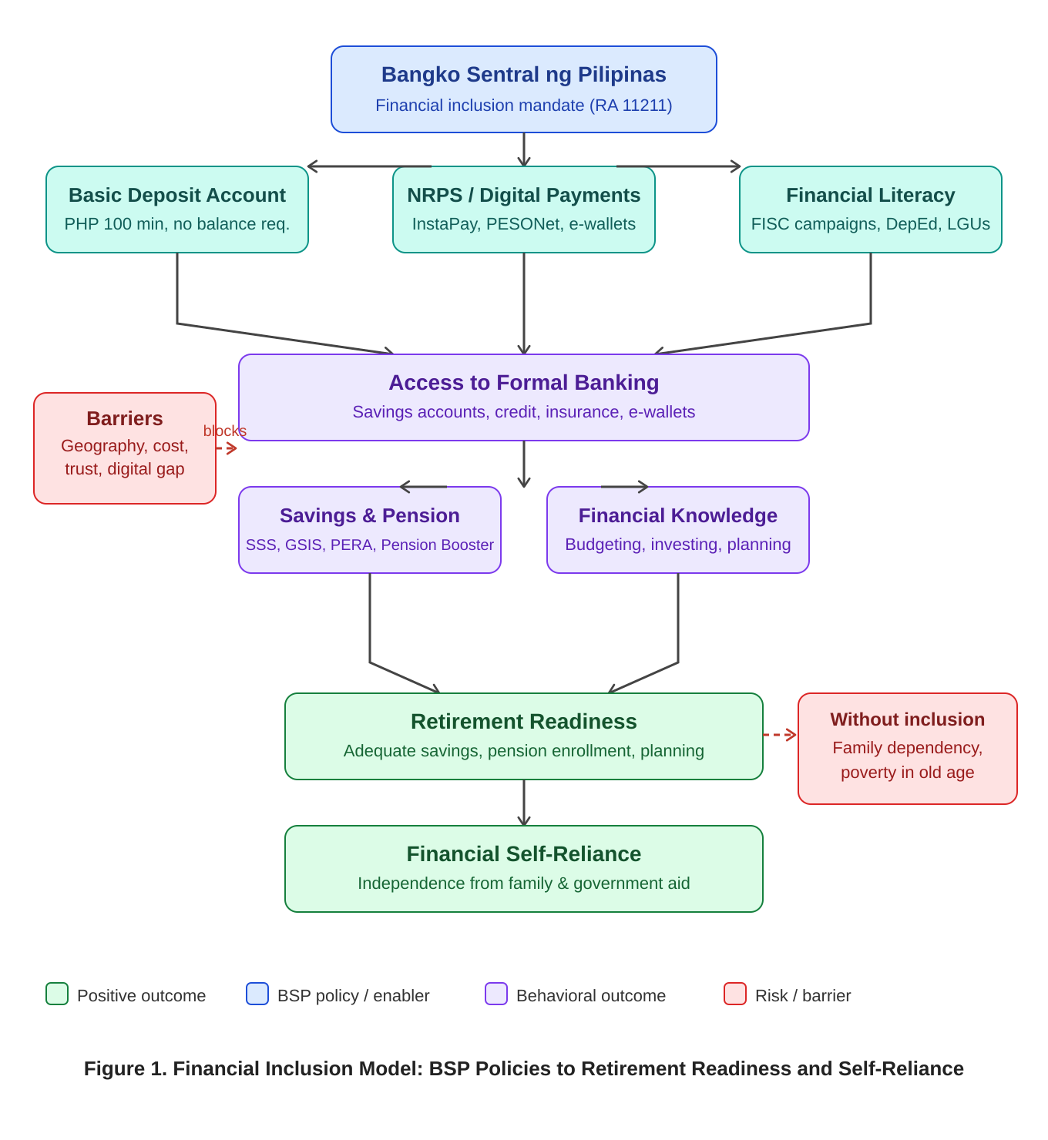
Figure 1. Financial Inclusion–Retirement Security Model (FIRSM): BSP Policies to Retirement Readiness and Self-Reliance
Literature Review
Scholarly literature consistently identifies financial inclusion as a key enabler of long-term household welfare in developing economies (Digital financial inclusion as a safety net: Empowering households against health shocks, 2025). Desello and Agner (2023) found that financial literacy is a significant driver of inclusion in the Philippines, with a one-standard-deviation increase in financial literacy scores increasing the likelihood of formal account ownership by 3.7 to 4.2 percentage points. This finding reinforces the Bangko Sentral ng Pilipinas (BSP) characterization of inclusion as a “national development agenda.” Debuque-Gonzales and Corpus (2024) identified high cost, distance, and lack of trust as the primary barriers to inclusion, with Filipinos more affected than their ASEAN counterparts. Additional evidence indicates that rural regions in the Visayas and Mindanao have digital financial adoption rates 1.8 times lower than those in urban areas, primarily due to limited smartphone access and inadequate infrastructure (Journal of Interdisciplinary Perspectives [JIP], 2025). Importantly, the literature consistently finds that access alone is insufficient; many individuals who open accounts do not transition to active financial management or retirement planning (Valera et al., 2024, pp. 2533-2550). Desello and Agner (2023) note that the Organisation for Economic Co-operation and Development (OECD) associates higher financial knowledge with increased long-term savings. However, the Sun Life Asia Financial Resilience Index (Sun Life Philippines, 2024) found that only 14% of surveyed Filipinos have a retirement or pension plan, and only 41% have any financial plan extending beyond one year. This persistent gap between access and outcomes is the focus of the FIRSM model and the present research.

BSP’s Key Financial Policies
The Bangko Sentral ng Pilipinas (BSP) has promoted financial inclusion through regulatory reform, digital infrastructure, and financial education. For example, BSP Circular No. 992 (2018) created the Basic Deposit Account (BDA), which has an opening amount of not more than PHP 100, no maintaining balance, no dormancy charges, and easy onboarding (CGAP, 2023). This enabled low-income Filipinos to open their first formal accounts. In contrast, the BSP’s National Retail Payment System (NRPS), established in 2015, led to PESONet and InstaPay—platforms that enable low-cost, real-time transfers around the clock (BSP, 2015). These digital platforms rapidly grew. In 2024, digital payments reached 57.4% by volume and 59.0% by value, surpassing targets. InstaPay alone saw a 67.8% rise in transaction volume from 2023 to 2024 (BitPinas, 2025, citing BSP, 2024). Also, in July 2025, the BSP expanded the Personal Equity and Retirement Account (PERA) program to digital platforms—such as GCash and UnionBank—letting individuals invest up to PHP 100,000 per year with a 5% tax credit (Philippine Tribune, 2026). Despite these steps, BSP policies have mainly widened access—focusing on accounts and transactions—while not significantly changing financial behaviors such as saving, pension enrollment, and retirement planning (Gasingan, 2024).
Barriers, Shallow Inclusion, and the Disconnect from Retirement Readiness
Approximately 37.6 million Filipinos remain unbanked, ranking the country among the top 10 globally for unbanked adults. This situation is driven by geographic barriers across more than 7,000 islands, stringent documentation requirements, and persistent institutional mistrust (UNSGSA, 2024; Lugtu, 2023). By 2024, nearly half of Philippine households had internet access at home, with 48.8 percent connected, according to the Philippine Statistics Authority. This level of connectivity demonstrates that digital banking solutions remain inaccessible for a significant portion of the population (Ta-Asan, 2025). Even among individuals with formal bank accounts, financial inclusion in the Philippines remains limited. While account ownership has increased, financial behavior is predominantly transactional, focusing on payments rather than savings or wealth accumulation (Debuque-Gonzales & Corpus, 2024). This limited inclusion is evident in retirement outcomes. SSS voluntary contribution programs require online registration through the My.SSS portal and a registered disbursement account (SSS, 2024), both of which are unattainable without formal banking access (Retirement Benefit | Republic of the Philippines Social Security System, 2025). The MySSS Pension Booster, launched in June 2024 with a minimum monthly contribution of PHP 500 and a 7.2 percent target interest rate (DOF, 2024), as well as the PERA program, are inaccessible to unbanked Filipinos, thereby increasing retirement vulnerability each year (Ta-Asan, 2025). Regarding the Financial Inclusion Readiness and Sustainability Model (FIRSM), the Access (A) component is improving, but Usage (U), Literacy (L), Trust (T), and Policy Integration (P) remain underdeveloped, resulting in an incomplete pathway to retirement readiness.
Conclusion and Recommendation
The Bangko Sentral ng Pilipinas (BSP) has achieved measurable progress in expanding financial access through the Basic Deposit Account (BDA) framework, National Retail Payment System (NRPS) digital infrastructure, and retirement instruments such as the Personal Equity and Retirement Account (PERA). Despite these advances, most unbanked Filipinos have not attained retirement readiness or self-reliance. According to the Financial Inclusion and Retirement Security Model (FIRSM), access represents only the first of five conditions for retirement security and remains the primary focus of current policy. The remaining conditions—usage, literacy, trust, and policy integration—require interventions of comparable strength. Financial inclusion initiatives should advance beyond access to emphasize meaningful, outcome-driven engagement. In the absence of integrated retirement mechanisms, millions of Filipinos are likely to continue experiencing insecurity in old age, thereby perpetuating intergenerational dependency. The following five recommendations are proposed. First, BSP should develop retirement-linked financial accounts that automatically connect banking services to the Social Security System (SSS) or PERA at account opening. Second, digital pension integration should be accelerated by mandating e-money issuers and digital banks to provide one-tap voluntary SSS enrollment. Third, behavioral policy tools, including automatic savings and retirement nudges, should be incorporated into BSP’s financial literacy campaigns. Fourth, retirement-specific education should be embedded in school curricula and community programs, framing retirement planning as self-reliance consistent with Filipino values. Fifth, BSP should transition from measuring account ownership to utilizing outcome-based indicators that assess retirement participation and financial security over time. For future research, primary surveys and interviews in rural areas are recommended to strengthen the evidence base and determine whether interventions foster sustained retirement-saving behavior.

References
Asian Development Bank. (2022). Aging well in Asia: Policies and programs supporting older persons. ADB. https://www.adb.org
Bangko Sentral ng Pilipinas. (2015). National Retail Payment System framework. BSP. https://www.bsp.gov.ph
Bangko Sentral ng Pilipinas. (2018). BSP Circular No. 992: Guidelines on the Basic Deposit Account. BSP Official Registry. https://www.bsp.gov.ph
Bangko Sentral ng Pilipinas. (2022). 2021 Financial Inclusion Survey topline report. BSP Financial Inclusion Office. https://www.bsp.gov.ph
Bangko Sentral ng Pilipinas. (2023). Financial inclusion at a glance. BSP Financial Inclusion Office. https://www.bsp.gov.ph
Bangko Sentral ng Pilipinas. (2024). Status of digital payments in the Philippines 2024. BSP Financial Inclusion Office. https://www.bsp.gov.ph
Bangko Sentral ng Pilipinas. (2025a). BSP organization primer. https://www.bsp.gov.ph
Bangko Sentral ng Pilipinas. (2025b). BSP's initiatives and regulations on financial inclusion. https://www.bsp.gov.ph
BitPinas. (2025). BSP digital payments 2024 report: InstaPay volume rises 67.8%. https://bitpinas.com
Consultative Group to Assist the Poor. (2023). Basic Deposit Account Philippines: Lowering barriers to entry. CGAP. https://www.cgap.org
Creswell, J. W., & Poth, C. N. (2018). Qualitative inquiry and research design: Choosing among five approaches (4th ed.). SAGE Publications.
Debuque-Gonzales, M., & Corpus, J. (2024). Understanding financial inclusion in the Philippines. Philippine Journal of Development, 48(1). https://doi.org/10.62986/pjd2024.48.1a
Debuque-Gonzales, M., & Corpus, J. (2024). Understanding financial inclusion in the Philippines (PIDS Discussion Paper Series No. 2024-07). Philippine Institute for Development Studies. https://pidswebs.pids.gov.ph/CDN/PUBLICATIONS/pidsdps2407.pdf
Department of Finance. (2024). SSS MySSS Pension Booster launched June 2024 [Press release]. https://www.dof.gov.ph
Department of Agriculture. (2026, January 25). PCIC gets bigger budget to shield Filipino farmers. https://www.da.gov.ph/pcic-gets-bigger-budget-to-shield-filipino-farmers/
Desello, J. M. U., & Agner, M. G. R. (2023). Financial inclusion and the role of financial literacy in the Philippines. International Journal of Economics and Finance, 15(3). https://ccsenet.org/journal/index.php/ijef/article/view/0/48464
Digital financial inclusion as a safety net: Empowering households against health shocks. (2025). Economic Modelling, 151, Article 107194. https://doi.org/10.1016/j.econmod.2025.107194
Enhanced Financial Institution Library System. (2025). Survey of unbanked cities and municipalities in the Philippines. EFILS.
Financial Inclusion Steering Committee. (2024). FISC annual report 2024. FISC. https://www.financialinclusion.gov.ph
Gasingan, D. (2024, September 18). BSP emphasizes importance of saving for emergencies, retirement. Philippine Information Agency. https://pia.gov.ph/news/bsp-emphasizes-importance-of-saving-for-emergencies-retirement/
HelpAge International & Coalition of Services of the Elderly. (n.d.). Older people's lives at risk: Addressing the crisis in the Philippines [Policy brief]. As cited in House Bill No. 6410, Republic of the Philippines House of Representatives. https://docs.congress.hrep.online/legisdocs/basic_20/HB06410.pdf
IBON Foundation. (2021). The Filipino elderly are left behind. https://www.ibon.org/the-filipino-elderly-are-left-behind/
Journal of Interdisciplinary Perspectives. (2025). Systematic review of digital financial inclusion in the Philippines 2014–2024. Journal of Interdisciplinary Perspectives, 3(1). https://www.jipsp.com/index.php/jip/article/view/985
Lugtu, R. (2023). Financial exclusion in the Philippines: Barriers and solutions. BusinessWorld. https://www.bworldonline.com
Mastercard & Rizal Commercial Banking Corporation. (2024). Financial inclusion in the Philippines: 2024 landscape study. RCBC.
Mercer CFA Institute. (2024). Global Pension Index 2024. Mercer. https://cfas.org.au/wp-content/uploads/2024/10/mercer-global-pension-index-2024.pdf
Panti, L. T. (2024, May 7). House panel eyes P89-billion budget for universal pension for the elderly bill. GMA News Online. https://www.gmanetwork.com/news/money/economy/906175/house-panel-eyes-p89-billion-budget-for-universal-pension-for-elderly-bill/story/
Pension Policy International. (2025). Philippines MySSS Pension Booster: A new voluntary retirement savings program. https://www.pensionpolicyinternational.org
Philippine Tribune. (2026, March 12). BSP expands PERA digital pilot through GCash and UnionBank. Philstar.com. https://www.philstar.com
Social Security System. (2024). Retirement benefit: Filing and disbursement requirements. My.SSS Portal. https://www.sss.gov.ph
Social Security System. (2025). Retirement benefit. https://www.sss.gov.ph/retirement-benefit/
Sun Life Philippines. (2024). Sun Life Asia Financial Resilience Index 2024: Philippines results. Sun Life Philippines Newsroom. https://www.sunlife.com.ph/en/about-sun-life/newsroom
Ta-Asan, K. (2025, August 30). Half of Filipinos still unbanked despite digital boom – study. Philstar.com. https://www.philstar.com/business/2025/08/31/2469245/half-filipinos-still-unbanked-despite-digital-boom-study
Ta-Asan, K. (2026, February 11). BSP tightens standards for tech-driven banks. Philstar.com. https://www.philstar.com/business/2026/02/12/2507365/bsp-tightens-standards-tech-driven-banks
United Nations Secretary-General’s Special Advocate for Inclusive Finance for Development. (2024). Philippines financial inclusion country report. UNSGSA. https://www.unsgsa.org
Valera, M. L., Lei, Z., & Fong, J. H. (2024). Determinants of financial inclusion in Southeast Asia. Applied Economics, 57(20), 2533–2550. https://doi.org/10.1080/00036846.2024.2326529

