**Calulang, Mary Jane P.** June 05, 2024

**BSCS 3B** CSE4 - Assign2

1. Write a Python Script to sort (ascending and descending) a dictionary by value.

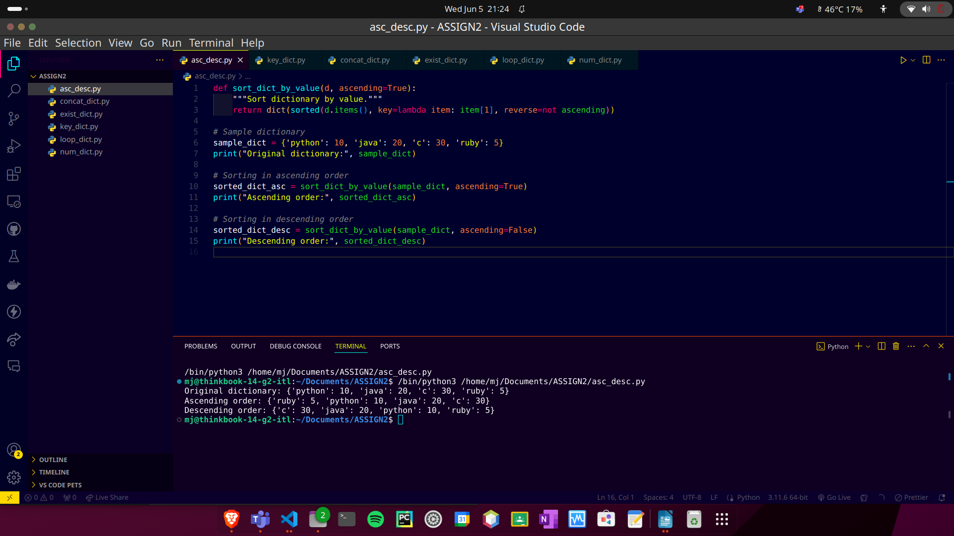

1. Write a Python script to add a key to a dictionary.

Sample Dictionary: {0:10, 1:20}

Expected Result: {0:10, 1:20, 2:30}

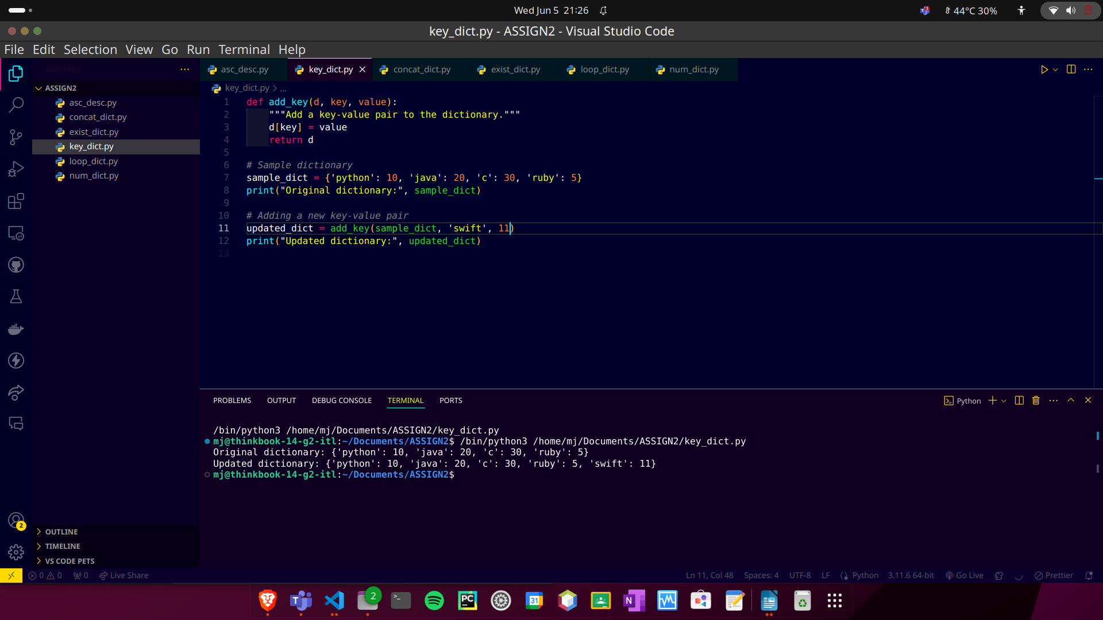

1. Write a Python script to concatenate following dictionaries to create a new one.

Sample Dictionary:

dic1= {0:10, 1:20}

dic2 = {3:30, 4:40}

dic3 = {5:50, 6:60}

Expected Result: {1:10, 2:20, 3:30, 4:40, 5:50, 6:60}

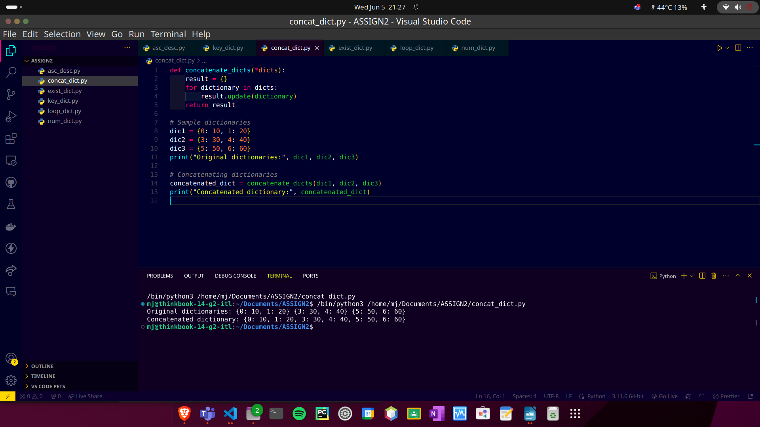

1. Write a Python script to check if a given key already exists in a dictionary.

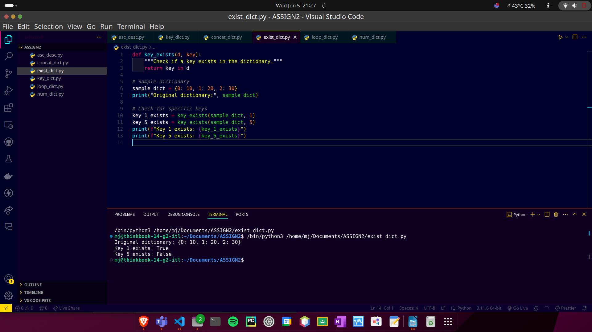

1. Write a Python program to iterate over dictionaries using for loops.

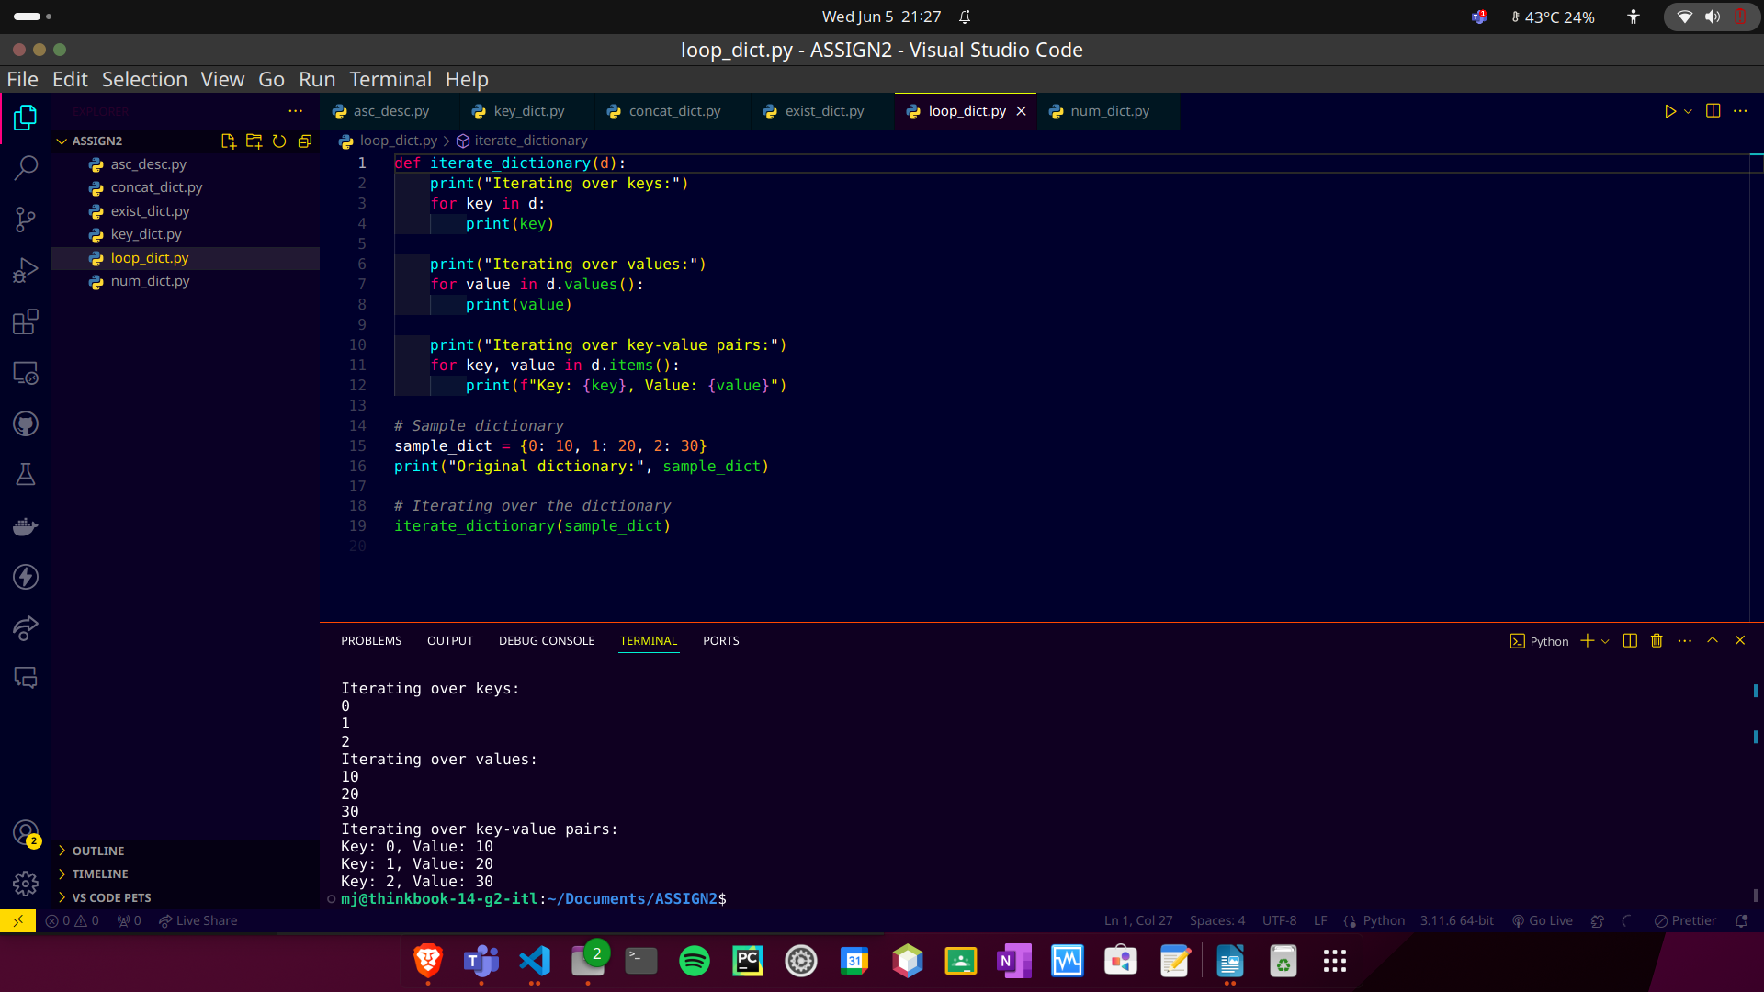

1. Write a Python script to generate and print a dictionary that contains a number (between 1 and n) in the form (x, x*x).

Sample Dictionary (n = 5):

Expected Output: {1:1, 2:4, 3:9, 4:16, 5:25}

