Checkpoint DB:
Convert the entity relationship model to a relational diagram :

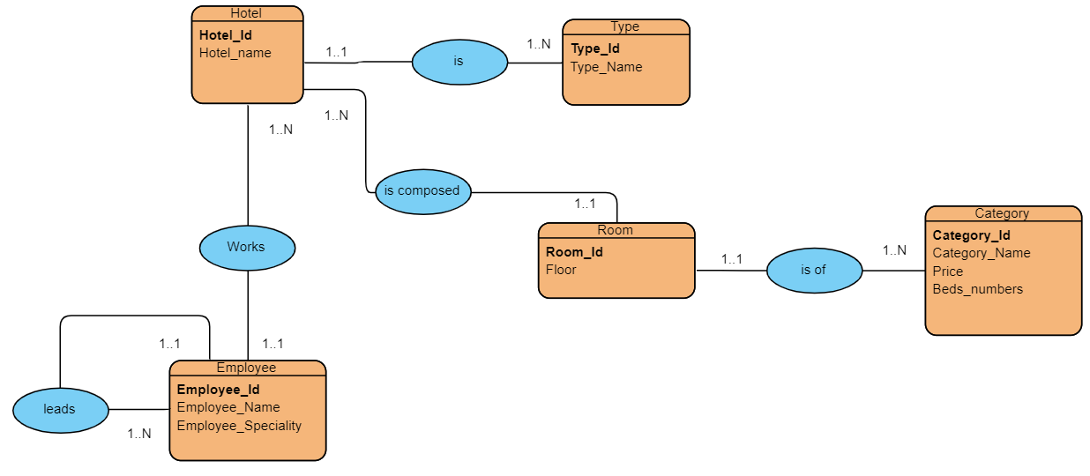
*Hotel(Hotel_id,Hotel_name,Type_id,Employ_id) ;

*Employee(Employee_id,Employee_name,Employee_speciality,leads_id) ;

*Room(Room_id,Floor,Hotel_id,Category_id) ;

*Type(type_id,type_name) ;

*Category(Category_id,Category_name,Category_numbers,) ;

