COMP3133 - Lab3 - Screenshots

- Get All Restaurants
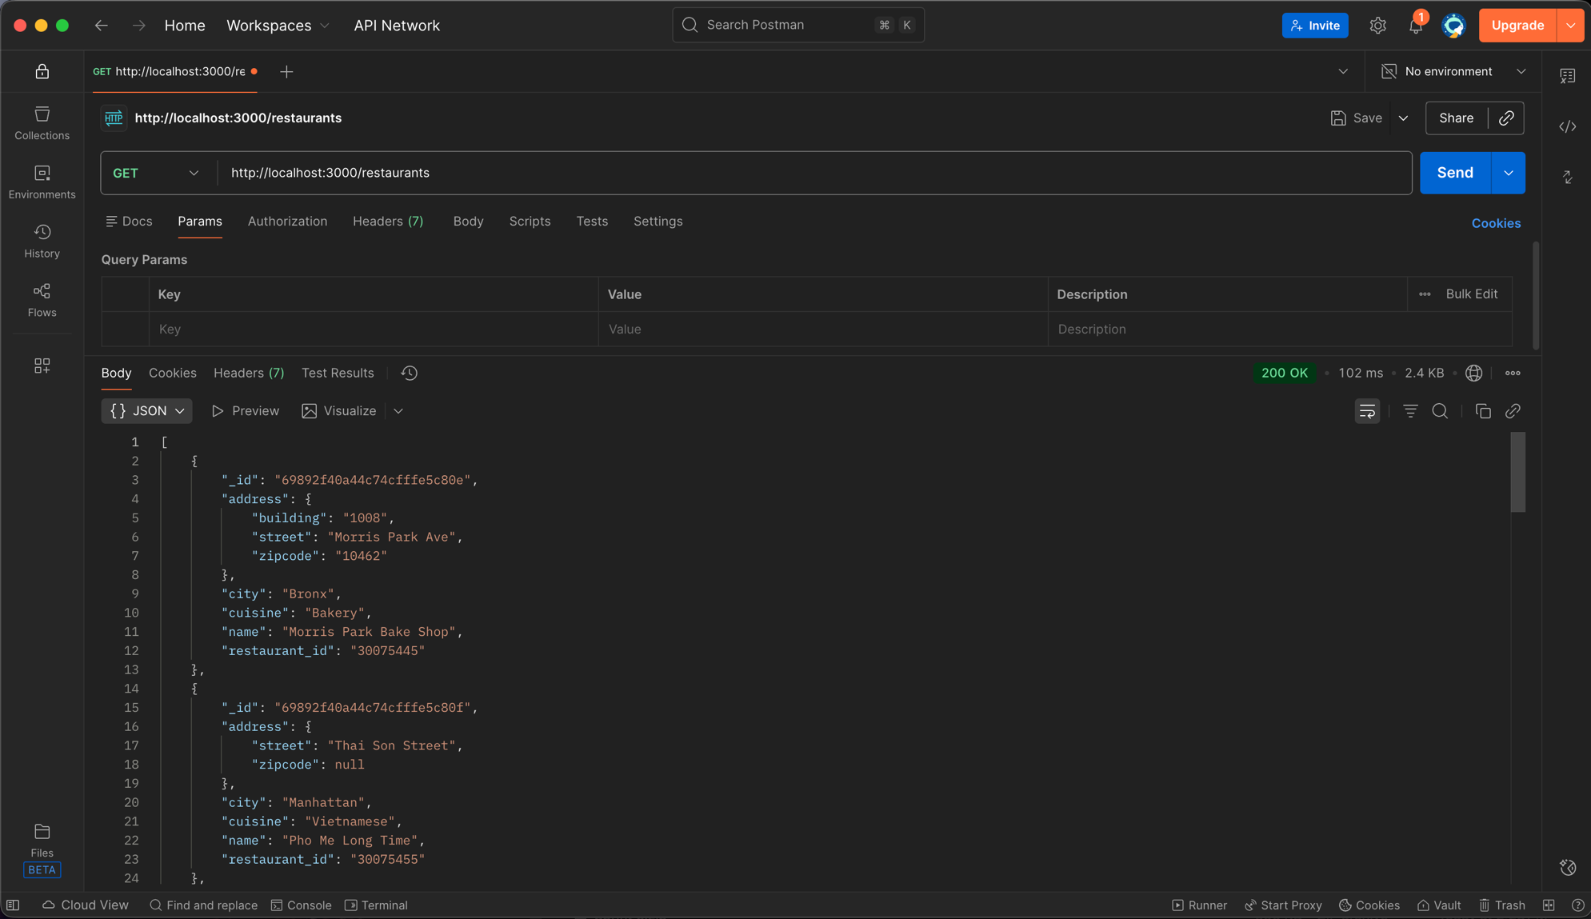
- Get Restaurants By Cuisine / Bakery
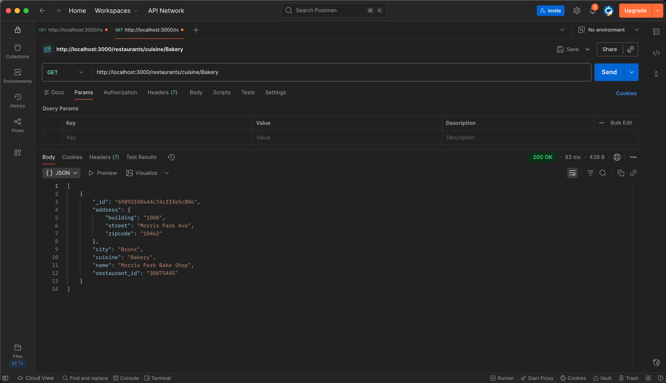

- Get Restaurants By Cuisine / Japanese
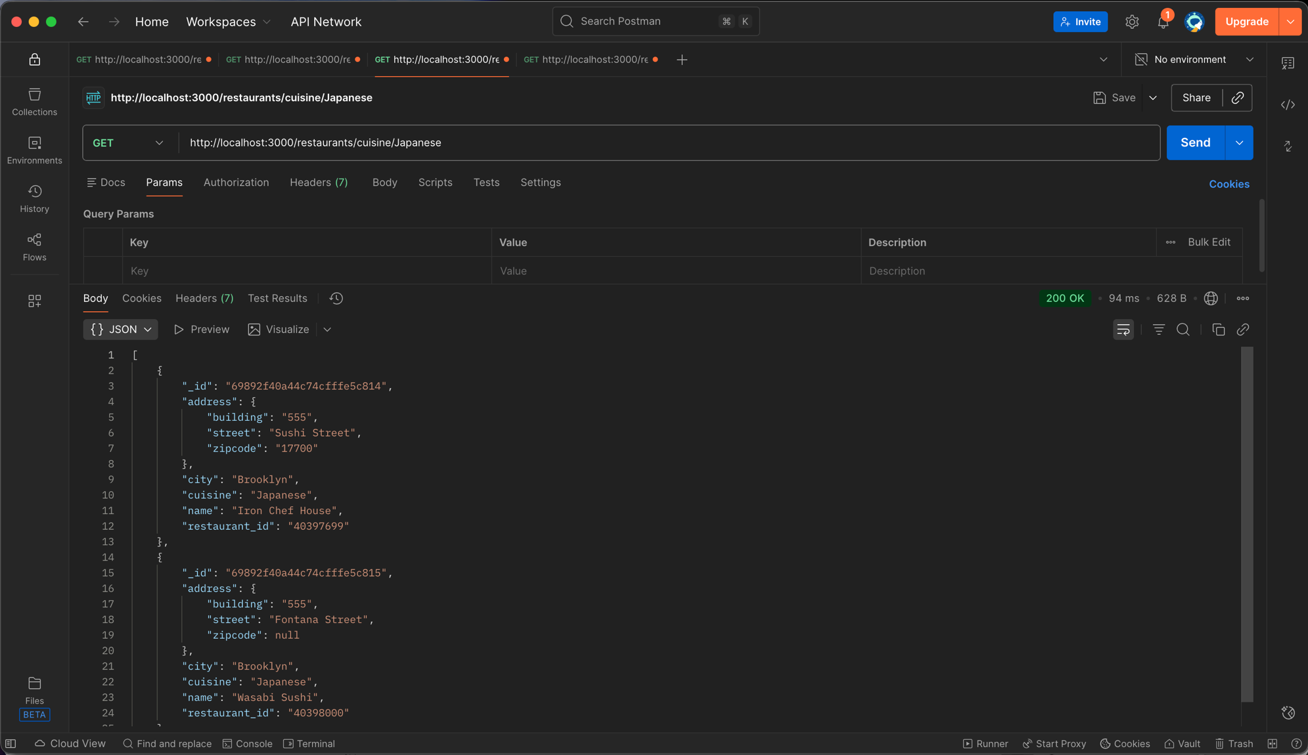

- Get Restaurants By Cuisine / Italian
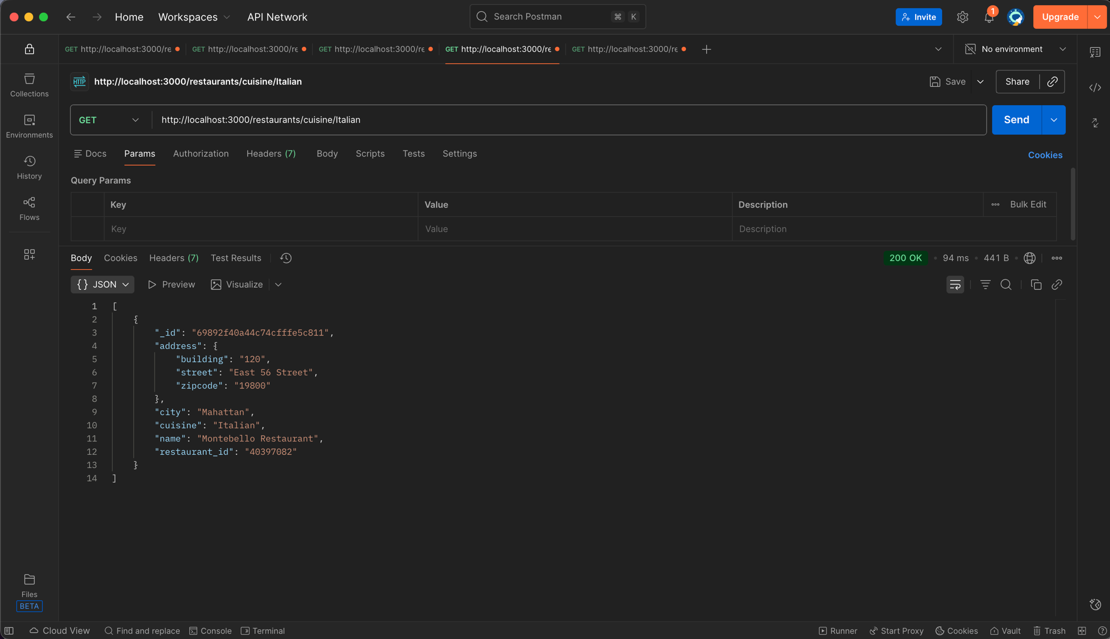

- Sort Restaurants By Ascending Order
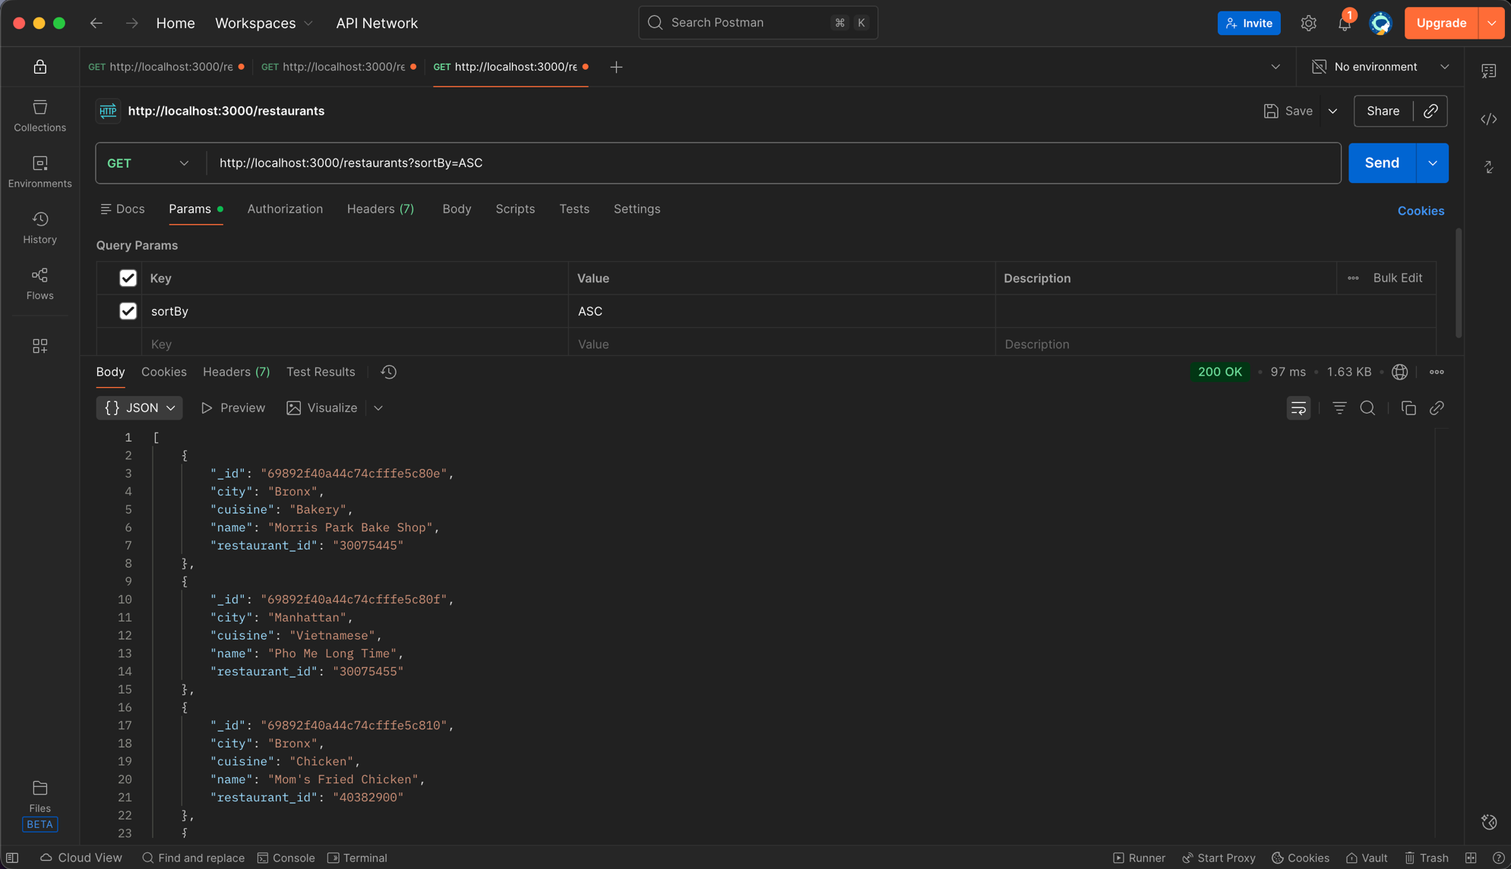

- Sort Restaurants By Descending Order
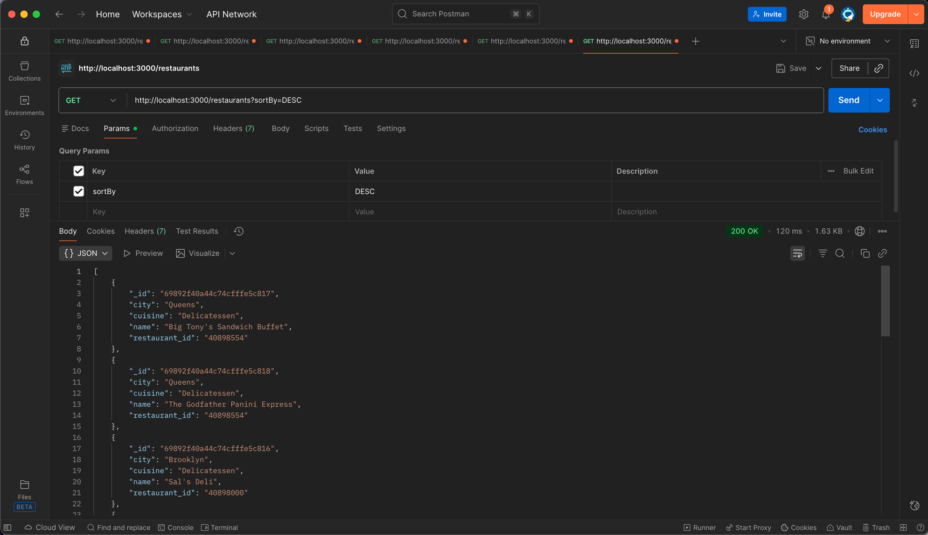

- Get Restaurants Where Cuisine is Delicatessen and City is not Brooklyn
