A.Weak Prompt:
Explain regression

A.Improved Prompt:

You are a data analytics instructor. Explain linear regression to a beginner in a data analytics training program who knows basic Excel but has no statistics background. Use a simple language.

Why it’s stronger: It gives the AI a role, describes the audience’s level, asks for a specific type of regression and a real example, and sets a length and format, so the answer is clear and useful instead of too general or technical.

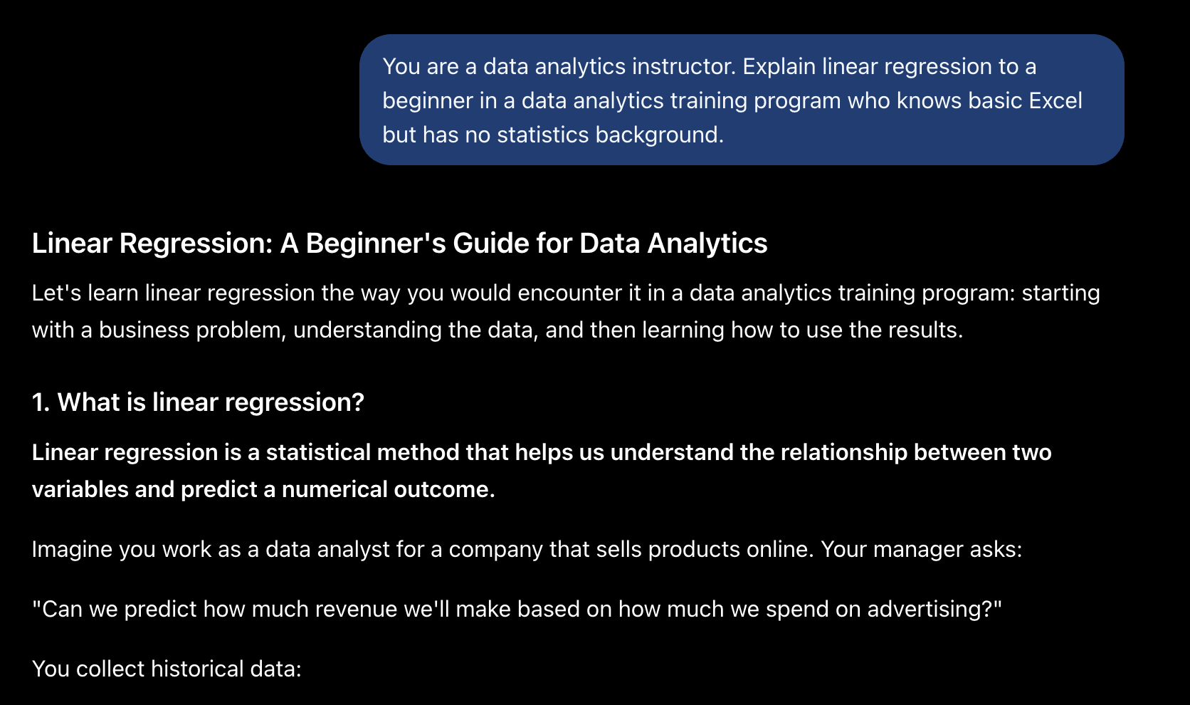

B. Weak Prompt:
Help me understand SQL
B. Improved Prompt:
You are a patient SQL tutor. I’m a beginner in a data analytics program and just installed MySQL. Explain the basic SELECT, WHERE, and ORDER BY commands using a small example table of store sales. Show each command with a short query and its result, and finish with two practice exercises.
Why it’s stronger: It narrows a huge topic down to three specific commands, gives context about my level and tools, and asks for examples and practice, so I get a focused lesson I can follow step by step.
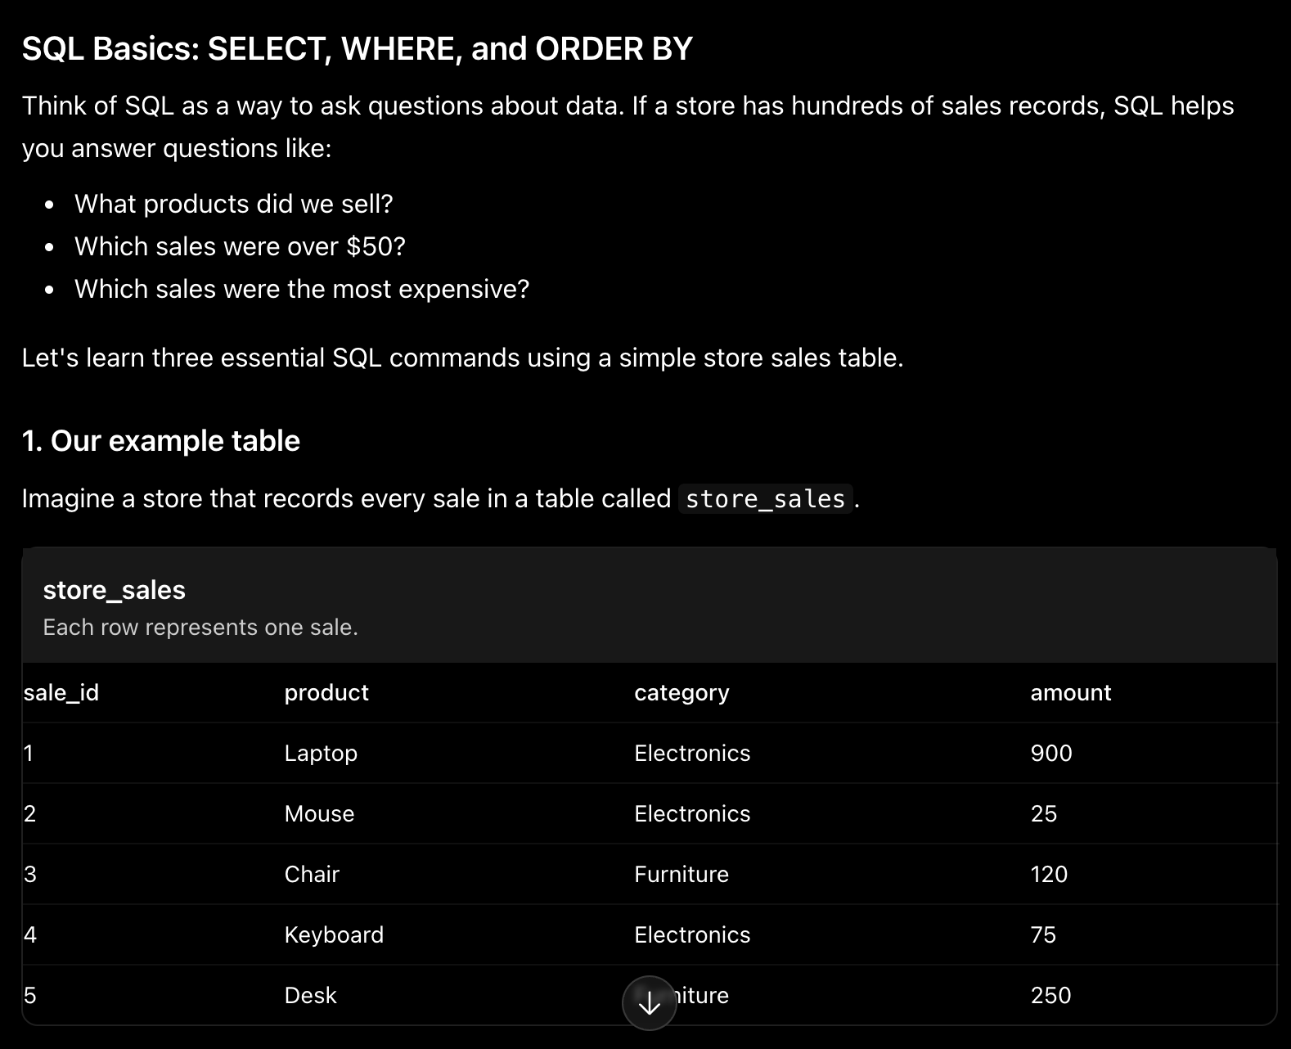

C.Weak Prompt:
Create a dataset
C. Improved Prompt:
Create a dataset with 10 rows showing Store Name, Region (North, South, East, West), Product Category, and Monthly Sales. Monthly Sales should range between 40 and 80, and include one unusually high value as an outlier. Format it as a table I can copy into Excel.
Why it’s stronger: It specifies the number of rows, the exact columns, realistic value ranges, and the output format, so the AI creates a dataset that’s ready to use for practice instead of random data.
