Must install the following dependencies:

Java 17.0.5

Groovy 4.0.18

How to run in command console:

1. Extract the downloaded program in a specified directory
2. Search command prompt and right+click then select Run as administrator

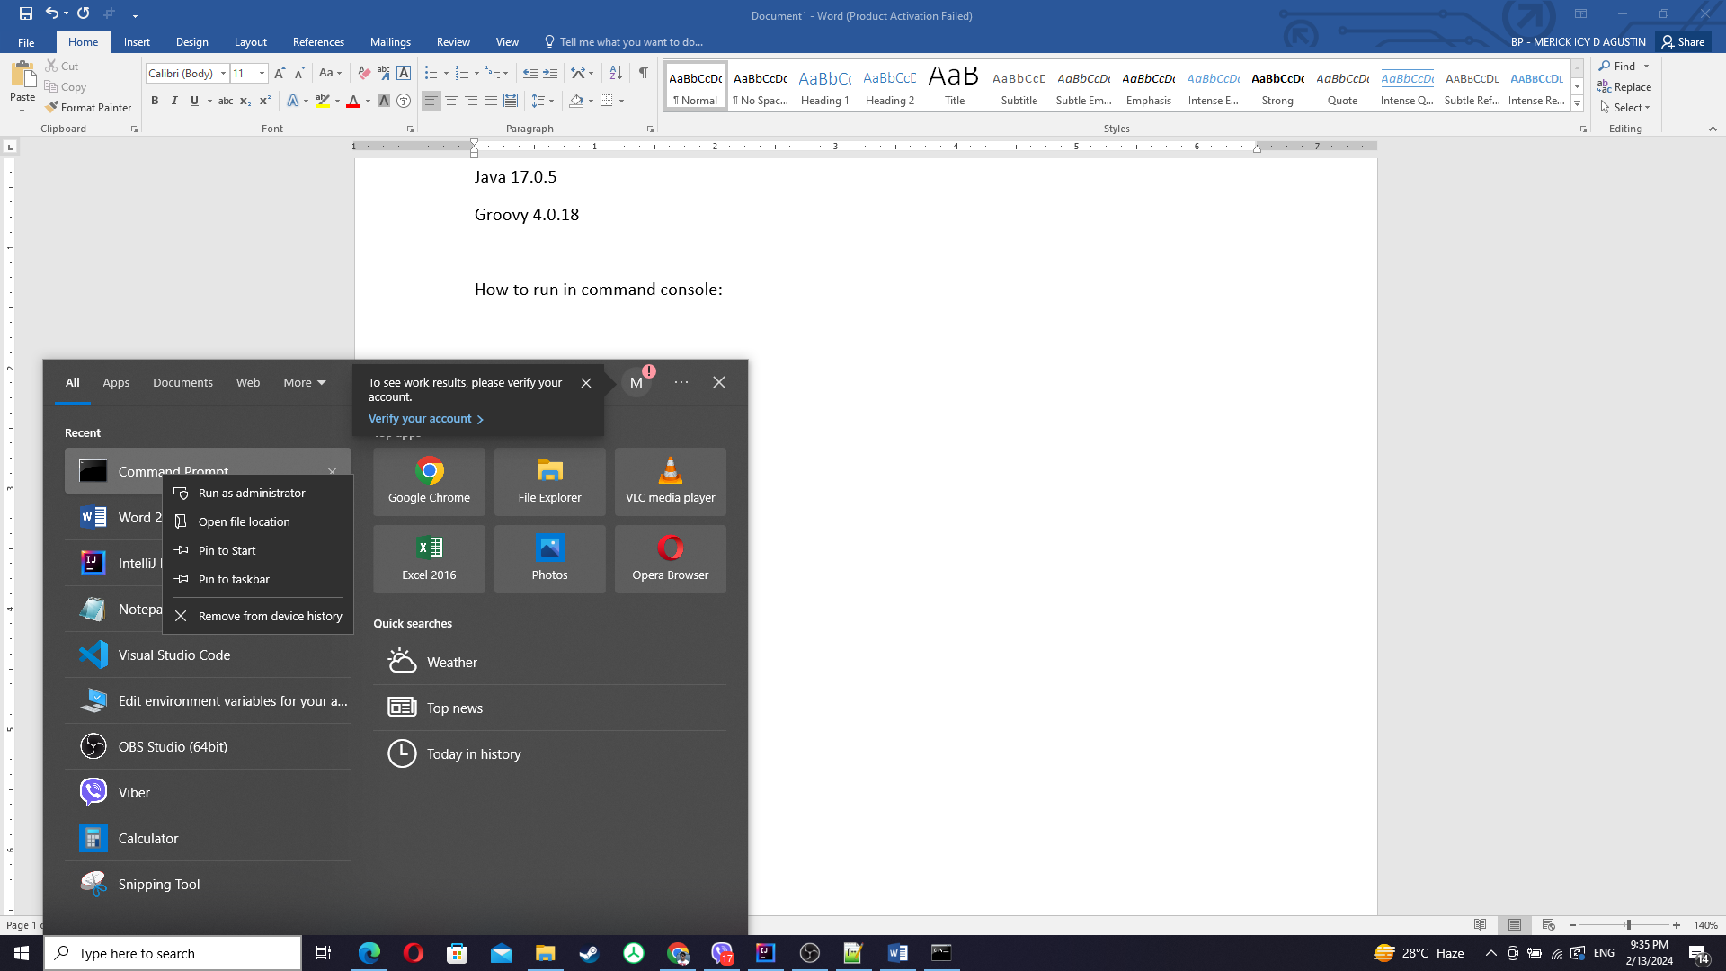

1. Check the directory where you extracted the downloaded program then type the drive name and hit the “Enter” key in the command line.

i.e

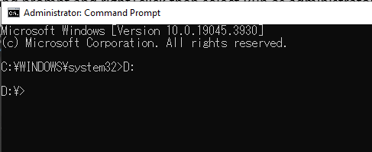

1. Copy the directory of the src folder of the program

i.e D:\Workspace\groovy\Coding Exercise\src

1. Type cd then space then paste the copy of the directory from step 4 then hit the “Enter” key

i.e

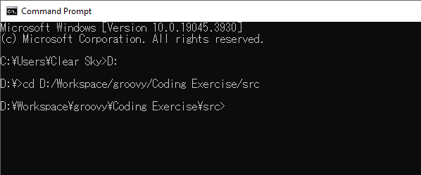

1. Type groovy .\Main.groovy then hit “Enter” key

i.e

