SR0001: Avoid SELECT * in stored procedures, views, and table-valued functions
If you use a wildcard character in a stored procedure, view, or table-valued function to select all columns in a table or view, the number or shape of returned columns might change if the underlying table or view changes. The shape of a column is a combination of its type and size. This variance could cause problems in applications that consume the stored procedure, view, or table-valued function because those consumers will expect a different number of columns.
How to fix violations
You can protect consumers of the stored procedure, view, or table-valued function from schema changes by replacing the wildcard character with a fully qualified list of column names.
Example
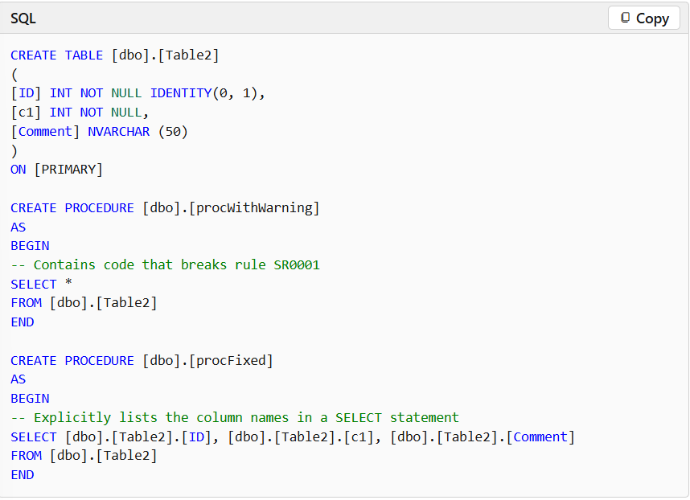
The following example first defines a table that is named [Table2] and then defines two stored procedures. The first procedure contains a SELECT *, which violates rule SR0001. The second procedure avoids SELECT * and explicitly lists the columns in the SELECT statement.

SR0008: Consider using SCOPE_IDENTITY instead of @@IDENTITY
Because @@IDENTITY is a global identity value, it might have been updated outside the current scope and obtained an unexpected value. Triggers, including nested triggers used by replication, can update @@IDENTITY outside your current scope.
How to fix violations
To resolve this issue you must replace references to @@IDENTITY with SCOPE_IDENTITY, which returns the most recent identity value in the scope of the user statement.
Example
In the first example, @@IDENTITY is used in a stored procedure that inserts data into a table. The table is then published for merge replication, which adds triggers to tables that are published. Therefore, @@IDENTITY can return the value from the insert operation into a replication system table instead of the insert operation into a user table.
The Sales.Customer table has a maximum identity value of 29483. If you insert a row into the table, @@IDENTITY and SCOPE_IDENTITY() return different values. SCOPE_IDENTITY() returns the value from the insert operation into the user table, but @@IDENTITY returns the value from the insert operation into the replication system table.
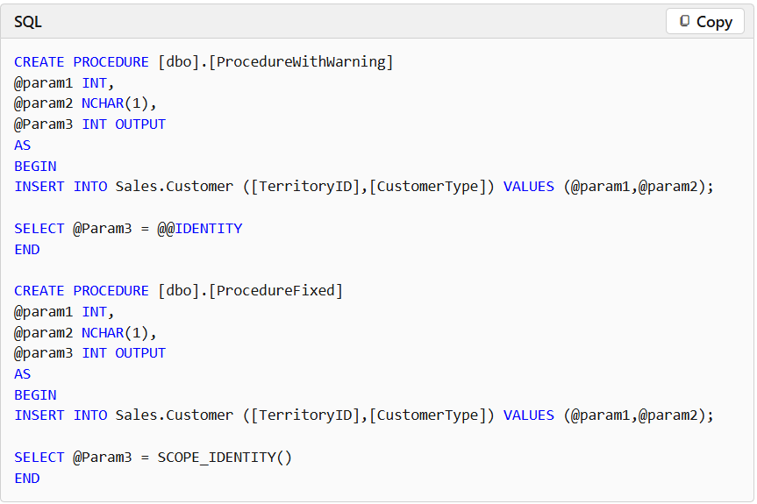
The second example shows how you can use SCOPE_IDENTITY() to access the inserted identity value and resolve the warning.

SR0009: Avoid using types of variable length that are size 1 or 2
When you use data types of variable length such as VARCHAR, NVARCHAR, and VARBINARY, you incur an additional storage cost to track the length of the value stored in the data type. In addition, columns of variable length are stored after all columns of fixed length, which can have performance implications. You'll also receive a warning if you declare a type of variable length, such as VARCHAR, but you specify no length. This warning occurs because, if unspecified, the default length is 1.
How to fix violations
If the length of the type will be very small (size 1 or 2) and consistent, declare them as a type of fixed length, such as CHAR, NCHAR, and BINARY.
Example
This example shows definitions for two tables. The first table declares a string of variable length to have length 2. The second table declares a string of fixed length instead, which avoids the warning.
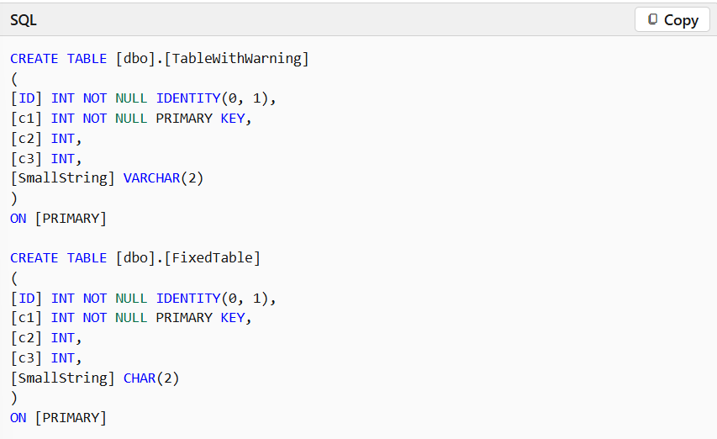
Data for types of variable length is physically stored after data for types of fixed length. Therefore, you'll cause data movement if you change a column from variable to fixed length in a table that isn't empty
SR0010: Avoid using deprecated syntax when you join tables or views
Joins that use the deprecated syntax fall into two categories:
- Inner Join: For an inner join, the values in the columns that are being joined are compared by using a comparison operator such as =, <, >=, and so forth. Inner joins return rows only if at least one row from each table matches the join condition.
- Outer Join: Outer joins return all rows from at least one of the tables or views specified in the FROM clause, as long as those rows meet any WHERE or HAVING search condition. If you use = or = to specify an outer join, you're using deprecated syntax.
How to fix violations
To fix a violation in an inner join, use the INNER JOIN syntax.
To fix a violation in an outer join, use the appropriate OUTER JOIN syntax. You have the following options:
- LEFT OUTER JOIN or LEFT JOIN
- RIGHT OUTER JOIN or RIGHT JOIN
Examples of the deprecated syntax and the updated syntax are provided in the following examples. More information on joins can be found at Joins.
Examples
The six examples demonstrate the following options:
- Example 1 demonstrates the deprecated syntax for an inner join.
- Example 2 demonstrates how you can update Example 1 to use current syntax.
- Example 3 demonstrates the deprecated syntax for a left outer join.
- Example 4 demonstrates how you can update Example 2 to use current syntax.
- Example 5 demonstrates the deprecated syntax for a right outer join.
- Example 6 demonstrates how you can update Example 5 to use current syntax.
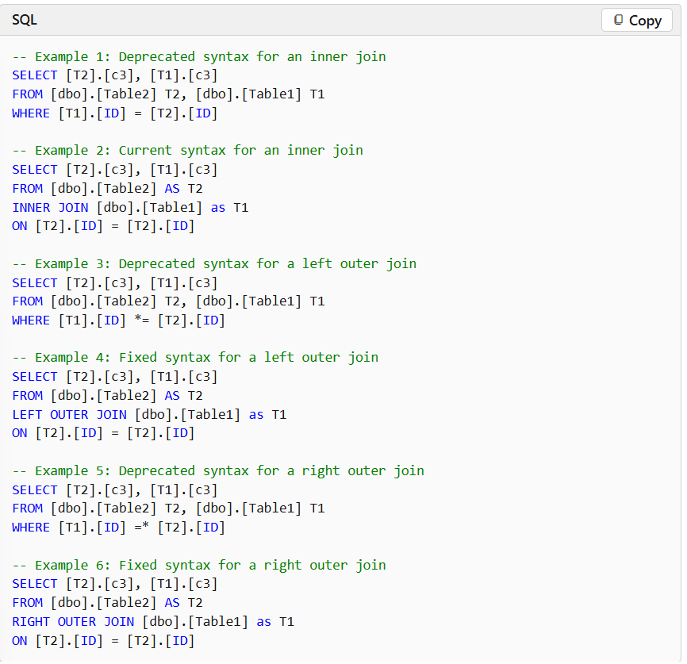

SR0013: Output parameter (parameter) isn't populated in all code paths
This rule identifies code in which the output parameter isn't set to a value in one or more code paths through the stored procedure or function. This rule doesn't identify in which paths the output parameter should be set. If multiple output parameters have this problem, one warning appears for each parameter.
How to fix violations
You can correct this issue in one of two ways. You can fix this issue most easily if you initialize the output parameters to a default value at the start of the procedure body. As an alternative, you can also set the output parameter to a value in the specific code paths in which the parameter isn't set. However, you might overlook an uncommon code path in a complex procedure.
Important
Specifying a value within the procedure declaration, such as CREATE PROC MyProcedure (@param1 INT = 10 OUTPUT) will not resolve the issue. You must assign a value to the output parameter within the procedure body.
Example
The following example shows two simple procedures. The first procedure doesn't set the value of the output parameter, @Sum. The second procedure initializes the @Sum parameter at the start of the procedure, which ensures that the value will be set in all code paths.

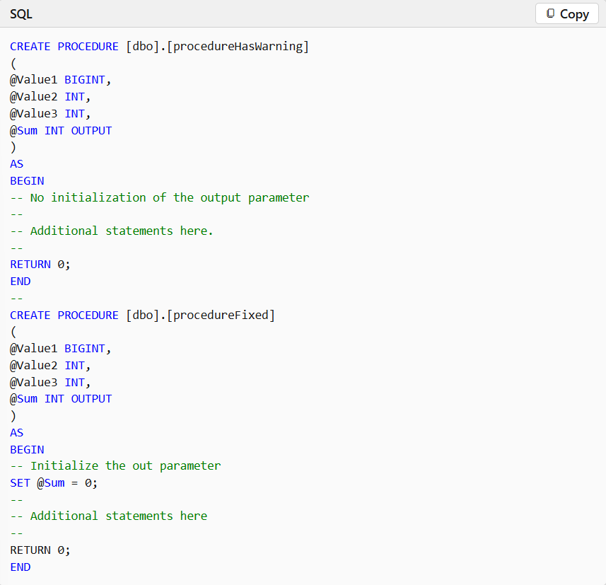

SR0014: Data loss might occur when casting from {Type1} to {Type2}
If data types are inconsistently assigned to columns, variables, or parameters, they're implicitly converted when the Transact-SQL code that contains those objects is run. This type of conversion not only reduces performance but also, in some cases, causes subtle loss of data. For example, a table scan might run if every column in a WHERE clause must be converted. Worse, data might be lost if a Unicode string is converted to an ASCII string that uses a different code page.
This rule does NOT:
- Check the type of a computed column because the type isn't known until run-time.
- Analyze anything inside a CASE statement. It also doesn't analyze the return value of a CASE statement.
- Analyze the input parameters or return value of a call to ISNULL
This table summarizes the checks covered by the rule SR0014:
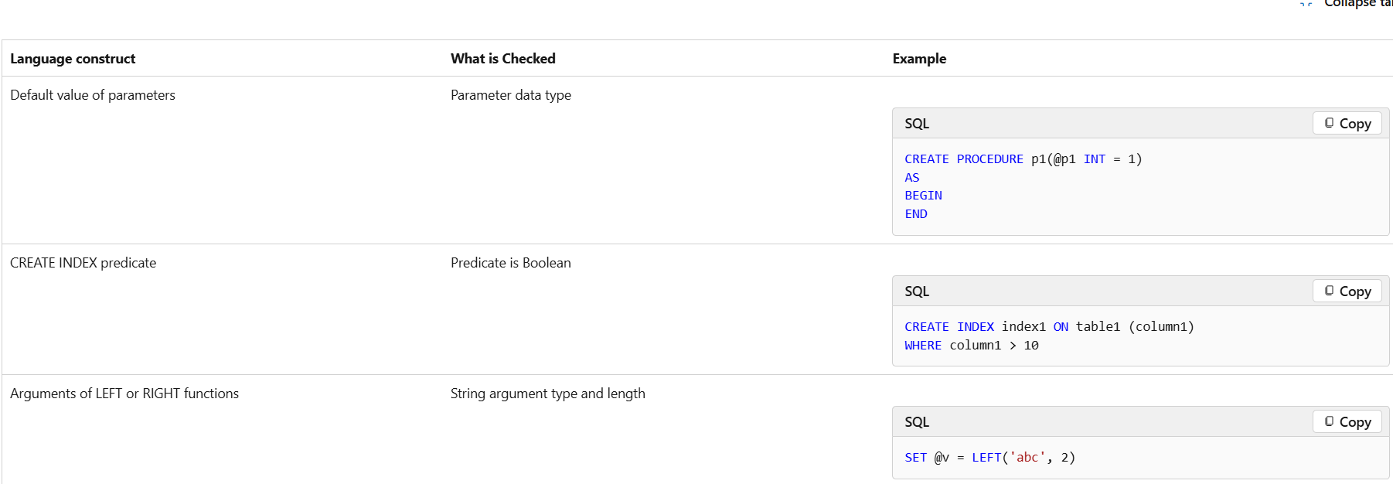
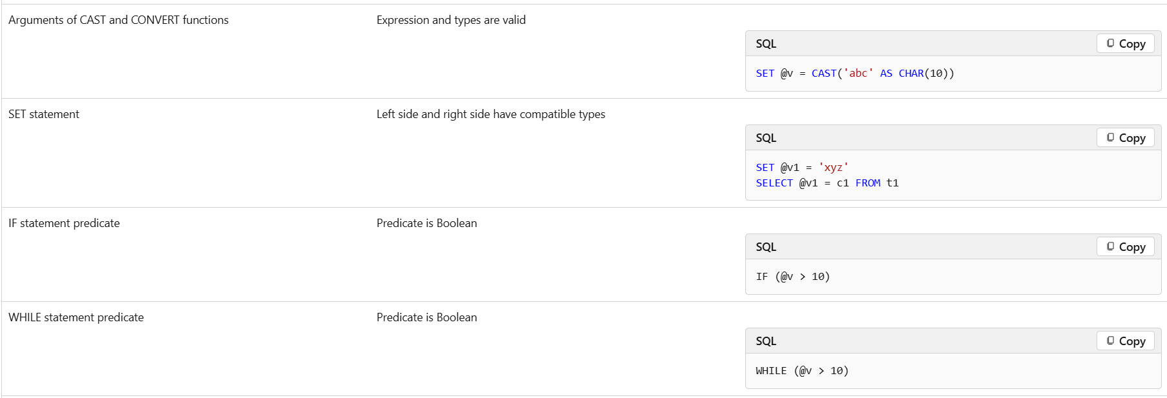
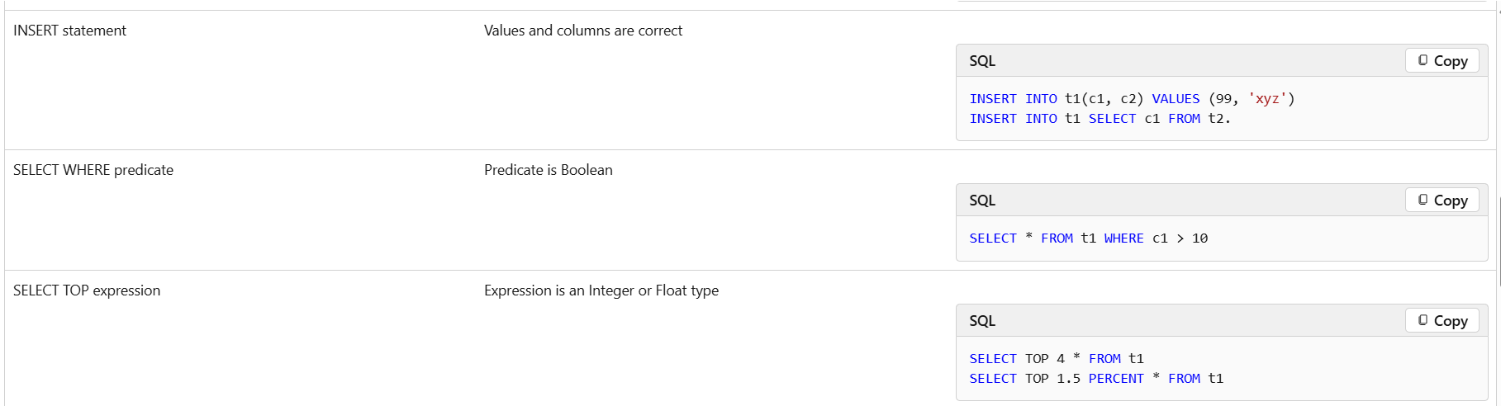
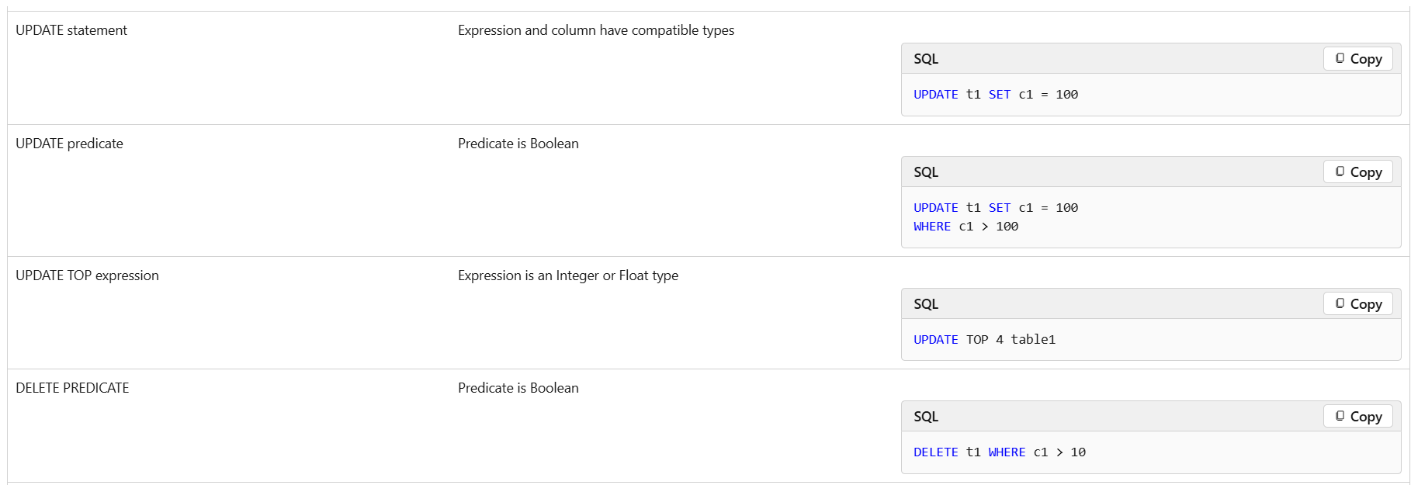
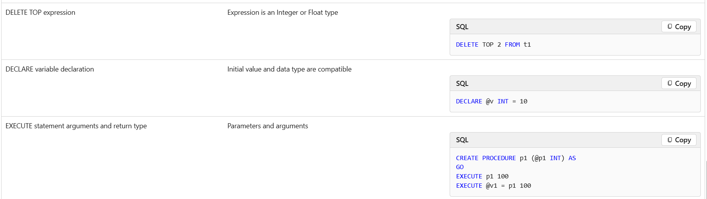
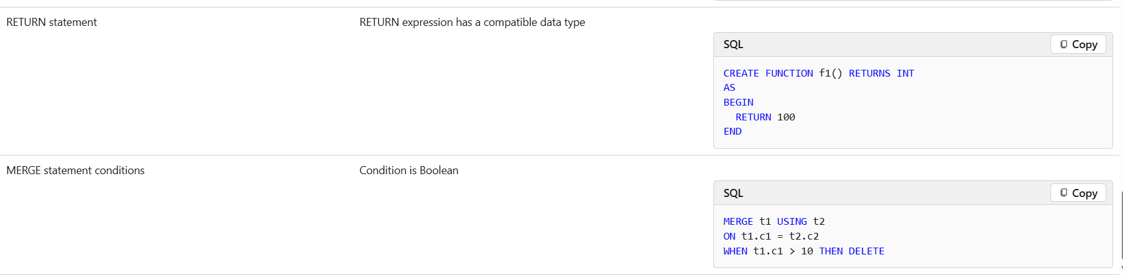
How to fix violations
You can avoid and resolve these issues by assigning data types consistently and by explicitly converting types where they're needed. For more information about how to explicitly convert data types, see this page on the Microsoft Web site: CAST and CONVERT (Transact-SQL).
Example
This example shows two stored procedures that insert data into a table. The first procedure, procWithWarning, will cause an implicit conversion of a data type. The second procedure, procFixed, shows how you can add an explicit conversion to maximize performance and retain all data.
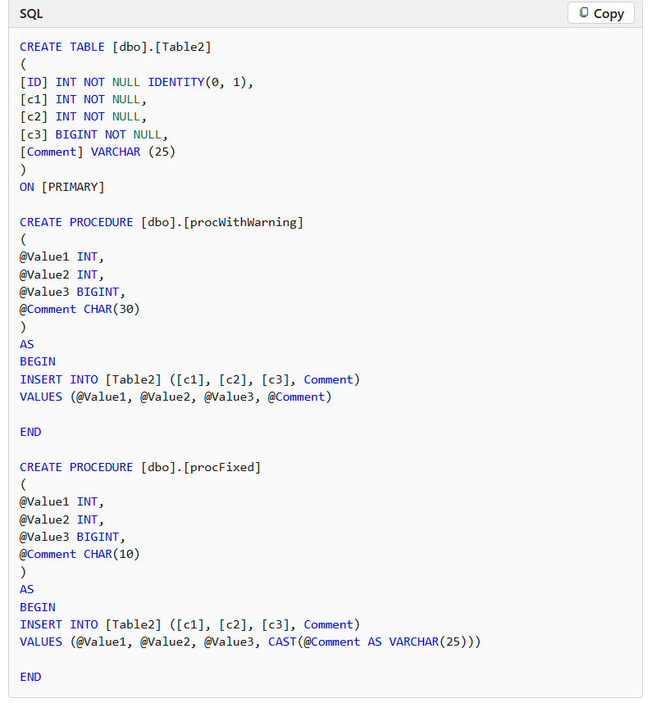
SR0016: Avoid using sp_ as a prefix for stored procedures
In SQL Server, the sp_ prefix designates system stored procedures. If you use that prefix for your stored procedures, the name of your procedure might conflict with the name of a system stored procedure that will be created in the future. If such a conflict occurs, your application might break if your application refers to the procedure without qualifying the reference by schema. In this situation, the name binds to the system procedure instead of to your procedure.
How to fix violations
To resolve this issue, you must replace sp_ with a different prefix to designate user stored procedures, or you must use no prefix at all.
Example
In the first example, the procedure name causes this warning to be issued. In the second example, the procedure uses an usp_ prefix instead of sp_ and avoids the warning.
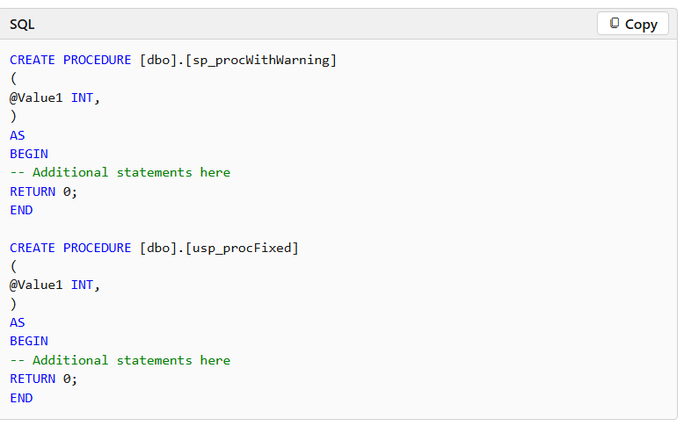
1. Index Your WHERE Clauses
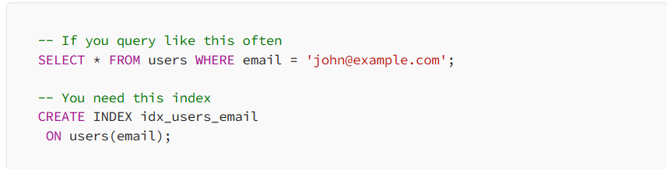
2. Composite Indexes for Multiple Conditions
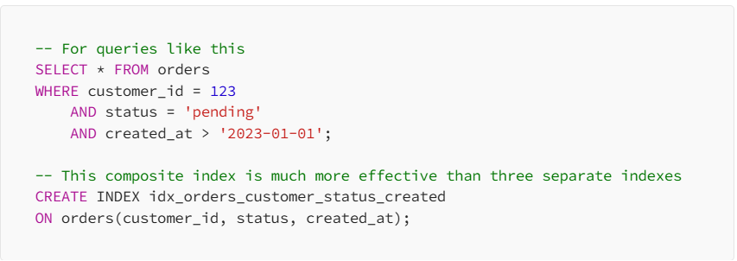
The order matters in composite indexes. Put the most selective column first (the one that filters out the most rows).
3. Don't Over-Index
Every index speeds up SELECT queries but slows down INSERT, UPDATE, and DELETE operations. I once worked on a system where someone had created 50 indexes on a single table. Updates were taking 30 seconds because the database had to maintain all those indexes.
Use EXISTS Instead of IN for Subqueries
I used to write subqueries like this:
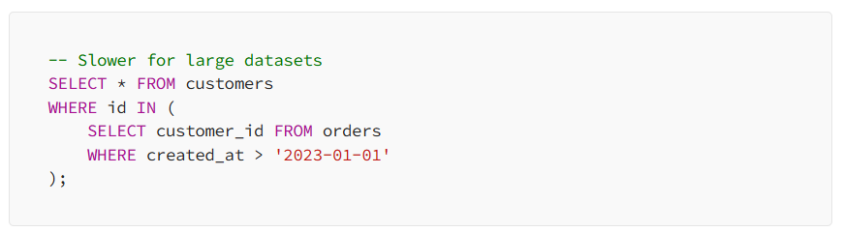
But EXISTS is usually faster:
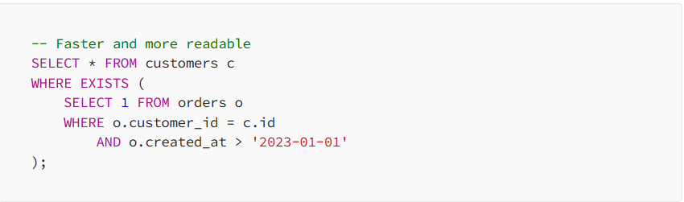
Why? EXISTS can stop as soon as it finds one matching row, while IN has to evaluate the entire subquery.
Avoid SELECT * Like the Plague
This seems obvious, but I still see it everywhere:
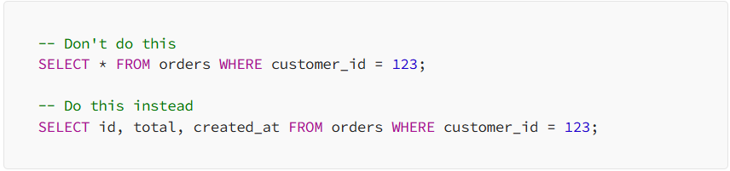
SELECT * is problematic because:
- It transfers unnecessary data over the network
- It breaks when table structure changes
- It prevents some query optimizations
- It makes your intent unclear

Use LIMIT Wisely

Always use LIMIT when you don't need all rows:

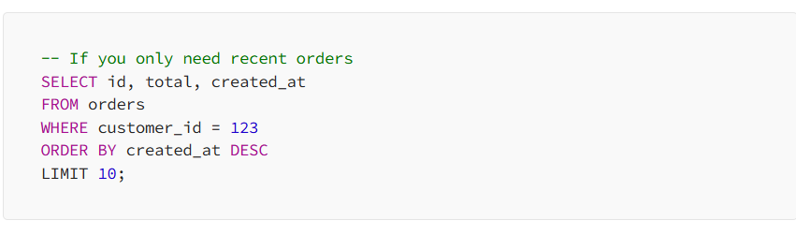

This is especially important for debugging. Instead of running a query that might return millions of rows, add LIMIT 100 to see a sample of the data first.

JOIN Strategies That Actually Work

JOINs are where queries get complex, and where I've made most of my mistakes. Here's what I've learned:

Inner JOIN vs LEFT JOIN vs RIGHT JOIN

Understanding the difference saved me countless hours of debugging:

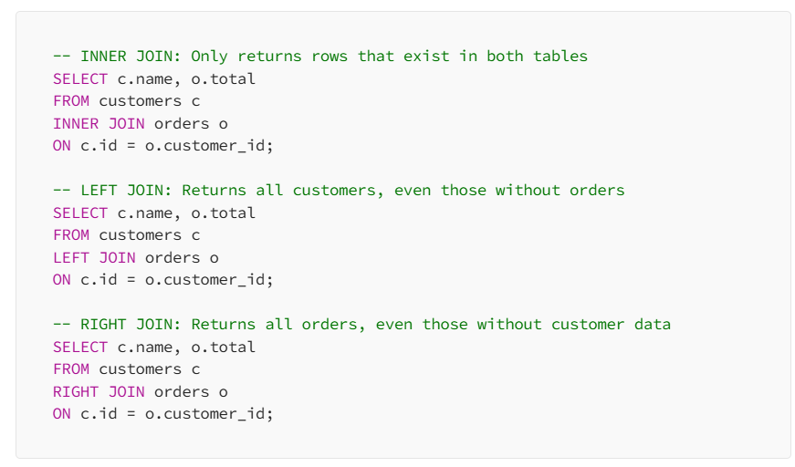

I rarely use RIGHT JOIN — it’s usually clearer to flip the tables and use LEFT JOIN instead.

The Dreaded N+1 Query Problem

This is a classic mistake that haunts many junior developers:

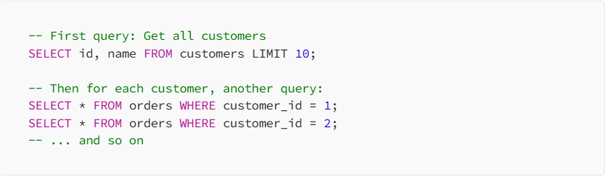

Instead, use a single JOIN:

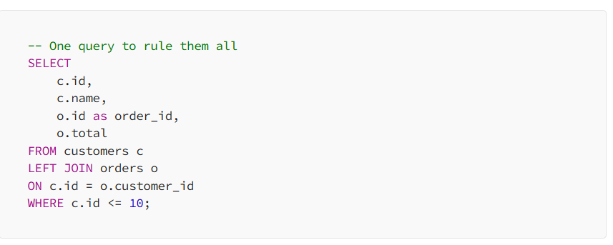

Window Functions: The Advanced Technique I Wish I’d Learned Sooner

Window functions are incredibly powerful but often overlooked. They let you perform calculations across a set of rows without needing a GROUP BY.

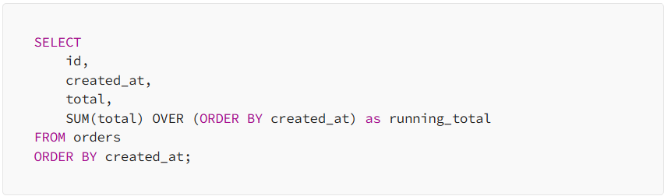
Running Totals

Row Numbers and Ranking

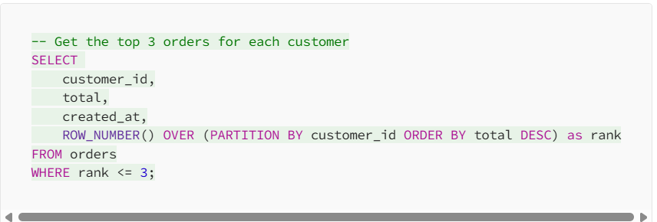

Moving Averages

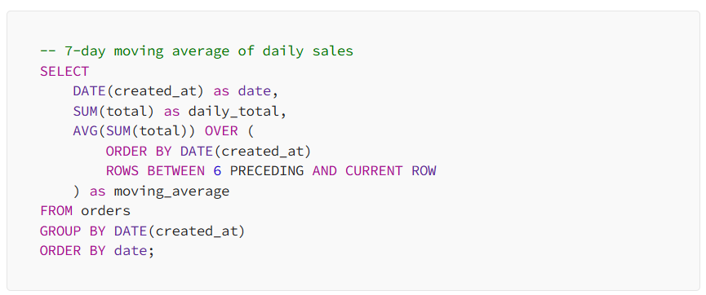

Window functions replaced so many complex subqueries in my code. They’re cleaner, more readable, and often more performant.

Transaction Management: Don’t Be That Developer

Don’t be that developer that brings down a production system with a poorly managed transaction. As much as lunch is absolute importance to a developer, running a long-running query before heading for lunch can lock up all operations from completing, causing the system ground to a halt.

Keep Transactions Short

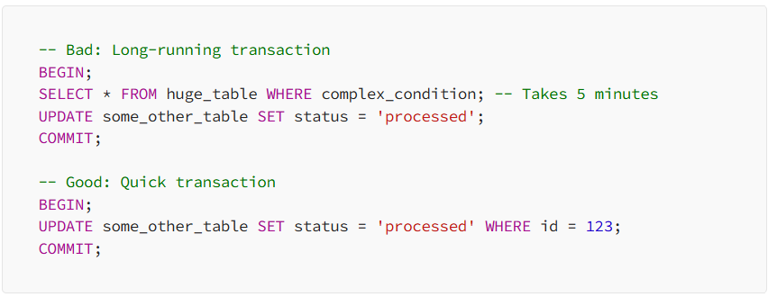

Use Appropriate Isolation Levels

Most databases default to READ COMMITTED, which is fine for most use cases. But sometimes you need stronger guarantees:

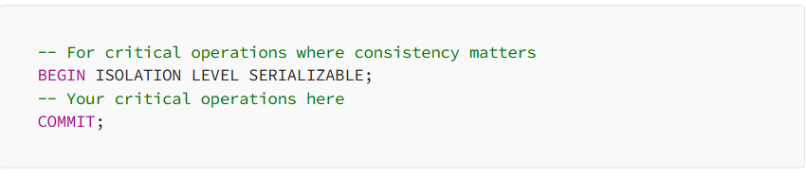

Handle Deadlocks Gracefully

Deadlocks happen when two transactions are waiting for each other. The database will kill one of them, but your application should handle it gracefully:

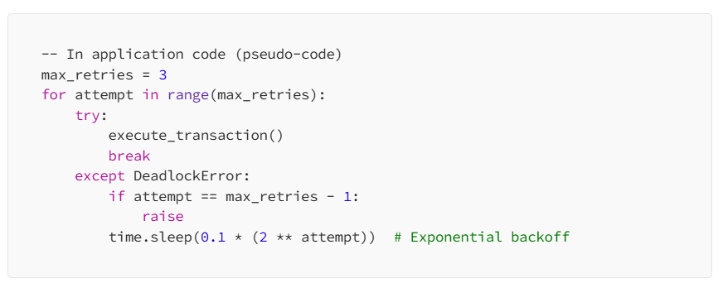

Data Types: The Details That Matter

Choosing the right data type isn’t just about storage — it affects performance, indexing, and query behavior.

Use the Smallest Data Type That Works

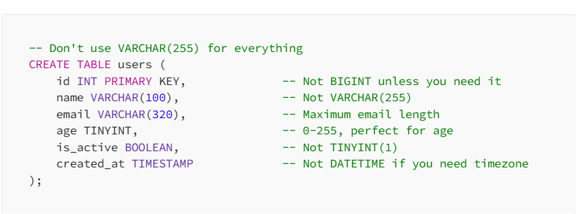

Be Careful with NULLs

NULLs can cause unexpected behavior:

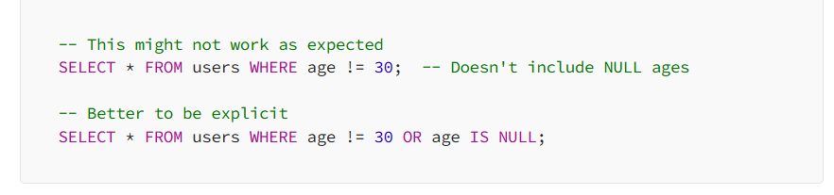

Testing and Debugging: Save Your Future Self

Use EXPLAIN to Understand Query Plans

This is the most important debugging tool you have:



Learn to read execution plans. Look for:
- Seq Scan: Usually bad on large tables
- Index Scan: Good
- Nested Loop: Can be expensive with large datasets
- Hash Join: Usually efficient for large datasets

Test with Realistic Data

I once spent hours optimizing a query that ran perfectly on my 1000-row test dataset but failed miserably on production’s 10-million-row table. Always test with realistic data volumes.

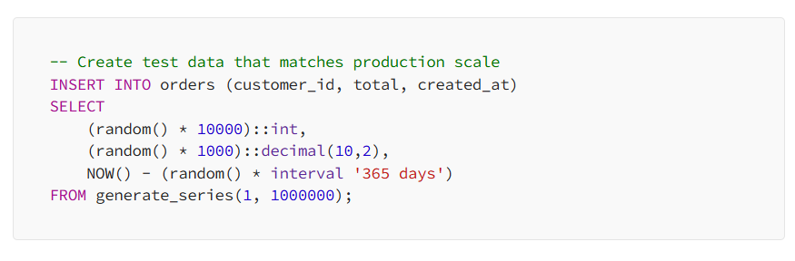

Common Pitfalls I’ve Learned to Avoid

1. The Implicit Conversion Trap

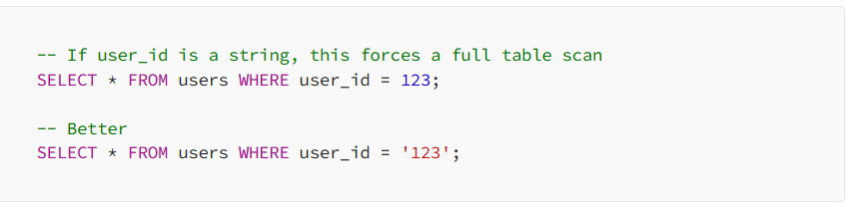

2. Functions in WHERE Clauses

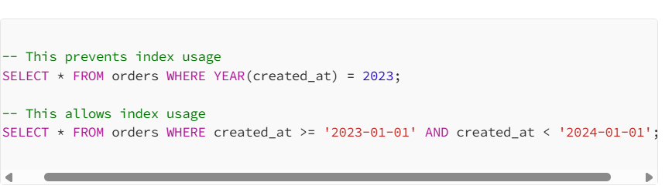

3. Leading Wildcards in LIKE

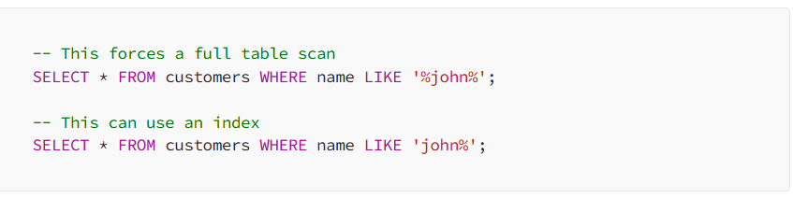

4. Correlated Subqueries

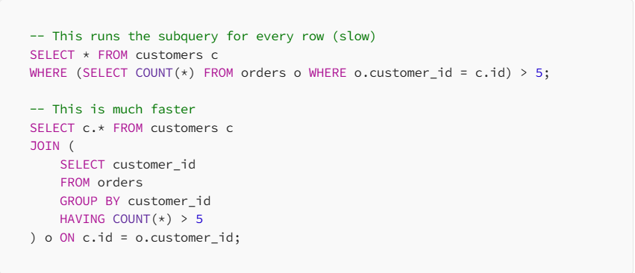

Database-Specific Optimizations

Different databases have different strengths. Here’s what I’ve learned about the major ones:

SQL Server
- Great optimizer, trust it but verify with execution plans
- Use indexed views for complex aggregations
- Columnstore indexes for analytical workloads
- Always specify schema names (dbo.users, not just users)

The Monitoring and Maintenance Nobody Talks About

Writing good SQL isn’t just about the initial query — it’s about long-term maintenance.

Monitor Query Performance

Set up alerts for:
- Queries taking longer than expected
- Queries using too much CPU or memory
- Queries causing lock contention

Regular Maintenance

-- SQL Server
ALTER INDEX ALL ON table_name REBUILD;

Keep Statistics Updated

Query optimizers rely on statistics to make good decisions. Outdated statistics lead to poor query plans.

My Current SQL Workflow

After years of mistakes and learning, here’s my current approach to writing SQL:
- Start simple: Write the basic query without optimization
- Add indexes: Based on WHERE clauses and JOIN conditions
- Test with realistic data: Not just the happy path
- Check the execution plan: Use EXPLAIN or equivalent
- Optimize: But only after measuring performance
- Document: Especially complex queries and their purpose

The Mindset Shift That Changed Everything

The biggest change in my SQL journey wasn’t learning new syntax or techniques — it was changing my mindset from “make it work” to “make it work reliably at scale.”

Every query I write now, I ask myself:
- How will this perform with 10x more data?
- What happens if this index gets dropped?
- Can someone else understand this query in six months?
- What’s the worst-case scenario for this query?

This mindset shift has saved me from countless production issues and made me a much better developer.

Final Thoughts

SQL is deceptively simple. The basic syntax is straightforward, but writing efficient, maintainable queries that perform well at scale is an art that takes years to master. I’m still learning new things after years of writing SQL professionally.

The key is to learn from mistakes — both your own and others’. Every slow query is a learning opportunity. Every production incident teaches you something new about database behavior.

Don’t be afraid to experiment, but do it safely. Use transactions, test with realistic data, and always have a rollback plan. The database is not your enemy — it’s a powerful tool that rewards understanding and punishes carelessness.

Most importantly, remember that readable code is maintainable code. Your future self (and your teammates) will thank you for taking the time to write clear, well-structured SQL that tells a story about what you’re trying to accomplish.

