A Deep Learning approach in estimation of maximum data rate and bit error rate in spatial modulation scheme
Reddy Vishwas, Mukesh Gandhi, E.S Gopi
¹ National Institute of Technology, Tiruchirappalli, Tamilnadu, India.
Abstract. This paper proposes a method to estimate the number of active antennas that can be chosen to maximize the data rate in Spatial Modulation (SM) technique and to predict the Bit error rate for QAM symbols transmission through Spatial modulation. For reducing the computational complexity, we propose two machine learning algorithms, one to predict the number of active antennas for a given number of antennas and a given modulation scheme M and the other to predict the Bit error rate for given values of active antennas, QAM modulation scheme M and SNR. We then compare the accuracy obtained in various optimization algorithms.
Keywords: Spatial Modulation, QAM, MIMO
- Introduction
  - Spatial modulation
Spatial Modulation is a transmission technology developed for MIMO systems to increase the channel capacity. In this technique, we can transmit information using both active antennas index and constellation symbols. The index of the active antennas is varied using the antenna switching mechanism and is chosen according to the user data. A unique transmission index is chosen from set of transmitting antennas, due to the variation in the characteristics of channel links the spatial positions of the transmitting antennas can be uniquely identified. The incoming data is divided into two parts as shown in Fig. 1, one part is for the symbol in constellation and the other part is for the index of the antennas.
To find the number of spatial bits that can transmitted, we need to find the number of combinations that are possible for a given number of antennas $n_{t}$. Let us choose $n_{r}$ number of antennas for transmitting a symbol, then total number of symbols that possible is given by$^{n_{t}}C_{n_{r}}$. Now the number of bits in spatial domain is given by$\log_{2}\left( ^{n_{t}}C_{n_{r}}\right)$. If each selected antenna is transmitting a M-ary modulated symbols, then the number of bits transmitted in constellation domain is given by $n_{r}\log_{2}{M}$. The total channel capacity ‘R’ is given by,
$R=\log_{2}\left( ^{n_{t}}C_{n_{r}}\right)+n_{r}\log_{2}{M}$ (1)
We see that it is difficult to maximize (1) by using differential calculus as the equation is in discrete form, but we can use a neural network to approximate a function which predicts $n_{r}$ for given values of $n_{t}$ and M for which R is maximized.
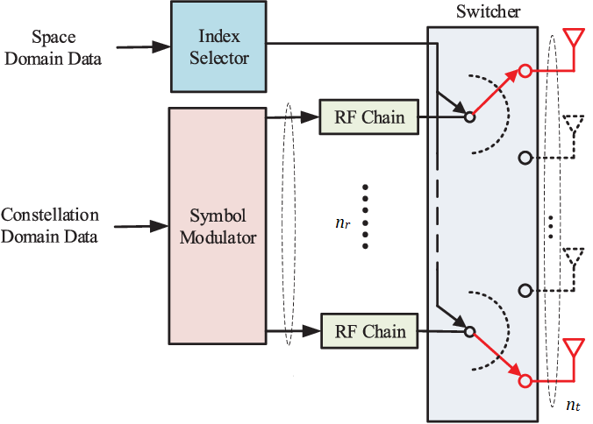
Fig. 1. A block diagram showing Spatial modulation of data.
- Optimizing the data rate equation
  - Finding the maxima point
In this section we will find whether the R has maxima or not. One way to find the maxima for (1) is by plotting the (1) by varying the values of $n_{r}$ for different values of $n_{t}$ and M.
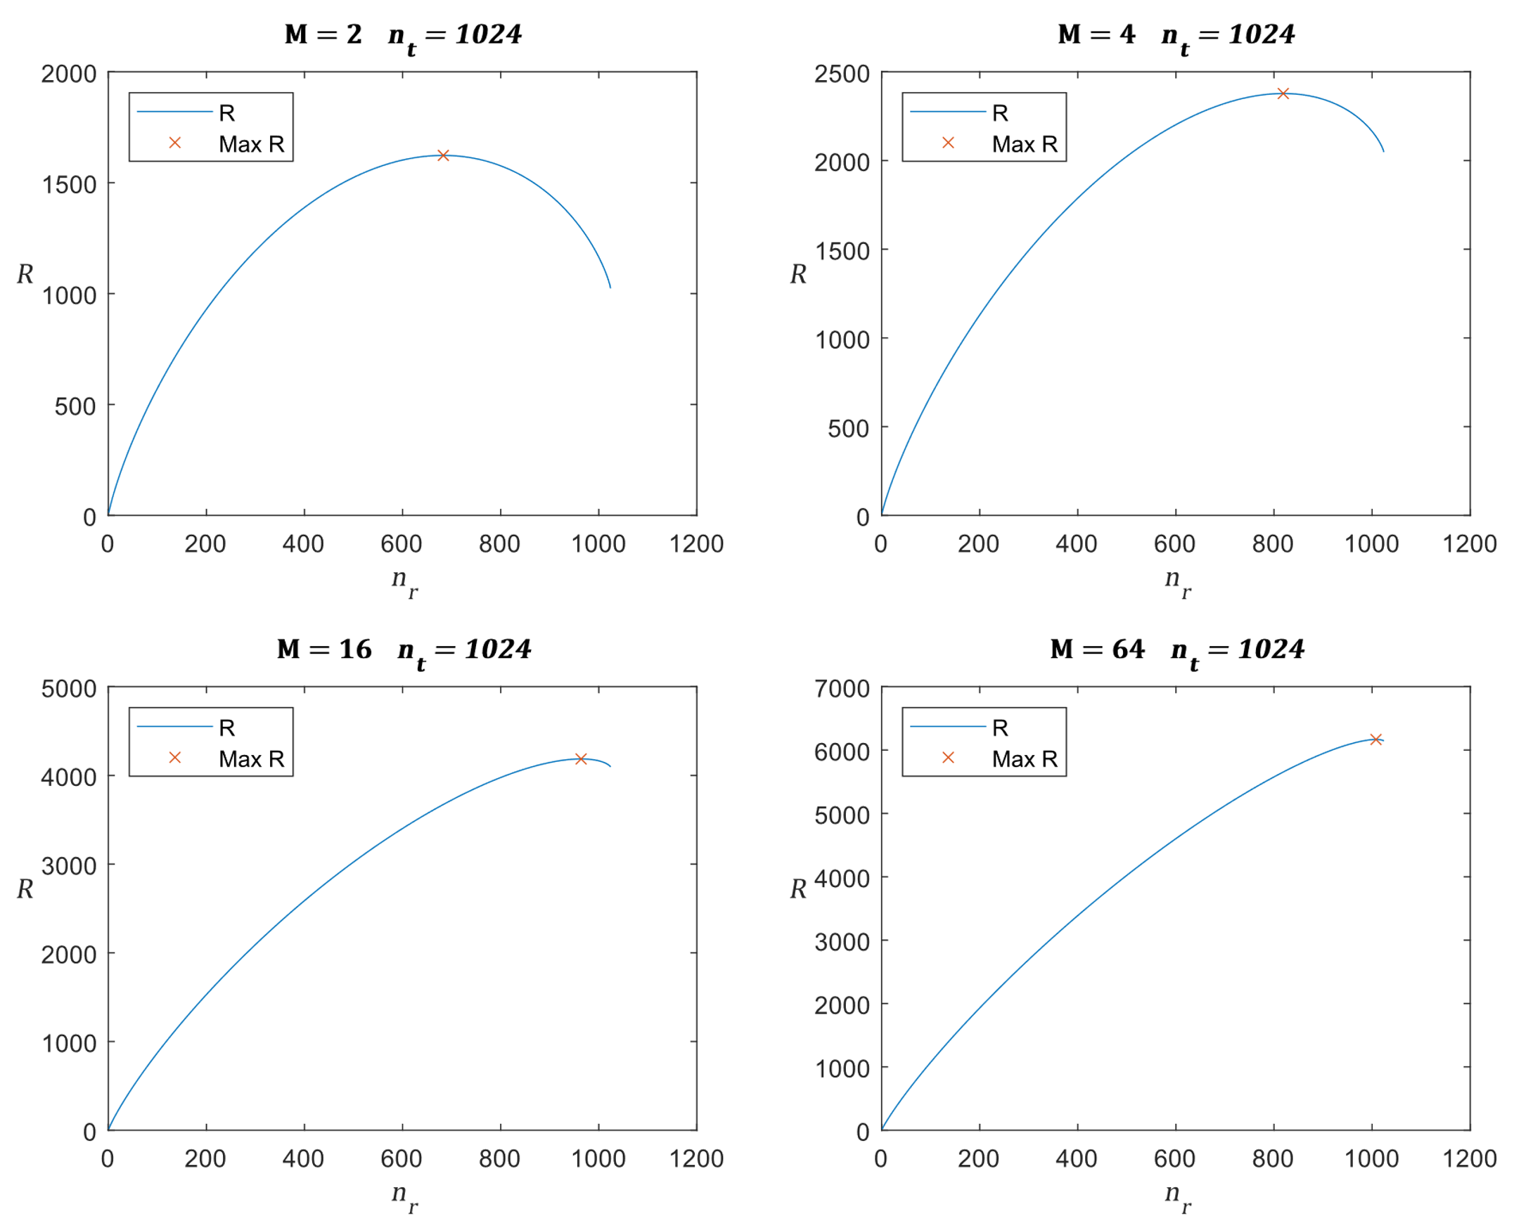
Fig. 2. Plots representing R vs $n_{r}$ for different values of $n_{t}$ and M.

From Fig. 2 we can interpret that the maxima exist at a value of $n_{r}$and as the number of points in the constellation increases the maxima shifts towards $n_{t}$.
A function to calculate $n_{r}$ at which R is maximum.
Data rate function ($m,n_{t}$)
$$y=\max_{i∈\left\{1,2, …,n_{t}\right\}}\left(\sum_{j=1}^{n_{t}}{\log_{2}\left(j\right)}-\sum_{j=1}^{n_{t}-i}{\log_{2}\left(j\right)}+\sum_{j=1}^{i}{\log_{2}\left(j\right)}+i\log_{2}\left(m\right)\right)$$
return y
Here summation of logarithmic values is used to have the values within the computational memory unit range, but it takes a lot of time to compute. We can reduce this time by using a trained neural network.
  - Training the neural network
We can decide the architecture and train Neural networks using a MATLAB tool called Neural Net Fitting but first we need to generate the dataset.
In the generated dataset first column represents the value of M; second column represents the value of $n_{t}$ and last column represents the value of $n_{r}$ and each row is a sample. We need to separate the inputs and outputs into two datasets and feed them to the Neural net fitting tool. In the tool we will select the architecture as 10 hidden neurons, after fixing the architecture we will use the Bayesian Regularization technique for training the network. The training will be automatically done by the MATLAB tool till the error reaches a minimum value as shown in Fig. 3. After the training we can use the tool to generate a MATLAB function of the network with the trained biases and weights. We can use this function to predict the values of $n_{r}$ for a given value of $n_{t}$ and M. This network function approximates the function of $n_{r}$ in terms of $n_{t}$ and M for which R will be maximum.
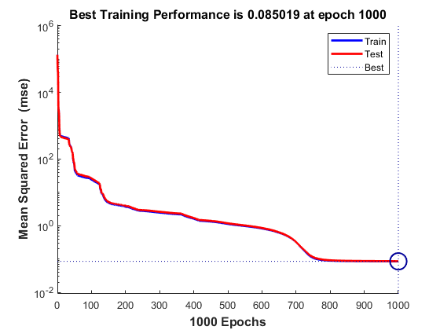
Fig. 3. Performance plot for 1000 epochs.
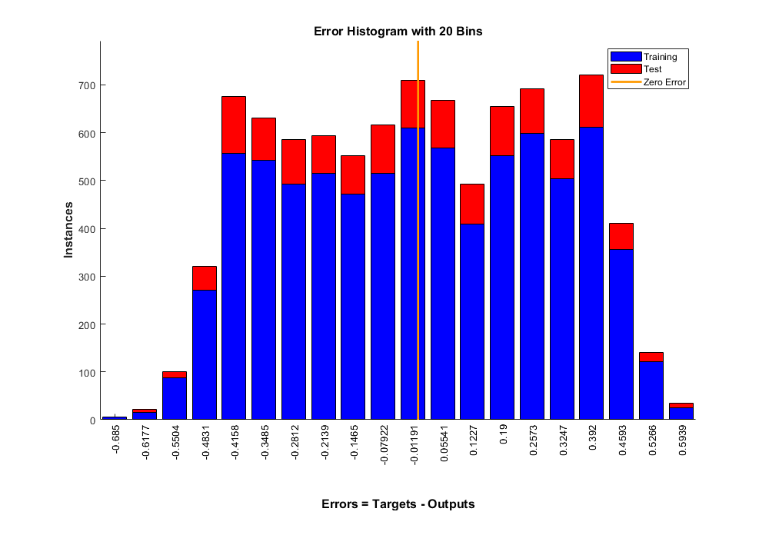
Fig. 4. Error histogram plot for training and testing data
- Results:
The network architecture and weights
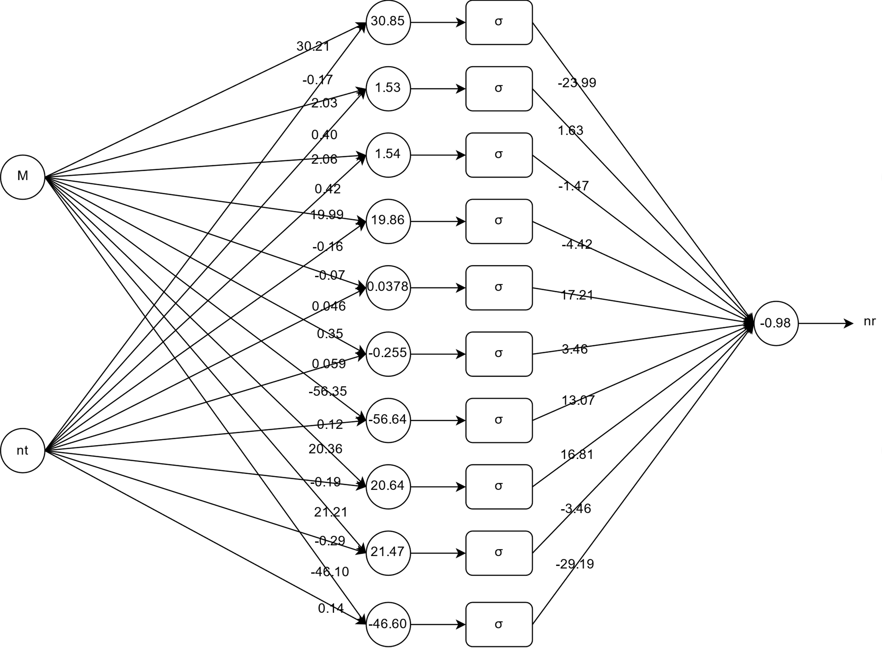
Fig. 5. Neural Network architecture with trained weights and biases
Using the neural network, we can predict the values of $n_{r}$ with error ± 0.6, this is shown in Fig. 4. The computing time is also reduced drastically, for example to calculate $n_{r}$ for m=64 and $n_{t}=1024$ using Data rate function it takes 0.080329 seconds, but by using the neural network it takes 0.005821 seconds. It is almost fourteen times faster than the Data rate function. We can see the network predicted values are very closer to the actual values from the plots in Fig. 6.
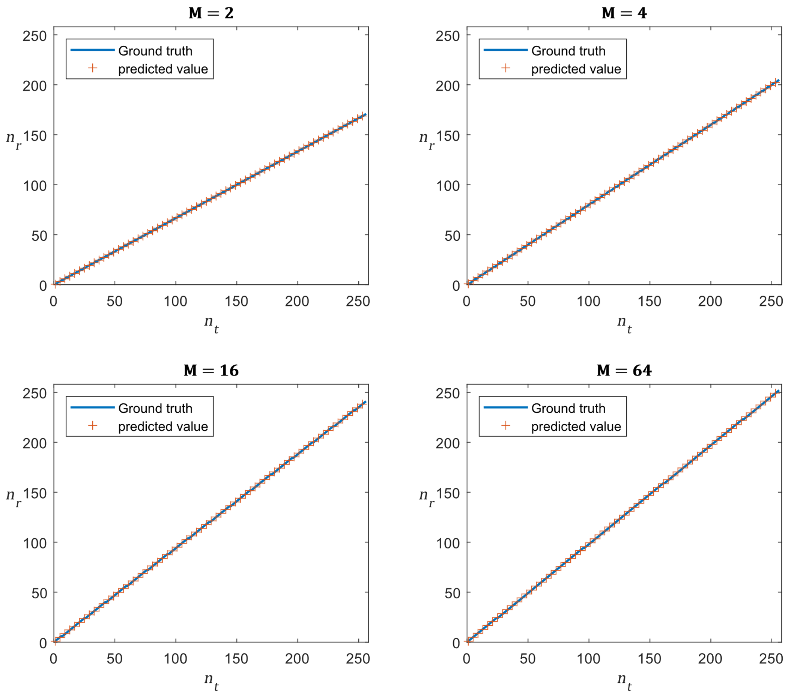
Fig. 6. Predicted and actual data plots of $n_{r}$ vs $n_{t}$ at different values of M.

- Obtaining Bit Error Rate
  - Transmitter and Receiver Model
We use the Quadrature Amplitude Modulation technique for generation of constellation data, these QAM symbols are then transmitted using the transmission model shown in Fig.1 where the channel is modeled as a Rayleigh Flat fading channel.
Consider the example where the number of transmitting antennas and receiving antennas are fixed as 64, the real and imaginary parts of the channel coefficients are assumed to be outcome of a random variable with gaussian distribution with mean 0 and variance 2.
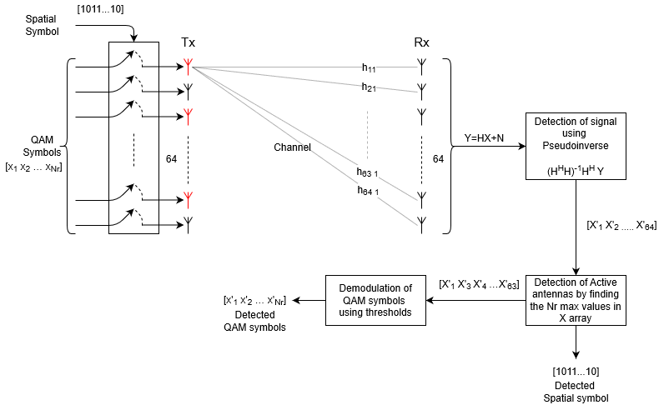
Fig. 7. Transmitter and receiver model
The bits transmitted are divided in two parts, first part contains $n_{r}\log_{2}{M}$ bits which are modulated using QAM constellation and second part contains$\log_{2}\left( ^{64}C_{n_{r}}\right)$ bits which is used for active antenna index. These modulated symbols are transmitted through a Rayleigh channel with channel matrix denoted as $H$. Let the channel also add noise to each symbol which is gaussian distributed with mean = 0 and variance = $σ_{N}^{2}$.
$$H=\left[\begin{matrix}h_{11} & ⋯ & h_{1 64} \\ ⋮ & ⋱ & ⋮ \\ h_{64 1} & ⋯ & h_{64 64}\end{matrix}\right]$$
At the receiver the received signal is $Y=HX+N$ where $X$ is transmitted signal vector and $N$ is Noise vector. In our model we assume that the perfect channel state information is known so at the receiver pseudoinverse technique is used to detect the signal.
$$\hat{X}={\left(H^{H}H\right)}^{-1}H^{H}Y$$
From the detected signal $\hat{X}$ the largest $n_{r}$ elements in the magnitude vector of $\hat{X}$ are taken and their indices are the demodulated the spatial bits. The detected $n_{r}$ values from the $\hat{X}$ vector are then sent to a QAM demodulator which uses thresholds to detect the symbols.
  - Bit Error Rate
Bit error rate is the ratio of number of symbols detected wrong to the number symbols transmitted. To calculate this, we will randomly select $n_{r}$ QAM symbols of Modulation scheme M and randomly select $n_{r}$ transmit antennas and store their indices, the selected QAM symbols are transmitted through the selected transmit antennas, in the channel noise is added whose power is obtained from given SNR value. At the receiver these symbols are detected as described in section 4.1. After detection the number of symbols that are mismatched are counted including the spatial symbol, this value is divided with $n_{r}+1$ to get the Bit Error rate. This process is repeated for thousand times for a given $n_{r}$ , M and SNR values and the average of the Bit Error rate is calculated. Thus, obtained BER is plotted by varying SNR for fixed values of $n_{r}$ and M.

` Fig. 8. Plots representing BER vs SNR for different values of $n_{r}$ and M.

- Training the neural network to predict BER
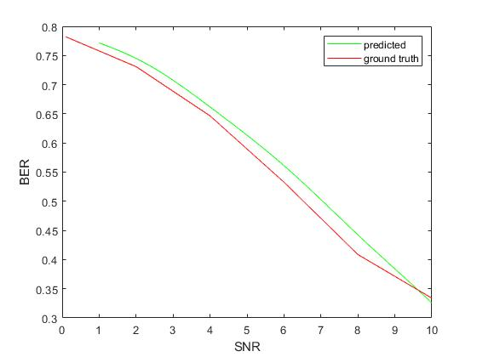
The dataset consisting of “number of bits”, “number of antennas”, “SNR”, “BER” was obtained from the methodology described in Section 4. The open source library Pytorch was used to design and train the neural network. The network was trained in Google Colab’s Tesla K80 for 1000 epochs. Batch normalization and dropouts were added to prevent the overfitting of model. The neural network consisted of 5 hidden layers with 50 neurons/layer.
Fig. 9. Plots representing BER vs SNR for predicted and ground truth values.

