|  |  |
| --- | --- |
| **Level : 4th Year**  Lesson 10: Review |  |
| Module : CCCA4  Instructor(s) : English Unit | |
| **Learning outcomes:**  **By the end of this session, you will be able to:**   * Practice on various grammatical points * Reinvest idioms in speaking and writing * Review the structure of opinion and For and Against essays | |

**Numbers**

**Write these numbers in full.**

|  |  |  |
| --- | --- | --- |
| **1** | 14-05-1687=May, fourteenth, sixteen, eighty-seven |  |
| **2** | 40 = forty |  |
| **3** | £8.50 =eight pounds fifty |  |
| **4** | €515 =five hundred and fifteen euros |  |

**5** 12.5 %=twelve point five percent

**Trends**

**Write the verbs below next to the appropriate trends (1-11)**

|  |  |  |  |  |  |  |  |  |
| --- | --- | --- | --- | --- | --- | --- | --- | --- |
| decline | gain | drop | increase | rocket | plummet | double | fall | halve |
| level off | triple | recover | decrease | fluctuate | improve | peak | rise | jump |

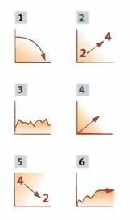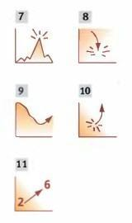

|  |  |
| --- | --- |
| 1 decline, drop, fall, decrease | 6 level off |
| 2 double | **7 peak** |
| 3 fluctuate | **8 plummet** |
| 4 gain, increase, rise, improve (unless you’re talking about something bad like unemployment) | **9 recover** |
| 5 halve | **10 rocket, jump** |
| 11 triple |  |

**Tenses**

**Use the correct tense to fill in the gaps.**

A: So it seems you ........ have had............... (have) a very good year so far.

B: Absolutely! Sales ...........stood..... (stand) at €14m at the end of the last quarter, and they ............have already increased.................. (already / increase) by 6%.

A: What about your market share?

B: It ..........has remained................... (remain) stable since 2008, but we are confident it ………………will increase…………(increase) when we launch our new product. Sitex …………………will have been marketed…………………..…. (market) worldwide by 2022.

A: ..............have you had to...................... (you / have to) make anyone redundant?

B: No. At Lortex, we pride ourselves on the fact that there…………have not been…………. (not/be) any redundancies for over eight years.

A:What about your competitors.

B:We…………had already been………………(be) ahead of our rivals until 2003 when they……………outstripped………. (outstrip) us for the first time. It was a critical situation for our company but our team ………had exceeded……………. (exceed) all expectations.

**Describing a process \ Passives**

**Put the verbs in the right tense and aspect**

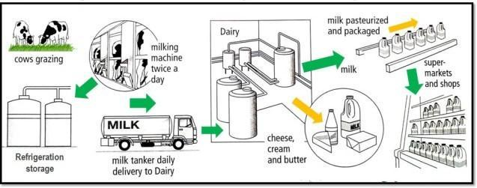

The diagram **(illustrate)** …………**illustrates**……………the way milk, cheese, cream and butter **(produce)** …**produced**………, processed and packaged so as to be sold to consumers. There are 8 stages in the diagram starting with cows grazing on grass, to the sale of dairy products in supermarkets and shops.

At first, cows graze on grass in the fields, after which they **(take)**……are taken……… to a milking machine twice a day. Following this, the milk **(put)**………is put ………. into refrigeration storage on a daily basis. Next, the milk **(put)**………is put……….. into a tanker and once the milk **(transfer)**………is transferred………. to a tanker, it is then ready to be delivered to the dairy. This process **(repeat)**……is repeated……… every day.

When the milk **(deliver)**………………is delivered……………. to the dairy, it **(subsequently/process)**

………is **subsequently processed**………………………. into various dairy products such as cheese, cream and butter.

Following this, the milk is then put through a pasteurization process and it is now ready to **(package)**……**packaged**…….

Finally when the milk and dairy products have been processed and packaged they are then **(sent out)**…sent out………..………….. to supermarkets and shops where they are ready for purchase by consumers.

**Conditionals**

**1- Match the sentence halves.**

1. If they didn't offer such good terms, a) we'll have to cancel it.
2. If you ordered a larger quantity, b) the consignment will reach us in time.

3 If we offer them a 10% discount, c) we can start production as scheduled.

4 If you don't confirm your order soon, d) we wouldn't do business with them.

1. As long as we get the parts in May, e) we could negotiate a better price.
2. Provided that it is sent by air, f) they say they'll place an order today.

|  |
| --- |
| 1- d 2- e 3-f 4-a 5-c 6-b |

**Writing:**

Some people think that to be successful you need to get a university degree whereas others relate success to risk-taking.

Discuss both views and give reasons for your answer. Include any relevant examples from your own knowledge or experience.

In a serious world, an individual's instructive capabilities have a significant part in accomplishing a fruitful profession. It is an everyday person's viewpoint that a college degree is fundamental in driving a decent vocation. Actually, others accept that this is not, at this point pertinent in the present-day situation.

In any case, regardless, a college degree is significant for an individual to find a decent line of work and professional openings. Despite the fact that organizations are receiving totally new procedures to enlist their workers, they generally give an impressive significance to up-and-comers instructive capabilities. It is the key factor that assists an individual with catching everyone's eye. At the point when we settle on professional educations, we are really zeroing in on a specific space of our advantage. For example, if an understudy is keen on the bookkeeping field, he ought to definitely pick a business-related stream for accomplishing a degree. Accordingly in the wake of escaping the school, he can search for a bookkeeping position dependent on his capability.

Then again, a few groups contend that training is not, at this point a fundamental factor to find a new line of work. As indicated by them, an individual's insight and extraordinary abilities are the significant factors that choose his future work life. As of now organization’s determination measures are finished transformed, they really search for special abilities instead of instructive capabilities. Moreover, a few people have some inherent stand apart capacities. For instance, in the event that you think about the instance of Mark Zuckerberg, the founder of Facebook, e is actually a college dropout. Yet, he has a few thoughts and really dealt with that and turned into a colossal effective business visionary.

So, we can not say that college degrees are not, at this point needed for effective work life. The facts demonstrate that some are capable make incredible progress without the help of instructive capabilities yet it isn't something similar for everybody.

…………………………………………………………………………………………………………………………………………………………………………………………………….

…………………………………………………………………………………………………………………………………………………………………………………………………….

…………………………………………………………………………………………………………………………………………………………………………………………………….

…………………………………………………………………………………………………………………………………………………………………………………………………….

…………………………………………………………………………………………………………………………………………………………………………………………………….

…………………………………………………………………………………………………………………………………………………………………………………………………….

…………………………………………………………………………………………………………………………………………………………………………………………………….

…………………………………………………………………………………………………………………………………………………………………………………………………….

…………………………………………………………………………………………………………………………………………………………………………………………………….

…………………………………………………………………………………………………………………………………………………………………………………………………….

…………………………………………………………………………………………………………………………………………………………………………………………………….

…………………………………………………………………………………………………………………………………………………………………………………………………….

…………………………………………………………………………………………………………………………………………………………………………………………………….

…………………………………………………………………………………………………………………………………………………………………………………………………….

…………………………………………………………………………………………………………………………………………………………………………………………………….

…………………………………………………………………………………………………………………………………………………………………………………………………….

…………………………………………………………………………………………………………………………………………………………………………………………………….

…………………………………………………………………………………………………………………………………………………………………………………………………….