EXAM OPTIMIZE YOUR AUTOMATION SKILLS

# GENERAL

The System Under Test (SUT) is <http://automationpractice.com/index.php>. Thisis really a nice fake e-commerce site to practice test automation. If youhave a project where you need to practice different flows for online stores,this is the website you want. All exercises must be executed within KatalonStudio and of course you should create test cases, test suites and so on.

# PREPARATION

1. Follow the instructions in [Prepare exam optimize your automation skills.docx](https://teams.microsoft.com/_#/docx/viewer/teams/https%3A~2F~2Fcapgemini.sharepoint.com~2Fsites~2FPizzasessionsimproveyourautomationskillsclass1~2FShared%20Documents~2FGeneral~2FPrepare%20exam%20optimize%20your%20automation%20skills.docx?threadId=19%3A29eaab7e020f42fc80c62fac954902df%).
2. Open a web browser and go to <http://automationpractice.com/index.php?controller=authentication&back=my-account>
   1. Create an account (if necessary) and use a simple password like **abc** because later on this password may be stored on the public site Github.com:  
        
      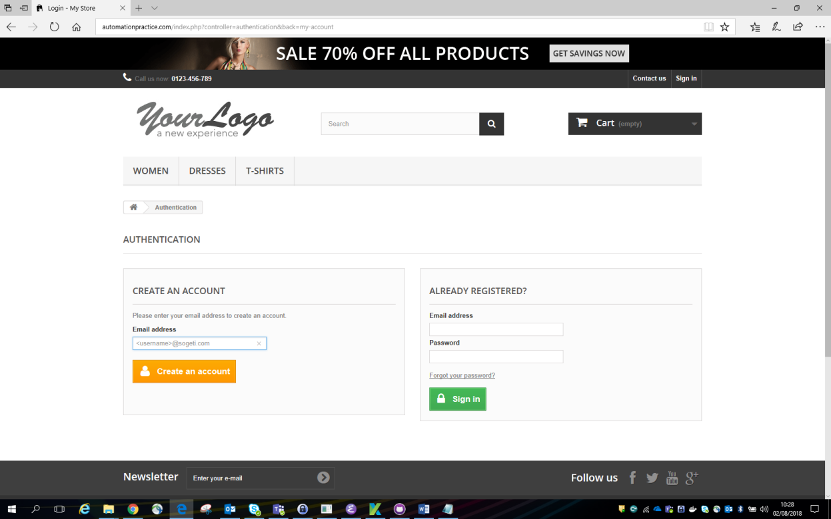
3. Open Katalon Studio 5.5 or higher
   1. Enable Git, if necessary:  
        
      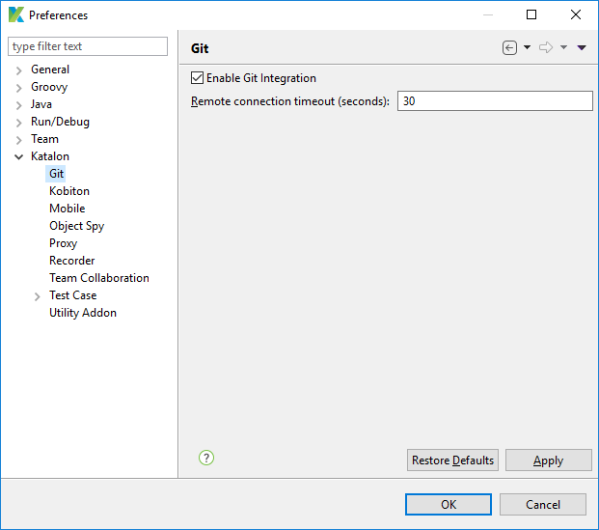
   2. Checkout the GitHub project katalon-exam (replace <username> by your GitHub username in both the Repository URL and User):  
        
      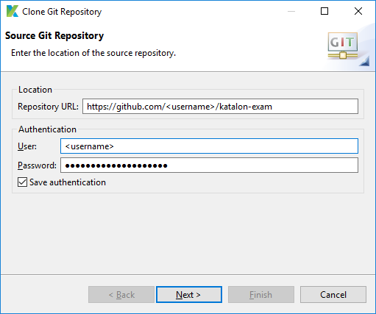
   3. Go to Profiles and choose the default profile. Change there the loginUsername and loginPassword to the email address and password you have used in Create an account in the previous step (step 2):  
        
      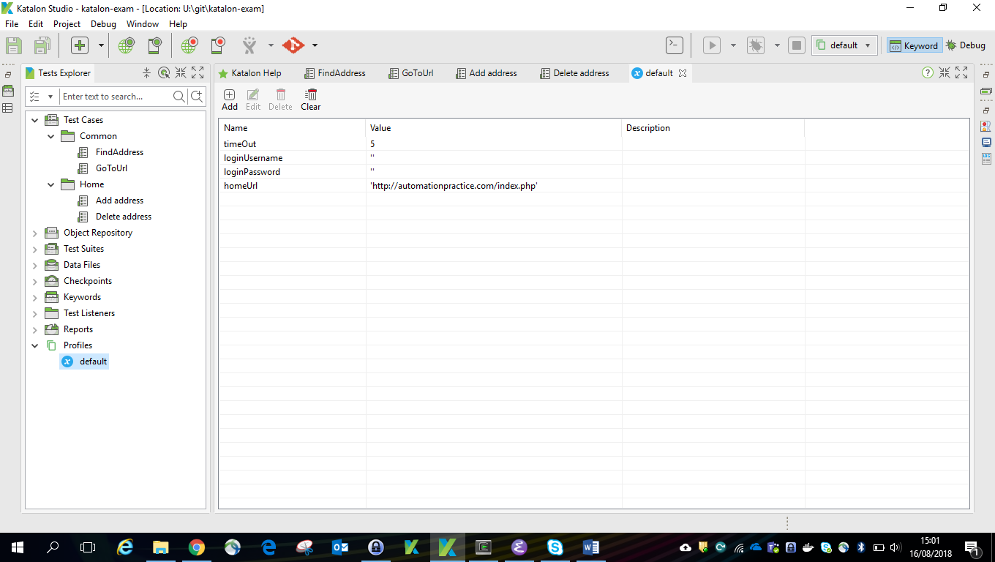
   4. Run the test case **Add address** (Test Cases -> Home) just to check whether everything works fine. At the end you should be signed in.

# EXERCISE 1 - Add an address

Detailed steps:

1. Select the **Add address** test case and start the Record Web. You should see this:  
     
   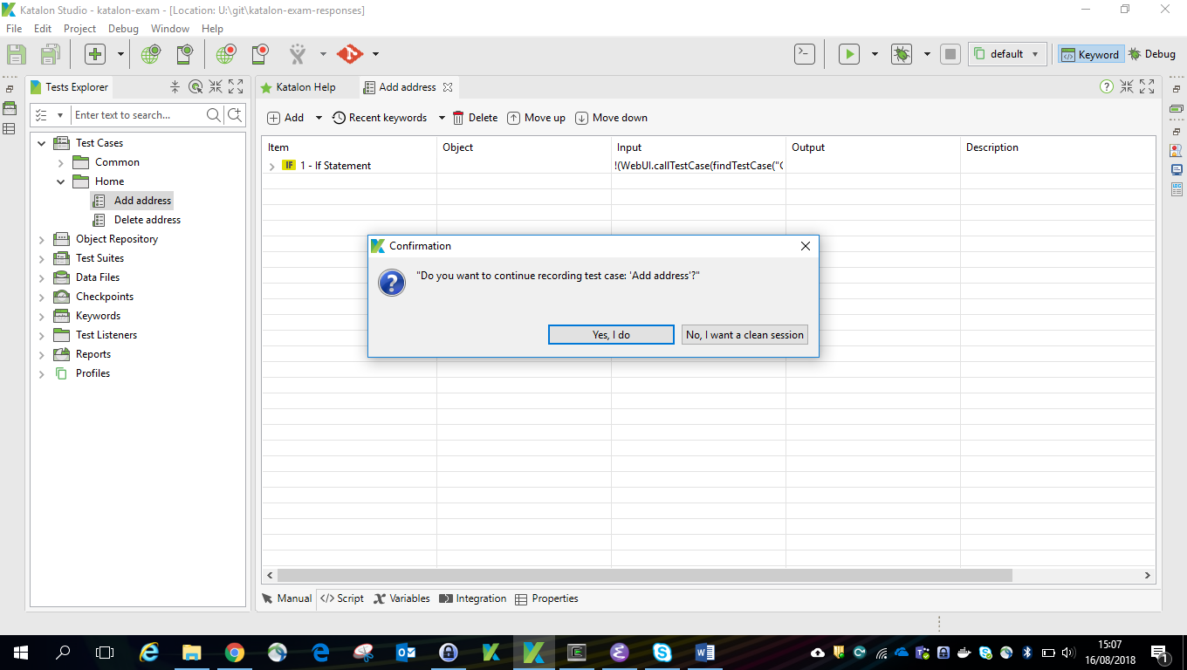  
   1. Accept the dialog (Yes, I do) to start the recorder.
   2. In the recorderempty the URL and click Run (all steps) and wait till he is ready.
   3. In the browser(the SUT) go to the bottom and click the button **Add a new address**.
   4. The last line shown in the recorder will now look something like this:  
        
      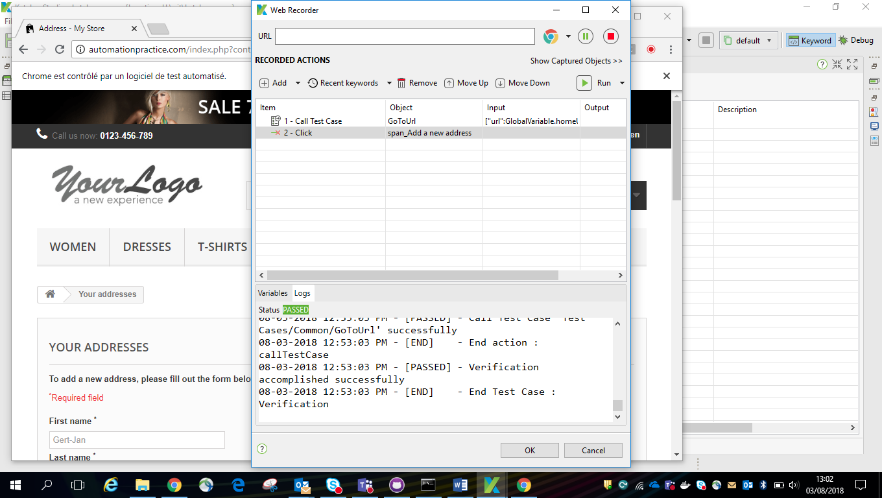
   5. Click OK and once more OK here:  
        
      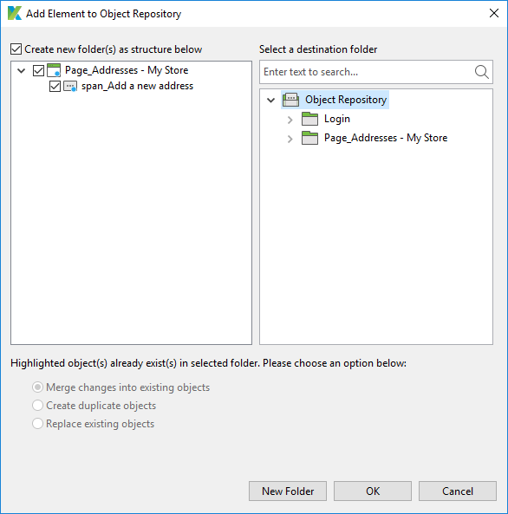
2. Repeat the previous step but now you have to enter an address in the last page (after the button Add a new address has been pressed by the recorder). Replace the values you have entered by variables and save the **Add address** test case.
3. Create an internal spreadsheet **Addresses**in the Data Files directory with one column for each variable defined in the test case. Create one Home and one Work address.
4. Create a Test Suite **Add addresses**and use the data driven approach to combine the spreadsheet and the test case.

# EXERCISE 2 - Delete an address

Detailed steps:

1. Create a Test Suite **Delete addresses** using the test case **Delete address**and use the data drivenapproach to combine the spreadsheet **Addresses**and the test case.

# EXERCISE 3 – Improve Add and address

The **Add address** test case should also handle the case when the address is already there. The alias created in the Add new address Web page is the key for checking this information. Look at the **Delete address** test case and change the **Add address** test case in a similar fashion.

You can check your solution by running test suite**Delete addresses** first and then twice **Add addresses**. There should be no error in the logs.

# EXERCISE 4 - Best practices

The answers to the questions below can be found in the Word document [Improveyour automation skills](https://teams.microsoft.com/_#/docx/viewer/teams/https%3A~2F~2Fcapgemini.sharepoint.com~2Fsites~2FPizzasessionsimproveyourautomationskillsclass1~2FShared%20Documents~2FGeneral~2FImprove%20your%20automation%20skills.docx?threadId=19%3A29eaab7e020f42fc80c62fac954902df%40thread.skype&bas) in Microsoft Teams.

Which best practices have you used? Describe them in the table below (please note that the number of lines is arbitrary):

|  |  |
| --- | --- |
| Best practice | Example |
| 6. |  |
| 8. | Name : Add Adresses, Delete Adresses |
| 10. | Videos of Test Suites |
| 13. | Definition of spreadsheet **Addresses** |
| 14. | Add addresses, Delete adresses |
|  |  |

# EXERCISE 5 - Cleanup / efficiency

Ensure that in all test cases the browser is only opened when necessary andnever closed by you. Remove all unnecessary objects.

*** THE END ***