**CURRICULUM VITAE**

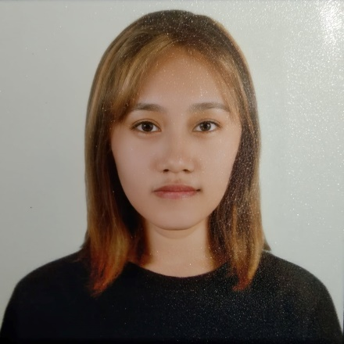

**Personal Information**

Name Meriflor N. Gonoy

Address Purok-3 Libertad Kolambugan Lanao del Norte

Birthplace Rizal Medical Center, Pasig City

Religion Roman Catholic

Father’s Name Romerico A. Gonoy

Mother’s Name Florenda N. Gonoy

**Educational Qualification**

Elementary Holy Cross High School

Secondary Holy Cross High School

Collage Mindanao State University – Maigo School of Arts and Trades

**CURRICULUM VITAE**

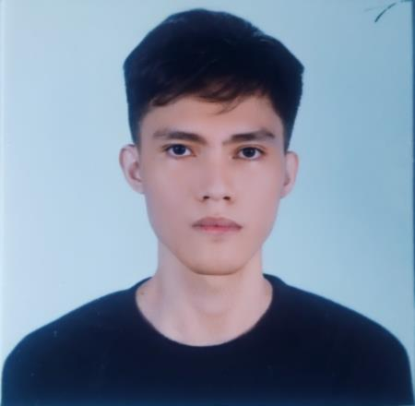

**Personal Information**

Name Rotsen V. Baroquillo

Address Purok-4 Riverside Kolambugan Lanao del Norte

Birthplace Purok-3 Rebucon Kolambugan Lanao del Norte

Religion Roman Catholic

Father’s Name Nestor A. Baroquillo

Mother’s Name Rosalinda V. Baroquillo

**Educational Qualification**

Elementary Riverside Elementary School

Secondary Holy Cross High School

Collage Mindanao State University – Maigo School of Arts and Trades

**CURRICULUM VITAE**



**Personal Information**

Name Olympio B. Sumbilon Jr

Address Poblacion Tubod Lanao del Norte

Birthplace Palao Tubod Lanao del Norte

Religion Church of God 7th day

Father’s Name Olympio C. Sumbilon Sr.

Mother’s Name Adelina A. Bocatot

**Educational Qualification**

Elementary Tubod Central Elementary School

Secondary Lanao del Norte National Comprehensive High School

Collage Mindanao State University – Maigo School of Arts and Trades

**CURRICULUM VITAE**

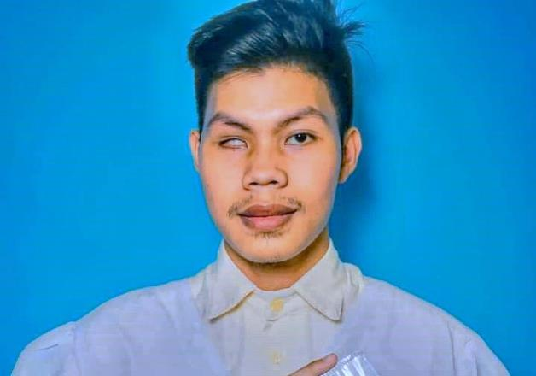

**Personal Information**

Name Harris de la Torre Revelo

Address Purok-1 Sta.Cruz, Maigo, Lanao del Norte

Birthplace Maigo, Lanao del Norte

Religion Baptist

Father's Name Generoso Revelo

Mother's Name Marivel Revelo

**Educational Qualification**

Elementary Sta.Cruz, Elementary School

School Secondary Maigo, National High School

College Mindanao State University - Maigo School of Arts and Trades

**CURRICULUM VITAE**

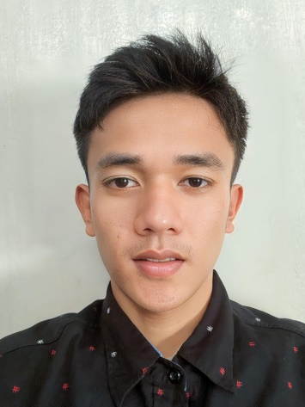

**Personal Information**

Name Bryan Bangcale Ladion

Address Purok-4, Poblacion, Bacolod, Lanao del Norte

Birthplace Bacolod, Lanao del Norte

Religion Roman Catholic

Father's Name Rufo Sebial Ladion Jr.

Mother's Name Marcia Bangcale Ladion

**Educational Qualification**

Elementary Bacolod Central Elementary School

School Secondary Binuni-Demologan National High School

College Mindanao State University - Maigo School of Arts and Trades