**Computer Hardware**

Computer hardware includes the physical parts of a computer, such as a case, central processing unit (CPU), random access memory (RAM), monitor, and mouse which processes the input according to the set of instructions provided to it by the user and gives the desired output.

The computer has mainly has two major components:

1. Hardware
2. Software

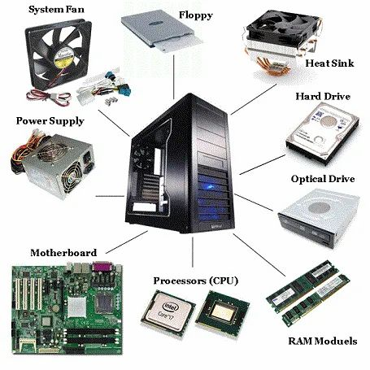

**What is Computer Hardware?**

Computer hardware is a physical device of computers that we can see and touch. For e.g. [Monitor](https://www.geeksforgeeks.org/monitor-vs-semaphore/), [Central Processing Unit](https://www.geeksforgeeks.org/central-processing-unit-cpu/), [Mouse, Joystick](https://www.geeksforgeeks.org/difference-between-mouse-and-joystick/), etc. Using these devices, we can control computer operations like [input and output](https://www.geeksforgeeks.org/input-and-output-devices/).

**Computer Hardware Parts**

These hardware components are further divided into the following categories, which are:

1. Input Devices
2. Output Devices
3. Storage Devices
4. Internal Components

**1. Input Devices**

[Input devices](https://www.geeksforgeeks.org/what-are-input-devices/) are those devices with the help of which the user interacts with the computer. Or, In other words, with the help of input devices, the user enters the data or information into the computer. This information or [data](https://www.geeksforgeeks.org/what-is-data/) is accepted by the input devices and converted into a computer-acceptable format, which is further sent to the [computer system](https://www.geeksforgeeks.org/computer-system-life-cycle/) for processing.

* **Keyboard:** It is the most common and main input device for computers. The data is inputted by typing on the keyboard. It consists of 104 keys in total. It contains numeric keys, alphabet keys, and different function keys as well. Earlier, it was connected to the computer via cable, now as technology has advanced, you can connect a keyboard using Bluetooth.
* **Mouse:**A mouse is a kind of pointing device which is rolled over to control the cursor on the screen and it has functional keys like left, middle, and right buttons. Using these functional keys, on by the click of which an object is selected or to open a file by just a click of a mouse. It also consists of a sensor inside which notifies its speed to the computer and according to which the cursor is moved on the screen.
* **Scanner:** As the name suggests, it scans images, documents, etc., and converts them into digital form and that can be further edited and used. It works just like a Xerox machine.
* **Track Ball:** It is a device much like an upside-down mouse. It does not use much space for movement like a mouse. As the trackball remains stationary and the user moves the ball in various directions, it affects the screen movements directly.

**2. Output Devices**

These are the devices that are used to display the output of any task given to the computer in human-readable form.

* **Monitor:** The monitor is the main output device. It is also called [VDU(visual display unit)](https://www.geeksforgeeks.org/what-is-vduvisible-display-unit/) and it looks like a TV screen. The Monitor displays the information from the computer. It is used to display text, video, images, etc.
* **Printer:**A [printer](https://www.geeksforgeeks.org/what-is-a-printer/) is an [output device](https://www.geeksforgeeks.org/what-are-different-output-devices/) that transfers data from the computer in a printed format by using text or images on paper. There are both colored and black & white printers. Further, there are also different types of printers, like [Laser Printer, Dot-matrix](https://www.geeksforgeeks.org/difference-between-dot-matrix-printer-and-laser-printer/) printers, and Inkjet printers.
* **Plotter:**It is similar to a printer but potters are large in size. A plotter is used to generate large drawings, architectural blueprints, etc. on paper and these are high-quality images and drawings and large in size.
* **Speakers:** It is a very common output device and it gives sound as an output. Speaker is generally used to play music or anything having sound.

**3. Storage Devices**

There are some devices that are used for storage purposes and are known as secondary storage devices. Some of them were discussed below:

**1. CD (Compact disc):**A [CD](https://www.geeksforgeeks.org/cd-full-form/) is circular in shape and made up of thin platted glass and plastic polycarbonate material. It has a storage capacity of 600 MB to 700 MB of data. It has a standard size of 12 cm with a hole in the center of about 1.5 cm and 1.2 mm in thickness. There are basically 3 types of CDs, which are:

* **CD-ROM (CD – Read Only Memory)**
* **CD-R (CD-Recordable)**
* **CD-RW(CD-Rewritable)**

**2. DVD (Digital Video/Versatile Disc):**A [DVD](https://www.geeksforgeeks.org/advantages-and-disadvantages-of-dvd/) is the same as a CD but with some more features. A DVD comes in single and dual-layer formats. It has much greater storage capacity in comparison to CD. The storage capacity of a DVD with one-sided single layer is – 4.7 GB, one-sided double layer – 8.5 GB, double-sided single layer – 9.4 GB, and double-sided double layer – 17 GB. There are also some types in DVDs, which are :

* **DVD-ROM**
* **DVD-RAM**

**3. Hard Disk:**An [hard disk](https://www.geeksforgeeks.org/advantages-and-disadvantages-of-hard-disk/) is a non-volatile storage device that uses its read/write heads to store digital data on a magnetic surface of a rigid plate. It is generally 3.5 inches in size for desktops and 2.5 inches in size for laptops. A hard disk can be classified further into 3 types, which are:

* **Internal Hard Disk**
* **Internal Cartridges**
* **Hard Disk Packs**

**Hardware Components**

Some important hardware devices known as the internal components are discussed below:

**1.CPU (Central Processing Unit)**

The CPU is also known as the heart of the computer. It consists of three units, generally known as the control unit, [Arithmetic Logical Unit (ALU)](https://www.geeksforgeeks.org/introduction-of-alu-and-data-path/), and the [memory unit](https://www.geeksforgeeks.org/introduction-to-memory-and-memory-units/). Below is the block diagram of the CPU is given:

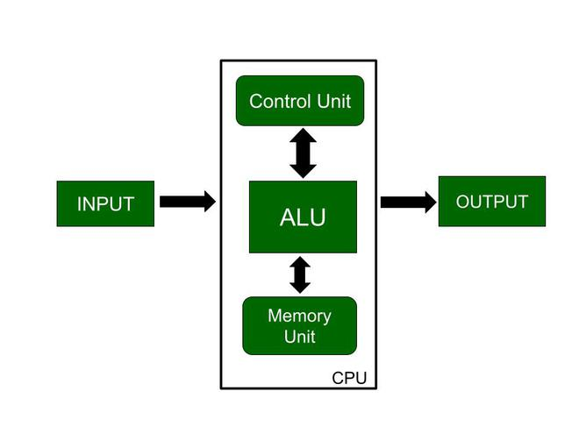

As shown in the diagram input is given to the CPU through input devices. This input goes to memory and the control unit gets instructions from memory. The control unit now decides what to do with the input or instructions and transfers it to ALU. Now, ALU performs various operations like addition, subtraction, multiplication, division, logical operations, etc. After that, the final result gets stored in memory and finally passed to output devices to give the output. So, this is how the CPU works.

**2. Motherboard**

It is the main circuit board inside a computer and it contains most of the electronic components together. All the components of the computer are directly or indirectly connected to the [motherboard](https://www.geeksforgeeks.org/what-is-motherboard/). It includes [RAM](https://www.geeksforgeeks.org/random-access-memory-ram/) slots, controllers, system chipsets, etc.

Some of them are:

* **CPU Slot:**The CPU can be installed in this space. It serves as a connector between a motherboard and a microprocessor. It makes the CPU easier to operate and guards against harm when installing or removing it. It also has a lock to stop the CPU from moving and a heat sink to get rid of the additional heat.
* **RAM Slot:** The RAM (Random Access Memory) is installed in a memory slot or socket on the motherboard. A computer may have two or more memory slots.
* **Expansion Slot:** It is often referred to as an extension port or a bus slot. It is a connection or port on the motherboard that offers a place to put an expansion card for components. It goes by the names bus slot and expansion port as well. It is a port or connection on the motherboard that offers a place to add a hardware expansion card. For instance, you could buy a video expansion card, put it in the expansion slot, and then install a new video card in the computer. AGP, [AMR](https://www.geeksforgeeks.org/what-is-amradaptive-multi-rate-codec/), CNR, PCI, and other popular expansion slots in computers are only a few examples.
* **Capacitor:** Two conducting plates and a thin insulator are placed together to form a capacitor. These components are contained in a plastic bag.
* **Inductor(Coil):** A conducting wire is wrapped around an iron core to create an electromagnetic coil known as an inductor. It stores magnetic energy by functioning as an electromagnet or inductor.
* **Northbridge:** An integrated chip called the northbridge enables communication between the CPU interface, AGP, and memory. Additionally, it enables communication between the southbridge chip and the graphics controller, CPU, and RAM.
* **Southbridge:** Controls the input and output functions. Due to its location, it is referred to as southbridge. it enables communication between the northbridge chip.
* **USB Port:**You can attach hardware like a mouse and keyboard to your computer using the USB port.
* **PCI Slot:** This term refers to a slot. It enables you to connect [Peripheral Component Interconnect Slot(PCI)](https://www.geeksforgeeks.org/peripheral-component-interconnect-pci/)hardware, like as sound and video cards, network hardware, and modems. These are used to connects the peripherals.
* **AGP Slot:** This is referred to as an [Accelerated Graphics Port(AGP)](https://www.geeksforgeeks.org/what-is-agpaccelerated-graphics-port/)slot. The slot for connecting graphics cards is provided. It is used for displaying graphics on the screen.
* **Heat Sink:** The heat created by the computer processor is absorbed and dispersed by the heat sink. Its main function is to cool down the CPU by absorbing the heat while the system is running.
* **Power Connector:** The purpose of the power connector is to give power to the motherboard.
* **CMOS Battery:** Complementary Metal Oxide Semiconductor is the abbreviation for the [CMOS Battery](https://www.geeksforgeeks.org/what-is-the-need-of-cmos-battery-in-computers/). It is a storage memory. A battery that provides backup power.

**Integrated Circuits (IC):** IC is also very important component of motherboard. [Integrated circuit](https://www.geeksforgeeks.org/types-of-integrated-circuits/) is used for data processing and storage.

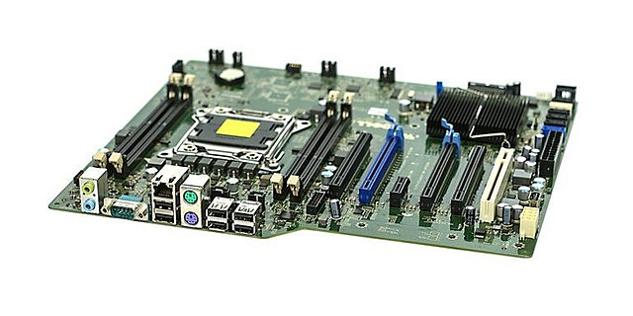

**3. RAM (Random Access Memory)**

It is also known as temporary or volatile memory. It holds the program and data, which are currently in process or processing. All the data is erased as soon as the computer is turned off or in case of a power failure. Data stored in this memory can be changed.

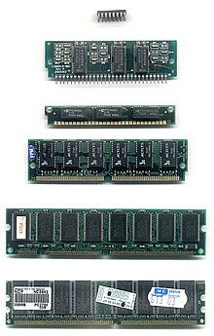There are two types of RAM:-

1. **SRAM (Static RAM):**[SRAM](https://www.geeksforgeeks.org/sram-full-form/) basically consists of a flip-flop using a transistor or Mosfet (MOS). It is fast and has less access time. In this refreshing circuits are not required. But it is costly and requires more space. For e.g. cache memory.
2. **DRAM (Dynamic RAM):** [DRAM](https://www.geeksforgeeks.org/dram-full-form/) consists of capacitors and the data is stored in the form of capacitors. [Capacitors](https://www.geeksforgeeks.org/energy-stored-in-a-capacitor/) charge when data is 1 and don’t charge if data is 0. It requires refreshing circuits, as leakage of current in the capacitor can occur, so they need to be refreshed to the data. It is slower and has a higher access time. It is cheaper in comparison with [SRAM](https://www.geeksforgeeks.org/sram-full-form/). For e.g. Main memory.

**4. Hard Drive**

On a computer system, files, programs, and other types of information are stored on hard drives, which are data storage devices. They utilise hard drives, which are magnetically coated discs used to store digital versions of information. A computer technician can suspect a corrupt hard disk when a hard drive dies.

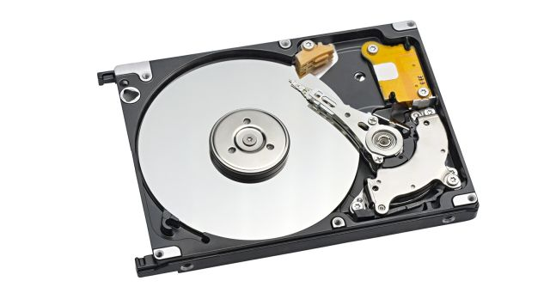

**Daughter card**

A daughter card, also known as a daughterboard, piggyback board, or riser card, is a small circuit board that connects to a computer's motherboard. It's designed to extend the functionality of the motherboard.

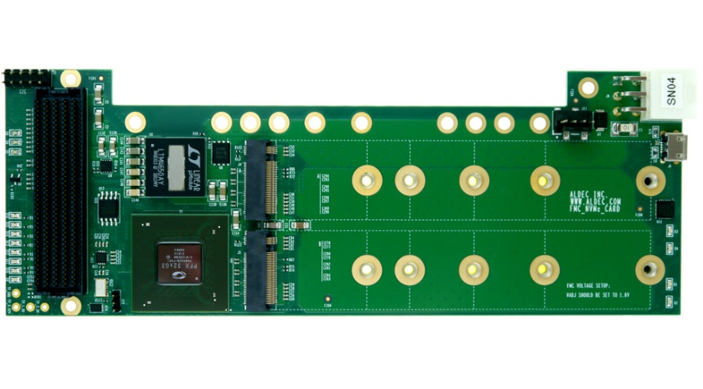

**Bus Slot**

An expansion slot is a bus slot or expansion port found on the motherboard of a computer. It performs as a socket on the motherboard. Basically, it holds expansion cards featured in a computer so that it can use those features for better operation—say, a video card for better graphics and sound, Ethernet for an increased internet speed, and memory for an increased storage capacity. Any slot on the motherboard that can hold an expansion card is an expansion slot.

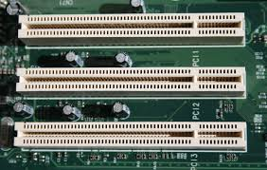

**SMPS**

SMPS stands for Switched Mode Power Supply, which is a power supply unit (PSU) that converts electrical power for a computer. It's also known as a switcher.

A switched-mode power supply (SMPS), also called switching-mode power supply, switch-mode power supply, switched power supply, or simply switcher, is an electronic power supply that incorporates a switching regulator to convert electrical power efficiently.

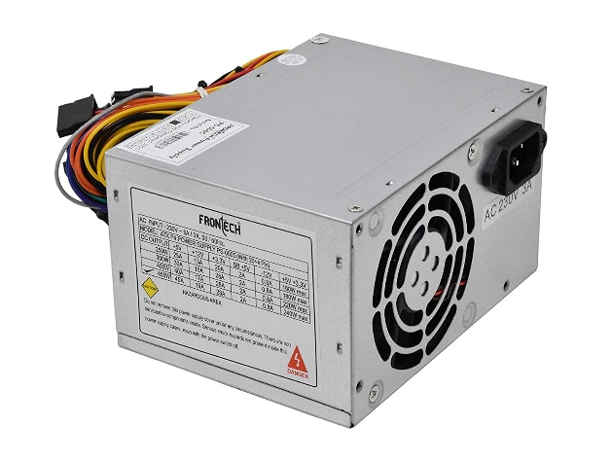

**Internal storage devices**

Internal storage devices are permanently installed inside a computer and include magnetic storage devices, solid state drives (SSDs), optical drives, and flash memory devices.

* **Magnetic storage devices**

Typically hard drives that are magnetic in nature

* **Solid state drives (SSDs)**

Store data in an integrated circuit and can be used as internal or external drives

* **Optical drives**

Can be internal or external and are installed directly into the computer's electronics

* **Flash memory devices**

Usually built-in and house the operating system and files needed for the device to operate

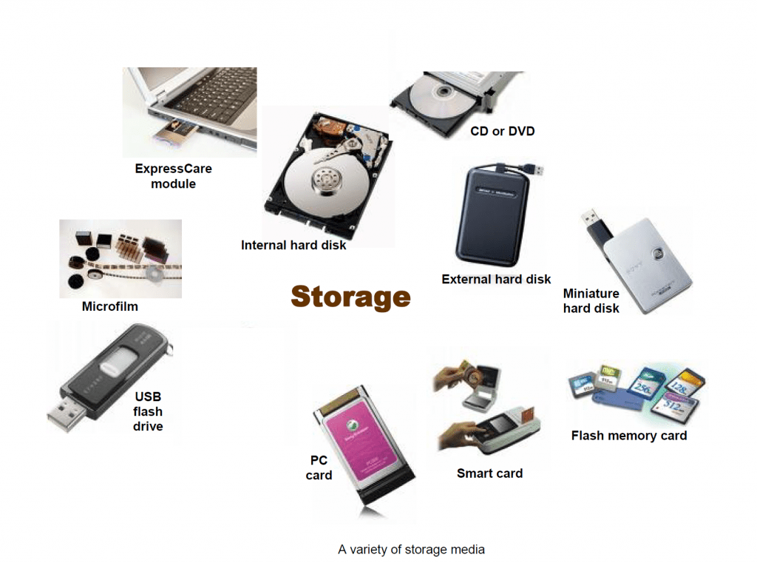

**Interfacing ports**

Interfacing ports are communication channels that allow a microprocessor to communicate with external devices. They can be used to read data from input devices like keyboards and mice, and to send data to output devices like CRT displays.

* **Parallel port**: Also known as a printer port, this was an industry standard for many years in the late 1990s.

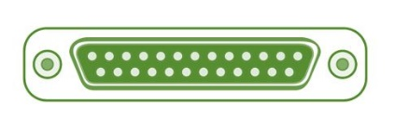

* **Ethernet port**: Connects a network cable to a computer, allowing it to connect to a network and the internet.

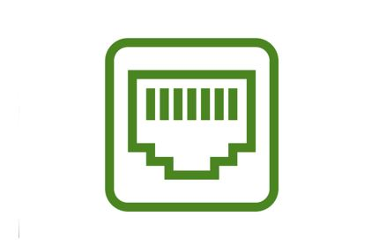

* **PS2 port**: An interface for keyboards and mice to communicate with the host.

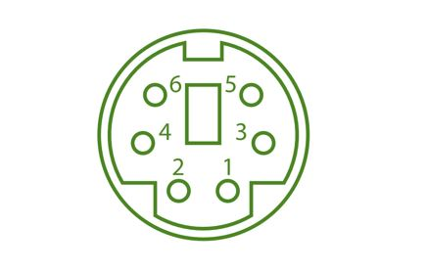

* **Serial port**: A port that can be used for data communication.

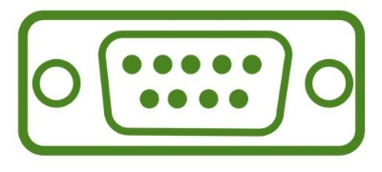

* **USB port**: An interface that supports plug and play, and can be used to connect a Universal Serial Bus (USB) device to a computer.

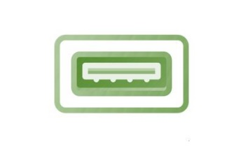

* **FireWire port**: A type of serial port that can be used to connect audio and video devices to computers.

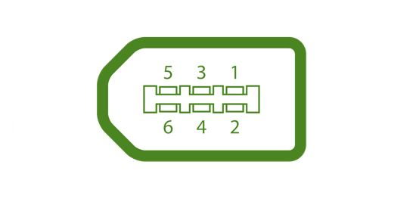

* **HDMI port**: A common interface for onboard connections.