1. Introduction
1.1 Introduction
Auto Book (E-library) is a full-featured software programme created to automate and optimise all aspects of library operations, including acquisitions, circulation, cataloguing, and patron administration. It functions as a centralised platform that helps librarians effectively manage library resources and give users easy access to information.
Libraries now have to meet higher standards for efficiency, accessibility, and user involvement in the digital age. These demands can no longer be addressed by the manual methods of E-library that were once common. In order to modernise their operations and improve user experiences, libraries are now relying on technology-driven solutions like E-library.

1.1 Statement of the Problem
The main problems with E-library are low user experience, restricted accessibility, and inefficient manual cataloging. Suboptimal utilization and decision-making challenges are caused by insufficient resource tracking and inefficient circulation management. Furthermore, because of antiquated systems, security and compliance issues continue to exist. A contemporary E-library must be put in place in order to guarantee security and compliance, improve user experience, maximise resource utilisation, and enable data-driven decision-making.

1.2 Objectives
Specific Objectives
- Efficient Resource Management
- Enhanced User Experience
- Optimized Resource Utilization
- Improved Accessibility
- Administrative Efficiency

2. Background and Literature Review

2. Background and Literature Review

2.1 Background Study
In the present era, there has been a noticeable uptick in individuals seeking varied literary experiences and exploration throughout the year, which has significantly impacted the library sector. This increasing trend reflects a heightened interest in diverse reading adventures among the populace. The convenience of accessing and managing library resources online from anywhere has become a major draw for modern readers. Online platforms empower library patrons to easily search, access, and manage their reading materials at any time and from any location with internet access, contributing to the unprecedented growth in the library sector.
Continuing with this trend, libraries benefit from an increasingly connected and engaged population. The ease of accessing information and managing reading materials online plays a crucial role in shaping the preferences and behaviours of contemporary readers. This underscores the significant transformative impact of technology on the landscape of library management.
E-libraries offer numerous advantages, including 24/7 remote accessibility, enhanced resource sharing and collaboration, cost efficiency by reducing physical storage needs, and advanced search capabilities that improve information retrieval. However, they also face challenges such as ensuring digital rights management, maintaining robust technological infrastructure, providing adequate user training and support, and preserving digital content. Solutions to these challenges include implementing DRM technologies, investing in scalable cloud-based solutions, offering user tutorials and ongoing training, and using standardized formats and regular backups for preservation.
Technological considerations for e-libraries involve leveraging cloud computing for scalability and accessibility, employing AI and machine learning to enhance search functions and automate cataloging, utilizing blockchain for secure digital rights management, and adhering to interoperability standards for seamless system collaboration.
Notable examples of e-libraries include Project Gutenberg, which offers over 60,000 free e-books, Google Books, which digitizes millions of books worldwide, and Europeana, a platform providing access to millions of digitized items from European cultural institutions. Future trends in e-libraries point towards the use of virtual and augmented reality to enhance user engagement, developing more intuitive and user-friendly interfaces leveraging AI, and increasing collaboration between institutions for resource sharing.

3. System Analysis and Design

3.1 System Analysis
This System is designed with the help of Agile methodology. We use the different processes starting with Plan, design, develop, test, deploy and review. This system is developed according to the requirement then designing and testing of the system is carried out. After the design process, coding and development part is started then use different approaches for testing of the system. If the testing is positive, then the system is implemented, otherwise some maintenance is done and the system come in operation. This project has specific documentation, requirements and well-understood technology. So, it is built on Agile Methodology. Accessible design principles should be considered to ensure inclusivity.

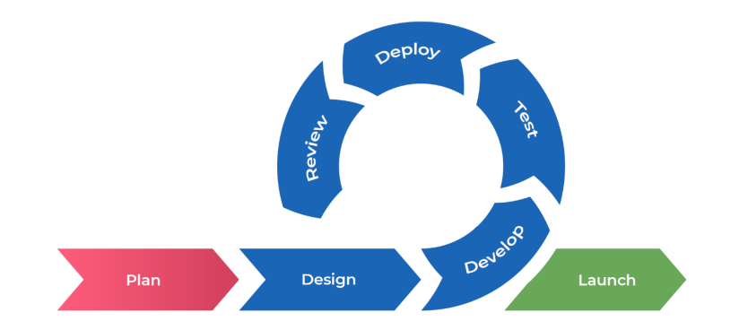

Fig: Agile methodology for Auto Book

3.1.3 Feasibility Analysis
i.Technical feasibility
This system is easy to design and this system uses existing technologies, software and hardware so there is less chance of arising problems while building the system.
ii.Economic Feasibility:
This system utilizes open-source technologies, eliminating the need for additional software and hardware. Only an internet connection is required to access the system. Following the system's completion, the organization doesn't need to deploy any new hardware or software, as the necessary resources are already incorporated into the existing system.
iii.Operational Feasibility:
This system does not require extra hardware and new software. The system is easy to operate with the basic knowledge of computer and internet. This system uses the existing technologies. So, It is easy to design and provide user friendly environment.
iv.Schedule Feasibility:
A Gantt chart is a graphical representation of a project schedule that displaysthe tasks, dependencies, and duration of a project. The chart provides atimeline view of the project, with each task represented by a horizontal bar.The length of the bar represents the duration of the task, while the start and end points of the bar represent the start and end dates of the task.
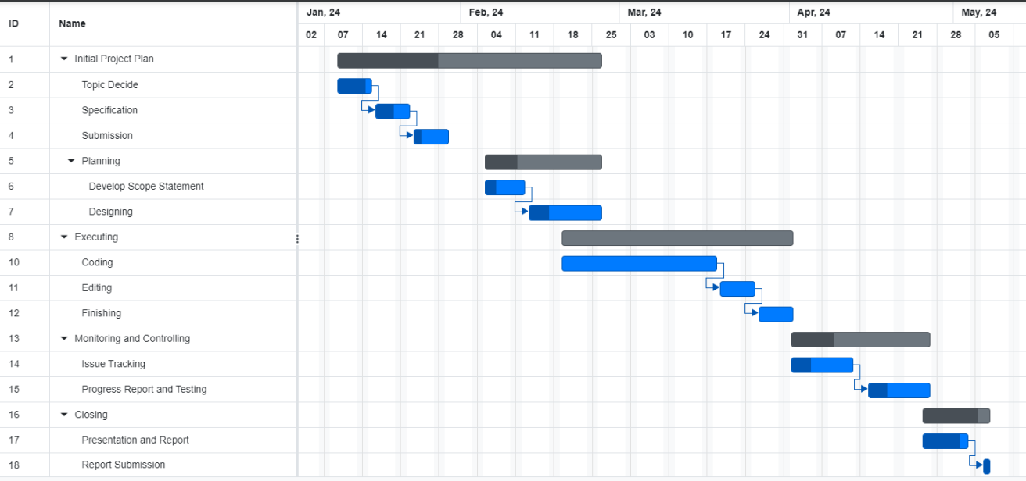

Fig 3.3- Gantt Chart

4.Implementation and Testing
4.1 Implementation
The system “AutoBook” needs some resources for its deployment. The different resources are hardware, software, server and database too. All the involved implementation sources are mentioned here in the tables below:
4.1.1 Tools Used
4.1.1.1 CASE Tools Table 1
Tools | Description
Draw.io, Lucid chart, dbdiagram.io | Used for drawing UseCase, ER diagram
Git and GitHub | Version control of code
Visual Studio Code | Integrated development environment
MS Word | Software documentation

4.1.1.2 Programming Languages and Libraries
Table 2
Language/ library | Description
Python, Django Framework | Programming Language, framework and ORM used for backend development
HTML, CSS, Bootstrap Framework, JavaScripts | Framework used for frontend development and styling

5. Conclusion and Future Recommendation
5.1 Summary
This section outlines the conclusions and suggestions provided by the researcher regarding the design and implementation of an E-Library.It is a digital platform that provides online access to a vast collection of digital resources, including books, journals, articles, and multimedia. Accessible from anywhere with an internet connection, e-libraries offer users the convenience of 24/7 availability. They feature powerful search tools and organized databases, making it easy to find specific information quickly. Many e-libraries include interactive features such as text highlighting, note-taking, bookmarking, and content sharing. While some e-libraries are freely accessible, others may require a subscription or membership, providing a cost-effective way to access extensive resources. E-libraries support educational institutions by offering up-to-date materials, enhancing learning and teaching experiences, and ensuring the long-term preservation and management of data. Additionally, it discusses potential areas for future research and the constraints encountered during the study.
5.2 Recommendations
The researcher recommends the following improvements for the E-Library :
i. Conduct training sessions for employees responsible for managing records and granting staff access to student details to ensure they are proficient in system usage.
ii.Implement measures to maintain password privacy, ensuring that access is restricted to authorized personnel for security purposes.
iii.Establish a regular backup procedure to safeguard data integrity and ensure the continuity of operations for the Library Management System.
5.3 Conclusion
The researcher's primary objective was to rectify the shortcomings of the existing E-Library by crafting a new and dependable solution. This objective was accomplished through the researcher's detailed exposition of the system in the conceptual model, followed by research activities that facilitated the completion of the entire research endeavor.

