REQUIREMENT GATHERING
Stakeholders
Requirements for MEDINEX were gathered by identifying the key stakeholders who interact with the platform — platform Admins, Hospitals, Doctors, Patients, and Pharmacists — and analysing the responsibilities and pain points specific to each role.
Functional Requirements
- The system shall allow an Admin to approve or reject hospital registrations.
- The system shall allow a Hospital to add or remove doctors and manage complaints raised against them.
- The system shall allow a Doctor to search for a patient record and view their profile, allergies, and medication history.
- The system shall allow a Doctor to issue a digital prescription with dosage, timing, and food instructions, using an AI Safety Check before signing.
- The system shall allow a Patient to view reports, upload lab documents, chat with an AI assistant, and raise complaints against doctors.
- The system shall allow a Pharmacist to view verified prescriptions, dispense medicines, and mark them as dispensed.
- The system shall automatically lock a prescription once it has been dispensed, preventing reuse.
- The system shall maintain a status history for complaints raised against doctors.
Non-Functional Requirements
- Security: role-based authentication (JWT), password hashing, and OTP-based password reset.
- Usability: role-specific dashboards that show only functionality relevant to that user.
- Reliability: a normalized MySQL schema to maintain data consistency across modules.
- Performance: rate limiting and lightweight REST APIs to keep response times low.
- Maintainability: a modular codebase separating frontend (React), backend (Express), and data layers.

USER STORY CREATION
Role | User Story | Benefit
Admin | As an Admin, I want to review and approve hospital registrations, | so that only verified hospitals join the platform.
Hospital | As a Hospital, I want to create doctor accounts with login credentials, | so that my doctors can access the system securely.
Hospital | As a Hospital, I want to view and resolve complaints against my doctors, | so that patient concerns are addressed and tracked.
Doctor | As a Doctor, I want to search for a patient by their unique ID, | so that I can quickly pull up their record during a consultation.
Doctor | As a Doctor, I want to see a patient's allergies and medication history before prescribing, | so that I avoid unsafe drug combinations.
Doctor | As a Doctor, I want an AI safety check on the medicine I prescribe, | so that dosage or interaction issues are flagged before I sign it.
Patient | As a Patient, I want to view my medical reports and prescriptions online, | so that I don't have to carry paper documents.
Patient | As a Patient, I want to chat with an AI assistant about my medicines, | so that I understand what I've been prescribed.
Patient | As a Patient, I want to raise a complaint against a doctor, | so that my concerns are formally recorded and tracked.
Pharmacist | As a Pharmacist, I want to verify a prescription before dispensing, | so that I only give out medicines that are authentic and safe.
Pharmacist | As a Pharmacist, I want the system to lock a prescription after dispensing, | so that it cannot be reused at another pharmacy.

UI DESIGN — LIVE APPLICATION SCREENS
The screens below are captured directly from the running MEDINEX application (React + Bootstrap), showing the actual implementation of the role-based portals.
Login
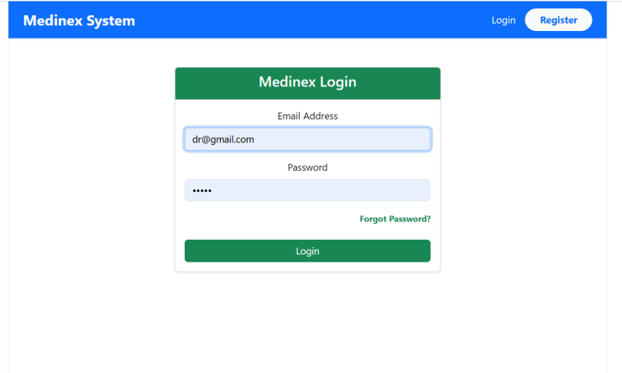
Shared login screen with email and password fields, and a forgot-password link.
Registration
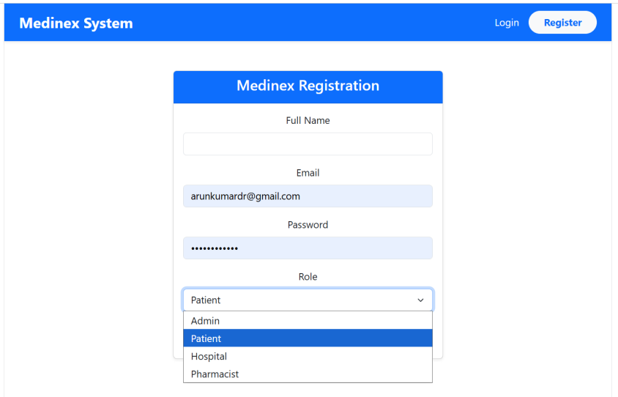
New users register with name, email, password, and select their role (Admin, Patient, Hospital, Pharmacist).
Doctor Workspace

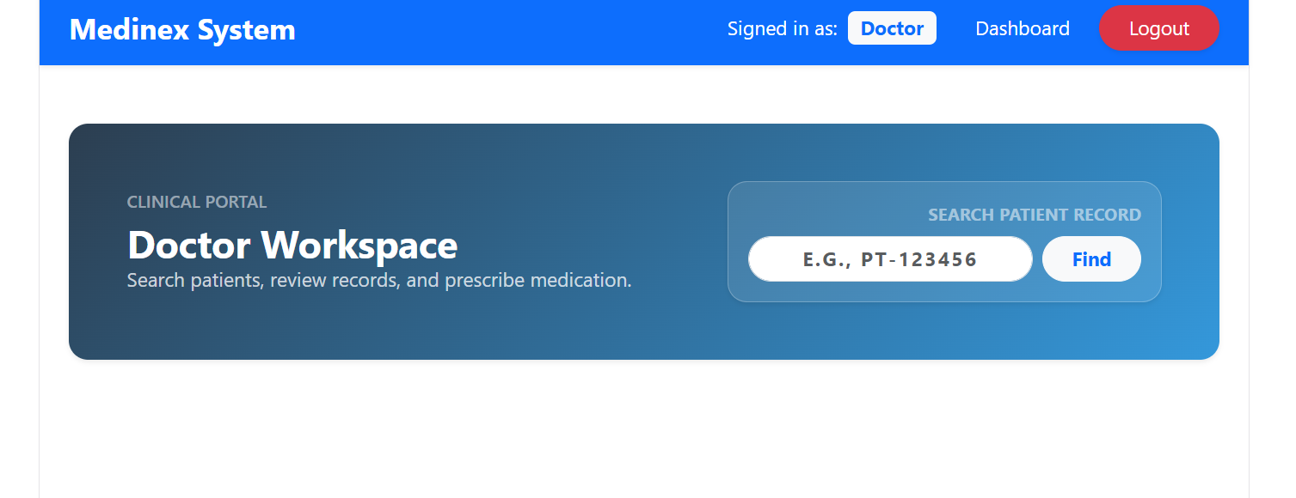
Doctor's landing page with a patient-record search bar (search by unique patient ID).

Admin — Hospital Approvals
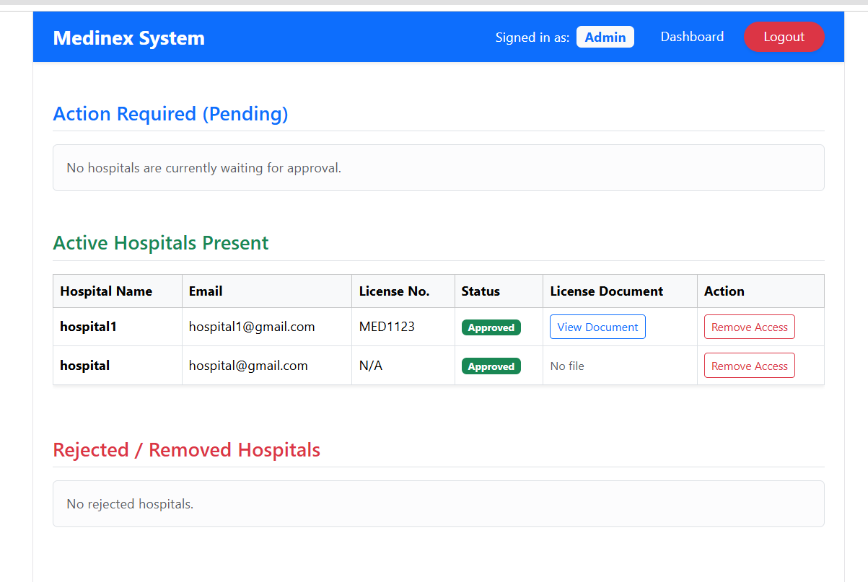
Admin view of pending, active, and rejected hospitals, with license document review.

