UML DIAGRAMS
Use Case Diagram
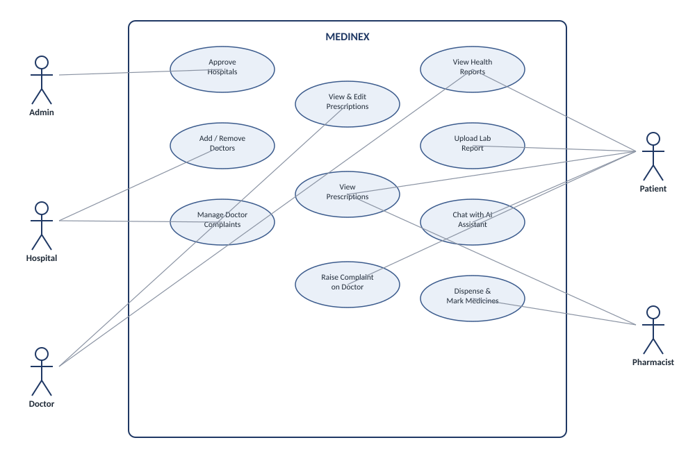
Actors (Admin, Hospital, Doctor, Patient, Pharmacist) and their key interactions with MEDINEX.

Entity Relationship Diagram (Core Tables)
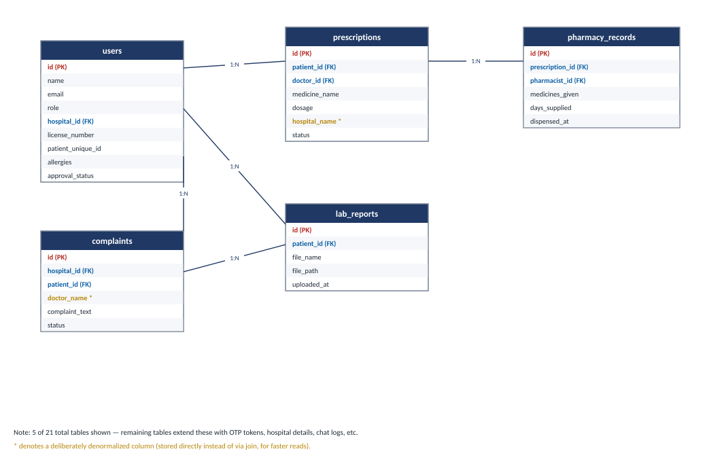
Simplified view of 5 of the 21 planned tables, showing primary/foreign key relationships between users, prescriptions, pharmacy records, lab reports, and complaints.

TABLE DESIGN
The MEDINEX database (medinex_db) is planned around 21 tables in MySQL. The core tables and their purpose are summarised below; the remaining tables extend these to support OTP verification, hospital details, and chat/session logs.
Table | Purpose | Key Columns
users | Stores all platform users across every role (single-table design). | id (PK), name, email, password, role, hospital_id (FK), license_number, patient_unique_id, allergies, approval_status
prescriptions | Stores prescriptions issued by doctors. | id (PK), patient_id (FK), doctor_id (FK), medicine_name, dosage, duration_days, status, hospital_name
pharmacy_records | Logs medicines dispensed against a prescription. | id (PK), prescription_id (FK), pharmacist_id (FK), medicines_given, days_supplied, dispensed_at
lab_reports | Stores uploaded patient lab reports. | id (PK), patient_id (FK), file_name, file_path, uploaded_at
complaints | Tracks complaints raised by patients against doctors. | id (PK), hospital_id (FK), patient_id (FK), doctor_name, complaint_text, status
Column names above are taken directly from the actual SQL queries in the backend controllers (authController, doctorController, patientController, hospitalController, pharmacistController), not assumed. The pharmacy_records structure has additionally been cross-checked against the phpMyAdmin SQL export of medinex_db, which confirms the columns above plus a dispensed_at timestamp (defaulting to CURRENT_TIMESTAMP) and MyISAM as the storage engine.

TABLE DESIGN: CUSTOMIZATION ON TEMPLATES
A textbook healthcare schema template usually creates a separate table per role (admins, doctors, patients, hospitals, pharmacists) and keeps every reference strictly as a foreign key. MEDINEX's table design deliberately customizes this standard template in a few ways to better fit a fast-moving, role-based platform.
- Single-table role design: instead of five separate role tables, MEDINEX uses one users table with a role column (Admin / Hospital / Doctor / Patient / Pharmacist). Role-specific fields that don't apply to every user — license_number and license_file for hospitals, patient_unique_id and allergies for patients — sit as nullable columns on the same table rather than in separate child tables.
- Self-referencing hospital → doctor link: a Doctor row stores hospital_id (FK) pointing back to its own users table, avoiding a separate 'doctor_hospital' mapping table since each doctor belongs to exactly one hospital.
- Selective denormalization for display speed: prescriptions stores hospital_name directly (alongside patient_id and doctor_id), and complaints stores doctor_name directly, instead of relying purely on joins back to users. This trades a small amount of redundancy for simpler, faster read queries on screens that just need to display a name.
- Built-in auth/security columns on the same table: rather than a separate 'credentials' table, password, reset_password_token, reset_password_expires, current_otp, and otp_expires_at live directly on users, keeping authentication logic in one place.
- Human-friendly patient identifier: alongside the numeric id primary key, patients get a separate patient_unique_id (shown on-screen, e.g. PT-399496) so doctors and pharmacists can search for a patient without exposing or typing the internal database ID.

TABLE NORMALISATION
The MEDINEX schema is planned to be normalized up to the Third Normal Form (3NF) to avoid data redundancy and update anomalies across its 21 tables.
1NF — First Normal Form
Most tables store atomic, single-valued columns and every row is uniquely identified by a primary key (id). The one deliberate exception is users.allergies, discussed below, which is kept as a single text field for simplicity since it is only ever displayed, not queried.
2NF — Second Normal Form
All tables will use a single-column surrogate primary key (id), so there are no composite keys and therefore no partial dependencies. Every non-key column, such as a prescription's dosage or a complaint's status, will depend on the full primary key of its own table.
3NF — Third Normal Form
Most transitive dependencies are removed by splitting related data into their own tables linked by foreign keys — dispensing details live in a separate pharmacy_records table (linked via prescription_id) rather than inside prescriptions, and lab reports live in their own table linked via patient_id.
Deliberate Departures from Strict 3NF
Two columns are intentionally denormalized rather than left as strict 3NF would require: prescriptions.hospital_name and complaints.doctor_name store text directly instead of being derived only through a join back to users. Strictly, a hospital's name depends on hospital_id (transitively, not on the prescription's own key), so this is a controlled 3NF exception, accepted to keep read queries for these display-only fields simple and fast.
Similarly, users.allergies stores a patient's allergies as a single text column rather than a separate allergies table with one row per allergy. This keeps 1NF informal for that column (it can hold multiple values, e.g. “peanuts, pain killers”) in exchange for simplicity, since allergies are only displayed as read-only tags and are not queried or filtered individually elsewhere in the system.
Benefit
This normalized design is intended to prevent inconsistent data (e.g., a hospital's name changing in one place but not another), reduce storage redundancy, and keep updates — such as marking a prescription as dispensed — isolated to a single table.

