**A Guide to the MLTreeMap imagemaker:**

MLTreeMap is a software framework, designed for phylogenetic and functional analysis of metagenomic data. It searches for instances of marker genes on nucleotide sequences and deduces their most likely origin in a set of reference phylogenies. The MLTreeMap imagemaker has been designed to visualize the placement results within the reference phylogenies. It is not part of the MLTreeMap stand-alone package and has to be installed individually.

**A) Installation of the MLTreeMap imagemaker**

The MLTreeMap imagemaker consists of Perl scripts and has the following dependencies:

GD

Math::Trig

If these dependencies are satisfied, the MLTreeMap imagemaker is ready to use.

**B) Usage of the MLTreeMap imagemaker**

The MLTreeMap imagemaker has to be accessed on the command line and needs MLTreeMap output files as input.

An example for a valid input command is: ./mltreemap_imagemaker.pl –i example_input

This will concatenate all files of the same analysis type into one file and then generate the pictures (they will be written to the output directory MLTreeMap_imagemaker_2_04/output/).

If you want to enter a single file as input, this is also possible:

./mltreemap_imagemaker.pl –i example_input/p_E_coli_RAxML_parsed.txt

Optional input parameters are:

-b parameter for the size of the placement bubbles (default: 0.9).

-d use different colors for different datasets (0: don't use this mode (default), 1: use this mode). See below for a more detailed description.

-o use this option if you want to write the output to another directory than the default.

-r display 16s and 18s rRNA hits in different trees (2, default) or one tree of life (1). Note:  
MLTreeMap treats the 16s and 18s rRNA reference data as two different trees. But for displaying reasons it might make sense to print all results into a single tree-of-life.

**C) Detailed information about the –d input option.**

The –d option is designed to print the concatenated results from different datasets into one single picture, while each dataset is represented by its own color. For the principle see Fig. 1.

This mode works only if you enter a directory as input e.g. –i example_input (if you enter only one file as input, the –d option is irrelevant).

Currently the imagemaker supports up to 4 datasets. If your input directory contains more than 4 files of the same type of analysis, the program will die with an error message. You can expand the number of supported datasets by adding more colors in RGB format to the file tree_data/available_dataset_colors.txt.

The content of this file is used to alphanumerically assign the input files to it.

E.g. Let us assume that the color list contains blue, green and red as follows:

0 0 255

0 255 0

255 0 0

Let us further assume that your input files are the same as in Figure 1. If that is the case, then “h_file_1…” will get the blue, “h_file_2…” the green and “h_file_3…” the red color.

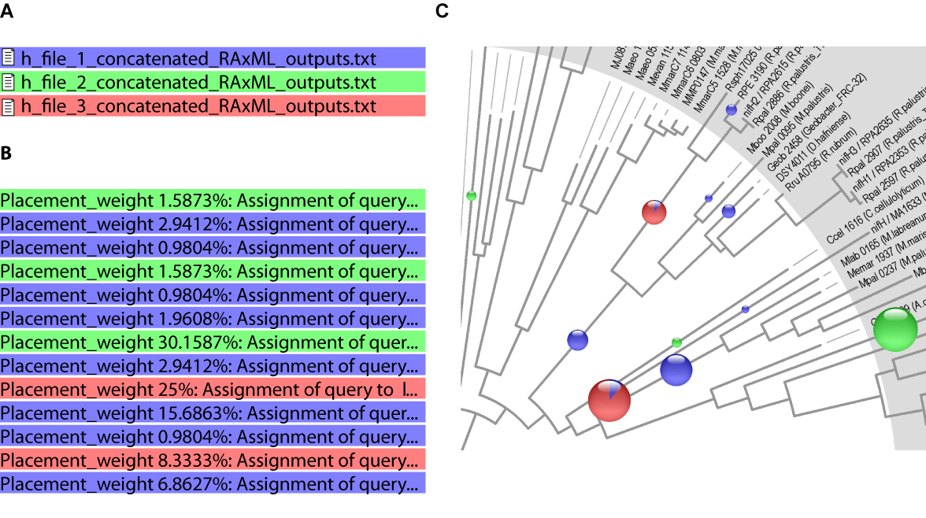

**Fig. 1: usage of the –d input option.**

./mltreemap_imagemaker.pl –i your_input –d 1

A: If you use the –d option, each file in your_input will be treated as an individual dataset (as indicated by the colored bars). B: Before concatenating the files, each line is labelled with a color code, representing its origin. C: The output picture is drawn according to this color code. If several datasets have placements at the same nodes, pie chart bubbles are drawn to represent the fractional weights.